

UNDP Project Document

Governments of Djibouti, Egypt, Eritrea, Ethiopia, Jordan, Lebanon, Palestinian Authority, Saudi Arabia, Sudan, Syria, Yemen

United Nations Development Programme

BirdLife International

Mainstreaming Conservation of Migratory Soaring Birds into Key Productive Sectors Along the Rift Valley/Red Sea flyway

Brief Description

The Rift Valley/Red Sea flyway is the second most important flyway for migratory soaring birds (raptors, storks, pelicans and some ibis) in the world, with over 1.5 million birds of 37 species, including 5 globally threatened species, using this corridor between their breeding grounds in Europe and West Asia and wintering areas in Africa each year. The aim of this project is to mainstream migratory soaring bird considerations into the productive sectors along the flyway that pose the greatest risk to the safe migration of these birds – principally hunting, energy, agriculture and waste management – while promoting activities in sectors which could benefit from these birds, such as ecotourism. The project will pilot a new, innovative and cost-effective approach, termed "double-mainstreaming", that seeks to integrate flyway issues into existing national or donor-funded "vehicles" of reform or change management in the key sectors through the provision of technical tools, content, services and support.

January 2008

Table of Contents

SECTION I: ELABORATION OF THE NARRATIVE 7
PART 1: Situation Analysis 7
1.1 Context and global significance 7
1.2 Sectoral Framework 11
1.3 Threats to the Rift Valley/Red Sea Flyway 13
Hunting 13
Energy 14
Agriculture 15
Waste management 15
1.4 Barriers to Mainstreaming 16
1.5 Stakeholder analysis 18
1.6 Baseline Analysis 18
PART 2: Strategy 19
2.1 Project Rationale 19
2.2 Project Goal, Objectives, Outcomes and Outputs/Activities 25
2.3 Policy Conformity 28
2.4 Project Indicators, Risks and Assumptions 29
Risks and Mitigation 29
2.5 Expected global, national and local benefits 31
2.6 Country eligibility and drivenness 31
GEF Eligibility 31
Country Drivenness 31
2.7 Linkages with UNDP Country Programme 33
2.8 Linkages with GEF-financed Projects 33
Coordination Plan for the AEWA and Siberian Crane GEF Flyway Projects 35
Review of potential links to “Development of a Wetland Site and Flyway Network for the Conservation of the Siberian Crane and other Migratory Waterbirds in Asia” project. 36
2.9 Sustainability 37
2.10 Replicability 40
2.11 Lessons Learned 41
PART 3: Management Arrangements 44
3.1 OVERALL MANAGEMENT ARRANGEMENTS 44
3.2 REGIONAL PROJECT MANAGEMENT ARRANGEMENTS 45
1. UNDP-Jordan (Amman) 45
2. BirdLife International 46
3. UNDP country Offices 49
4. The Regional Flyway Facility 50
3.3 NATIONAL MANAGEMENT ARRANGEMENTS 51
PART 4: Monitoring and Evaluation Plan and Budget 52
4.1 Introduction 52
4.2 Monitoring and Reporting 52
Project Inception Phase 52
Monitoring responsibilities and events 53
Terminal Tripartite Review (TTR) 54
Project Monitoring Reporting 54
4.3 Independent Evaluation 56
Mid-Term Evaluation 56
Final Evaluation 56
Audit Clause 57
4.4 Learning and Knowledge Sharing 57
4.5 Indicative Monitoring and Evaluation Work plan and corresponding Budget for Tranche 1 57
PART 5: Legal Context 59
SECTION II: Strategic Results Framework and GEF increment Error! Bookmark not defined.
PART 1: Incremental Cost Analysis Error! Bookmark not defined.
A. project background Error! Bookmark not defined.
B. incremental cost assessment Error! Bookmark not defined.
PART 2: Logical Framework Analysis 67
SECTION III: Total Budget and Workplan 82
1. Project Total Budget: 82
2. Regional Component: BLI 86
3. National Component (LEBANON): BLI / SPNL 91
4. National Component (JORDAN): BLI / RSCN 93
5. National Component (DJIBOUTI): BLI / MOE 95
6. National Component (EGYPT): BLI / MOE 97
SECTION IV: Additional information 99
PART 1: Other agreements 99
PART 2: Terms of References for key project staff and main sub-contracts 99
2.1 TERMS OF REFERENCE- REGIONAL FLYWAY FACILITY 100
2.2 TERMS OF REFERENCE- NATIONAL 165
PART 3: Stakeholder Involvement Plan 171
SIGNATURE PAGE 174
ANNEXES……………………………………………………………………………………………175

list of annexes

Annex 1: Map of Rift Valley / Red Sea Flyway 124
Annex 2: Soaring bird migration in the Middle East and North East Africa: the bottleneck sites 126
Annex 3: Migratory Soaring Birds: Review of status, threat and priority conservation action 168
Annex 4: Key socio-economic Indicators 210
Annex 5: Problem Tree and Project Structure 213
Annex 6: Double Mainstreaming “Vehicles” 215
Annex 7: BirdLife and Double Mainstreaming 236
Annex 8: Capacity assessment for mainstreaming Migratory Soaring Birds conservation in productive sectors 238
Annex 9: GEF Tracking Tool 274

List of Tables
Table 1: Species of soaring birds that migrate along the Rift Valley / Red Sea Flyway 9

Table 2: Project Risks 29

Table 3: Lessons Learned 41

Table 4: Comparison of Expected Outputs in PDF-B and in Full Project Document 42

Table 5: Summarizes the implementation arrangements 49

Table 6: Identifies coordination mechanisms 50

Table 7: Monitoring & Evaluation workplan & budget 57

Table 8: Incremental Cost Matrix 65

Table 9: Logical Framework and Objectively Verifiable Impact Indicators 69

List of Figures

Figure 1 Diagram of implementation arrangements 47

Figure 2: BirdLife International Management Arrangements 49

List of Acronyms

AEWA | African-Eurasian Waterbird Agreement
APD | Assistant Project Director
ATLAS | UNDP Financial System – People Soft Based
APR | Annual Progress Report
AWP | Annual Work Plan
BD | Biological Diversity
BLI | BirdLife International
CBD | Convention on Biological Diversity
CBO | Community-based Organisation
CEO | Chief Executive Officer
CITES | Convention on International Trade in Endangered Species
CMS | Convention on the Conservation of Migratory Species of Wild Animals
CMPA | Coastal and Marine Protected Areas
COPs | Conferences of the Parties
DDT | Dichlorodiphenyltrichloroethane
EEC | European Economic Community
EIA | Environmental Impact Assessment
ERP | Enterprise Resource Planning
EU | European Union
FAO | Financial and Administration Officer
FO | Flyway Officer
GDP | Gross Domestic Product
GEF | Global Environment Facility
GEF – OFP | Global Environment Facility – Operational Focal Point
HoD | Head of Division
IA | Implementing Agent / agency
IBA | Important Bird Area
IBRD | International Bank for Reconstruction and Development
ICZM | Integrated Coastal Zone Management
IEM | Integrated Ecosystem Management
IR | Inception Report
ITA | International Technical Advisor
IW | Inception Workshop
M&E | Monitoring and Evaluation
METAP | Mediterranean Environmental Technical Assistance Program
MOU | Memorandum of Understanding
MSBs | Migratory Soaring Birds
MW | Megawatt
NA | National Assistant
NAC | National Advisory Committee
NC | National Committee – Egypt
NBSAP | National Biodiversity Strategy and Action Plan
NEAP | National Environmental Action Plan
NIAs | National Implementing Agents
NGO | Non-governmental Organisation
NR | Nature Reserve
NPM | National Project Manager
PA | Protected Area
PD | Project Document
PDF-A | Project Development Fund – A
PDF-B | Project Development Fund – B
PIR | Project Implementation Review
PMU | Project Management Unit
PPRR | Principal Project Resident Representative
PSC | Project Steering Committee
RCU | Regional Coordinating Unit
RFF | Regional Flyway Facility
ROAR | Result-Oriented Annual Report
RSCN | Royal Society for the Conservation of Nature
SAP | Strategic Action Program
SAU | Site Action Unit
SB | Soaring Birds
SEA | Strategic Environmental Assessment
SEC | Secretary and Receptionist
SPNL | Society for the Protection of Nature – Lebanon
STAP | Scientific & Technical Advisory Panel
TOR | Terms of Reference
TPR | Tripartite Review
Tranche 1 Country | Jordan, Lebanon, Egypt and Djibouti
Tranche 2 country | Jordan, Lebanon, Egypt, Djibouti, Lebanon, Palestine, Syria, Saudi Arabia, Yemen, Ethiopia, Eritrea
TTR | Terminal Tripartite Review
UK | United Kingdom
UNDP | United Nations Development Programme
UNDP- CO | United Nations Development Programme Country Office
UNEP | United Nations Environment Programme
US | United States
USAID | United States Agency for International Development
US$ | United States Dollar
WB | World Bank
WI | Wetland International
WTO | World Tourism Organisation
WWF | World Wildlife Fund

SECTION I: ELABORATION OF THE NARRATIVE

PART 1: Situation Analysis

Problem: Populations of many globally threatened and vulnerable migratory soaring birds are threatened by anthropogenic activities during their seasonal migrations along the Rift Valley/Red Sea flyway.

Definition: Double mainstreaming is the process whereby migratory soaring bird conservation objectives are mainstreamed into the relevant threatening sector through a planned or existing reform process or project (the vehicle) targeting a related issue in the same sector, e.g. adding issues of hunting migratory soaring birds to the UNDP project Supporting Enforcement of Environmental Legislation in Lebanon.

1.1 Context and global significance
1 The Rift Valley/Red Sea flyway is the second most important flyway for migratory soaring birds (MSBs) in the world and the most important route of the Africa-Eurasia flyway system. Over 1.2 million birds of prey and 300,000 storks migrate along this corridor between their breeding grounds in Europe and West Asia and wintering areas in Africa each year. In total, 37 species of soaring birds (raptors, storks, pelicans and some ibis), five of which are globally threatened, regularly use the flyway. While these birds are relatively well conserved in Europe, and valued in east and southern Africa as part of the game park experience, they receive practically no conservation attention during their migration. Yet this is where the MSBs are the most physiologically stressed and in some species 50-100% of their global or regional populations pass along the route and through flyway “bottlenecks” (strategic points where soaring birds are funnelled, either to make water crossings or to maintain flying height) in the space of just a few weeks. As a result, MSBs are at their most vulnerable during the migration along the Rift Valley/Red Sea flyway. These large, highly visible slow-moving birds are susceptible to localised threats during migration, such as hunting and collision with wind turbines (particularly when they fly low or come in to land), which could have severe impacts on global populations. Most MSBs are predators at the top of their food chain and occur across a wide range of habitats. Removing these birds, by allowing threats to their populations to continue, would upset the balance of prey populations and disrupt the assemblage of species in the critical ecosystems of both Europe-West Asia and Africa. Unfortunately, the characteristics of the MSBs migration (it is difficult to predict where the birds will come down because their migrations are dependent upon weather conditions) make it unfeasible to improve the safety of the flyway simply through the protection of key sites. Consequently, conservation actions need to address the flyway as a whole, at a regional rather than national level and not through the traditional site-based approach. Therefore, the project aims to mainstream MSB considerations into the productive sectors along the flyway that pose the greatest risk to the safe migration of soaring birds.

2 The phenomenon of bird migration is a well-known phenomenon and one of the greatest spectacles of the natural world. Many of the methods and routes used have been well studied and understood. Migration is an energetically costly activity that places the birds under considerable physiological stress. Many smaller bird species are active flyers and migrate on a “broad front” with birds moving in a wave, which spans a continent from east to west. Some of these birds store fat reserves before making their flights then climb to high elevations to make their long migratory “jumps”. Other birds, predominantly large broad-winged birds e.g. raptors, storks, cranes, pelicans, conserve energy by soaring on local rising air currents, either those deflected upwards by hills and mountains or hot air thermals formed over land, to provide uplift, circling in such currents to gain height and, where the lift ceases, gliding slowly down until they reach the bottom of another thermal where they repeat the process. In this way, many can fly over 300 km in a single day, almost without a wing-beat. These birds, here termed migratory soaring birds (MSBs), tend to follow regular routes, termed “flyways”, that maximise opportunities for soaring whilst minimising migration distances. Because thermals do not form over large areas of water or tall mountain ranges, MSBs are restricted to traditional routes or “flyways” with large concentrations of birds occurring at migration “bottlenecks”, such as narrow sea crossings and mountain passes, and other strategic points where the birds are funnelled or guided by lines of hills, ridges or edges of valleys and other places where they can maintain their flying height. These include the classic world “land-bridges” such as the Panama isthmus in the Americas, Gibraltar and the Bosphorus in Europe and, in the Middle East, the Gulf of Suez and Bab al-Mandeb at the southern end of the Red Sea.

3 Managing and protecting migratory bird populations, is particularly challenging because of the vast range of habitats they occupy during the course of their seasonal cycle, and the need to undertake work in very different ecological and political conditions in the breeding grounds, wintering areas and along the migratory routes. Some birds are more vulnerable than others when on migration. For those making long migratory jumps along a broad front, habitat choice during migration can be wide and threats are generally few and dispersed. However, MSBs are very vulnerable during their migration, not only from the physiological stress imposed by the effort of migration, but from the fact that a large proportion of the global or regional populations of these large, highly visible, slow-moving birds, become densely congregated as they migrate along narrow flyways, follow reasonably predictable timetables and are reliant on a small number of crossing points. As such, they can be disproportionately susceptible to localised threats. From a conservation perspective, the quality of information is particularly good for many of these species when in their northern breeding grounds, and improving for their southern wintering grounds. However, relatively little attention has as yet been given to the protection of birds while in transit on their migratory routes. The conservation work that has been done has mainly concentrated on the bottleneck sites, and wider flyway issues have so far received little or no attention.

4 Global significance: The Rift Valley/Red Sea Flyway, which includes 11 countries, is the second most important flyway in the world for soaring birds in terms of numbers of birds involved. Systematic surveys conducted at bottleneck sites since the mid-1960s have revealed that over 1.2 million birds of prey and over 300,000 storks pass along this route each year on their annual migrations between breeding grounds in Eurasia and wintering grounds in Africa, but given many bottleneck sites have been only poorly surveyed, the numbers involved are thought to be much higher. In broad terms, the northern end of the flyway is along the Syria-Turkey border. It includes the Jordan Valley through Syria, Lebanon, Jordan, and Palestine, and then splits into three, with two routes crossing the Gulf of Suez and passing down the Nile Valley and the west coast of the Red Sea (Egypt, Sudan, Eritrea, Ethiopia and Djibouti), and the third route along the east coast of the Red Sea (Saudi Arabia, and Yemen) which crosses the southern end of the Red Sea at the Strait of Bab al-Mandeb to rejoin the other two before continuing south to the East African Rift Valley (see map in Annex 1).

5 Thirty-seven species of MSB are recognised as using this flyway (Table 1), of which five are globally-threatened – Critically Endangered Northern Bald Ibis (Geronticus eremite); Endangered Saker Falcon (Falco cherrug); Vulnerable Greater Spotted and Imperial Eagles (Aquila clanga and A. heliaca), and Lesser Kestrel (Falco naumanni) – and three globally near-threatened – White-tailed Eagle (Haliaeetus albicilla) Cinereous Vulture (Aegypius monachus) and Pallid Harrier (Circus macrourus). Almost 100% of the world population of Levant Sparrowhawk (Accipiter brevipes) pass along this flyway twice yearly, along with >90% of the world population of Lesser Spotted Eagle (Aquila pomarina), c. 60% of Eurasian Honey Buzzard (Pernis apivorus), and c. 50% of each of Short-toed Eagle (Circaetus gallicus), Booted Eagle (Hieraaetus pennatus), Egyptian Vulture (Neophron percnopterus) and White Stork (Ciconia ciconia). Details of all species and highest passage counts are given in Annexes 2 and 3. Most species of MSB are highly valued in the European countries in which they breed, e.g. raptors, in particular, have been subject to widespread and expensive conservation and re-introduction programmes which have seen populations recover from their pesticide-induced nadir of the early 1960s. The EU Wild Birds Directive (79/409/EEC) was the first piece of EU environmental legislation, indicating the importance given to bird conservation in Europe. This reflects the high regard in which birds are held across Europe. For example, the UK NGO the Royal Society for the Protection of Birds has more than 1 million members, and considerable funds are used to support bird conservation programs in Europe (combined budget for the BirdLife Partners US$189 million for 2002). Many species are also part of European and African mythology, e.g. White Storks are still believed to bring good luck to the house that they nest on. MSBs are also valued highly by eco-tourists in their wintering grounds in eastern and southern Africa where they provide part of the “African safari experience”. The tourism industry of which eco-tourism forms a big part, earns Botswana $240m a year (10% of GDP) and Kenya US$339 million (9.8% of GDP). The continued existence of these economic, cultural, and aesthetic values are dependent upon safeguarding passage along the migratory flyway.

Table 1: Species of soaring birds that migrate along the Rift Valley / Red Sea Flyway

English Name | Scientific Name
White Pelican | Pelecanus onocrotalus
Black Stork | Ciconia nigra
White Stork | Ciconia ciconia
Northern Bald Ibis | Geronticus eremita
European Honey Buzzard | Pernis apivorus
Crested Honey Buzzard | Pernis ptilorhyncus
Black Kite | Milvus migrans
Red Kite | Milvus milvus
White-tailed Eagle | Haliaeetus albicilla
Egyptian Vulture | Neophron percnopterus
Eurasian Griffon | Gyps fulvus
Short-toed Snake-eagle | Circaetus gallicus
Western Marsh-harrier | Circus aeruginosus
Marsh Harrier | Circus cyaneus
Pallid Harrier | Circus macrourus
Montagu's Harrier | Circus pygargus
Levant Sparrowhawk | Accipiter brevipes
Eurasian Sparrowhawk | Accipiter nisus
Goshawk | Accipiter gentilis
Common Buzzard | Buteo buteo
Long-legged Buzzard | Buteo rufinus
Lesser Spotted Eagle | Aquila pomarina (pomarina)
Greater Spotted Eagle | Aquila clanga
Steppe Eagle | Aquila nipalensis
Imperial Eagle | Aquila heliaca
Booted Eagle | Hieraaetus pennatus
Osprey | Pandion haliaetus
Lesser Kestrel | Falco naumanni
Common Kestrel | Falco tinnunculus
Red-footed Falcon | Falco vespertinus
Eleonora's Falcon | Falco eleonorae
Sooty Falcon | Falco concolor
Eurasian Hobby | Falco subbuteo
Lanner Falcon | Falco biarmicus
Saker Falcon | Falco cherrug
Peregrine Falcon | Falco peregrinus
Eurasian Crane | Grus grus

6 Ecological context: With the Rift Valley/Red Sea Flyway extending across 11 countries, the project area covers a wide range of climatic variation and spans a large number of ecosystems. Twenty-three eco-regions are traversed along the flyway, ranging from temperate deciduous and coniferous forests in the north through steppe to various types of hot, dry deserts across most of the central area, and tropical mountain forests towards the southern limits. The preponderance of desert and semi-desert habitats is one of the key features of this flyway and goes someway to explain the importance of wetlands amongst the bottleneck sites along it. MSBs also associate with and have a greater impact on important WWF Eco-regions in their northern breeding grounds and southern wintering areas. For instance, Steppe Eagles breed or feed in grassland and mixed steppe regions in Western Asia, including the Middle Asian Mountains Temperate Forests and Steppe (Ecoregion 71), and Central Asian Sandy Deserts (Ecoregion 124), whereas Lesser Spotted Eagles breed in hilly mixed and deciduous forests, including Mediterranean Shrublands and Woodlands (Ecoregion 129). In Africa, these species have different food sources and feeding behaviours but again occur in important ecoregions, including dry Miombo (Ecoregion 99) and East Africa Acacia Savanna (Ecoregion 102) amongst others. For some species there is a closer association with specific ecoregions, e.g. Lesser Kestrel, a specialist insect feeder, is particularly associated with the Karoo in South Africa (Ecoregion 119) during winter. Most of the MSB species, particularly raptors but also storks and pelicans, are predators at the top of food chains in these Ecoregions and consequently, conservation of these species along the flyway contributes to efforts in Europe and West Asia and Africa to protect critical ecosystems and maintain their ecological integrity. Moreover, the birds are particularly vulnerable along the flyway and unless the threats these birds face during migration are addressed conservation efforts of their breeding and wintering ecosystems will be undermined (this applies to all 37 species that use the flyway, not only to the 8 threatened species).

7 Most MSBs (especially broad-winged raptors and storks) aim to complete the journey between wintering and breeding grounds as quickly as possible. This is particularly the case when crossing the hot and inhospitable deserts of the Middle East and North Africa. Many do not (or rarely) feed and drink during this passage, and only land to roost at night or during adverse weather conditions. Birds arriving at water-crossing points (e.g. Southern Sinai, Suez and Bab al-Mandab), will, on a few occasions, be forced to congregate until weather conditions and time of day are favourable, as the birds need sufficient time to make the crossing before night-fall. As a rule, migrating raptors will roost at night wherever they find themselves, although some species of MSB will show a preference for certain habitat types (e.g. storks, cranes at wetlands, pelicans at open water bodies, and some raptors amongst trees). Therefore timing, local weather conditions and people’s attitudes (persecution) play a vital part in the vulnerability of MSBs at bottlenecks, and may be more important than habitat type or condition. It is because of these characteristics that a mainstreaming, rather than a site-based approach, is necessary. Although birds do tend to congregate and probably land more often at migratory bottlenecks, protection of isolated sites along the flyway is not an adequate approach for MSB conservation. Instead it is necessary to integrate flyway considerations into activities at a broad level along the flyway. For this reason the project is following the Strategic Priority II (BD2) mainstreaming rather than a site-based approach focused on protected areas.

8 Most of the MSB species, particularly raptors but also storks and pelicans, are predators at the top of food chains and hence play a crucial role in widespread terrestrial and freshwater ecosystems in their northern breeding and southern wintering zones. Many MSBs are also important in agricultural landscapes through their impact on pest populations, e.g. Steppe and Lesser Spotted eagles feeding on sousliks and other rodents. Removing these birds, by allowing threats to their populations to continue, would upset the balance of their immediate prey populations and other animal species further down the food chain resulting in significant adverse impacts on the ecosystems as a whole. In addition, MSBs are an integral part of threatened or high biodiversity habitats in their northern breeding grounds and southern wintering areas (including many WWF Ecoregions). For instance, Steppe Eagles breed or feed in grassland and mixed steppe regions in Eastern Europe and Western Asia, including the Middle Asian Mountains Temperate Forests and Steppe (Ecoregion 71) and Central Asian Sandy Deserts (Ecoregion 124), and in Africa they occur in dry Miombo (Ecoregion 99) and East Africa Acacia Savanna (Ecoregion 102) amongst others habitats. Consequently, conservation of MSB species along the flyway contributes to efforts in Europe, West Asia and Africa to protect critical ecosystems and maintain their ecological integrity (this applies to all 37 species that use the flyway, not only to the 8 threatened species). Furthermore, unless the threats these birds face during migration are addressed, conservation efforts in their breeding and wintering ecosystems will be undermined.

9 Socio-economic context: The total population of the 11 countries along the flyway exceed 271 million people. Economically, these countries are generally poor or very poor with per capita incomes in the Middle East being US$3,400-5,000 and in Africa considerably lower at US$800-1,300. However, this somewhat masks the fact that there are major discrepancies in income distribution and the proportion of the population below the poverty line is generally high. Populations are growing fast with all but Lebanon (1.26%) and Egypt (1.78%) over 2% per annum, and demographic profiles are heavily weighted towards the younger age classes suggesting that such rates are likely to continue in the medium-term – median age of population is between 16.54 years (Yemen) and 27.34 years (Lebanon). The poorer countries are still largely agrarian-based (percent GDP from agriculture: Ethiopia 47%, Sudan 39%, Syria 25%) while elsewhere the industrial base is well established (percent GDP from industry: Saudi Arabia 67%, Yemen 45%, Egypt 33%) but these agrarian-based countries also exhibit the fastest rates of industrial growth (Sudan 8.5%, Syria 7%, Ethiopia 6.7%). Levels of unemployment are moderate (10.9% in Egypt) to very high (20% in Syria, 25% in Saudi Arabia; 35% in Yemen, 50% in Djibouti). Health care is also variable – life expectancy is high in the more developed countries (76 (male)/81 (female) years in Jordan; 73/78 Saudi Arabia; 70/75 Lebanon) but remains low in the poorer ones (42/44 Djibouti; 48/50 Ethiopia; 51/53 Eritrea), and infant mortality similarly varies (1.324% in Saudi Arabia, 1.735% in Jordan but 9.532% in Ethiopia and 10.413% in Djibouti). Literacy rates show the same dichotomy (96% (male)/86% (female) in Jordan; 93%/82% in Lebanon; 90%/64% in Syria, but only 50%/35% in Ethiopia; 68%/47% in Egypt; and 70%/48% in Eritrea). Further socio-economic data is given in Annex 4.

10 These socio-economic factors – widespread poverty, burgeoning human populations, high unemployment, limited education and healthcare – all place pressures upon governments to prioritise development to raise living standards and improve basic services. Add to this the recent civil and ethnic unrest experienced by some countries, and major security concerns in others, national agendas are focussed on rural development, industrialisation, and economic growth. Conservation, although becoming a more important issue, is not a priority despite well-meaning statements contained in national biodiversity strategies and other policies. Bird migration issues have barely registered. The associated impacts of increasing levels of development, together with the general lack of conservation efforts in the region, are increasing the mortality of many globally threatened and vulnerable MSBs during their seasonal migration through the region. Four key sectors are seen as impacting MSBs along the Rift Valley/Red Sea flyway – hunting, energy, agriculture, and waste management – while a number of other sectors are considered to be of particular relevance in certain countries, e.g. tourism, urban development, industry and manufacturing, transport, fisheries, petroleum and gas, communications, and defence. The GEF will finance the incremental costs of lifting barriers to mainstreaming MSB conservation objectives into the production sectors that pose the greatest threat to the safe migration of MSBs – hunting, energy, agriculture, and waste management – while promoting activities that would benefit these birds, particularly ecotourism.

11 The human and economic costs, actual and potential, associated with the flyway are also considerable. For instance, the concentration of an extremely large number of birds in limited airspace creates a severe hazard for aircraft through bird strikes; particularly with medium and large size MSBs. In the Middle East, between 1972 and 1983, hundreds of accidents occurred and 74% occurred during migration months with losses in the tens of millions of dollars annually as well as substantial loss of human life. While the number of accidents has been cut by 81% and the costs by 88% through careful flight planning and raised awareness of the problem, costs associated with bird strikes in the region still exceed US$ 5 million per year. With the countries in the region developing quickly and passenger, cargo and military flights increasing, the potential for bird strikes remains huge. To date, globally, over 400 people have been killed and 420 aircraft destroyed through bird strikes during the decade 1990-99. The US Federal Aviation Administration estimates that US civilian aircraft sustained US$ 4 billion worth of damage and associated losses and 4.7 million hours of aircraft downtime due to bird strikes. Approximately 97% of these involved common, large-bodied birds or large flocks of small birds, and 70% involved gulls, waterfowl, and raptors (hawks and vultures).

1.2 Sectoral Framework
12 MSB migration, while following relatively clear “flyways” and traversing critical “bottlenecks” (especially water crossings) is still unpredictable, in part because MSB behaviour depends largely on local weather conditions. MSBs are most at risk from anthropogenic activities when flying low, roosting, feeding or drinking. For instance, birds may come down to drink at wetland areas in the middle of a desert or in agricultural lands in hot weather, and there are even records of birds being forced down by a storm in the middle of urban areas. Consequently, it is difficult to accurately identify specific landscapes that represent major threats to MSBs. Rather than take a landscape approach; the project will focus on productive sectors that represent the greatest risk to MSBs all along the flyway. The PDF-B has identified these sectors within which lie the greatest threats to MSBs, from intentional persecution, including hunting and “protection” of livestock, to unintentional activities, such as collisions with energy sector structures, poisoning from agricultural pesticides, and ingestion of waste materials and waste water. By mainstreaming MSB considerations into the sector frameworks in each country and changing the way people behave, MSBs will be safer regardless of where they are on the flyway.

13 A review of the conservation legislation enacted in the 11 countries along the Rift Valley/Red Sea flyway reveals that while there are large variations between countries in the levels and nature of protection offered by the legislation, no country has legislation that relates specifically to MSBs in the productive sectors. In several countries, overall policies and strategies for biodiversity and wildlife conservation are well designed and could be strong mechanisms for directing MSB conservation efforts. However, the translation of such policy statements into effective national legislation has in many cases not happened or, where the legislation exists, the institutional capacity and resources for effective implementation are lacking. These are common problems across the entire region.

14 A detailed profile of each sector in each country was not possible within the limitations of the PDF-B phase. Moreover, given the project strategy of working in partnership with other national development projects (see paragraph 34), it is not considered necessary since such analyses will have been undertaken by the national development projects. However, summaries of the four key target sectors into which MSB considerations will be mainstreamed by the project are given below:
- Hunting: has huge cultural and traditional in most countries in the region, and it remains prevalent along the Rift Valley/Red Sea flyway particularly in the Levant countries – Lebanon, Jordan, Palestine, Syria and Egypt – although much less so in the African states. Bird hunting tends to be excessive and indiscriminate in many countries with threatened protected species taken as well as common legal prey species. Raptors and storks are particularly vulnerable because being large and relatively slow-flying they make easy targets, and the daily passage of hundreds and even thousands of MSBs at bottleneck sites at predictable times and places presents hunters with an abundant good sport. Legislation is weak (laws and/or implementing regulations not yet enacted or incomplete; lack of recognition of important biodiversity and threatened species) and enforcement poor across the region. Lebanon, Palestine, and Saudi Arabia are not party to CITES and Syria has not formally declared national species lists, weakening attempts to implement national legislation. In Jordan, almost all hunting is carried out as a hobby of the rich where an estimated 4,000 licensed hunters spend an average of US$ 150 per person per month on hunting (estimated annual total of US$ 7.2 million), in Lebanon, as many as 600,000 people (17% of the population) are involved, with only a third of these having the necessary permit, although in Saudi Arabia, only the “traditional” hunting practices, using falcons and hunting dogs are permitted.
- Energy: The economies of the countries along the flyway are generally growing quickly with rates of GDP growth between 1.9% (Yemen) and 11.6% (Ethiopia). Much of this growth is through increasing industrialisation and annual industrial production growth rates are between 2.5% (Egypt) and 8.5% (Sudan). Such growth provides an increasing demand for power that is still met largely by fossil fuel power stations although hydroelectric sources, e.g. from the various Nile Valley dams, are also important for some countries. Wind energy is developing and being promoted, and one of the world’s largest wind farms has been established at Zafarana along the Gulf of Suez, Egypt. In all cases, power needs to be transmitted, most commonly by overhead cables and these too are increasing, e.g. power generation capacity increased in Eritrea from <30 MW in 1991 to 150 MW in 2004, and the length of transmission lines from 800 km to 1,300 km.
- Agriculture: The poorer countries along the flyway have largely agrarian-based economies, e.g. agriculture contributes 47% of GDP in Ethiopia, 39% in Sudan, and 25% in Syria, and as such is a key sector in providing livelihoods for large proportions of the populations, e.g. 60%-70% of people in Eritrea rely on agriculture for income and employment. Increasing agricultural intensification is occurring across the region in response to rising populations, causing habitat destruction and degradation although this is not seen as a direct threat to MSBs, except perhaps to pelicans through the loss of wetlands. However, there is a significant increase in the area under irrigation and over-abstraction of freshwater or increased salinity due to salt water infiltrating aquifers in coastal areas have caused a decline in the availability of freshwater. In some countries in the region, e.g. Jordan and Lebanon, agriculture is responsible for 60 to 70% of the total national water demand. In most countries there is no requirement for EIA for land reclamation or irrigation, no SEA and no awareness of the likely ecological impacts of such schemes. With increasing intensification has come increasing use of agro-chemicals, particularly pesticides. These are now used widely across the region to control pests such as desert locust, army worm, Red-billed Quelea and rodents. Persistent organochlorine and mercury-based pesticides which are banned or restricted by the World Health Organisation and which are no longer in use in most developed countries continue to be manufactured and are still in widespread use in the region (e.g. DDT, Lindane, Paraquat in Palestine and other countries) along with other toxic alternatives such as organophosphates, carbamates and pyrethroid compounds. While some countries along the Flyway have banned the most toxic pesticides, such bans are often ignored or the regulation and enforcement mechanisms for their control are lacking. The problems are exacerbated by misuse and overuse due to lack of awareness and information as well as widespread illiteracy.
- Waste management: is becoming an increasing problem along the flyway as human populations rise and industrialisation increases. Waste management is generally poor with solid waste thrown into open pits, burned, or dumped into rivers and lakes, and waste water and effluents usually discharged directly into rivers without prior treatment. Municipal rubbish tips are usually poorly managed with large amounts of exposed waste, and toxic materials are often present. Where waste sites are designed and managed properly, especially open waste-water treatment plants, e.g. at Aquaba in Jordan, they can provide important and safe habitat for birds. Although efforts have been made to address the waste disposal issue in some countries, it is often only the aesthetic aspect of the problem that is addressed and ecological impacts are ignored.

1.3 Threats to the Rift Valley/Red Sea Flyway
15 The threat analysis is derived from problem reviews commissioned during the PDF-B from all 11 countries along the flyway. Annex 5 shows the problem tree constructed from these. The overall problem can be stated thus:
Populations of many globally threatened and vulnerable migratory soaring birds are threatened by anthropogenic activities during their seasonal migrations along the Rift Valley/Red Sea flyway.

Hunting
16 Sport shooting and trapping, mostly illegal, kills many tens of thousands of MSBs along the flyway. Impacts of hunting vary along the flyway according to national hunting practices and traditions and the degree to which legislation is respected and enforced. In Jordan, large numbers of raptors are hunted or caught along the Rift Valley margins, particularly in the southern part of the Jordan Valley in areas close to Karak and Tafileh. In Lebanon, where hunting is a social sport and hunters have no knowledge of or respect for species, season, timing, laws, private or protected land, or safety of others, practices include shooting, poisoning, capture and trapping using various mostly illegal practices (e.g. glue sticks, light equipment). MSBs such as eagles, vultures, ospreys, accipiters and falcons are all hunted despite protection under international law, particularly along the western slopes of Mt. Lebanon. In Palestine, despite hunting legislation and prohibition of weapons in the West Bank and Gaza Strip, trapping and netting continue unsupervised and killing of MSBs, particularly Honey Buzzard, Black Kite, Short–toed Eagle, and White Stork, is common throughout the Jordan Valley, but especially in Jericho District. In Saudi Arabia, hunting legislation prohibits use of fire-arms for hunting and only the “traditional” methods are permitted in specified areas and seasons, and no hunting is permitted in protected areas. However, Saudi hunting law is not comprehensively enforced and raptors are sometimes shot in the vicinity of falconry areas. In Yemen, hunting and trapping sites include Bab Al-Mandeb, one of the most important points for MSBs crossing the Red Sea into north-east Africa. In the deserts of northern Sinai, Egypt, trapping of falcons is widespread with high value falcons caught along with other bird of prey species which are used as decoys or sold as pets or for taxidermy. White Storks are also hunted for food, generally by poorer communities along the Nile Valley. In Ethiopia, where laws are not enforced, wildlife is killed for subsistence and for commercial purposes and occurs in protected areas.

17 Shooting of MSBs for sport is considered the biggest single threat to MSBs at many bottleneck sites (see Annex 2) is a significant threat for many species. Although the shooting of all soaring bird species is generally illegal, huge numbers were routinely shot for trophies in the early 1990s in many countries, particularly in parts of the Middle East. Tens of thousands have been shot in the past in Lebanon, and foreign hunters in Syria were estimated to shoot 10,000 – 100,000 birds per year. Military personnel have also been recorded using migrating raptors for shooting practice in Syria and Yemen. Despite a lack of quantitative data, there is abundant anecdotal evidence that hunting of migratory raptors remains widespread and largely indiscriminate. Although not quantified for any species, the numbers shot annually are probably sufficient to have significant impacts on the populations of some species. In 2004, reports of raptors shot in Jordan included the globally threatened species Imperial and White-tailed Eagles along with Steppe Eagle, and Honey Buzzard; in Saudi Arabia an estimated 500 birds of prey are trapped annually at bottleneck sites, and in Yemen 500-1,000 birds are trapped annually. There is also a small trade in MSBs and illegal smuggling across borders, either live for the pet trade or stuffed birds for display. The situation is extremely bad in Syria where large numbers of birds are killed to support a thriving taxidermy trade. At sites (especially wetlands) where shooting is particularly prevalent, poisoning of MSBs due to discarded lead shot is believed to be an associated threat.

18 Trapping of falcons on migration to supply the demand for falconry in the Gulf States is a particular concern in Syria, Egypt and Yemen. However, because it is known that falcons can fetch a high price on the market, other raptors are frequently caught in the misguided belief that they too will sell for falconry. In Saudi Arabia, illegal trapping of raptors is reported from Al Hada in the north and at Mugermah, a bottleneck site south of Jeddah, with an estimated 500 birds trapped annually. In addition, the by-catch of non-target species is high, and many birds are killed and maimed during the trapping process – such birds do not show up in the statistics on trapped/traded birds. Other reliable estimates include 30-40 large falcons (nearer 100 in a good year) in Egypt, and 100 Lanners in Yemen taken annually.

19 Persecution of MSBs has historically been a key factor causing population declines and range contractions in many raptors. While legal protection of most raptors in almost all developed countries has greatly reduced this, in the countries of the Rift Valley/Red Sea flyway legal protection is often poorly enforced and persecution is considered to have been one of the main causes of severe declines in many raptor populations in parts of the region over the past 50 years, including local extirpations of Greater Spotted Eagle Aquila clanga, White-tailed Eagle Haliaeetus albicilla, Lappet Faced Vulture Torgos tracheliotus and Lammergeier Gypaetus barbatus.

Energy
20 Wind turbines, power lines and pylons present collision and/or electrocution risk to MSBs and injure or kill birds on the flyway. Collision with power lines and associated structures is a major cause of death and injury to MSBs and major economic losses accrue from the ensuing power cuts. Large and less manoeuvrable species such as Aquila eagles, vultures, and storks are most susceptible. Quantitative data is largely lacking from the Rift Valley/Red Sea flyway but good data are available from the USA and Spain. A study along the Jordan Rift Valley showed that of 147 White Storks found dead between 1993-97, 87 (59%) had died after collision with power lines, and another 361 were counted with broken wings, legs or beaks attributed to similar collisions. Another study of White Storks fitted with transmitters showed that in 1995-98, 10 of 84 birds (12%) killed during their migration through Europe and Turkey, died after collision with power lines. Detailed calculations from the State of California published in 2005 suggest that the annual cost of wildlife-caused power cuts lie between US$32 million and US$317 million – a level of loss that developing countries can not afford to sustain. Other anecdotal evidence indicates that wildlife interactions with power lines can have other costs, e.g. a fire in 2004 triggered by a hawk colliding with a power line prompted the evacuation of 1,600 homes and charred 6,000 acres; in 2005 Los Angeles International Airport experienced three power cuts attributed to bird collisions within 10 days, delaying flights and threatening airport security; and the California Condor Recovery Team reported that nine of the 144 condors released into the wild since 1992 at a cumulative cost of nearly $40 million have died from electrocution from power equipment – a cost of US $2 million to the taxpayers. The most detailed quantitative bird data come from Spain where in the late 1990s 1% of the population of White Storks present during post breeding migration and 7% during pre-breeding migration and wintering season died due to power lines with annual mortality rates from collision of 3.9 birds/km and electrocution of 0.39 birds/pylon. Also in Spain, a large percentage of the country’s Bonelli’s Eagles are killed by electrocution and collision with power lines. Other species for which figures are available from a year’s survey along a 100km length of power lines are: Black Kite 82; Common Buzzard 35; Red Kite 15; Griffon Vulture 14; Kestrel 10; Booted Eagle 9; Short-toed Eagle 8; Bonnelli’s Eagle 4; Egyptian Vulture, Goshawk and Peregrine 1 each. Elsewhere in the world, studies show that constant low-level bird mortality occurs. In South Africa, during three years of monitoring of an unknown length of power lines, 59 Blue Cranes, 29 Ludwig’s Bustard, and 13 White Storks were found dead. In another study from South Africa, bi-monthly monitoring of a 10 km section of 132kV power line killed 0.36 White Storks per year plus other large cranes and bustards. Between 1968-98, the US Fish and Wildlife Service documented over 1,000 raptors electrocuted in the eight-state Mountain-Prairie region alone, and it is thought that the problem is much greater with hundreds or thousands of birds dying every year across the USA. Along the Rift Valley/Red Sea flyway, areas with existing or planned networks of pylons and wires of particular concern for MSBs include: Kfar Zabad in the Beka’a Valley, Lebanon, where new power lines are being constructed next to marshland; Ein Mousa and Ain Sukhna along the northern Red Sea, the El Qah plain of South Sinai, and very high pylons conveying power across the Suez Canal and River Nile in Egypt; power stations at Hodiedah, Mokha and Aden linked by a network of pylons along the Yemeni coast; Hirgigo and Asmera in Eritrea; and Merowe and Khartoum along the Nile Valley in Sudan.

21 Collision with wind turbines is an increasing threat for MSBs. The majority of studies indicate that while collision rates per turbine are low, mortality can be significant where wind farms comprise several hundred turbines, especially so for rarer longer-lived species. Evidence from the US suggests that this is a site-specific problem which does not affect wind turbines generally. In California, a comprehensive four-year study has shown that at the Altamont Pass Wind Resource Area, comprising 4,955 turbines (494MW), 1,766-4,721 birds are killed annually including 881-1,300 raptors, while another study at Solano County Wind Resource Area comprising 90 turbines (162MW), recorded 95 raptors killed annually. However, at Tehachapi Wind Resource Area comprising 3,591 turbines, early studies found low bird use and corresponding low fatality rates, although raptors still appear to be more susceptible to collision than other birds, and limited studies at wind sites in Minnesota where raptor activity is low report few or no deaths. High levels of mortality have been found at sites with smaller numbers of turbines in coastal locations with large concentrations of waterfowl, and it seems appropriate to use caution in siting wind projects in known areas of high migration. The Gulf of Suez and northern Red Sea coast have a high wind energy resource, and wind farms are being developed at Zafarana and planned for Gabel El Zeit in Egypt. There are also plans to develop wind farms at Rhaita, Ghahro, Haleb, Asseb Port, Beilul and Berasole along the Red Sea coast of Eritrea and Gizgiza in Eritrea, all of which pose a risk to Aquila eagles passing through these areas unless carefully sited.

Agriculture
22 Toxic pesticides and untreated effluents may poison some species of MSB along the flyway. Agriculture provides livelihoods for large proportions of the populations of most countries along the flyway. Intensification has brought about the increased use of agro-chemicals, particularly pesticides. As a result, mortality from pesticide poisoning through ingestion of prey or through drinking contaminated water while on migration may represent a significant threat to MSBs in the region. The extent of the problem has not been measured in most countries, but most national reports undertaken during the PDF-B cite this as potentially one of the most significant damaging impacts to MSBs. Extensive and intensive use of pesticides occurs throughout the region, and is of particular concern in the northern Jordan Valley; over much of the agricultural lands of Yemen; the Jericho District in the Palestinian Territories; state-controlled lands in northern, central and coastal lands in Syria where pesticides may be provided free by the government; in newly created farming lagoons and irrigation schemes in Saudi Arabia where intensive farming is promoted; in recently reclaimed desert lands in Egypt which traditionally use heavier pesticide loads than established agricultural lands; in Gezira and government-run lands in Sudan; and on the Hazomo plains in central Eritrea. Contaminated water, due to agricultural runoff, is a particularly high risk to MSBs in hot deserts, where thousands of birds could be affected in a single event.

23 Rodenticides, used to control outbreaks of rats and voles in agricultural areas, can be a particular problem to raptors, particularly anticoagulants, zinc phosphide and sodium fluoroacetate; whilst insecticides to control locusts (vast areas are frequently sprayed in the event of an outbreak) and other insects can affect migrating storks. Avicides, used in particular against Red-billed Quelea Quelea quelea, can also lead to indirect poisoning of raptors. The incidental (or sometimes deliberate) poisoning of scavenging birds of prey, such as vultures, kites and eagles, by carcasses laced with rodenticides laid as bait to kill wolves, jackals, foxes and feral dogs that are said to prey on sheep, chickens or other livestock, is also widespread over much of the Rift Valley/Red Sea flyway, although its impact has not been quantified. Poisoned baits are used because they are the cheapest way to control predators in livestock areas but the risks to other animals are not recognised by farmers. Sub-lethal doses of pesticides can also adversely affect survivability and reproduction. As above, the impact of pesticides is probably greatest for storks, pelicans, cranes, harriers and falcons, which frequently feed during stopovers rather than those that simply pass through the region.

Waste management
24 Open land-fill sites and waste water treatment plants attract, injure, and kill MSBs. Waste sites are generally poorly managed and large amounts of exposed waste attract scavenging birds including soaring raptors. Visiting birds can ingest toxic substances and frequently become entangled in plastic, wire, and other debris, or are injured by metal scrap or fire. Large numbers of MSBs often also die at poorly managed waste water treatment facilities (domestic and industrial) due to drowning, entrapment in sludge (due to inappropriate pond designs) or die or become sick from drinking contaminated water. Waste sites pose particular threats in desert environments where they represent an obvious and attractive source of food and water to MSBs. In a rare study, the 60-year old Betgiorgis land fill site on the eastern outskirt of Asmara, Eritrea, (at the top of the eastern escarpment, an important bottleneck) was shown to contain 546,000m³ of solid waste increasing at a rate of 1.2%/year. Samples taken from the site showed a high concentration of heavy metals – lead, cadmium, mercury, zinc, and chromium – along with hydrocarbons, pesticides, dyestuffs, and radioactive substances. Many MSBs (and other wild animals, e.g. baboons) feed at the site and frequent deaths of MSBs have been reported by local people, though there is no quantitative data on mortality. Accidental poisoning of raptors at open rubbish tips from poison baits set to control scavenging foxes, jackals and feral dogs is a related problem in some areas of the Middle East. Such baits are the cheapest way to control predators at waste sites and risks to other animals are not recognised by, or are unimportant to, site managers.

25 Systematic and quantitative data relating to the problem along the flyway is again lacking, but sites where waste management is known to be a threat to MSBs include the River Hasbani in Lebanon, where domestic and industrial waste management are considered major problems; Taiz solid waste dump and lagoons in Yemen, where cement, pesticide and soap factories and livestock breeding facilities dispose of their waste and where thousands of storks and raptors feed; at Sharm el Sheikh in Egypt where White Storks congregate at rubbish tips; numerous tourist resorts along the Red Sea coast; and military camps, e.g. along the coast in Yemen and Djibouti. In Egypt and Sudan there are unregulated discharges of industrial effluents into the River Nile, Suez Canal and coastal areas, where much of both countries’ industries are based, such as a manufacturing and industrial zone and port at Ain Sukhna, Suez, Egypt, which is a very important bottleneck for MSBs, and many other areas identified for future industrial development, e.g. El Qah Plain in Egypt.

1.4 Barriers to Mainstreaming
26 The Rift Valley/Red Sea flyway is the second most important flyway for migratory soaring birds (MSBs) in the world with over 1.5 million birds comprising 37 species migrating along this corridor twice each year between their breeding grounds in Europe and West Asia and wintering areas in Africa. Between 50-100% of the global or regional populations of some of these species pass along this route and through narrow "bottlenecks" in the space of just a few weeks, which makes them highly vulnerable to human threats particularly from hunting, energy and waste management sector developments, and certain agricultural practices. Unfortunately, because migration movements are largely weather dependent it is difficult to predict where the birds will land and a traditional site-based approach to conservation of MSBs is neither practical nor feasible (or cost-effective). Conservation actions need to address the flyway as a whole, at a regional rather than at a national or site level. Therefore, the project seeks to address the threats to the birds through mainstreaming MSB considerations into the productive sectors that pose the greatest risk to the safe migration of soaring birds along the flyway. However, there are a number of barriers that currently handicap the use of the mainstreaming approach in this context which are detailed below:
- Ignorance of flyway concept and value of the birds: Very few people outside of the conservation sector understand the larger picture of bird migration, particularly the concept that their country is a link in a chain of countries through which the birds migrate i.e. that the flyway is a single unit and that actions taken in one country can have knock-on effects beyond its borders, and that there is therefore a joint responsibility for the conservation of these birds. Equally importantly, most are unaware of the potential economic benefits from protecting these birds along the flyway, such as the local and national benefits from ecotourism development at bottleneck sites, or the benefits to production sector companies in niche markets where consumers look for environmentally responsible producers. Similarly, there is a low appreciation of the potential costs of inaction, e.g. migrating birds hitting power lines can cause shortages and disrupt electricity supplies which can be very costly, or the ecological functions that some species perform, e.g. rodent and insect pest control, and therefore how protection of these birds can directly benefit farmers and other local land users. However, once individuals appreciate that they can directly benefit economically, socially, culturally environmentally and at a personal, community and national level from protecting the flyway and understand that this requires an international coordinated approach, support for conservation measures to protect MSBs will grow and individual behaviour and sectoral practices towards the birds will alter. This can be reinforced through generating a sense of pride in and responsibility for the birds that pass through their country.
- Difficulty in gaining sector entry: A major obstacle to mainstreaming MSB issues into productive sectors across the region is gaining entry to those sectors in the first place. MSBs are not a major issue for productive sector change as they currently have limited economic value in the region and do not drive sector markets, do not represent a traditional concern to the productive sectors’ constituents, and their conservation is of a regional nature, and hence is generally not treated as a national priority. As a result, they have little intrinsic ability to act as a driver of sectoral change. Although there has been a shift among conservationists to dialogue and partnership with productive sectors, global initiatives are still largely led by multilateral or bilateral institutions, well-funded environment ministries or the largest of the international NGOs. It continues to be difficult for national NGOs (and indeed under-resourced environment agencies) to gain entry into national productive sectors where capacity levels on both sides are low and processes for policy setting and budget allocations have not traditionally been participatory and open for public scrutiny and comment.
- Difficulty in addressing change within complex sectors: Even assuming sector entry can be accomplished; leveraging the desired changes within the chosen sector presents a number of barriers. Firstly, sectors have to be addressed issue-by-issue, market-by-market, and country-by-country all along the flyway. There is no common market or regional policy mechanisms existing that allow MSB issues to be addressed at the flyway level. Secondly, sectors do not function as homogenous two-dimensional businesses with clearly defined counterparts representing the entire sector. It is necessary to have a deep appreciation of the complex web of interests, levers and incentives as well as external influences that drive sectoral change and to work with these to design effective sectoral change mechanisms. Thirdly, the capacity to bring about change must be in place. The capacity to bring about sectoral reforms varies greatly both between the agencies and other stakeholders involved within a country, and between similar agencies in different countries leading to difficulties in coordinating necessary reforms across the flyway as a whole. Finally, all successful “agents of change” must convince the sector actors that the change is in their own interest. This is a two-fold process of building an appreciation of why the change is necessary and also of how economic benefits will accrue from the change. Mainstreaming the spectacle of MSB migration into eco-tourism sectors represents the best opportunity to demonstrate an economic value to countries along the flyway that mainstream MSB considerations into the threatening sectors.
- Shortage of technical information on which to base decision-making: It has become apparent during the PDF-B that there is a lack of quantitative information on whether and how some productive sectors are having an effect on populations of MSBs. This is a major barrier since it limits the design of appropriate responses. While experiences from other countries strongly suggest that certain issues should be considered as causes for concern and the precautionary principle should be applied (e.g. heavy use of organic pesticides, location of power lines and turbines along the flyway and particularly close to bottlenecks), actual data on the scale of the problem are poor. This is important since other experiences can differ in small but possibly crucial ways (e.g. the impacts of pesticides in raptors in the northern hemisphere in the 1950/60s came about from bioaccumulation through the food chain, but many soaring raptors appear to feed little or not at all during their migration so may by-pass this potential problem). The project will need to establish the real level of threat posed by some sectors and provide appropriate resources for the collection and dissemination of data on MSBs throughout the region.

1.5 Stakeholder analysis
27 Various participatory approaches were employed, as appropriate, in each of the 11 project countries during the PDF-B stage, to identify and involve project stakeholders (both beneficiaries/ supporters and those who may be opposed to the project or consider that it may have a negative impact on them). National stakeholder workshops were held in 8 countries (in most cases these dealt with the initial problem analysis for the project; in one case, Syria, the focus was on education and awareness and participants included representatives from education and other sectoral ministries including agriculture, electricity, tourism and others). In other countries (e.g. Egypt) aspects of project preparation, including the problem analysis, were carried out as desk exercises. In all countries, there was extensive consultation with relevant ministries, their agencies and other identified stakeholders at various stages of the project preparation (through bilateral meetings, circulation of draft national reports for review and comment, provision of relevant information and feedback on project development from key stakeholders). Due to the “mainstreaming” nature of the project, these consultations involved a very wide range of organisations and sectors, including productive sectors identified as having actual or potential negative impacts on MSBs (agriculture, hunting, energy, waste management) and sectors with potentially positive impacts on MSBs conservation (tourism, education). Project partners carried out national analyses, identifying for each stakeholder: their current role; priorities; expected or potential role in the project; nature of involvement in PDF-B phase; “readiness” and “power” to contribute; in some countries a ranking as “essential”, “supporting” or possible “conflicting” relationship with the project. Capacity and training needs assessments were also carried out for each relevant sector. A Stakeholder Involvement Plan is provided in Section IV / Part IV.

1.6 Baseline Analysis
28 The countries of northern and eastern Europe have invested significant resources in the conservation of raptors and other MSBs on their breeding grounds. In eastern and southern Africa, countries have also invested heavily in conservation, and tourism, primarily ecotourism, now accounts for significant economic activity, e.g. in 2003 Kenya played host to over 1.1 million tourists earning US$339 million, its third largest source of foreign exchange, while in Botswana, tourism has become the country's second largest foreign exchange earner accounting for $240m a year (10% of the GDP). The weak link for MSBs in migrating between their breeding and wintering areas is that conservation in the countries along the Rift Valley/Red Sea flyway is at best well intentioned and at worst absent. Without this UNDP-GEF intervention, the awareness of the need for conservation of MSBs will remain low, the requisite information upon which to base conservation measures will remain poor, conservation legislation will remain weak, the technical capacity for conservation activities and the resources committed to the enforcement of environmental regulations will remain inadequate, and the economic incentives necessary to encourage fundamental changes in human behaviour will remain unshaped. As a result, MSBs will continue to be shot in large numbers as they pass through Syria, Lebanon, Jordan and Palestine; collide with power lines and wind turbines at existing and new sites; and succumb to physical and chemical threats associated with waste and agriculture management.

29 The existing pressures upon MSBs that add significantly to the mortality rates experienced during naturally hazardous journeys – those of shooting, trapping, poisoning, and collision – will continue to increase as human population and industrialisation in the flyway countries continues to grow. In addition, without the necessary conservation measures, inadvertent destruction and degradation of key bottleneck sites along the route will escalate as agricultural, industrial, and tourism development continues to occur without knowledge of MSBs’ requirements and hence with inadequate planning controls and environmental mitigation measures.

30 The 11 countries making up the Rift Valley/Red Sea flyway receive varying amounts of foreign assistance through bi-lateral and multi-lateral projects and programmes. These provide support for development and reform across the spectrum of productive and other sectors in an effort to help the countries reach their full potential. This level of assistance will continue in the absence of this proposed GEF project but will continue to have little or no beneficial effect on MSBs (and in some cases may inadvertently have negative impacts for them), and the opportunity available for them to act as vehicles of change for MSB issues will be lost. For example, although a USAID-funded project will promote sustainable tourism development along the Red Sea and include significant conservation actions, no specific opportunities to include MSB issues will be realised. Similarly, although efforts will be made to strengthen the enforcement of environmental legislation in Lebanon and Jordan through EU-funded projects, no specific attention will be given to MSB considerations in developing legislation, and no support will be provided to the application of environmental legislation with respect to MSBs. In Djibouti, a World Bank-funded project is seeking to stimulate development of renewable energy in the country through erection of a 2 MW wind farm at Ali-Sabieh and restructuring of the power sector, but no actions to include MSBs in the wind farm’s design or in a renewable energy strategy are included.

31 In the business-as-usual scenario, a number of national and local conservation-based NGOs – particularly the national partners in the BirdLife network – will continue to promote the conservation needs of MSBs. However, these will mainly be small-scale interventions at the level of individual sites. They will also be more traditional conservation approaches – advocating site protection and management measures. The better run organisations will have some limited reach into Ministries of Environment and may be able to contribute to conservation policies, but this will be on an ad hoc basis and without any specific focus on MSBs. In the business-as-usual scenario those national organisations best placed to act as MSB “agents of change” within the threatening sectors will have virtually no contact with those productive sectors, except perhaps isolated farming communities. They will have no influence over decision-makers within the sectors and it is safe to conclude that MSB considerations will not be taken into account in any of the target sectors.

32 General tourism is a significant contributor to national economies throughout the region (e.g. US$1.3 billion in Lebanon in 1998). The World Tourism Organisation (WTO) estimates that “nature tourism” specifically generates 7% of all international travel expenditure and predicts that receipts from international tourism will climb by 6.7% a year over the next two decades. Nature travel is estimated to be increasing at an annual rate between 10% and 30%. Another global estimate is that 40-60% of all international tourists are “nature tourists” and that 20-40% are wildlife-related tourists (calculated differently). Governments recognise the potential benefits of ecotourism. At least 6 of the 11 project countries include ecotourism in national tourism or development strategies or are considering its inclusion as a specific sub-sector. In Palestine, for instance, there is a Wildlife Society/ Ministry of Tourism MOU to promote ecotourism. In Egypt the southern Red Sea coast has been declared an “eco-tourism zone”. In the business-as-usual scenario, this zone would be developed without specific reference to the migration spectacles that occur at Suez and the Ras Mohammed/El Qa/Gebel El Zeit crossing. The Egyptian Tourism Federation has established an eco-tourism committee to oversee implementation of environmental regulations by the tourism industry, but while the committee mandate does cover the issue of bird hunting tourism, there is no specific reference to managing this niche tourism with MSB migration.

33 Economic and social benefits can be derived from the spectacle of large soaring birds concentrated at migratory bottleneck sites (themselves often wild areas attractive for nature tourism, e.g. Wadi Dana in Jordan). Facilities and tours can be designed to ensure that local communities derive income and to raise awareness of the conservation needs of MSBs, as has occurred in other regions (e.g. US$ 31 million into the local economy at Cape May bottleneck site, New Jersey from more than 100,000 birdwatchers annually). Several flyway countries have established ecotourism industries (e.g. 63 “nature-based” tourism companies in Ethiopia; estimate of 15% of tourists in Yemen are “ecotourists”; nearly 2000 “ecotourists” including students each year using one tour operator in Lebanon) and “ecotourists” visit many bottleneck sites (e.g. Abijata-Shalla lakes in Ethiopia; Jordan Valley, many Red Sea sites). In Lebanon, the total recreational value of bird watching is estimated at US$ 1.65 million annually and Ministry of Tourism web sites list bird-watching as an activity at some bottleneck sites. The direct economic benefit from visitors to Al-Chouf Nature Reserve is estimated at US$ 50-70,000 a year (plus US$ 100-150,000 indirect benefit to the local community). However, in general, visits to such bottleneck sites in the region are not marketed as MSB tours, countries do not collate information on numbers of birdwatchers or reasons for visits, no specific attempts are made to raise awareness of MSBs conservation and few economic benefits are derived by communities local to the sites. There is huge potential to achieve both national and local economic benefits through more active promotion of the “MSBs experience” while also using this to achieve greater awareness of MSBs conservation needs.

PART 2: Strategy

2.1 Project Rationale
34 Threats to MSBs along the Rift Valley/Red Sea flyway will continue to grow over time. Although conservation actions are being taken by some of the countries involved, these are generally of a broad nature whose influence on MSBs will be peripheral. There is no indication that specific actions will be undertaken shortly, or in fact that they will occur at all. A number of barriers have been identified that work against the reform of productive sectors to assimilate MSB issues and this UNDP-GEF intervention is designed to remove these to facilitate cost-effective modification of people's economic and social behaviour by mainstreaming MSB issues into such sectors.

35 In GEF’s Strategic Priorities, mainstreaming is used to refer to efforts to get biodiversity considerations included in productive sector programs. The traditional approach to mainstreaming involves building awareness, establishing effective relationships between the project and sector agencies and advocacy at high political and donor level to gain sector entry, and then building sufficient capacity and technical knowledge to ensure a shift in sector policy and practice. The advantage of any mainstreaming approach is that if it is done well to start with and the behavioural changes are put in place appropriately, those changes should keep going well after the project ends and there should be little or no ongoing costs for maintaining the changes. However, this approach generally has a lengthy ‘start up’ period – frequently several years – as it negotiates “sector entry”, and is often very costly with the creation of new institutional structures and mechanisms (establishing a project unit within the line ministry, for example), and expensive staff appointments, and even then integration of the conservation message can still be poor. In addition, mainstreaming requires the actors in the productive sectors to agree to the changes and have some perception that the changes are in their best interest. If the changes are not put in place properly to start with, people will revert back to the behaviour they perceive to be in their best interest as soon as the project ends. The conclusion from the PDF-B phase was that, given the low intrinsic ability for conservation issues to drive change management or reform processes, particularly in the key productive sectors where the scale and political impact are large; the resources needed to achieve change; and the capacity and readiness of productive sectors to receive independent contributions from conservation NGOs, the traditional approach of using the GEF project as the vehicle of change – particularly for issues such as migratory birds – would have a high risk of failure and was considered unlikely to be successful here.

36 As an alternative, this UNDP-GEF intervention intends to use a new innovative approach by making partnership agreements with existing or planned donor-funded development projects termed “vehicles” (e.g. introducing reform processes, institutional, and sectoral strengthening programmes) to provide specified technical services on MSB issues to be mainstreamed through those vehicles. The term “Double Mainstreaming” has been coined to describe this process, i.e. in order to mainstream MSB flyway issues into the key productive sectors, the project will mainstream MSB considerations into existing vehicles of reform or change management in those sectors. The double-mainstreaming approach will use these existing structures and relationships to deliver MSB content and tools directly into current mainstreaming processes, plans and projects, and as a result is believed to offer a greater reach and deeper penetration into the key sectors than a traditional approach that looks to “inject” mainstreaming messages from outside the sectors, often as add-on programmes managed by the environmental sector agencies. Consequently, the chances of success in overcoming the identified barriers and in producing effective and enduring change are envisaged to be much higher. In addition, project costs will be reduced because project management, capacity building and field operating costs will be largely shared with, or taken up by, the targeted vehicles; there will be less need for expensive demonstration sites; and, other than a Regional Flyway Facility (see below), no new institutional structures will need to be created. Furthermore, levels of co-financing from national and local government environmental agencies will be lower and consequently, more likely to be delivered. “Double mainstreaming” represents a reduced-risk and more effective alternative to the traditional approach, confirmed by the comments of the STAP Reviewer and UNDP-GEF’s Peer Reviewer. It has also been endorsed by BirdLife International, leading migratory soaring birds experts, the World Bank and participating governments. It is already being replicated in Bulgaria in another MSB project with the support of RSPB. We know of no other GEF Biodiversity project that utilises the same modality.

37 Agreements between the project and each targeted ‘vehicle’ will specify that BirdLife national partners will act as service providers delivering technical content (e.g. technical advice, training courses, guidelines) on MSB and flyway issues into relevant activities to be undertaken by the vehicle. The project will fund this service provision while the vehicle will co-finance its delivery through its existing or planned activities. To this end, in principle agreements have already been reached with six sectoral programmes of different Governments and NGOs in four countries within the flyway, which are funded by the EU, World Bank, USAID, UNDP and RSCN (Jordan), to provide MSB technical content into these six vehicles. Full details are given in the next section.

38 Considerable time and effort has been expended on identifying appropriate “reform vehicles”, and working with their project managers and donor agencies to determine where double mainstreaming could operate, what the Soaring Birds Project would provide to the reform “vehicle” in terms of content, tools, services and support, and how they will be integrated during Tranche I. Reform “vehicles” were chosen on the basis of: how successfully they could demonstrate the double mainstreaming approach during Tranche I; having a representative spread of projects funded by the primary donors in the region for the target sectors (EU, WB, UNDP, USAID – thus facilitating scaling-up and replication in Tranche II and beyond); and the possibility for expansion and development of new linkages during Tranche II.

39 Consideration was also given to the capacity of the national partners to undertake mainstreaming activities (although special capacity support measures have been provided for Egypt and Djibouti given the importance of the sectors and geographical locations) and to the nature of the “vehicle” – its predisposition to working with the project and ability to absorb the technical content. In addition, each reform “vehicle” had to have a focus on at least one of the target sectors and a focus in at least one country possessing either large numbers of bottleneck sites (e.g. Jordan and Lebanon) or with the key water crossings (Egypt and Djibouti) where biological impacts of the approach can be maximized. Given the severity of the threat to MSBs, there was also a focus on reform “vehicles” in countries where the hunting sector poses the greatest threat (Lebanon and Jordan, and Egypt for trapping and sale of live birds).

40 Initially the approach will be demonstrated through six pre-identified practical examples, which have been selected through extensive discussions between UNDP-GEF, UNDP Country Offices, the BirdLife national partners and the concerned programmes’ stakeholders, resulting in principle agreement for all six. A summary of this analysis for the initial 6 project “vehicles” is shown in Annex 6 of the Pro Doc. Content delivery, and operational, financial and management arrangements will be formalised before CEO endorsement. The six selected projects to demonstrate the double mainstreaming approach are listed below:

- Strengthening the Lebanese Judiciary System in the Enforcement of Environmental Legislation (SEEL), Lebanon – funded by the EU. GEF-funded technical provision will include raising awareness of the impacts to MSBs from weak law enforcement in the target sectors; reviewing jurisprudence cases specifically related to birds; identifying MSB experts relevant for the database; developing MSB training modules and training experts and judges in flyway issues, including international law relevant to MSBs, and the impacts from the target sectors and legislative enforcement; reviewing environmental legislation materials relevant to MSBs; carrying out a needs assessment; and developing new modules relevant to MSBs for the Environmental Course to be introduced in the Institute of Judicial Training at the Ministry of Justice
- Strengthening Environmental Enforcement, Jordan –funded by the Royal Society for Nature conservation, Jordan. GEF-funded technical provision will include joint field patrols during migration seasons at critical bottleneck sites; MSB training needs assessed and training provided for environmental police department and wildlife liaison officers; linking regional cooperation to the regional flyway facility; monitoring of local markets for MSBs for sale; developing MSB sustainable hunting guidelines; working with hunters’ groups to agree and apply sustainable hunting guidelines; promoting sustainable hunting at MSB bottleneck sites in Jordan; reviewing existing legislative and regulatory enforcement and incentive systems related to MSBs; assessing the efficiency of existing systems to support enforcement of MSB protection laws; identifying other legislation relevant to MSBs (eg. waste management) and developing training materials; training of experts and judges in international law relevant to MSBs; reviewing jurisprudence cases specifically related to MSBs; provide best practice MSB legislative models from USA and Europe; and BirdLife International establishing links to a RARE “Pride” campaign.
- Building Capacity for Sustainable Hunting of Migratory Birds in Mediterranean Third Countries, Lebanon – funded by EU LIFE. GEF-funded technical provision will include providing training on MSB identification and survey techniques to more effectively include MSBs in national data gathering arrangements, national reports and position papers; incorporating MSB considerations in the Guidelines for Sustainable Hunting and ensuring that the strategy paper reflects these; sharing the guidelines with other countries along the flyway; provision of a study tour to Lebanon for other countries on the flyway where hunting has been identified as a threatening sector; promotion of sustainable hunting at MSB bottleneck sites in Lebanon; establishing links to the RARE “Pride” campaign and provision of MSB-specific educational materials to hunters’ groups; introducing specific MSB information to a general awareness campaign on responsible hunting; providing links to the SEEL project (above); providing best practice MSB legislation models from USA and Europe; reviewing incentives and mechanisms to complement enforcement and financial mechanisms to fund enforcement; supporting the enactment of hunting legislation; developing MSB modules for workshops to resolving conflict and building partnerships; and linking the regional action plan process to the Soaring Birds regional flyway facility; supporting production of the regional action plan and disseminating it to the project partner.
- The Power Access and Diversification Project, Djibouti – funded by the World Bank. GEF-funded technical provision will include provision of guidance on the micro-sitting of the individual turbines at Ali-Sabieh as this can be critical to MSBs (e.g. avoidance of wetland areas, use of concrete bases to prevent build-up of rodents which can attract birds); development and operation of a monitoring programme to determine mortality at the wind-farm and turbine levels (as per the recommendation of the WB EIA) including training of wind-farm staff in bird ID and mortality analysis, and feed results into the strategy to scale-up wind energy to 10MW; testing mitigation measures if mortality rates are high using schemes being tested in the US and Europe, e.g. factoring critical migration periods into the turbine operation schedule, painting blades with ultra-violet paints; training wind-farm managers in MSB issues, field surveys and monitoring techniques; awareness raising around the site of the wind-farm’s bird mitigation efforts; development of a “flyway friendly” accreditation scheme to be used by the wind-farm and the electricity it sells; contribution of MSB data and considerations into any national wind-power generating strategy; and contribution to the choice of area in which the wind farms are sited, through: provision of national MSB data including migration data overlays for site selection and demarcation of critical bottleneck boundaries, and input into field surveys as part of the EIA.
- Sustainable Economic Growth in the Red Sea Governorate, Egypt – funded by USAID LIFE. GEF-funded technical provision will include ensuring that the ecotourism framework accounts for “flyway friendly” issues at regulatory, financial, marketing, and management support levels; including MSB concerns as part of ecotourism branding; developing training modules and delivering training on MSB concerns for the ecotourism sector; including MSB concerns in solid waste management systems at the design and implementation levels; introducing “flyway friendly” considerations into Environmental Assessments of energy components of the project; undertaking capacity needs assessment and delivery of training related to MSB for concerned stakeholders; undertaking monitoring and surveys and establishing an MSB-related database; and awareness-raising related to MSBs
- Agricultural Development Project, Lebanon – funded by the EU. GEF-funded technical provision will include identifying experts on MSBs for provision of technical advice along with technical packs, newsletter and website information; introducing MSB concerns to and training of farmers’ groups; researching links between pesticides and MSBs and monitoring the impact of pesticides on MSBs; assessing feasibility of “flyway friendly” markets for agricultural products; developing “flyway friendly” pesticide use and “flyway friendly” marketing material; piloting agreements ensuring promotion of “flyway friendly” products; developing niche “flyway friendly” products and adopting MSB bottlenecks as geographical indicators for territories and niches produce; developing “flyway friendly” practice guidelines for Good Agriculture Practice Charters; and providing MSB information material for awareness campaigns.
41 The project follows a tranched approach. The first Tranche will establish the environment required to initiate the double mainstreaming approach, including the creation of the Flyway concept and its application as a marketing tool in selected awareness campaigns, establishment of the Regional Flyway Facility, building the capacity of the BirdLife national partners to provide all aspects of the double mainstreaming approach, and the testing of the double mainstreaming approach in at least 6 pre-identified reform vehicles (see Annex 6). The second tranche of the project foresees a major expansion of the double mainstreaming approach to more participating flyway countries, and to additional sectors and reform “vehicles” in the first group of countries. Key to achieving this will be development of the RFF to support BirdLife national partners to identify and negotiate partnership deals with, appropriate donor-funded reform “vehicles” planned for their country. Such development of the RFF, and its associated running costs, will be funded primarily from co-financing raised by BirdLife during Tranche 1, supplemented by “vehicle” co-financing obtained during Tranche 2. Key to realising success will be assistance given in identifying services that can be provided to such “vehicles” and determining and agreeing the incremental costs and the level of co-financing applicable in their provision. A significant factor in negotiating a partnership agreement with a donor will be the degree of confidence afforded by the RFF as a backstopping resource when the donor is dealing directly with the BirdLife national partner. Confidence in this capacity will be generated directly from the RFF’s track record in the successful management of double mainstreaming “vehicles” developed during Tranche 1, and is hence one of the triggers included for moving from Tranche 1 to Tranche 2 (see below). Building the capacity of the BirdLife national partners to provide all aspects of the double mainstreaming approach (Annex 7).

42 The second Tranche will commence on the satisfactory achievement of the following triggers:
- Successful execution of at least four of the six double mainstreaming pilots in Tranche I with at least one success in a country in the Middle East and one in Africa (individual PIRs will be prepared for each pilot double-mainstreaming vehicle, as a means of measuring and reporting progress towards the expected indicators set out in the LogFrame. This will be included in the signed statements from the project vehicle managers on successful partnerships).
- Commitment of a 1:3 GEF: co-financing ratio for Tranche II that would include altered baseline funding for the reform vehicles and 1:2 cash co-financing for the Flyway Facility (verification - written guarantees of co-financing).
- At least 5 BirdLife national partners achieving capacity markers that indicate their ability to provide double mainstreaming technical content. BirdLife has conducted a capacity needs assessment of its project partners to carry out mainstreaming work and identified how this can be built during Tranche I (see Annex 8). Entry into Tranche II will require the project partner to have achieved a score of at least 2 (scores range 0-3) for 9 principal capacity measures identified by the assessment. (Verification: through a follow-up partner assessment using the same agreed approach and methodology adopted at the PDF-B stage to be carried out during year 4).
- BirdLife national partners have identified and negotiated agreements with at least one new reform vehicle that is congruent with the Regional Flyway Facility’s criteria and guidelines. The RFF and national partners will identify and review potential project vehicles throughout the first tranche in consultation with donor agencies and UNDP Country Offices (verification - a written agreement between the project and reform vehicle).
- For moves into new target sectors, the establishment of material links between sector activity and bird mortality along the flyway and the establishment of baseline data against which impact indicators can be measured (verification – independent, peer-reviewed research reports showing impact of sector policies and activities on MSBs along the flyway, with further expert input from the technical committees and agreement from the PSC).

43 The second Tranche will establish the sustainability of the Regional Flyway Facility while a third phase would ensure the financially viability of the RFF as a mechanism that is able to offer technical mainstreaming services on a commercial basis and to recognised standards (such as a certification process or audit standards). It is expected that significantly less GEF funds would be required for the second Tranche owing to the co-financing triggers and the fact that the first Tranche includes start-up costs, particularly for the RFF – see cost estimates. To achieve this, the second Tranche will build upon the foundations laid by the activities of the first tranche, with the aim of developing the project in four areas outlined below.
- Increasing the number of “vehicles” in the key sectors that double mainstreaming is operating through. Building on the experience gained with the pre-identified reform “vehicles” during the first tranche, project partners in Djibouti, Egypt, Jordan and Lebanon will be supported by the RFF to replicate their successes and expand their activities not only by increasing the number of “vehicles” in the sector with which they have experience, but also into those other sectors identified as key during the PDF-B, namely hunting, energy, agriculture and waste management, which are beyond their immediate experience but with which other first tranche BirdLife national partners have been working.
- Increasing the number of countries in which double-mainstreaming is operating. Using the capacity of the BirdLife national partners built during activities of the first tranche, directed by criteria and guidelines produced by the RFF, and incorporating the experiences gained and lessons learned from working with partner donors through the initial “vehicles”, the double mainstreaming approach will be expanded to operate in the seven countries not included in the first tranche, i.e. Eritrea, Ethiopia, Palestinian Authority, Saudi Arabia, Sudan, Syria, and Yemen, concentrating initially upon the four key sectors that most impact MSBs, identified during the PDF-B. The criteria and guidelines for selecting vehicles and entering into co-financing agreements with them will be developed by the RFF in Tranche 1 and will be applied in Tranche 2, thereby ensuring that the transaction costs will be lower in Tranche 2. Furthermore, there will be a body of double mainstreaming content and approaches available to the expansion from Tranche 1 (e.g. training modules for certain sectors), which will also provide savings.
- Increasing the range of sectors that MSB considerations are double mainstreamed into. While the five sectors for which pre-identified “vehicles” have been included in Tranche 1 have been regarded as key, the PDF-B identified a number of other sectors which may impact MSBs on a wide geographic scale or that do impact MSBs but on a narrow geographic basis, e.g. petroleum sector along the Egyptian Red Sea coast and Gulf of Suez, Using the data collected and/or collated in the database established in the RFF during the first tranche, these additional sectors will be prioritised and the nature of the threats more closely established. With the assistance of the RFF, national project partners in all countries will be encouraged to identify reform “vehicles” and develop double mainstreaming partnerships that can be used to address these key issues affecting MSBs in these sectors.
- Development of the Regional Flyway Facility to establish commercial services. The long-term financial and institutional sustainability of the RFF will be dependent upon (a) its ability to promote “flyway friendly” services, products and incentives that are economically valuable to the private sector, and (b) in becoming a certification body for “flyway friendly” services and products for which it can make charges for services to the private sector and government and donor-driven projects. The underlying principle here is that the “flyway friendly” accreditation provided by the RFF will provide added value to (a) the commercial sector where economic advantage can be leveraged from incorporating MSB considerations into their activities, e.g. bird-oriented eco-tourism, organic food production, responsible hunting integrated into local livelihood systems; and (b) the donor/banking sector where there is a need to meet corporate environmental and social responsibility policies demanded by their shareholders for funding projects, especially if they have signed up to the Equator Principles or similar schemes. Feasibility studies will be undertaken during Tranche 1 but development of these capabilities will be undertaken during Tranche 2 when details of the certification process will be further developed. At present it is envisaged that the RFF would review an organisation’s activities in relation to MSBs and make recommendations where necessary to negate adverse impacts. When such activities are either neutral or beneficial to MSBs, “flyway friendly” certification would be awarded. It may be necessary to undertake periodic audits to ensure continued compliance. Sustainability of the RFF will begin by raising co-financing for its running costs from those project “vehicles” that it develops partnerships with on behalf of the national project partners – both in new countries and in additional sectors in those countries already featuring in Tranche 1. From these first steps, and on the back of the development of the Flyway Concept and the technical content produced for foregoing project “vehicles”, it will begin to identify commercial opportunities, develop services that fit market needs, and establish a visible niche within the region as a whole that will attract customers from national and local governments and the private sector.

Labelling and certification processes and schemes for ‘flyway friendly’ products and services associated with the target sectors will be developed in Tranche II and are not expected to be introduced until Tranche II is well underway (the focus in Tranche I will be on developing links to producers and strengthening understanding of impacts on MSBs). The project aims to establish a labelling or certification mechanism through the Regional Flyway Facility in collaboration with the national partners, with a clear written plan of action by the end of Tranche I (one of a series of targets the RFF should meet for project entry into Tranche II). During Tranche I, market analyses and economic feasibility studies will be undertaken for each sector through the RFF with a view to identifying specific products and services that would already qualify for or could be developed as ‘flyway friendly’. The RFF will hold consultations with organisations running other certification schemes (e.g. Forest Stewardship Council, Marine Stewardship Council etc) to develop appropriate models and approaches. Success in certification also depends on linking the environmental benefits of adopting the scheme with economic or Corporate-Social-Responsibility benefits for operators, therefore consultations will also be held with ‘producers’ and their ‘markets’.

Currently there is no independent certification process for flyway friendly activities in the target sectors. That is why the goal is to transform the Regional Flyway Facility into such an independent certifier. Labels and products may include: a Regional Flyway Facility (RFF) approved training course on integrating MSB issues into EIA processes for environmental consultancy companies; electricity generated from wind turbines that meet international ‘best practice’ designs as endorsed by the RFF; adoption by farmers of less toxic pesticides or integrated pest management that don’t threaten raptors at bottleneck sites (again endorsed by the RFF); or endorsement of tour companies who look to build partnerships with local communities around bottleneck sites with increased ecotourism revenue flowing into addressing the threats to MSBs at these sites.

2.2 Project Goal, Objectives, Outcomes and Outputs/Activities
44 The overall project goal is to ensure that globally threatened and significant populations of soaring birds that migrate along the Rift Valley/Red Sea flyway are effectively maintained. The immediate objective is that conservation management objectives and actions for MSBs are mainstreamed effectively into the hunting, energy, agriculture, waste management and tourism sectors along the Rift Valley/Red Sea flyway, making this a safer route for soaring birds.

45 The initial phase of the project will have four components to deliver the expected outcomes – development of the Flyway concept to be used for “flyway friendly” promotion and double mainstreaming; building capacity of national partners and other agencies to effect double mainstreaming; the actual delivery of double mainstreaming to incorporate MSB issues into targeted sectoral programmes; and the monitoring and adaptive management of the approach.

Outcome 1: Raised awareness of the flyway and altered social and cultural behaviours among target groups that threaten MSBs in the key sectors, decision-makers and the general public

46 Multi-sectoral and multi-stakeholder partnerships will be developed at regional, national, and local levels to effect long-term changes to the perception, value, and sustainable management of MSBs along the flyway leading to three Outputs.

Output 1.1: Concept of MSB Flyway established and promoted
47 The development of the Flyway concept is critical to the success of the project. It will articulate why MSB considerations are important and reinforce the position that flyway considerations have a value and are worth mainstreaming into the target productive sectors. The aim is to lift the barriers to sector change. It will create a “brand” upon which a common approach can be based all along the flyway that simply and creatively expresses the aim of the project – to have the needs of MSBs mainstreamed into the targeted productive sectors. This will provide the foundation for the development of a marketing strategy, a logo, presentational materials (leaflets, fact sheets, PowerPoint presentations) and other standardised project materials that can be applied across the project, both for awareness-raising and authenticating productive sector actions as “flyway friendly”. Regional stakeholder workshops will be held during the inception stage to develop the Flyway concept, a project communication strategy prepared and a professional marketing company engaged to advise on logo design and branding of project materials.

Output 1.2: Regional “Flyway Facility” established to promote mainstreaming of MSB considerations
48 A regional “Flyway Facility” will be established that will help overcome the barrier of lack of information. It will allow content providers and recipients to communicate and share knowledge throughout the flyway acting as an interactive repository for all issues connected to MSBs and the double mainstreaming process. This will be provided through the Facility staff themselves and targeted additional technical services; project services and products. It will provide a source of MSB and flyway concept materials, including details of training courses and guidelines, manuals, information sheets; links to funding sources for local mainstreaming initiatives and other relevant data sources. It will establish partnerships, especially with relevant actors in the MSBs’ breeding and wintering grounds (e.g. EU conservation programmes).

49 The Facility will develop eligibility criteria for double mainstreaming (which sectors to mainstream into, what sort of “vehicles” are acceptable, what instruments will measure benefit) and review and facilitate the maintenance of content standards along the flyway. The Facility will also develop delivery systems and incentive schemes for mainstreaming MSB issues into the key sectors. For instance, during the Tranche II the Facility will develop a certification system for ‘Flyway Friendly’ services and products that promote conservation of MSBs, and establish links to eco-labelled markets.

50 The Facility will include staff experienced in marketing and business development, communication and advocacy as well as technical issues relating to MSBs and their conservation.

Output 1.3: Targeted awareness campaigns on MSB flyway issues designed and carried out
51 National studies undertaken during the PDF-B highlighted the lack of awareness of threats facing MSBs and solutions to these among key sector groups, such as hunters, decision-makers and the general public. National partners will use the Flyway concept as a central element of awareness campaigns targeting the general public in order to build a constituency for change, and decision makers within the key sectors, groups and communities around bottleneck sites with a direct role in the management or use of bottleneck sites.

52 Once the Flyway concept has been developed, awareness of it and the project’s aims will be promoted at the national level by each of the BirdLife International national partners involved. This will be complemented on the ground at three bottleneck sites (one each in Lebanon, Jordan and Egypt) by subcontracting RARE to undertake a Pride Campaign concentrating on the issues of hunting and trapping. A Pride campaign, RARE’s flagship programme, focuses on turning a charismatic flagship species into a symbol of local pride, and through a combination of grassroots and mass-marketing techniques generates broad-based support for ecosystem protection on a regional or national level.

Outcome 2: Increased national and regional capacity to effect double mainstreaming and application of flyway concept

53 The second component will target the “agents of change” in seeking to overcome the barrier of bringing about sectoral change. Nationally-based activities will seek to facilitate mainstreaming by strengthening the capacity of key institutions and partners to address MSB issues and through increasing co-operation and co-ordination between stakeholders leading to two Outputs.

Output 2.1: Capacity of national partners strengthened to develop and promote concept of Flyway, respond to new opportunities, and monitor content standards
54 It is apparent from the PDF-B that not all national partners currently have the capacity to deliver high quality content consistently into reform and change management processes. It is critical that capacity is built to address this since the “double mainstreaming” approach will fail if the recipients of the flyway content question its technical standard or added value. Upholding the Flyway “brand” will be important – ensuring that content standards are maintained, creating content development methodologies, creating networks and opening up access to BirdLife International best practice worldwide, and building BirdLife International national partner capacity to identify new opportunities for providing content (i.e. flyway business development). In order to achieve this, the project will provide training, resources and support to national BirdLife International partners through, or coordinated by, the RFF with support of outside consultancies as required, based on capacity needs assessments undertaken during the PDF-B and further refined at the inception stage. This training and support will focus on the means to (a) identify double mainstreaming opportunities, (b) conclude successful negotiations to include MSB issues into such vehicles, and (c) produce and deliver the technical content necessary to achieve effective double mainstreaming.

55 BirdLife International will ensure the technical quality of the targeted and tailored content developed for the six pre-identified demonstration in Tranche I. This will be ensured through expert input, application of BirdLife International best practice, and peer review of content using the technical expertise from its world wide networks. Two regional workshops (Middle East and Africa) will be held on the mainstreaming “flyway friendly” practices, standards and methodologies, key sectors and identification of double mainstreaming opportunities, negotiating sector entry, and producing and delivering technical content to ensure national partners function as effective “agents of change”. Key individuals in project partners will also receive training and support in the following: effective communication and awareness-raising; advocacy and negotiation; marketing and business development; networking and partnership building; and project management and financial administration. Building partner capacity will draw on the lessons learned from the UNDP-GEF/BirdLife African NGO-Government Partnerships for Sustainable Biodiversity Action Project to develop the most effective modalities for building partner capacities.

56 A National Project Manager will be appointed to manage project activities in those countries with vehicles during Tranche I (Lebanon, Jordan, Djibouti and Egypt), with support from a secretary/assistant and support from the Project Officers of the RFF as needed. All partners will receive financial resources during Tranche I to identify and develop links to promote mainstreaming of MSB concerns into both the public and the private sector, e.g. to give presentations at trade fairs and business seminars, briefings to government-led committees, work with ministries on policy and planning reviews.

Output 2.2: Capacity of national government and private sector institutions strengthened to promote “flyway friendly” practices
57 The capacity of recipients to be able to deliver MSB content through their vehicles will also need to be built through additional training and support. A full capacity needs assessment for each vehicle will be undertaken upon agreement between the project and vehicle task manager. Key individuals within the project vehicle will be identified for training along with the resources needed to deliver project content into the vehicle.

58 At a national level, training seminars on MSB issues, including information on sensitive sites and sector impacts, relevant sector legislation, the double mainstreaming process, integrating MSB concerns into EIA and economic opportunities associated with MSBs, along with manuals and other training literature, will be offered to relevant government and private sector institutions.

59 The project will also support national efforts to positively promote MSBs and the flyway. For example, efforts to include bird-watching at bottleneck sites in eco-tourism strategies and eco-tour packages. These efforts will be consistent with the flyway “brand” created under output 1.1 so that the eco-tourism initiatives positively reinforce the project’s awareness raising efforts. They will also contribute to the lifting of the sector change barrier by emphasising the potential benefits from making the flyway safer. The project will also identify and test other incentive mechanisms for “flyway friendly” alternative practices.

Outcome 3: Content and tools to enhance flyway friendly practice developed, delivered, and mainstreamed effectively into sector processes and programmes

60 Regional and nationally-based activities will provide high quality technical materials to be integrated into existing vehicles of change management (reform processes, institutional and sectoral strengthening processes) to achieve the desired changes leading to a single Output.
Output 3.1: Technical content developed and integrated into appropriate reform vehicles
61 The provision of content is at the heart of delivering double mainstreaming – the application of BirdLife-developed information concerning MSBs into existing vehicles of reform, i.e. other projects and initiatives already developed for the productive sector in question. This approach has two significant advantages. First, it overcomes the barriers associated with sector entry since the existing vehicle of reform will already operate within the sector. Second, it is an extremely cost-effective method of achieving the necessary changes since a double mainstreaming project will be co-financed by the existing reform vehicle and there will be a much reduced need for independent project management and implementation structures thereby making significant savings.

62 There are numerous ways that MSB content may be added to programmes, such as: additional analysis of MSB impacts when EIAs and SEAs are being undertaken; provision of information to decision-makers on cause-effect relationships between sector actions and MSB impacts; identification of specific and targeted policy opportunities; development of innovative incentive mechanisms; additions to training manuals, courses, workshops, and guidelines; additional complementary workplan activities, particularly at the site level; and complementary demonstration activities, some of which will take place at bottleneck sites. The content will be tailored to the needs and circumstances of the partnership. Although the details of the first 6 practical examples of “double mainstreaming” will be set out in service agreements to be finalised before CEO endorsement, a summary of the technical content, costs and co-financing is provided in Annex 6.

63 Reform “vehicles” were chosen on the basis of: how successfully they could demonstrate the double mainstreaming approach during Tranche I; having a representative spread of projects funded by the primary donors in the region for the target sectors (EU, WB, UNDP, USAID – thus facilitating scaling-up and replication in tranche II and beyond); and the possibility for expansion and development of new linkages during Tranche II. Consideration was also given to the capacity of the national partners to undertake mainstreaming activities (although special capacity support measures have been provided for Egypt and Djibouti given the importance of the sectors and geographical locations) and to the nature of the “vehicle” – its predisposition to working with the project and ability to absorb the technical content. In addition, each reform “vehicle” had to have a focus on at least one of the target sectors and a focus in at least one country possessing either large numbers of bottleneck sites (e.g. Jordan and Lebanon) or with the key water crossings (Egypt and Djibouti) where biological impacts of the approach can be maximized. Given the severity of the threat to MSBs, there was also a focus on reform “vehicles” in countries where the hunting sector poses the greatest threat (Lebanon and Jordan, and Egypt for trapping and sale of live birds).

64 Partnerships with these vehicles will pave the way for future cooperation not only with the concerned Government or NGOs implementing the project, but also with the donors funding these vehicles. UNDP programmes will also be targeted as potential vehicles, because of the ease of access through UNDP country offices (CO), the common financial systems, and the additional advantage that the transaction costs involved in UNDP facilitating the mainstreaming of MSB content into its programmes could be paid by a transfer of funds from the project through the UNDP CO.

Outcome 4: Learning, evaluation and adaptive management increased
Management procedures adopted at all levels of the project will lead to three Outputs.
Output 4.1: Project management structure established
65 The Project Management Unit/Regional Flyway Facility office will be established in Amman, Jordan. Project staff will be recruited with the senior positions advertised internationally.

Output 4.2: Project monitoring, evaluation, reporting, and dissemination systems and structures established and operational
66 Project progress will be monitored according to the Monitoring and Evaluation Plan (see Part 4) with an adaptive management framework feeding monitoring results and risk reviews back into the Workplan (Section III) and Logframe (Section II/ Part II). This is especially important for the activities associated with double mainstreaming where progress is in part dependent on how well the project vehicle itself is progressing. Progression to Tranche 2 (inclusion of the other partner countries and expansion into new vehicles and sectors) will be dependent on meeting predefined triggers.

Output 4.3: Establishment of appropriate monitoring schemes to assess impact of mainstreaming interventions, strengthen impact indicators, and assess other potential target sectors
67 Monitoring schemes and field research will be established to assess the impact of the mainstreaming interventions. This will include the collection of outstanding data at the start of the project or during Year 1 to provide a baseline for project impact assessment (see Logframe in Section II / Part II). A system of data gathering will also be established as part of the project’s adaptive management framework to ensure the routine measurement of progress towards the impact indicators.

68 The degree of threat to MSBs from activities in some sectors, such oil pollution and contamination, identified during problem analysis workshops conducted during PDFB could not be fully established and will therefore form an area for further investigation during Tranche I. If activities in sectors other than hunting, energy, agriculture and waste management are found to pose a significant threat to MSBs these will be targets for action during Tranche II (see triggers for Tranche II above).

2.3 Policy Conformity
69 The project’s focus on addressing barriers in key production sectors to the uptake of measures for the conservation of MSBs along the Rift Valley/Red Sea flyway is consistent with GEF Operational Programme 1 on Arid and Semi-arid Zone Ecosystems, and Operational Programme 2 on Coastal, Marine, and Freshwater Ecosystems – the two main groupings of ecosystems present along the flyway. The project’s objectives and activities have been designed to conform fully to GEF’s Strategic Priority BD2 – Mainstreaming Biodiversity in Production Landscapes and Sectors – by mainstreaming conservation management actions specifically for MSBs into key productive sectors – hunting, agriculture, energy, and waste management – within the 11 countries along the flyway, to make this route safer for soaring birds. In doing so, it has adopted the guidance provided by the UNDP-GEF Biodiversity Advisory Note on GEF Biodiversity Strategic Priority 2 issued on 9 March 2005 by mainstreaming within a distinct geographical area (the Rift Valley/Red Sea flyway) as well as specific sectors, and incorporated the design elements included therein, thus: (i) strengthening sectoral policies and policy making capacities to take account of biodiversity; (ii) integrating biodiversity conservation objectives into sectoral and spatial planning systems; (iii) building broad-based awareness in the production sectors of the relationship between biodiversity and sector performance; (iv) promoting and adopting “flyway friendly” practice in different productive sectors through partnerships, technical assistance, and demonstration activities; and (v) reforming supply chains to better take account of biodiversity friendly production practices (e.g. certification schemes). The project has built on the concept that mainstreaming is a process, hence, its design stresses its catalytic function in transforming systems primarily through raising awareness and altering social and cultural behaviours among target groups in the key sectors, as well as the general public – by increasing national and regional capacity to achieve the required changes; and by developing and delivering the tools necessary to enhance flyway-friendly practices. The GEF Secretariat Information Paper on “Strategic Priorities in the Biodiversity Focal Area” dated March 2003 states that: “Given the broad character of mainstreaming, the operational emphasis will be flexible to allow for the development of tailored activities based on understanding of country context, biodiversity conservation problems, opportunities and demand.” The project has been designed with full cognizance of this need for operational flexibility, not least because of the wide range of vehicles and country contexts that will be encountered in double mainstreaming activities along the Rift Valley/Red Sea Flyway.

2.4 Project Indicators, Risks and Assumptions

Risks and Mitigation
70 The main project risks and their significance, as well as the ways in which the project aims to mitigate these risks are outlined in Table 2 below.

Table 2: Project Risks

Risk | Rating* | Risk Mitigation Measure
Existing reform vehicles do not accept, or choose not to implement, MSB technical content. | H | Vehicles will be targeted carefully so that MSB technical content complements their own work and contributes to their objectives (see paragraph 63 for rationale and criteria on selection of reform “vehicles”). Input will be tailored to their needs, following their formats and procedures and they will receive world-class technical input pro bono. BirdLife can also provide existing relationships with many stakeholders, access to local communities, NGO “credibility”, etc. Added value of the content will be highlighted and, as the project progresses, examples of successful double-mainstreaming project (initial list of 6 “vehicles”) will be promoted. Relevant donor-agency (USAID, EU, UNDP, WB) staff will be kept informed of project progress by the project Director and other staff of the RFF and invited to attend project demonstrations.
Markets for “flyway-friendly” services and products are too small to be sustainable and/or do not develop sufficiently within the timeframe of the project to sustain interest or are affected by a global economic downturn. | H | Eco-friendly products and services are still a relatively small but rapidly growing component of the world economy and recent market analyses suggest this is set to continue (recently put at 6.5%/year for tourism as a whole with some estimates putting “nature tourism” at 40-60% of all international tourists). During the first phase of the project, financial and technical resources will be allocated to identifying markets, building capacity of producer groups and relevant stakeholders, and promoting “flyway-friendly” services and projects nationally, regionally and internationally, to address this issue. The project will promote bird-watching at the bottleneck sites (within carrying capacity), and thereby ecotourism generally to the region, through the BirdLife network and partnerships with the private sector and local NGOs, and link the certification of “flyway-friendly” products with other certification systems and eco-friendly markets.
Recipients of flyway content question technical standard or added value of content provided by project because project is testing a new approach (double mainstreaming) | M | The project will ensure the technical quality of the targeted and tailored content by: strengthening national partners in the areas of professional service, business management, partnership building, etc; having the Regional Flyway Facility providing quality control on technical content with additional expert input, application of BirdLife best practice, and peer review of content using the technical expertise from its world wide networks; and, establishing capacity benchmarks before moving to Tranche III
Government contributions (finances, counterpart staff) and co-financing contributions are not forthcoming in a timely manner. | M | The Project assumes a six-month start-up phase (3 months hiring and 3 months inception periods) to bring all staff, partners, governments and co-financiers on board. Co-financing commitments with reform vehicles will be detailed and confirmed before CEO endorsement as part of a service contract between the project and vehicle donor. Co-financing will be confirmed once specific negotiations have taken place between BirdLife, UNDP-COs and the Project Donors as to the nature of technical content they are able willing to receive. Additional co-financing commitments, e.g. for the Flyway Facility will be confirmed prior to and as a pre-condition for commencement of Tranche II of the project.
Amendments to legislation and regulations modifications are not officially approved or enacted in a timely fashion. | M | The double mainstreaming approach, with MSB activities set within existing mainstreaming projects and processes, is likely to facilitate and speed the adoption of measures to better protect MSBs through the greater influence and lobbying capabilities of the two sets of partners (this project and the mainstreaming vehicle).
Failure to secure legal protected status for bottleneck sites not fully protected undermines attempts to protect MSBs along the flyway. | L | Many MSBs, particularly raptors, do not use regular roost or feeding sites or habitat types while on migration with weather conditions playing a bigger role in dictating landings. Furthermore, although the birds travel the same route, they do not stop at all 23 bottleneck sites. Many pass through at height and consequently the air space above the bottleneck is more important than the habitats on the ground, although these habitats may generate good thermals for soaring at these sites. (Indeed, the Important Bird Area criteria that define a "bottleneck" relate to the number of birds sighted, not the numbers resting or roosting). Consequently, strengthening the protection of all 23 sites would have questionable effectiveness and failure to secure legal protected status for bottleneck sites not fully protected does not pose a major risk. Rather it is landscape and production sector activities, such as hunting and wind farm developments, that occur along the whole flyway that need to be addressed, which is why the project has taken a mainstreaming (BDII) rather than a protected area (BDI) approach.
Regional projects frequently consist of countries with different priorities and degrees of interest, which can make project management and administration difficult and progress slow. The current project is particularly ambitious given it comprises 11 countries spanning two regions with differing cultures and at different stages of social, economic and scientific development. Consequently there is a risk that some countries may not be able to deliver on project activities. | L | The successful completion of the PDF-A and PDF-B against severe constraints and deadlines demonstrates that the countries along the flyway are willing and able to work together and that the political will to implement the full project exists. However, during the PDF-B phase capacity issues were identified as a limitation to full project implementation in some countries. This will be addressed through a phased approach with project partners in Djibouti, Egypt, Jordan and Lebanon undertaking the full suite of activities during Tranche I, while the other project partners (and relevant collaborating institutions) in Eritrea, Ethiopia, Palestine, Saudi Arabia, Sudan, Syria, and Yemen will undergo capacity building to enable them to participate fully and effectively during Tranche II. Many of the project partners – in Egypt, Ethiopia, Jordan, Lebanon, Palestine, Saudi Arabia, Sudan and Yemen – are BirdLife Partners or Affiliates within the Middle Eastern or African Partnerships and therefore have experience of working together on large regional or global projects.
There is significant difficulty in being able to demonstrate biological impacts in breeding and wintering grounds as a result of the project interventions because the flyway is an open system subject to greater external influences than are inherent in the flyway itself – namely breeding success and wintering mortality. | L | The project has no alternative but to accept this as a likely outcome. The current monitoring techniques lack the sensitivity to identify the results of project interventions at a population level, but the monitoring system will do its best to come up with meaningful indicators. Quantifiable indicators for threat reduction and mainstreaming will be determined and achieved instead.
The pool of educated English-speaking government, NGO and private sector staff is limited in many of the 11 countries, where Arabic or French are the predominate languages. The project may have difficulty recruiting sufficiently experienced, multi-lingual personnel as project staff in some countries. | L | During the first two years the project will train native-speaking trainers to provide the capacity building inputs so as to reduce this risk as far as possible.  BirdLife has an extensive network of contacts in the region that it can draw upon to help identify suitable project staff in countries where recruitment may be a problem.
* Risk rating – H (High Risk), M (Modest Risk), and L (Low Risk).

2.5 Expected global, national and local benefits
71 The project will realise a number of environmental benefits. At the global level, these will involve safeguarding MSBs including five globally-threatened and three near-threatened species during their migration across the Middle East and along the Red Sea. Significantly lowered mortality of these species, during an already arduous journey, will provide the last link in the chain of protection covering their annual cycle and help maintain their populations in both their European breeding grounds where they are aesthetically highly valued by people (e.g. storks breeding on houses) and in their African wintering grounds where they are one of the attractions for a highly valuable eco-tourist industry. National environmental benefits will accrue through increased awareness at all levels of a major natural system running through each participating country with knock-on effects for wider conservation issues in each country and increased cooperation between neighbouring states. The main benefits at the national and local level would be an increased protection for certain important sites; strengthening of the conservation ethic within government legislative, policy and economic machinery; enhanced institutional mechanisms for collaboration between sectors and institutions for dealing with environmental problems e.g. government, NGOs and the private sector (seriously weak in all the African countries concerned); and capacity development for institutions and individuals that would “spill-over” to other sectors and help enhance efficiency of key institutions and potential benefit in terms of income to individuals and whole regions through ecotourism.

72 Local environmental benefits include safe-guarding of key agricultural habitats and wetland sites, for example by helping to minimize the use of pesticides and herbicides. This is a major problem at some key sites e.g. in Egypt. This in turn would safeguard food production systems and fresh water fisheries (local and national benefit). National-level institutionalization of environmentally friendly practices would also “spill-over” into other sectors and practices benefiting local environments. The potential economic benefits from ecotourism, noted above, would profit local people throughout the flyway, and especially at sites of MSB concentration. Enhancing biodiversity-development linkages in this way helps reinforce local incentives for conservation measures. Enhanced access to national decision making processes for local communities through project structures and processes (e.g. EIA) will be a further local benefit, helping to ensure that developments reflect local environmental concerns.

2.6 Country eligibility and drivenness

GEF Eligibility
73 The following countries ratified the Convention on Biological Diversity (CBD) on the dates given and are eligible for technical assistance from UNDP: Djibouti on 1 September 1994; Egypt on 2 June 1994; Ethiopia on 5 April 1994; Jordan on 12 November 1993; Lebanon on 15 December 1994; Syria on 4 January 1996; Sudan on 30 October 1995; Yemen on 21 February 1996; while Eritrea acceded to the CBD on 21 March 1996 and Saudi Arabia acceded on 3 October 2001. Under paragraph 9 (b) of the Instrument and according to GEF-CEO letter of 2 August 1996 to GEF Executive Council Members, the Palestinian Authority is eligible for GEF financing through regional or global projects.

Country Drivenness
74 Migratory birds are recognised as key priorities for biodiversity conservation by governments and other stakeholders in the region. Nine of the 11 project countries have National Biodiversity Strategy and Action Plans (NBSAPs) and/or National Environmental Action Plans (NEAPs) with biodiversity elements relevant to the conservation of MSBs. Some make specific reference or include Action Plans relating to migratory birds (e.g. Egypt), species at risk outside protected areas (Jordan) or habitats used by MSBs including protected areas, Important Bird Areas (IBA) and bottleneck sites (Egypt, Ethiopia, Syria). Some national conservation policies (e.g. Jordan Parks Policy, Ethiopia Wildlife Policy) pay specific attention to the conservation needs of migrants or the creation and protection of habitat corridors along which species can migrate and several countries have afforestation/ reforestation policies (e.g. Eritrea, Jordan) or coastal/ marine strategies (Jordan, Lebanon, Saudi Arabia, Yemen) incorporating species or habitat conservation measures at bottleneck sites and other key areas on the migratory flyway. Of the 23 bottleneck sites along the flyway, identified by the project, eight have some level of protection and 15 are unprotected (see Annex 2). Despite their priority status, there is a general lack of awareness of the impacts of productive sectors on MSBs and their conservation needs among sector players, although this has been recognised by some governments, NGOs and other stakeholders (e.g. Syrian Education Ministry commitment made at PDF-B stakeholders’ meeting to introduce MSBs concerns into the curriculum review process). Eight project countries have ratified either or both the CMS and AEWA, which commit the Parties to action to conserve migratory species and their habitats, including concerted action between Range States. AEWA specifically covers several MSBs (storks, pelicans, cranes) and Resolution 7.5 of the 7th COP of the CMS details potential negative impacts of wind turbines on migratory birds and calls on Parties to take action (identifying areas where migrant birds are vulnerable, strengthening impact assessments).

75 In addition, the project is consistent with three articles of the Convention on Biological Diversity (CBD) and guidance provided by recent Conferences of the Parties (COPs) of the CBD. Article 6 (b) of the CBD calls on Contracting Parties to ‘integrate, as far as possible and as appropriate, the conservation and sustainable use of biodiversity into relevant sectoral or cross-sectoral plans, programmes and policies’. In Decision VI/21, the COP of the CBD further adopted an annexed contribution to the World Summit on Sustainable Development in which it urged Member States and all relevant stakeholders to make further efforts to incorporate and mainstream the objectives of the Convention into relevant national sectoral or cross-sectoral plans, programmes and policies and to recall that the conservation and sustainable use of biodiversity is a cross-cutting issue.

76 The project also addresses Article 14 of the CBD on ‘Impact Assessment and Minimising Adverse Impacts on Biodiversity’ as well as Article 22 which deals with the ‘Relationship with other International Conventions’. In Decision VI/7, the CBD COP approved the guidelines for incorporating biodiversity-related issues into environmental impact assessment legislation and/or processes and urged Parties, other Governments and organisations to apply the guidelines. The guidelines recommend that EIA procedures should refer to the policy documents of other biodiversity-related Conventions of which the Convention on Migratory Species was specifically mentioned.

77 Similarly, Decision VI/20 of the CBD Conference of the Parties endorsed a joint work programme between the CBD and the CMS and recognized that the conservation and sustainable use of migratory species need to be undertaken in their migratory range and through cooperative action. Furthermore it invited the CBD Secretariat to generate guidance for the integration of migratory species into the national biodiversity strategies and action plans. The joint work programme (Document UNEP/CBD/COP/6/INF/15 of 14 March 2002) details specific activities to be carried out jointly by the CBD and the CMS and covers several areas relevant to this project including: the biodiversity of dry and sub-humid lands; the ecosystem approach: indicators, identification and assessment and monitoring of biodiversity: impact assessment and minimising adverse impacts: public education and awareness: sustainable use of biodiversity and sustainable tourism: and national strategies, plans and policies. One particularly important activity listed in the work programme is the inclusion of migratory species considerations in guidelines for the integration of biodiversity considerations in impact assessment procedures.

78 NGO interest in MSBs conservation in the region is strong and increasing. In most countries, this is led by national NGOs or institutions that are BirdLife Partners, and both the Middle East and African Regional Programmes of the BirdLife Partnership (both 2004-2008) highlight mainstreaming of migratory bird conservation into policies and legislation, monitoring of traded and migratory species, and the need to work with national governments to conserve bird migration flyways. Stakeholder input in the PDF-B project stage has been wide-ranging, with representation and feedback from ministries and other government agencies across all relevant sectors (environment, agriculture, hunting, waste management, energy, tourism, education, sustainable development and others), universities, the private sector, and NGOs. Key stakeholders were represented at the two Project Steering Committee meetings held during the PDF-B phase and have been involved with design of the Full Project proposal (See Institutional Framework, Stakeholder Analysis and Stakeholder Implementation Plan).

2.7 Linkages with UNDP Country Programme
79 The project is consistent with UNDP’s framework cooperative strategy in the participating countries, aimed at enhancing national-local capacity and human resource development to achieve environmental protection and sustainable human development. This includes poverty eradication, pro-poor policies, governance, sustainable livelihoods, empowerment of women, and protection and regeneration of the environment. By demonstrating double mainstreaming opportunities within UNDP Country Programmes (such as the UNDP Environmental Legislation project in Lebanon), the project will not only create direct links between national development processes and global environmental benefits, but build direct links between UNDP core commitments and GEF financing. It is expected that this demonstration will be replicated across more UNDP Country Offices in Tranche 2.

80 The project will also coordinate with UNDP’s Regional Programme for the Arab States, 2006-2009. The environmental focus of the Regional Programme is water governance and there will be opportunities to contribute MSB considerations into UNDP’s water governance work in the region. UNDP also supports the Mediterranean Environmental Technical Assistance Program (METAP), which has been identified as one of a number of potential double mainstreaming “vehicles” and initial discussions were held during the PDF-B stage.

2.8 Linkages with GEF-financed Projects
81 The current proposal builds on the lessons and experiences of a number of important GEF-funded projects in the region. These lessons will continue to be applied during project implementation and the RFF team will be provided with copies of their evaluation reports during the Inception Phase. In particular, evaluation results have been studied from the following projects:
- African NGO-Government Partnerships for Sustainable Biodiversity Action – UNDP/BirdLife 1997-2003: This project aims at enhancing biodiversity conservation in Africa through local and national NGO-government partnerships in the Important Bird Areas Process. Using birds as biodiversity indicators, national teams identify sites, known as IBAs, agree on priorities for action and advocate and monitor their conservation. Regional coordination among the 10 African countries and sharing of skills will be enhanced, and the institutional base and sustainability consolidated to permit the expansion and replication of the process.

- Conservation of Wetlands and Coastal Ecosystems in the Mediterranean Region (MedWetCoast) – UNDP/ GEF 1999-2004: This project aims at conserving globally significant flora and fauna in key wetland habitats along the Mediterranean shorelines of six countries: Albania, Egypt, Lebanon, Morocco, Palestine Authority, and Tunisia. In Lebanon, the project has worked at the Ammiq wetlands site in the Bekka Valley, one of the most important wetlands along the flyway (see the Data Sheet for Ammiq in Jordan, Annex 2).
- Socotra Conservation and Sustainable Use Project, Yemen - UNDP/GEF 1996-2001: This project was instrumental in providing participatory examples in sustainable management and development of natural resources. It has successfully developed conservation development plans and strategies and completed baseline ecological inventories related to all components of biological diversity including the ecosystem of the archipelago. A second phase MSP project is aimed at enhancing protected area management capacity in a demonstrative nature protectorate of the island.
- Dana Azraq Project – UNDP/GEF 1993-1996; 1996-1998: This project is one of the pioneer GEF projects that have addressed nature conservation in the context of protected area management, building on sustainable use and management of biological resources. Good practices in reserve management, income generation, legislation enforcement, learning and awareness raising, and networking could be transferred from this pioneer project and applied in the context of the proposed initiative. Similar to this project is the Lebanon Protected Area Project, which provided a good example of national NGO-academic-governmental and private partnerships for conservation and sustainable management of biological diversity in three protected areas: Arz-Ashouf, Palm islands and Horsh Ehdain.
- Implementation of the Strategic Action Program (SAP) for the Red Sea and Gulf of Aden (Red Sea SAP) – UNDP/UNEP-IBRD/GEF 1997-Ongoing: Participating countries are: Djibouti, Jordan, Saudi Arabia, Egypt, Somalia, Sudan and Yemen. The project will develop and implement a Strategic Action Program and regional conservation plans for key marine species and coastal habitats including coral reefs, seagrasses mangroves and seabirds. The region's capacity in habitat assessment, monitoring and management will be strengthened. A regional programme on marine protected areas will be established focused on effective and efficient management of protected areas and to ensure exchange of experience among countries of the region.

- Egypt-Red Sea Coastal and Marine Resources Management – World Bank/GEF 1995-2000: The project was initiated to assist in ICZM, EIA and Coastal and Marine Protected Areas (CMPA) capacity building. It sought to develop effective conservation mechanisms to maintain the ecological functioning of significant biodiversity for coastal and marine ecosystems along the Red Sea shorelines, with emphasis on coral reefs, mangroves, sea-grasses and wadis.

82 In addition, links have been established with the following on-going GEF projects during the PDF-B (including participation in PDF-B Steering Committee meetings, sharing of information and validating scientific data):
- Enhancing Conservation of the Critical Network of Wetlands Required by Migratory Waterbirds on the African/Eurasian Flyways – GEF/Wetlands International 2005-ongoing: The project works in more than 12 countries in Eurasia and Africa to support the improvement of conservation status of African/Eurasian migratory waterbirds, by enhancing and coordinating the measures taken by countries to conserve the critical network of wetland areas that birds require to complete their annual cycle.
- Integrated Ecosystem Management in the Jordan Rift Valley Project – GEF/World Bank: PDF signed in 2002, Expected to start June 2006, four stages with five years duration: The five components for the project have been endorsed by the PSC, including the: Integrated Ecosystem Management (IEM); Community Development; New Nature Reserves (4 + plus improvements at Mujib NR); Capacity Development; and Conservation Finance. The project will be designed to focus on the mainstreaming of biodiversity and nature conservation activities into integrated ecosystem management (including land-use planning) processes. A complementary program of community development and job creation related to nature conservation (with poverty alleviation benefits) will be included as a second principal component of the mainstreaming activity. IEM and biodiversity conservation mainstreaming will be undertaken at three levels including: national policy and regulatory reform, institutional reform, agency by agency; and local demonstration projects in IEM pilot areas. There will be seven IEM demonstration sites in the project. The project will address the combined Capacity Development needs and will address a long-term program for Conservation Finance focusing on the sustainability of the new nature reserves and related nature-based business developments in the Jordan Rift Valley. The GEF core budget will provide for a Community Development Fund and a Enterprise Development Fund.
- Development of a Wetland Site and Flyway Network for the Conservation of the Siberian Crane and other Migratory Waterbirds in Asia - UNEP/GEF Project GF 2712-03-4627. The project aims to improve the ecological integrity of a network of globally important wetlands that are of critical importance for migratory waterbirds and other wetland biodiversity, using the globally threatened Siberian Crane as a flagship for this effort. The project works at three main levels: addressing threats to the sixteen selected project sites through a wide range of activities aiming to strengthen protection and improve management capacity; national level activities in support of wetland and waterbird conservation that will strengthen site protection; and international activities to develop wetland site networks along the concerned flyways and build capacity for coordination of flyway level activities. The project focuses on flyways in Western/Central Asia (Russia, Kazakhstan, Iran) and East Asia (Russia and China), through the participation of the governments of these four countries (National Executing Agencies) under the overall coordination of the International Crane Foundation (International Executing Agency) in cooperation with the Convention on Migratory Species.

Coordination Plan for the AEWA and Siberian Crane GEF Flyway Projects
83 The project team will establish coordination mechanisms with relevant GEF-funded projects in the region during the inception phase. The most relevant projects are the following (see previous section):
- Implementation of the Strategic Action Program (SAP) for the Red Sea and Gulf of Aden (Red Sea SAP) – UNDP/UNEP-IBRD/GEF 1997-Ongoing but very close to completion
- Enhancing Conservation of the Critical Network of Wetlands Required by Migratory Waterbirds on the African/Eurasian Flyways – UNEP/GEF/Wetlands International 2005-ongoing
- Integrated Ecosystem Management in the Jordan Rift Valley Project – GEF/World Bank (PDFB stage)
- Development of a Wetland Site and Flyway Network for the Conservation of the Siberian Crane and other Migratory Waterbirds in Asia - UNEP/GEF Project GF 2712-03-4627
84 The Project Director will liaise with his counterparts on other GEF projects to determine the most effective mechanisms for coordination. The Project Director and other members of the Regional Flyway Facility will also work closely with the relevant national Project Managers and contact points within national executing organisations to ensure effective coordination at national level.
85 The UNEP/GEF/WI flyway project ‘Enhancing Conservation of the Critical Network of Wetlands Required by Migratory Waterbirds on the African/Eurasian Flyways’ is the project which offers the most significant opportunities for collaboration. Opportunities exist in relation to the following (the possibilities of coordination have been discussed with Wetlands International during the PDFB stage, and will be developed during project inception):
- Component 1: Rational basis for conservation activities strengthened through development of a comprehensive, flyway scale, and critical site network planning and management tool. Under this component possibilities exist for collaboration in relation to sites used by pelicans. Although most migrating soaring birds are not specific about roosting sites (see below), pelicans do require wetlands.
- Component 2: Establishing a basis for strengthening decision-making and technical capacity for wetland and migratory waterbird conservation. This component concerns production and implementation of a transferable model framework - Training and Awareness Raising Programme - for developing wetland and waterbird conservation capacity. The content of this training programme is still being developed (by Wetlands International). However, modules are likely to include relevance and implementation of the CMS and its Agreements, as well as a general introduction to migratory bird species, their ecology and the threats they face. These elements are of equal relevance to MSB conservation, providing opportunity to coordinate.
- Component 3: Enhanced availability and exchange of information through improved communications capacity and resource provision; Outcome 3.2: Mechanisms for governments and NGOs to communicate between themselves and with each other strengthened. Although the two projects address a significantly different set of species and adopt different strategic approaches, there is potential to coordinate and share experiences of effective communications technologies across flyway countries.
86 However, it is also important to recognise that there are significant differences between the two projects. For example, soaring birds migrate along relatively narrow ‘flyways’, and mostly at high altitude once height has been gained. Water birds migrate on a much broader front, and fly much closer to the ground. The two groups also have significantly different requirements whilst on migration. Raptors rarely feed whilst on migration, and tend to be non-specific about roosting sites, coming to ground wherever they find themselves at nightfall or when adverse weather conditions prevail. For most MSBs, key sites are those which provide thermals to enable soaring, and those points where the flyway crosses large water bodies or mountains. Given the tendency for MSBs to roost wherever they find themselves, the flyway system is of key importance and needs to be treated as a whole. Waterbirds, on the other hand, need wetlands for roosting and feeding even when on migration, consequently conservation of a network of the principal wetland sites is a critical conservation measure for these birds. Because of these differences, MSBs and Waterbirds are exposed to different threats, and suffer different impacts from the productive sectors. In addition, although both projects are operating in a number of countries they only have one country in common (Yemen). Therefore whilst there are opportunities for coordination (noted above), the projects are also clearly differentiated

Review of potential links to “Development of a Wetland Site and Flyway Network for the Conservation of the Siberian Crane and other Migratory Waterbirds in Asia” project.
87 As with the African/Eurasian Flyway project, this project involves a different geographic region, and birds with different ecological requirements from raptors (the majority of the MSBs using the Rift Valley/Red Sea flyway). However, cranes are MSBs, and the nature of the project does provide opportunities for coordination and exchange of lessons. Discussions with the ITA of the Siberian Crane project have identified the following as potential areas of coordination, which will be explored further during the inception phase:

Output 1.3: External threats to sites reduced through off-site activities. This output recognises that wetlands are highly susceptible to external influences, which will be addressed by linking site management concerns to regional water management policies, plans, and programmes. The project experience to date (as of 19 September 2005) has been in NE China, where water supply is a critical issue for the wetlands. Here the project is making progress in linking site water management plans to long term regional water distribution plans, and securing emergency water supplies to sustain wetlands. Experience here may be relevant to the mainstreaming approach.

Output 1.6: Capacity of staff of relevant agencies strengthened to ensure effective implementation of site management plans. Training provided will include issues of common relevance such as monitoring and integrated management, conservation biology, and conflict resolution. Opportunities for sharing capacity-strengthening materials will be explored.

Output 2.1: Improvements made to national and sectoral legislation, policies, plans, and financial mechanisms in support of the conservation of migratory waterbirds and wetland biodiversity. This output includes activities on legislation harmonization and strengthening of national programmes on wildlife and natural resource management. Relevant work to date includes: in Russia, harmonizing federal and regional legislation; in Iran, Department of Environment (DOE) has increased penalties for illegal killing of Siberian Cranes; and in Kazakstan, the project NEA (the Forest & Hunting Committee of Min Agriculture) has been actively working towards membership of CMS (a bill has been prepared for Parliament). Lessons learned will be applied to sector policy in the MSB flyway countries.

Output 2.2: Wetland biodiversity input to provincial land use planning, water resource management and coastal zone management through baseline surveys, monitoring and improved inter-sectoral cooperation. The project has made limited progress in West Asia to date, but is working in Iran to ensure the DOE is represented on local Administrative Councils which make development decisions. This output has relevance to the sectoral, mainstreaming approach for MSB conservation, and coordination will ensure that any relevant experience is shared.

Output 2.4: Measures undertaken at national level to enhance international cooperation. This output addresses the capacity of NEAs to implement their obligations under international agreements, including through improved networking and access to relevant information. Lessons learnt will be shared.

Output 2.6: Environmental education and public awareness measures undertaken at national level. The project will undertake both site level and national environmental education and public awareness activities. Experiences relevant to the Soaring Birds awareness campaigns will be shared, e.g. the Crane Day activities may have some parallels for migrating raptors.

Output 3.1: Regional flyway networks developed in Western/Central Asia and Eastern Asia, and a programme of regional activities undertaken within the framework of adopted conservation plans for cranes. This output will build capacity for flyway coordination and wetland site network development, including the establishment of a Regional Coordination Centre. A recent development is the approval of the Western/Central Asian Site Network for the Siberian Crane (and other waterbirds) under CMS in June 2005. Activities are covered by the CMS MoU on the Siberian Crane, linked to the biennial Conservation Plans. So far, 21 sites have been identified by the Range States, and the official nomination, review and approval process will soon be starting for proposed network sites. The Siberian Crane Flyway Coordinator (Elena Ilyashenko) is based at Moscow Zoo, and links CMS, the GEF project and the Crane Working Group of Eurasia. Already a lot of work is being done on “Crane Day” celebrations at sites in several countries using education materials prepared by Elena. There is an email network for sharing news on migrating Siberian Cranes. In East Asia, the main emphasis is to strengthen the existing NE Asia Crane Site Network. The project also plans to deploy satellite transmitters on birds in East population in 2006. Experiences will be of relevance to networking and communications within the MSB flyway, and to the establishment of the Regional Flyway Facility.

Output 3.2: Results of project disseminated for the benefit of the global conservation community. Lessons learnt on the most effective tools for dissemination will be shared and the two projects could link websites (www.birdlife.org and www.scwp.info )

88 Crawford Prentice, the International Technical Advisor also notes ‘We have two raptor experts working on our project – Evgeny Bragin at Naurzum Nature Reserve (one of the world’s largest concentrations of breeding Imperial Eagles) and Alexander Sorokin at ARRINP in Moscow (he oversees a raptor collection at the institute and is a government expert on Russian raptors as well as Siberian Cranes). So there may be a human dimension to the connection between the projects. There is interest in establishing an international research station at Naurzum, and Tom Katz from the US National Aviary is thinking about conducting some genetic research on breeding raptors at Naurzum. These raptor studies are not directly related to our project, but there may be some indirect links.’

Financial allocations to ensure coordination

89 Given the regional nature of the project, coordination is most likely to be efficient and cost-effective if carried out through the regular sharing of project reports, and by keeping in touch on issues of most direct relevance through regular e-mail and telephone communication. This will ensure that costs are minimised. However, whenever the project team is travelling and visiting a country where a relevant GEF project is being implemented the opportunity will be used to organise face-to-face meetings. Visitors to Jordan will also be encouraged to arrange meetings with the RFF (to be based in Amman). In addition, the RFF has a travel budget which will allow members of the project team to travel to meetings to ensure effective coordination, should this be considered necessary.

Coordination with World Bank

90 UNDP-GEF and WB-GEF have established good working relations in the Arab States region and have held recent discussions not only regarding this project but other opportunities for collaboration in the region. The Djibouti “Power Access” program was suggested by the WB-GEF Regional Coordinator as a good double-mainstreaming candidate. Discussions have since taken place with the WB Task Manager.

91 WB-GEF and UNDP-GEF Regional Coordinators have agreed to regularly share GEF pipelines, with the aim of identifying potential future double mainstreaming opportunities. The WB will also be invited to sit on the regional steering committee for the Soaring Birds Project and as the Regional Flyway Facility develops its own capacity, direct coordination between the WB and the RFF is anticipated.

2.9 Sustainability
92 As indicated above, this project has built on the concept that mainstreaming is a process; hence its design stresses its catalytic function in transforming systems primarily through raising awareness and altering social and cultural behaviours. The innovative technique of double mainstreaming is believed to offer a greater reach and deeper penetration into the key sectors than a traditional approach that looks to “inject” mainstreaming messages from outside the other key sectors; as a result its chances of producing enduring change are envisaged to be much higher. Since the ultimate reach of the technique will in part be determined by the reform vehicles that it is able to partner, determining how far the mainstreaming process will go is difficult to determine. However, as the Biodiversity Advisory Note states “a project may launch a mainstreaming process but does not need to conclude it”, but the changes brought about by the project are intended to be permanent and irreversible as successful mainstreaming requires.

93 Environmental sustainability: will be achieved by:
- Mainstreaming “flyway friendly” practices – Traditional bird conservation initiatives that focus on injecting large interventions at small sites have often faced sustainability crises. By taking a mainstreaming approach the immediate ecological returns may be less (i.e. the aim is to modify people’s behaviour, not eliminate it), but the chances of sustainability are higher. If people understand why they should modify their behaviour and the value of making the change, there is, prima facie, no reason to suggest they should revert once the project ends.
- Monitoring of impact indicators – The impact indicators in the logframe have been designed to measure the project’s environmental sustainability. A regional programme for monitoring of key bottleneck sites will provide a mechanism to check and verify the ecological status of individual sites along the flyway and allow information to be fed back to governments, NGOs, conventions and other relevant agencies so that appropriate action can be taken quickly.

94 Social sustainability: will be achieved by:
- Local and national participation – The project will enhance participation of local stakeholders, the private sector and NGOs in conservation programmes. It has been designed using a collaborative approach, involving consultations with a wide range of NGOs, local and national government authorities, and local communities, as well as UNDP Country Office staff, to ensure that stakeholder interests and needs have been incorporated and to seek feedback on the emerging design. This participatory approach will continue through multi-stakeholder mechanisms.
- Empowering local communities – Training in natural resource management and the development of markets for flyway friendly goods and services will bind stakeholders to sustainable and economically viable systems that will control actions not in their shared interest. The stakeholder groups at the double mainstreaming vehicles’ demonstration sites will be encouraged to participate in relevant workshops and events increasing their capacity to address the underlying causes of biodiversity loss in these areas. Training and participation will also allow local stakeholders to identify needs and then request and access resources from national sources.
- Building political will – National, local and provincial government authorities and institutions will be involved from the start of the project in the capacity building and education activities which will increase awareness and experience of the importance of MSBs and flyway friendly practices as factors in decision-making processes and help build political will in government institutions.
- Wide national constituency supporting soaring bird conservation – The project’s branding, marketing, certification, and education and awareness-raising components will build local, national and regional constituencies that are aware of the issues and supportive of conserving MSBs, creating a favourable political and social environment for sustaining project processes.

95 Institutional sustainability: will be achieved by:
- Government commitment – Most of the countries involved in the project have national policies and strategies containing elements of relevance to soaring bird conservation, e.g. NBSAPs, NEAPs (see Annex 3). By reviewing existing policy and legislation, and supporting efforts to fill ‘gaps’ where soaring bird conservation is concerned, the project will help to create policy frameworks that support soaring bird conservation after the end of the project.
- Use of existing structures – Working through existing national and local structures and institutions and donor-funded programmes, for project execution, management and coordination, will help ensure institutional sustainability. Apart from the Flyway Facility, no new institutional structures will be created specifically for the project, but those already in existence will be strengthened. This will ensure that when the project ends, the structures (skills and experience) to continue project processes remain in place.
- Implementation by NGOs and CBOs – The project will be implemented through a partnership between government, NGOs and CBOs, and private businesses (e.g. environmental consultancy groups, waste management companies, energy providers and tour companies), with each organization carrying out activities for which their mandate and resources make them most suited. This will help to ensure the sustainability of project processes. In addition, working through NGOs and CBOs is a cost-effective way of achieving conservation because of the lower overheads usually associated with these types of organization, and engagement of the business community offers opportunities for raising awareness through customers and shareholders and potentially corporate sponsorship further embedding the project’s message within national populations.
- Increased capacity of stakeholders – The development of systemic and institutional capacities of governments, NGOs and other stakeholders, through a strong focus on training personnel (for research, planning, management, education), legislation and policy and building new partnerships between the public and private sectors, will help to secure biodiversity conservation in the long term. The engagement of key sector agencies will contribute to integration of bird friendly measures within broader development activities in the agriculture, energy, urban development and environmental sectors.
- Benefits of double mainstreaming – The project’s ‘double mainstreaming’ approach means that project activities at the national level will be carried out largely within existing or approved future donor-funded mainstreaming initiatives that are consequently already embedded within country driven development strategies and programmes, and allow for shared management, planning and costs, bringing added value to both initiatives.
- Sustainability of Flyway Facility – The Project Management Unit (PMU)/Regional Flyway Facility will become a certification body for “flyway friendly” services and products. It will be institutionalised within BirdLife International, based at BirdLife International’s Middle East Regional Office in Amman, and is expected to become self-sustaining upon termination of the project financially through charges for services to the private sector and government and donor-driven projects, as well as being part of BirdLife International. The groundwork for making the RFF financially sustainable will be laid during Tranche 1 and continued and developed further in Tranche 2 when it will be required to raise co-financing for its running costs from those project “vehicles” that it develops partnerships with – both in new countries and in additional sectors in those countries already featuring in Tranche 1. By the third phase (beyond the lifespan of this project) it will have become a viable commercial operation providing technical services and accreditation in return for fees.
- Continuing local community involvement – The project will support community involvement in MSB planning and management to strengthen local conservation efforts and community livelihood activities, building upon existing initiatives and strengthen existing committees at the demonstration bottleneck sites wherever possible. A feasibility study will be undertaken in Tranche 1 to assess the possibility of mainstreaming MSB considerations into national GEF Small Grants Programmes along the flyway. For example, it may be possible to replicate the double mainstreaming approach for Small Grants awarded for communities living near bottleneck sites.
- Knowledge management – The knowledge gained by the project will be shared with other practitioners working on MSBs conservation, environmental education and awareness, and eco-product promotion and certification (so encouraging replication), through provision of reports, training, and best practice manuals, accessed via the project’s website.
- RARE campaigns – In addition, RARE Pride campaigns are specifically designed around the concepts of long-term sustainability and targeted conservation impact and use appropriate tools, particularly social marketing, that allow organisations to produce long-term or permanent changes in attitudes and behaviours among target groups and to replicate the successes to other projects and areas. They also build sustained capacity in the partner themselves, including project development and fundraising. For instance, an ongoing study of 26 of RARE’s earliest Pride campaigns shows that more than 80% of campaign managers are still using their skills in outreach and education, sometimes more than a decade later, and several Mexican organizations which started implementing Pride campaigns in 1999 and 2000 are on their fifth and sixth generation of campaigns.

96 Financial and economic sustainability: will be achieved by:
- Development of flyway friendly products and services – The project will promote economic sustainability through the development and promotion of ‘flyway friendly’ services, products and incentives that are economically valuable, e.g. bird-oriented eco-tourism, organic food production, responsible hunting, which will be integrated into local livelihood systems through demonstration activities at key bottleneck sites. As these activities will be linked to (and in some cases dependent on) conservation of migrating soaring birds, local communities will promote the protection of these sites.
- Reduced costs through economies of scale – As a largely capacity building and awareness-raising and demonstration project, one-off costs will be incurred in testing ideas, undertaking training and developing tools and strategies. However, the focus on working with existing programmes and institutions, and across 11 countries many of which share languages and similar social and political conditions, will reduce the scale of recurring costs to finance MSB conservation and ‘Flyway Friendly’ activities, fostering financial sustainability.
- Involvement of private sector – Although many of the countries along the flyway have a well-developed private sector, there is a poor awareness of the marketing advantages and advertising opportunities that corporate sponsorship of environmental programmes can bestow. The PDF-B has made initial investigations into private sector finance for MSB conservation in some countries as part of the sectoral reviews. Previous conservation programmes by some of the project partners, e.g. SPNL in Lebanon, have been successful in raising private sponsorship, particularly education and awareness raising projects, and this means of financing will be developed further by the Flyway Facility during the lifetime of the project.
Building fund-raising capability of project partners for MSB projects – The Flyway Facility will review the financial status, funding needs and opportunities for the project partners within the project, produce recommendations for improving fund-raising and financial allocation mechanisms and offer training and capacity building in sustainable financing for MSB conservation projects.

2.10 Replicability
97 Replication of the project approach is at the heart of the project strategy and design, and the replication strategy aims at ensuring that lessons learnt are distilled and actively disseminated to inform similar initiatives elsewhere. The project does not expect to achieve complete transformation throughout the region but looks to achieve direct, measurable and sustainable impact largely through existing programs (vehicles) to promote replication elsewhere.

98 The Project has been designed to integrate MSB issues into existing or planned mainstreaming programs in the target sectors (the ‘double mainstreaming’ approach). Six existing programs in Djibouti, Egypt, Jordan and Lebanon have been identified as project vehicles during Tranche I of the project. If successful, the project will target additional project vehicles in each of these countries as new vehicles develop and the project approach will be replicated in Eritrea, Ethiopia, Palestine, Saudi Arabia, Sudan, Syria and Yemen during Tranche II. Furthermore, mainstreaming vehicles in other sectors, e.g. transport, oil and gas production, will be targeted during Tranche II if field and monitoring studies planned for Phase I show that they pose a significant threat to MSBs along the flyway (‘horizontal’ mainstreaming). In addition, the project will achieve ‘vertical’ mainstreaming by scaling up from demonstrations and other activities at bottleneck sites and trickling down from national policy level work.

99 If proved successful, the double mainstreaming approach will be directly applicable to other mainstreaming projects in other parts of the flyway to the north and south. As an example, a UNDP-GEF PDF-A in Bulgaria has already decided to apply the double mainstreaming approach to its flyway issues as a result of this proposal. Indeed, double-mainstreaming could provide a cost-effective model for integrating wider biodiversity concerns into productive and landscape sectors in many other regions of the world.

100 The project has a strong emphasis on raising awareness of the flyway concept and MSB issues among the general population of the region as well as communities around bottleneck sites and decision makers in the key sectors. This will help build constituency for addressing wider biodiversity conservation concerns at the political level. The awareness campaigns piloted in Jordan, Lebanon and Egypt during Tranche 1 will be replicated to other project countries during Tranche 2, and, given that they will be tailored to the regions cultural and social conditions, will be applicable to other parts of the Middle East or north-east Africa.

101 Similarly, the capacity building element of the project will support the replication of the project approaches and tools at other sites important for MSBs and use in other conservation projects. For instance, the positive focus on building capacity for sustainable ecotourism, specifically birdwatching, at key bottleneck sites during Tranche 1, will be replicated at other bottleneck sites during Tranche 2, if it can be shown to benefit local communities.

102 Specific products of the project will inform and guide the conservation of MSBs in other countries in the region and beyond through the transfer of knowledge and techniques. These include the Guidelines on Responsible Hunting and Code of Conduct for hunters that will provide an important resource for developing a response to illegal shooting of MSBs in the North African and Southern European countries where hunting has be shown to have a major impact on migrating bird populations. Lessons learned on the siting, design and management of waste site, wind farms and power lines will be similarly available to inform the design of similar development in other countries along the Africa-Eurasia flyway important for MSBs, such as Spain, Morocco, Italy, Tunisia, Bulgaria and Turkey, particularly where developments are planned near bottleneck sites.

103 Key approaches to facilitate replication include knowledge transfer tools to support management and mainstreaming such as best practice guidelines, training manuals, presentations to the private sector, attendance of key staff at symposia at the local, national, regional and international levels, and a high quality project website. In addition, the development of a ‘flyway friendly’ labelling or certification system for hunting reserves, tour companies, agricultural produce, etc, in selected countries during Tranche 2, linked to market analysis, support and promotion, has considerable potential to be replicated in other countries in the region if it is shown to bring economic gains to local communities.

2.11 Lessons Learned
104 The project builds on the lessons learnt during the implementation of the PDF-B and those derived from other national and regional conservation programmes (see Table 3). The project will use participatory and adaptive management processes with planning process closely linked with monitoring and evaluation, in order to ensure that the learning is integrated into project plans and implementation.

Table 3: Lessons Learned

Lesson | Design Feature
Mainstreaming projects have been shown to require long timeframes in order to build national constituency and ownership. It provides new challenges to traditional conservation projects. | A timeframe of ten years and two phases has been selected for project implementation. Emphasis has been placed upon collaborative approaches, multi-stakeholder decision-making and coaching people as they undertake project activities themselves. “Branding” has also been suggested to facilitate mainstreaming.
Lack of capacity among some regional partners in the participating countries has caused delays in providing information and implementing national outputs in these countries. | The project will run in two tranches. During the first Tranche double-mainstreaming activities will be implemented in those countries that have shown a strong mobilization of resources and capacity to deliver PDF-B outputs. In the remaining countries, capacity will be built to the levels required to implement double mainstreaming during Tranche II.
The area covered by the project is vast and includes 11 countries. There was variability within these countries on priority sectors where intervention is targeted. | A regional consensus has been built on the sectors included. This has been largely influenced by availability of data and resources.
Threats to MSBs while they are migrating can be different to threats in their breeding or wintering grounds. Deeply held beliefs about what threatens MSBs during migration may not be supported by evidence. | The PDF-B spent consideration effort testing assumptions – even those held by recognised experts. The project has been designed without relying on these assumptions and where uncertainty remains, further monitoring will be undertaken during project implementation
Bird data are incomplete and because of the difficulties in counting MSBs they are not useful for measuring project impact. | The project will not spend significant funds on expensive survey training and counting programmes. Alternative indicators have been developed that do not rely entirely on count figures. MSB identification training will focus on key actors within the productive sectors (hunters, wind-farm operators, etc)
The participatory process and advocacy are not well-understood in all countries and for all partners. | Facilitation in the participatory process will be one of the skills desirable of RFF and managers and staff. Training will be given to those stakeholders or organisations requiring it.

Several changes were made to the project design during the PDFB phase as a result of lessons learned; consequently some elements of the original project design set out in the PDFB application were eliminated or modified. These changes are detailed in Table 4.

Table 4: Comparison of Expected Outputs in PDF-B and in Full Project Document

Outcomes and outputs in Full Project Document | Related outcomes (objectives) defined at PDF-B stage | Explanatory Notes
Outcome 1: Raised awareness of the flyway and altered social and cultural behaviours among target groups that threaten MSBs in the key sectors, decision-makers and the general public  - Concept of MSB Flyway established and promoted  - Regional ‘Flyway Facility’ established to promote mainstreaming of MSB considerations  - Targeted awareness campaigns on MSB flyway issues designed and carried out | Immediate objective 2: Awareness and constituency building  - Key stakeholders sensitised and made aware  - Availability and resourcing of specialist facilities for environmental education  - Cultural traditions  - Number and/or strength of environmental NGOs  - Cultural and religious ethics relevant to conservation  - Indigenous knowledge | Basically unchanged at objective level, although more detail provided at PDF-B stage. The ‘targeted awareness campaigns’ (Full Project Document) will research and build on cultural traditions, religious ethics and indigenous knowledge (included in PDF-B) in the design of their ‘message’ etc. There will be three RARE-led programmes targeted at the hunting sector in Lebanon, Jordan and Egypt with a focus on one or more bottleneck sites in each country.  The most significant change was the removal of outputs related to specialist facilities for Environmental Education. Such facilities were felt to be inappropriate within the context of a ‘mainstreaming’ project.
Outcome 2: Increased national and regional capacity to effect double mainstreaming and application of Flyway concept  - Capacity of national partners strengthened to develop and promote concept of Flyway, respond to new opportunities and monitor content standards  - Capacity of national government and private sector institutions strengthened to promote “flyway friendly” practices | Immediate objective 6: Capacity Building  - Resources committed for MSB conservation  - Number of people with relevant skills  - Status of conservation-related careers  - Expertise on soaring birds transferred from expatriates to nationals | Basically unchanged.
Outcome 3: Content and tools to enhance flyway friendly practice developed, delivered and mainstreamed effectively into sector processes and programmes  - Technical content developed and integrated into appropriate reform “vehicles” | Outputs for immediate objective 4: Sustainable management and socio-economic development  - Information available  - Demonstration models (to include production of guidelines on critical issues affecting soaring migratory birds [such as for wind-farms, sewage treatment plants, waste landfills etc.] that take soaring bird conservation into consideration with regards environmental management aspects).  - Land tenure issues  - Management plans for specific priority sites  - Participatory programmes of socio-economic development and income generation (including ecotourism)  Immediate objective 1: Policy, planning and legislation  - National policies and plans  - Legislation and policy measures  - Mechanisms for the mediation of conflicts of interest  - Network of protected areas | Given the poverty of many people in the region, the PDF-A workshops identified a need to link conservation measures to programmes of socio-economic development.  At the beginning of the PDF-B stage the focus was on a spread of initiatives which would demonstrate best practice in integrating MSB conservation into key sectors.  With the improved understanding of mainstreaming and the recognition of the limited potential for soaring birds to drive sectoral reform, the emphasis shifted to a focus on mainstreaming soaring birds within existing projects and programmes in the relevant sectors, rather than on establishing new, stand-alone demonstrations.  As noted above, it became apparent during the early months of the PDF-B that soaring birds would not have enough leverage to bring about sectoral reform or to carry through changes in national policy or legislation.  With an improved understanding of the root causes and factors driving the threats to the MSBs and the mainstreaming approach gained during the course of the PDF-B, the inclusion of outputs linked to a network of protected areas was removed. Whilst legislative protection at bottlenecks would probably add to conservation measures for soaring birds at some sites, it was felt inappropriate to mix protected area (BD1) and mainstreaming (BD2) approaches within the same project.
Outcome 4: Learning, evaluation and adaptive management increased  - Project management structure established and operational  - Project monitoring, evaluation, reporting and dissemination systems and structures established and operational  - Establishment of appropriate monitoring schemes at selected sites to assess impact of mainstreaming interventions, strengthen impact indicators and assess other potential target sectors | Immediate objective 5: Co-ordination, cooperation and communication  - Information network mechanisms  - Mechanisms for storage, archiving and dissemination of data  - Increased capacity of personnel  Immediate objective 3: Information  - National-level expertise required to collect and analyse data  - Systems for storage and dissemination of information  - Facilities and equipment required for research and monitoring  - Methodologies | Basically unchanged.  The key change here is the removal of a region-wide programme for monitoring of soaring birds. There are two reasons for this: (i) the nature of soaring bird migration means that data (at least in the short to medium-term) would not reliably measure the effect of mainstreaming measures along the flyway; (ii) to establish such a region-wide scheme would be very expensive and was not considered a cost-effective use of GEF resources

PART 3: Management Arrangements

3.1 OVERALL MANAGEMENT ARRANGEMENTS
- The proposed organizational arrangements for implementation of the project are illustrated in Figure 1. UNDP will be the GEF Agency for the project. The project will be executed through a combination of management arrangements in Atlas (NEX and NGO national Executions Modalities). It will be NGO Executed by BirdLife International at a regional level, as the main Implementing Partner, but through UNDP-COs in the double-mainstreaming countries as either National Execution or national NGO Execution. BirdLife International (BLI) will provide overall management and accountability through establishment of the Regional Flyway Facility (RFF) in Amman to act as Project Management Unit supported by its regional offices in Amman and Nairobi and through signing Memoranda of Understanding (MOUs). Signed MOUs with national partners will be considered as an important part of the project document signed between the national partner and UNDP-CO. The national Responsible Parties (Implementing Agents (IA)) will be the BirdLife Partner organizations (e.g. Royal Society for the Conservation of Nature in Jordan) or, where no BirdLife Partner exists or capacity is judged too low, another suitable national NGO or government institution, private contractor or BirdLife Regional Office (to be agreed at the inception stage). UNDP country offices in each participating country will also have specific project execution responsibilities. One project document is prepared with different signature pages to be signed between participating UNDP COs, BLI and respective governments.

- The project will undertake three types of activity:
- Regional activities (e.g. development and promotion of the Flyway concept) will be undertaken directly by the Regional Flyway Facility, with assistance from the National Implementing Agents (NIA) as appropriate.
- National activities separate from the vehicles (e.g. opportunities to mainstream MSB considerations directly into the national private sector) will be undertaken by the NIAs working with assistance from the Regional Flyway Facility (RFF).
- National activities directly through the vehicles (i.e. provision of technical content and services) will be undertaken by the national implementing agents (NIAs) working through the relevant UNDP-CO.
The overall project will be executed by BirdLife International through a Regional Flyway Facility (RFF) established in an office in Amman, Jordan, within the first three months of project commencement. BirdLife will institutionalize and operate the RFF ensuring standardisation of the Flyway concept and quality control of national project activities and products, including reports to UNDP.

3.2 REGIONAL PROJECT MANAGEMENT ARRANGEMENTS

- BirdLife International, through the Regional Flyway Facility supported by BirdLife International’s Middle Eastern and Africa Regional Offices, with the Cambridge Secretariat providing cross-regional coordination and technical guidance will manage regional activities and provide overall technical project management. National Execution will be through separate national arrangements (see next section). Project management will be in accordance with standard UNDP operational, financial guidelines and procedures. BirdLife, and other Implementing Partners, will be accountable to UNDP (the GEF Agency) for the delivery of agreed outputs as per agreed project work plan schedules.

UNDP through its Lead Country office for this Project in Jordan will enter into a project cooperation agreement with BirdLife International as the Implementing Partner. The project will be NGO executed in accordance with the established UNDP procedures, funds will be disbursed through direct payments modality, and BLI will be responsible for keeping record of payments.

- The key management responsibilities and functions of institutions are summarised below:

1. UNDP-Jordan (Amman)

- The UNDP CO in Amman shall be designated as the lead country office responsible for the overall supervision and monitoring of the project by all other UNDP COs and implementing partners.

- On behalf of UNDP/GEF, the Principal Project Resident Representative (PPRR) shall sign the project document with BirdLife International and the government of Jordan.
- UNDP Jordan shall assign a dedicated UNDP Coordination Officer and a Finance Assistant to oversee and monitor the implementation of the project, approve budgets certified by the RFF and ensure overall coordination among and between partners in support to the role of the RFF.
- Coordinate with other UNDP COs, RFF, UNDP-GEF, and BirdLife International throughout the duration of the project to ensure submission of high quality and timely reports as per the standard UNDP procedures.
- In collaboration with the RFF, and in consultation with UNDP-COs, establish the Project Steering Committee and represent UNDP GEF.
- Authorize and process payments based on submitted work plans and proper documentation
- Monitor financial transactions by COs and National and regional partners in terms of delivery, meeting targets and expenditure.
- Ensure in consultation with the RFF that all five-year work plans and annual work plans have been prepared in consultation with constituents and that measurable indicators have been developed and submitted for the approval of the Project Steering Committee.
- Facilitate and participate in the inception workshop ensuring that all stakeholders have attended and that project is put on track.
- Call for TPR meetings on annual basis. TPR meetings could be held back-to-back with annual project steering committee meetings.
- Prepare with the RFF and input from the different components, PIRs/APRs as requested by UNDP/GEF.
- Ensure that mid-term and final evaluations are conducted and that recommendations are followed up.
- Ensure that annual audits are conducted based on UNDP’s standard procedures.
- Liaise with UNDP COs to harmonize and simplify procedures and processes used for the implementation of the project taking into account the different execution modalities.
- Facilitate the signature of project documents with governments and national implementing partners as appropriate.
- Oversee and facilitate the signature of MOUs between the RFF and the NIA.
- Ensure that the Terminal TPR is held and a final project progress report is submitted at least 6 months before the end of the project and ensure the implementation of its recommendations.
- Establish a network among UNDP CO focal points to discuss and monitor implementation at the national level and contribution to the regional project.
- Review TORs of short-term consultants prepared by RFF and participate in the evaluation, selection and recruitment of individual experts or sub-contracted private companies or NGOs to perform specific tasks as needed by the project.
- Perform all functions as a UNDP-CO pertaining to the national component to be implemented in Jordan.

2. BirdLife International

- BirdLife International through the Site Action Unit (SAU), Regional Flyway Facility (RFF) and Regional Offices will undertake the following:

- Establish the RFF and ensure its adequate staffing and operations in order to institutionalize RFF within the BirdLife Secretariat management structure.
- In consultation with the UNDP lead office and according to the established UNDP procedures, appoint a Project Director and Assistant Project Director in the RFF (see ToRs below);
- SAU will be responsible for providing the overall cross-regional coordination and management support to RFF and Regional offices. Represented in the project PSC.
- RFF and Regional Offices shall be responsible for ensuring the implementation of regional activities as indicated in Figure 1.
- RFF shall prepare Memorandum of Understanding to be signed between RFF and NIAs and attached to the project document(s) signed between UNDP/CO and the NIAs.
- RFF shall certify budgets and narrative/financial reports annually from NIAs/Vehicles and coordinate with UNDP-Amman to disperse funds.
- Regional Offices shall coordinate implementation through the BirdLife network and institutionalise the flyway approach within BirdLife International. There will be strong linkages to BirdLife Partner and Affiliate organisations in participating countries, providing a network for influence, exchange, support, and capacity-development and knowledge management.
- In consultation with the UNDP lead office and according to the established UNDP procedures, appoint two RFF Flyways Officers, one to be placed in the RFF/Middle East Office, and one in the Africa regional office, and ensure adequate time is set aside by HoDs and other staff to coordinate RFF activities at the regional level.
- Appoint RFF support staff for efficient management of the RFF (see TORs, Section IV, Part II).
- BirdLife International shall ensure that the management arrangements, coordination and interaction between the different regional offices and the RFF is adequate and effective and serves to the utmost benefit of the project. The proposed regional coordination is presented in figure 2.

Figure 1 Diagram of implementation arrangements

1.1 Regional Activities separate from ‘vehicles’
UNDP-Jordan
BirdLife International / Regional Flyway Facility
Implementing Partner

Direct execution by RFF (or through BirdLife partners where appropriate)
NGO EXECUTION

1.2 National Activities separate from the “vehicles”
RSCN Jordan
UNDP-Jordan
SPNL Lebanon
NC Egypt
Nature Djibouti
BLI / RFF
NGO EXECUTION
UNDP COs
Tranche 2 countries or other appropriate parties

Double mainstreaming activities
1.3a Regional support to “vehicles”
RSCN Jordan
UNDP-Jordan
BirdLife International / Regional Flyway Facility
Implementing Partner

SPNL Lebanon
NC Egypt
Nature Djibouti
RFF Direct
NGO EXECUTION
1.3b. National support to “vehicles”
UNDP-COs
Gov’t Djibouti
Gov’t Egypt
SPNL Lebanon
RSCN Jordan
NGO EXECUTION
NEX
NEX
NC Egypt
Nature Djibouti

Blue arrows are UNDP Agreements
Black arrows are BirdLife Agreements (dashes represent “where appropriate”)
Red arrows are specified relationships between Government and preferred partner
Green arrows are signed Memorandum of Understanding between RFF and IAs
Shaded boxes are Implementing Agent / Responsible Party

Figure 2: BirdLife International Management Arrangements

BirdLife International
(Implementing Partner)

CROSS REGIONAL CO-ORDINATION

BirdLife Regional Offices

Regional Flyway Facility
JORDAN

JORDAN

Head of Division
Project Director
Assistant Project Director

Flyways Officer (Jordan)
KENYA
Head of Division;
Africa Programme Manager
Admin & Finance Officer

Secretary / Receptionist
Flyways Officer (Kenya)

3. UNDP country Offices
- Convene national Tripartite Review Meetings to monitor/evaluate national project implementation and provide management support and advice.
- Disburse funds for national implementation based on approved contract and payment schedules and on receipt of progress reports and workplans as verified by BirdLife
- Provide financial management and procurement services as appropriate, for more details, please see section III.

Table 5. Summarizes the implementation arrangements

Institution | Role | Relationship
 |  | Responsible to | Responsible for
UNDP Jordan | Lead UNDP executing agency responsible for reporting, contracting, procurements and disbursements of funds. | UNDP/GEF | BirdLife, UNDP Country offices, National implementing agents in Jordan
BirdLife Lead office | Responsible for technical project delivery through the RFF, reporting, M&E | UNDP Jordan | Regional Flyway facility, BirdLife regional offices
Regional Flyway facility | Responsible with UNDP COs for project delivery by the national Partners capacity development of national Partners, quality control of national outputs, management support to national implementing agents, clears national reports and annual proposals to UNDP, produces regional syntheses, support national implementing agents in delivering some outputs where needed. Development of technical content, marketing, certification, fund-raising for sustainability. | BirdLife Lead office | National implementing agents
BirdLife regional offices | Responsible for coordinating implementation through the BirdLife network and institutionalise the flyway approach within BirdLife International. Draw strong linkages to BirdLife Partner and Affiliate organisations in participating countries, providing a network for influence, exchange, support, and capacity-development and knowledge management. | BirdLife lead office | External vehicle projects
UNDP Country offices | Organize and facilitate UNDP M&E procedures, disburse funds, support procurement of goods and services  Support to national-level policy processes and regional coordination (through UNDP country offices)  Oversight of double mainstreaming vehicles (especially those executed through UN agencies) | UNDP-Jordan | National implementing agents
National implementing agents | Implementation of national activities, developing capacity for double mainstreaming, identifying new vehicles. | BirdLife regional offices and UNDP Country offices | National Activities

Table 6 identifies coordination mechanisms

UNDP-Jordan | Develops project cooperation agreement with BirdLife International
BirdLife Lead office | Develops cooperation agreements with National Implementing Agents. Signs off on reports to UNDP-Jordan, makes recommendations for disbursement based on delivery of project components.
BirdLife regional offices | Delegated by the BirdLife Lead office to supervise project implementation in the region, signs off on reports to BirdLife Lead Office
Regional Flyway Facility | Line managed by the BirdLife Lead office. Main contact to Partners and vehicles through the regional offices
UNDP Country offices | Provide disbursement and procurement support to national implementing organizations.
National Implementing Agent | Negotiates a MoU with the vehicle project, facilitated by UNDP Country office and BirdLife Secretariat /RFF.

4. The Regional Flyway Facility

- The RFF will be institutionalised within the BirdLife International management structure and will be headed by a Project Director (PD). The PD will be assisted by: one Assistant Director based at the RFF office; two Flyways Officers (one based in the RFF/BirdLife Amman office, and the other based in the Africa Regional Office – outposting the Africa Flyway Officer is critical to achieving the coordination necessary within the region) with appropriate technical skills and knowledge of the regions concerned; and a small support team including a financial and administrative officer and secretary/receptionist, along with specialist consultants as needed (See ToRs attached, section IV, part II ). Existing regional BirdLife International staff will also be key to the success of institutionalising the flyway concept into the BirdLife partnership. RFF staff will be recruited within the first three months of project commencement.

- The Regional Flyway Facility will help to build the capacity of the national partners to enable all of them to participate in Tranche II, at which time project partners will be expected to develop relationships with a wider range of stakeholders to achieve double mainstreaming. The RFF will be supported in day-to-day management by the BirdLife International Middle East office, also located in Amman, Jordan, and it is proposed that the RFF is located within the BirdLife office. Additional support will be provided through the regional offices of the BirdLife Secretariat in Cambridge and Nairobi. Through the BirdLife network there will be linkages to BirdLife Partner and Affiliate organisations in participating countries, providing a network for influence, exchange, support, capacity development and knowledge management. Working in association with the BirdLife Partnership, the flyways officers will be expected to deliver most of the regional components of the project and to oversee initiation and coordination of the national-level activities.

3.3 NATIONAL MANAGEMENT ARRANGEMENTS

- National management arrangements will be based on one of the following mechanisms (see Figure 1)
- National Government Execution arrangement between UNDP-Country Office and the national Government, with a separate agreement between the Government and the national implementing agent;
- National NGO Execution arrangement between UNDP-Country Office and the national implementing agent / implementing partner;
- MOUs between BirdLife Secretariat and the national implementing agent, regarding the roles of BirdLife Secretariat and RFF as technical manager of the project, and the implementing agent as conducting specified national project activities;

- UNDP-Country Offices will sign memorandum of understanding NIAs / responsible parties, in each country to implement the project at a national level in each participating country according to this structure. Funds disbursements to the National Implementing Agents will be direct from UNDP Country Offices for Tranche 1 countries as indicated or via BirdLife for other partners. These disbursements will require BirdLife (i.e. RFF, regional offices and SAU) recommendation before disbursement/procurements can take place.

- Two types of Memoranda of Understanding will be signed. The first between the RFF and NIAs for the execution of activities as described above and the second between NIAs and “vehicle” projects’ management agency to guide the collaboration facilitated by the UNDP-CO and BirdLife Secretariat.

- The national implementing agents will appoint a national project manager to cover the following main functions:
- Project coordination and management
- Implementation of mainstreaming activities, awareness raising and research
- Financial management and reporting

- The national implementation strategy and the engagement of stakeholders will be coordinated through the National Advisory Committee (NAC), which will include representatives from UNDP-CO, the national implementing agency, the vehicle project, RFF, government representative if the NIA is an NGO and other stakeholders. This committee will meet after the submission of each quarterly progress report by the national project manager who shall act as secretary to the NAC. The national advisory Committee will review progress reports and proposed work plans, review project compliance to implementation strategy, harness the engagement of other stakeholders and identify more opportunities for mainstreaming.

- Detailed 5-year national work plans and budgets will be developed by the national implementing agency, approved by the national advisory committee, UNDP CO and RFF director, on behalf of BirdLife International and forwarded to UNDP-CO.

- Every year, annual work plans and budgets will be developed by the national implementing agency, approved by the national advisory committee, UNDP CO and the Director of the RFF and forwarded to UNDP-CO with recommendations for disbursement/procurement. Similarly progress reports will follow through the same process of review before being submitted to UNDP-CO for review and approval.

- Financial Agreements will be scheduled according to the UNDP reporting guidelines and national agreements.

- Engagement of the vehicle project will be through the national implementing agency, guided by the MoU. Their contribution to project work plans and reports will be sought and incorporated in the documents to be presented to the national advisory committee.

- In summary the NIAs will:
- Be contracted by UNDP to undertake national activities.
- Sign an MOU with BirdLife International to coordinate overall project activities according to the established results based work plans.
- Coordinate with UNDP country offices and RFF to establish National Advisory Committee
- Ensure adequate financial and narrative reporting to RFF.
- Participate in technical or liaison groups powered by RFF.
- Implement national activities directly through the vehicles (i.e. provision of technical content and services), working through the relevant UNDP-CO.
- Implement National activities remote from the vehicles (e.g. opportunities to mainstream MSB considerations directly into the national private sector) working with assistance from the Regional Flyway Facility.
- Each national implementing organization of countries with one or more “vehicles” in Tranche I will appoint a full-time Project Manager according to established UNDP guidelines and procedures.

PART 4: Monitoring and Evaluation Plan and Budget

4.1 Introduction
- Project monitoring and evaluation will be conducted in accordance with established UNDP and GEF procedures and will be provided by the project team and the PPRR with support from UNDP-GEF. The Logical Framework Matrix (Section II/ Part II) provides performance and impact indicators for project implementation along with their corresponding means of verification. These will form the basis on which the project’s Monitoring and Evaluation system will be built.

- The following sections outline the principle components of the Monitoring and Evaluation Plan and indicative cost estimates related to M&E activities. The project's Monitoring and Evaluation Plan will be presented and finalized in the Project’s Inception Report following a collective fine-tuning of indicators, means of verification, and the full definition of project staff M&E responsibilities.

- An important finding of the PDF-B phase was that data on MSBs on migration (as compared to data from breeding and wintering grounds) is poor and unreliable. Moreover, meaningfully quantifying the biological impact of the project’s interventions on the migration path is virtually impossible because the migration path is just one part of an open flyway system. There are several reasons why it is impossible to directly assess the biological impact of the project’s intervention:
Gains made by the project on the migration section of the flyway can be offset by threats in the breeding or wintering grounds.
It is very difficult to attribute increases in population numbers to a particular intervention. Gains may be perceived to be a result of interventions on the migration path but may actually be due to good breeding seasons.
Survey/count data is not sensitive enough to detect changes attributable to any particular intervention.
Count data are notoriously variable and even when available over long time periods (10 years) are useful only for predicting trends. This is due to:
  - The extreme difficulty of counting MSB species passing over head at height (1,000-5,000 feet) and in large numbers;
  - The variability from one counter to the next;
  - The effect of time, weather and location on count data;
  - The need for expert ability to identify MSBs accurately;
  - Flyway paths are not fully understood and MSBs do not always follow the same path.
There is no time-series data of sufficient duration (it would need to be approx. 30 years) to screen out the variables statistically.
- As a result, the project does not pretend to be able to measure any impact at the population level. Instead, at the objective level, it will focus on measures of reduction in threat. More important will be the actual measures of impact at the Outcome level, where we aim to measure the level of mainstreaming achieved by the intervention.

- The proposal will work to better understand the threat levels during Tranche I. Ground-truthing will commence in the Inception Phase to develop baselines particularly in the hunting and energy sectors. Further investigation of threat levels in other sectors will also be undertaken. In some cases the lack of quantified data may suggest that established views even within the ornithological community must be questioned and tested.

4.2 Monitoring and Reporting

Project Inception Phase
- The inception phase will take place during the first three months of project implementation. It is designed to:

- Fully staff the project.

- Ensure the project team (the executing agency, the project staff in the Regional Flyway Facility and national partners) fully understands UNDP financial and administrative rules and requirements and the project has the necessary financial and reporting systems in place;
- Ensure the project team fully understands the GEF measures of success and reporting requirements;
- Detail and agree the project’s workplan, adaptive management framework and monitoring indicators;
- Finalise the project’s implementation arrangements including the composition of the Project Steering Committee and National Committees, review their TORs, hold an inception workshop and first Tripartite Project Review (TPR);
- Establish coordination mechanisms with relevant GEF-funded projects in the region.

- A Project Inception Workshop will be conducted with the full Regional Flyway Facility team, relevant government counterparts, co-financing partners, UNDP Country Offices and representation from the UNDP-GEF Regional Coordinating Unit, as well as UNDP-GEF (HQs) as appropriate. A fundamental objective of this Inception Workshop (IW) will be to assist the project team to understand and take ownership of the project’s goals and objectives, as well as finalize preparation of the project’s first annual work plan on the basis of the project's logframe matrix. This will include reviewing the logframe (indicators, means of verification, assumptions), imparting additional detail as needed, and on the basis of this exercise finalize the Annual Work Plan (AWP) with precise and measurable performance indicators, and in a manner consistent with the expected outcomes for the project. Additionally, the purpose and objective of the IW will be to: (i) introduce project staff with the UNDP-GEF expanded team which will support the project during its implementation, namely the PPRR, COs and responsible Regional Coordinating Unit (RCU) staff; (ii) detail the roles, support services and complementary responsibilities of UNDP-CO and RCU staff vis-à-vis the project team; (iii) provide a detailed overview of UNDP-GEF reporting and monitoring and evaluation (M&E) requirements, with particular emphasis on the Annual Project Implementation Reviews (PIRs) and related documentation, the Annual Project Report (APR), Tripartite Review Meetings, as well as mid-term and final evaluations. Equally, the IW will provide an opportunity to inform the project team on UNDP project related budgetary planning, budget reviews, and mandatory budget re-phasings.

- The IW will also provide an opportunity for all parties to understand their roles, functions, and responsibilities within the project's decision-making structures, including reporting and communication lines, and conflict resolution mechanisms. The Terms of Reference for project staff and decision-making structures will be discussed again, as needed, in order to clarify each party’s responsibilities during the project's implementation phase.

Monitoring responsibilities and events
- A detailed schedule of project review meetings will be developed by the project management in consultation with project implementation partners and stakeholder representatives and incorporated in the Project Inception Report. Such a schedule will include: (i) tentative time frames for Tripartite Reviews, Steering Committee Meetings (or relevant advisory and/or coordination mechanisms) and (ii) project related Monitoring and Evaluation activities.

- Day to day monitoring of implementation progress will be the responsibility of the Project Director based on the project’s Annual Work Plan and its indicators. The Regional Flyway Facility Team will inform the PPRR of any delays or difficulties faced during implementation so that the appropriate support or corrective measures can be adopted in a timely and remedial fashion.

- The relevant UNDP Country Office will be responsible for monitoring the double mainstreaming service contracts in each country. This will include normal financial oversight (including audits), reporting and quality assurances.

- The Project Director will fine-tune the progress and performance/impact indicators of the project in consultation with the full project team during the Inception Phase with support from UNDP Country Offices and assisted by the UNDP-GEF Regional Coordinating Unit. Specific targets for the first year implementation progress indicators together with their means of verification will be developed at this period. These will be used to assess whether implementation is proceeding in the right direction and at the intended pace and will form part of the Annual Work Plan. The local implementing agencies will also take part in the Inception Workshop in which a common vision of overall project goals will be established. Targets and indicators for subsequent years will be defined annually as part of the internal evaluation and planning processes undertaken by the project team.

- Periodic monitoring of implementation progress will be undertaken by the PPRR and UNDP-COs through quarterly meetings with the project proponent, or more frequently as deemed necessary. This will allow parties to take stock and to troubleshoot any problems pertaining to the project in a timely fashion to ensure smooth implementation of project activities.

- UNDP Country Offices and UNDP-GEF RCUs as appropriate, will conduct yearly visits to projects that have field sites, or more often based on an agreed upon scheduled to be detailed in the project’s Inception Report / Annual Work Plan to assess first hand project progress. Any other member of the Project Steering Committee (PSC) or National Committees may also accompany these visits. A Field Visit Report will be prepared by the CO and circulated no less than one month after the visit to the project team, all PSC members, and UNDP-GEF.

- Annual Monitoring will occur through the Tripartite Review (TPR). This is the highest policy-level meeting of the parties directly involved in the implementation of a UNDP-GEF project. The first such meeting will be held within the inception phase period. The TPR has the authority to suspend disbursement if project performance benchmarks are not met. Benchmarks will be developed during the Inception Phase, based on delivery rates, and qualitative assessments of achievements of outputs.

- The project proponent will prepare an Annual Project Report (APR) and submit it to the PPRR and the UNDP-GEF regional office at least two weeks prior to the TPR for review and comments. The APR will be used as one of the basic documents for discussions in the TPR meeting. The project proponent will present the APR to the TPR, highlighting policy issues and recommendations for the decision of the TPR participants. The project proponent will also inform the participants of any agreement reached by stakeholders during the APR preparation on how to resolve operational issues. Separate reviews of each project component may also be conducted if necessary. Efforts will be made to schedule subsequent TPRs so that the PIR format can also be used for the APR (see below).

Terminal Tripartite Review (TTR)
- The terminal tripartite review is held in the last month of project operations. The project proponent is responsible for preparing the Terminal Report and submitting it to UNDP-CO and UNDP-GEF’s Regional Coordinating Unit. It shall be prepared in draft at least two months in advance of the TTR in order to allow review, and will serve as the basis for discussions in the TTR. The terminal tripartite review considers the implementation of the project as a whole, paying particular attention to whether the project has achieved its stated objectives and contributed to the broader environmental objective. It decides whether any actions are still necessary, particularly in relation to sustainability of project results, and acts as a vehicle through which lessons learnt can be captured to feed into other projects under implementation or formulation.

Project Monitoring Reporting
- The Project Director in conjunction with the UNDP-GEF extended team will be responsible for the preparation and submission of the following reports that form part of the monitoring process. Items (a) through (f) are mandatory and strictly related to monitoring, while (g) through (h) have a broader function and the frequency and nature is project specific to be defined throughout implementation.

(a) Inception Report (IR)
- A Project Inception Report will be prepared immediately following the Inception Workshop. It will include a detailed First Year Annual Work Plan divided in quarterly time-frames detailing the activities and progress indicators that will guide implementation during the first year of the project. This Work Plan will include the dates of specific field visits, support missions from the UNDP Country Offices or the Regional Coordinating Unit (RCU) or consultants, as well as time-frames for meetings of the project’s decision making structures. The Report will also include the detailed project budget for the first full year of implementation, prepared on the basis of the Annual Work Plan, and including any monitoring and evaluation requirements to effectively measure project performance during the targeted 12 months time-frame.

- The Inception Report will include a more detailed narrative on the institutional roles, responsibilities, coordinating actions and feedback mechanisms of project related partners. In addition, a section will be included on progress to date on project establishment and start-up activities and an update of any changed external conditions that may effect project implementation. When finalized the report will be circulated to project counterparts who will be given a period of one calendar month in which to respond with comments or queries. Prior to this circulation of the IR, the PPRR and UNDP-GEF’s Regional Coordinating Unit will review the document.

(b) Annual Project Report (APR)
- The APR is a UNDP requirement and part of UNDP’s Country Office central oversight, monitoring and project management. It is a self-assessment report by project management to the CO and provides input to the country office reporting process and the ROAR, as well as forming a key input to the Tripartite Project Review. One overall APR for the regional project will be prepared on an annual basis prior to the Tripartite Project Review, to reflect progress achieved in meeting the project’s Annual Work Plan and assess performance of the project in contributing to intended outcomes through outputs and partnership work.

- The format of the APR is flexible but should include the following:
An analysis of project performance over the reporting period, including outputs produced and, where possible, information on the status of the outcome;
The constraints experienced in the progress towards results and the reasons for these;
The three (at most) major constraints to achievement of results;
AWP other expenditure reports (ERP generated);
Lessons learned; and,
Clear recommendations for future orientation in addressing key problems in lack of progress

(c) Project Implementation Review (PIR)
- The PIR is an annual monitoring process mandated by the GEF. It has become an essential management and monitoring tool for project managers and offers the main vehicle for extracting lessons from ongoing projects. Once the project has been under implementation for a year, one overall regional Project Implementation Report must be completed by the PPRR together with the project. The PIR can be prepared any time during the year (July-June) and ideally prior to the TPR. The PIR should then be discussed in the TPR so that the result would be a PIR that has been agreed upon by the project, the executing agency, PPRR and the concerned UNDP-GEF Regional Coordination Unit.

- The GEF M&E Unit provides the scope and content of the PIR. In light of the similarities of both APR and PIR, UNDP/GEF has prepared a harmonized format for reference.

(d) Quarterly Progress Reports
- Short reports outlining main updates in project progress will be provided quarterly to the local UNDP Country Office and the UNDP-GEF regional office by the project team.

(e) Periodic Thematic Reports

- As and when called for by UNDP, UNDP-GEF or the Implementing Partner, the project team will prepare Specific Thematic Reports, focusing on specific issues or areas of activity. The request for a Thematic Report will be provided to the project team in written form by UNDP and will clearly state the issue or activities that need to be reported on. These reports can be used as a form of lessons learnt exercise, specific oversight in key areas, or as troubleshooting exercises to evaluate and overcome obstacles and difficulties encountered. UNDP is requested to minimize its requests for Thematic Reports, and when such are necessary will allow reasonable timeframes for their preparation by the project team.

(f) Project Terminal Report
- During the last three months prior to the independent Final Evaluation the project team will prepare the Project Terminal Report. This comprehensive report will summarize all activities, achievements and outputs of the Project, lessons learnt, objectives met or not achieved, structures and systems implemented, etc., and will be the definitive statement of the Project’s activities during its lifetime. It will also lay out recommendations for any further steps that may need to be taken to ensure sustainability and replicability of the Project’s activities.

(g) Technical Reports (project specific - optional)
- Technical Reports are detailed documents covering specific areas of analysis or scientific specializations within the overall project. As part of the Inception Report, the project team will prepare a draft Reports List, detailing the technical reports that are expected to be prepared on key areas of activity during the course of the Project, and tentative due dates. Where necessary this Reports List will be revised and updated, and included in subsequent APRs. Technical Reports may also be prepared by external consultants and should be comprehensive, specialized analyses of clearly defined areas of research within the framework of the project and its sites. These technical reports will represent, as appropriate, the project’s substantive contribution to specific areas, and will be used in efforts to disseminate relevant information and best practices at local, national and international levels.

(h) Project Publications (project specific- optional)
- Project Publications will form a key method of crystallizing and disseminating the results and achievements of the Project. These publications may be scientific or informational texts on the activities and achievements of the Project, in the form of journal articles, multimedia publications, etc. These publications can be based on Technical Reports, depending upon the relevance, scientific worth, etc. of these Reports, or may be summaries or compilations of a series of Technical Reports and other research. The project team will determine if any of the Technical Reports merit formal publication, and will also (in consultation with UNDP, the government and other relevant stakeholder groups) plan and produce these Publications in a consistent and recognizable format. Project resources will need to be defined and allocated for these activities as appropriate and in a manner commensurate with the project's budget. UNDP and GEF logo policies will be respected for all project publications.

4.3 Independent Evaluation
- The project will be subjected to at least two independent external evaluations as detailed below:-

Mid-Term Evaluation
- An independent Mid-Term Evaluation will be undertaken four years from the Inception Workshop. The Mid-Term Evaluation will determine progress being made towards the triggers for Tranche 2. It will focus on the effectiveness, efficiency and timeliness of project implementation, will highlight issues requiring decisions and actions, and will present initial lessons learned about project design, implementation and management. Findings of this review will be incorporated as recommendations for enhanced implementation during the last year of Tranche 1. The organization, terms of reference and timing of the mid-term evaluation will be decided after consultation between the parties to the project document. The Terms of Reference for this Mid-term evaluation will be prepared by the PPRR based on guidance from the UNDP-GEF Regional Coordinating Unit. The independent evaluation team will be contracted directly by the PPRR. UNDP may call for independent adaptive management reviews at any time during the project.

Final Evaluation
- An independent Final Evaluation will take place three months prior to the terminal tripartite review meeting. The requirements of the Final Evaluation are set out in guidance provided by the independent GEF M&E Unit and also from UNDP-GEF. Priority emphasis must be put on the first three elements, i.e. assessment of the project achievements, sustainability of the project and strength of the project’s M&E system. The Final Evaluation should also provide recommendations for follow-up activities. The Terms of Reference for this evaluation will be prepared by the PPRR based on guidance from the UNDP-GEF Regional Coordinating Unit. The independent evaluation team will be contracted directly by the PPRR.

Audit Clause
- The Implementing Partner will provide the Resident Representative with certified periodic financial statements, with an annual audit of the financial statements relating to the status of UNDP (including GEF) funds according to the established procedures set out in the Programming and Finance manuals and in accordance with the Project Cooperation Agreement. The Audit will be conducted by a commercial auditor engaged by the Implementing Partner.

4.4 Learning and Knowledge Sharing
- Results from the project will be disseminated within and beyond the project intervention zone through a number of existing information sharing networks and forums. In addition:
- The project will participate, as relevant and appropriate, in UNDP-GEF sponsored networks, organized for Senior Personnel working on projects that share common characteristics; and,
- The project will identify and participate, as relevant and appropriate, in scientific, policy-based and/or any other networks, which may be of benefit to project implementation though lessons learned.
- The project will identify, analyze, and share lessons learned that might be beneficial in the design and implementation of similar future projects. Identification and analyzing lessons learned is an on-going process, and the need to communicate such lessons as one of the project’s central contributions is a requirement to be delivered not less frequently than once every 12 months. UNDP-GEF shall provide a format and assist the project team in categorizing, documenting and reporting on lessons learned. To this end a percentage of project resources will need to be allocated for these activities.

4.5 Indicative Monitoring and Evaluation Work plan and corresponding Budget for Tranche 1

Table 7: Monitoring & Evaluation workplan & budget

Type of M&E activity | Responsible Parties | Budget US$  Excluding project team Staff time | Time frame
Inception Workshop | - Regional Flyway Facility  - PPRR  - UNDP GEF | 20,000 | Within first two months of project start up (i.e. once regional flyway facility staff are recruited)
Capacity Assessment | - UNDP-Jordan  - UNDP-GEF | 15,000 | before GEF CEO endorsement
Inception Report | - Project Team  - PPRR | None | Within one month following Inception Workshop
Measurement of Means of Verification for Project Purpose Indicators | - Regional Flyway Facility will oversee the hiring of specific studies and institutions, and delegate responsibilities to relevant team members | To be finalized in Inception Phase and Workshop. Indicative cost 10,000 | Start, mid and end of project
Measurement of Means of Verification for Project Progress and Performance (measured on an annual basis) | - Oversight by Project GEF Technical Advisor and Project Coordinator  - Measurements by regional field officers and local IAs | To be determined as part of the Annual Work Plan's preparation. Indicative cost 40,000 | Annually prior to APR/PIR and to the definition of annual work plans
APR and PIR | - Project Team  - PPRR  - UNDP-GEF | None | Annually
TPR and TPR report | - Government Counterparts  - PPRR  - Project team | None | Every year, upon receipt of APR
Steering Committee Meetings | - Project Director  - PPRR | 25,000 | Following Project IW and subsequently at least once a year
Periodic status reports | - Project team | 10,000 | To be determined by Project team and UNDP CO
Technical reports | - Project team  - Hired consultants as needed | 50,000 | To be determined by Project Team and UNDP-CO
Adaptive Management Reviews | - Project team  - UNDP- CO  - UNDP-GEF Regional Coordinating Unit  - External Consultants (i.e. evaluation team) | 40,000 | At the mid-point of project implementation
Mid-term Evaluation | - Project team,  - UNDP-CO  - UNDP-GEF Regional Coordinating Unit  - External Consultants (i.e. evaluation team) | 100,000 | At the end of project implementation
Lessons learned | - Project team  - UNDP-GEF Regional Coordinating Unit (suggested formats for documenting best practices, etc) | 15,000 (average 3,000 per year) | Yearly
Audit | - UNDP-CO  - Project team | 20,000 (average $5,000 per year) | Yearly
Visits to participating countries | - Project management team  - UNDP Country Offices  - UNDP-GEF Regional Coordinating Unit (as appropriate)  - Government representatives | 25,000 (average one visit per year) | Yearly
TOTAL indicative COST for Tranche I (5 years)  Excluding project team staff time and UNDP staff and travel expenses |  | US$ 370,000

- In order to accord proper acknowledgement to GEF for providing funding, a GEF logo should appear on all relevant GEF project publications, including among others, project hardware and vehicles purchased with GEF funds. Any citation on publications regarding projects funded by GEF should also accord proper acknowledgment to GEF. The UNDP logo should be more prominent -- and separated from the GEF logo if possible, as UN visibility is important for security purposes.

PART 5: Legal Context

  - This Project Document shall be the instrument referred to as such in Article I of the Standard Basic Assistance Agreement (SBAA) between the Authorities of the Government of Jordan and the United Nations Development Project (UNDP), signed by the parties on 12 January 1976. The Government Implementing Agency shall, for the purpose of the Standard Basic Assistance Agreement, refer to the Government Cooperating Agency described in the aforementioned agreement.

  - The UNDP Resident Representative in Jordan is authorized to effect in writing the following types of revisions to this Project Document, provided that s/he has verified the agreement thereto by the UNDP – GEF Unit and is assured that the other signatories to the Project Document have no objections to the proposed changes:

    - Revisions of, or addition to, any of the annexes to the Project Documents;

    - Revision which do not involve significant changes in the immediate objectives, outputs or activities of the project, but are caused by the rearrangement of the inputs already agreed to or by cost increases due to inflation;

    - Mandatory annual revisions which re-phrase the delivery of agreed project inputs, or increased expert or other costs due to inflation, or take into account agency expenditure flexibility; and

    - Inclusion of additional annexes and attachments only as set out here in this Project Documents.

SECTION II: Strategic Results Framework and GEF increment

PART 1: Incremental Cost Analysis

A. project background

  - Bird migration is an energetically costly activity and places the birds under considerable physiological stress. Many large broad-winged birds e.g. raptors, storks, cranes, pelicans, conserve energy while migrating by soaring in thermals. These thermals do not form over large areas of water or tall mountain ranges, which restricts these birds to traditional routes or ‘flyways’. These migratory soaring birds (MSBs) are particularly vulnerable on migration because a large proportion of their global or regional populations become concentrated at a small number of bottleneck sites at predictable times of the year where they can be disproportionately susceptible to localised threats.

  - The Rift Valley/Red Sea flyway, which includes 11 countries, is the second most important flyway for MSBs in the world and the most important route of the Africa-Eurasia flyway system. Over 1.2 million birds of prey and 300,000 storks migrate along this corridor between their breeding grounds in Europe and West Asia and wintering areas in Africa each year. In total, 37 species of soaring birds (raptors, storks, pelicans and some ibis), five of which are globally threatened, regularly use the flyway. While these birds are relatively well conserved in Europe and valued in east and southern Africa as part of the game park experience, they receive practically no conservation attention during their migration. Yet this is where the MSBs are the most physiologically stressed and between 50-100% of the global or regional populations of 7 species pass along the route and through flyway “bottlenecks” (strategic points where soaring birds are funnelled, either to make water crossings or to maintain flying height) in the space of just a few weeks. As a result, MSBs are at their most vulnerable during the migration along the Rift Valley/Red Sea flyway. These large, highly visible slow-moving birds are susceptible to localised threats during migration, such as hunting and collision with wind turbines (particularly when they fly low or come in to land), and poor agricultural and waste management practices, which could have severe impacts on global populations. These represent the target productive sectors into which the project seeks to mainstream MSB considerations.

  - Most MSBs are predators at the top of their food chain and occur across a wide range of habitats. Removing these birds, by allowing threats to their populations to continue, would upset the balance of prey populations and disrupt the assemblage of species in the critical ecosystems of both Europe-West Asia and Africa. Unfortunately, the characteristics of the MSBs migration (it is difficult to predict where the birds will come down because their migrations are dependent upon weather conditions) make it unfeasible to improve the safety of the flyway simply through the protection of key sites. Consequently, conservation actions need to address the flyway as a whole, at a regional rather than national level and not through the traditional site site-based approach. Therefore, the project aims to mainstream MSB considerations into the productive sectors along the flyway that pose the greatest risk to the safe migration of soaring birds.

B. incremental cost assessment

Baseline

  - In the baseline no mainstreaming of MSB considerations would be made into the target productive sectors of agriculture, energy, hunting and waste management. As a result, very few – if any – “flyway friendly” activities would exist and the flyway would continue to become less safe for MSB as population growth, development and economic expansion continue to drive increased activity in the productive sectors. The decrease in flyway safety and the fact that large proportions of world MSB populations pass through the flyway at the same time would increase the chances of a localized threat having a catastrophic effect on MSBs. This in turn would affect species assemblages in critical ecosystems in east and southern Africa (wintering grounds) and northern Europe (breeding grounds).

  - Without this UNDP-GEF intervention, the awareness of the need for conservation of MSBs will remain low, the requisite information base upon which to base conservation measures will remain poor, conservation legislation will remain weak, the technical capacity for conservation activities and the resources committed to the enforcement of environmental regulations will remain inadequate, and the economic incentives necessary to encourage fundamental changes in human behaviour will remain unshaped. As a result, MSBs will continue to be shot in large numbers as they pass through Syria, Lebanon, Jordan and Palestine; collide with powerlines and wind turbines at existing and new sites; and succumb to physical and chemical threats associated with agriculture and waste management.

  - The 11 countries making up the Rift Valley/Red Sea flyway receive varying amounts of foreign assistance through bi-lateral and multi-lateral projects and programmes. These provide support for development and reform across the spectrum of productive and other sectors in an effort to help the countries reach their full potential. This level of assistance will continue in the absence of this proposed GEF project but will continue to have little or no beneficial effect on MSBs (and in some cases may inadvertently have negative impacts for them), and the opportunity available for them to act as vehicles of change for MSB issues will be lost. The six identified “vehicles” will be implemented in the business-as-usual scenario, delivering national benefits valued at $35,238,476. In addition, many more potential “vehicles” will be developed and implemented without considering the possibility of mainstreaming MSB issues.

  - In the business-as-usual scenario, a number of national and local conservation-based NGOs – particularly the national partners in the BirdLife network – will continue to promote the conservation needs of MSBs. However, these will mainly be small-scale interventions at the level of individual sites. They will also be more traditional conservation approaches – advocating site protection and management measures. Some of the better run organisations will have some limited reach into Ministries of Environment and may be able to contribute to conservation policies. However this will be on an ad hoc basis and without any specific focus on MSBs. In the business-as-usual scenario those national organisations best placed to act as MSB “agents of change” within the threatening sectors will have virtually no contact with those productive sectors, except perhaps isolated farming communities. They will have no influence over decision-makers within the sectors and it is safe to conclude that MSB considerations will not be taken into account in any of the target sectors.

  - The tourism sector and the eco-tourism segment are expected to grow in the baseline. However there is unlikely to be a significant increase is revenues from MSB tourism and certainly few mechanisms to ensure those involved in the destructive sectors receive benefits. For example, in Egypt the Red Sea tourism zone would be developed without specific reference to the migration spectacle across Ras Mohammed/El Qa/Gebel El Zeit and across the Suez. The Egyptian Tourism Federation has established an eco-tourism committee to oversee implementation of environmental regulations by the tourism industry. While the committee mandate does cover the issue of bird hunting tourism, there is no specific reference to managing this niche tourism with MSB migration.

Global Environmental Objective

  - The global environmental objective of the project, inscribed in the GEF Project Objective, is to mainstream conservation of MSBs into the hunting, energy, agriculture, waste management and tourism sectors along the Rift Valley/Red Sea flyway, making this a safer route for soaring birds.

  - The project will help conserve significant populations of globally threatened soaring birds that migrate along the Rift Valley/Red Sea flyway. Notably, the project will address threats to 37 species of birds, including 5 globally threatened and 3 globally near-threatened species, many of which are top-of-the-food chain predators and keystones species, along a stretch of their migration route where birds suffer a variety of threats and where conservation actions have been minimal. The majority of these species breed in Europe (largely Eastern Europe and western Asia) and winter in southern or eastern Africa, so high anthropogenic mortality along the flyway can have a significant impact on ecosystems, including agricultural areas where raptors and storks feed on pests, over an enormous area in Europe and Africa. In some cases, the majority of a species’ world population, e.g. Lesser Spotted Eagle (Aquila pomarina), Levant Sparrowhawk (Accipiter brevipes), or western palearctic population, e.g. Short-toed Eagle (Circaetus gallicus), Booted Eagle (Hieraaetus pennatus), Egyptian Vulture (Neophron percnopterus) and White Stork (Ciconia ciconia), pass along this migration corridor.

  - The project will conserve the populations of these birds by supporting transformation of the hunting, energy, agriculture, waste management and tourism sectors. The project will address threats from the first four of these sectors by supporting the development and adoption of ‘flyway friendly’ practices, tools and incentives that seek to integrate conservation of MSBs into sector policies plans and practices, in both the public and private sectors. The project will also promote the ‘flyway friendly’ tourism, particularly ecotourism that includes bottleneck sites that will help to support local economic development.

  - By conserving the MSBs along their migration path, the project will be making an indirect contribution to the conservation of important ecosystems in east and southern Africa (MSB wintering grounds) and in northern Europe (MSB breeding grounds). Most of the MSB species are predators at the top of food chains and hence play a crucial role in widespread terrestrial and freshwater ecosystems in their northern breeding and southern wintering zones. Many MSBs are also important in agricultural landscapes through their impact on pest populations, e.g. Steppe and Lesser Spotted eagles feeding on sousliks and other rodents. Removing these birds, by allowing threats to their populations to continue, would upset the balance of their immediate prey populations and other animal species further down the food chain resulting in significant adverse impacts on the ecosystems as a whole. In addition, MSBs are an integral part of threatened or high biodiversity habitats in their northern breeding grounds and southern wintering areas (including many WWF Ecoregions). Consequently, conservation of MSB species along the flyway contributes to efforts in Europe, West Asia and Africa to protect critical ecosystems and maintain their ecological integrity. Furthermore, unless the threats these birds face during migration are addressed, conservation efforts in their breeding and wintering ecosystems will be undermined.

Alternative

  - A number of approaches were considered to address the threats to MSBs from productive activities along the flyway. A site-based approach was quickly discounted. Due to the characteristics of the migration and its vulnerability to the vagaries of local weather conditions, soaring birds do not regularly make predictable stops at any particular habitat type along the flyway. They are therefore vulnerable to anthropocentric threats at any point along the flyway. The most effective response is to alter the threatening behaviour at the sector level so that MSB issues are considered along the flyway. It is not easy to change actions that are undertaken to earn a living (agriculture), have strong cultural and historical links (hunting), are designed to deliver developmental benefits (energy) or are considered to be of little consequence (waste). It is a costly and time consuming exercise to develop an appreciation of the sector, the factors that influence and drive the sector, to establish mechanisms to mainstream the global environment issues and to build working relationship with those within the sector who can bring about the change. Experience suggests that it takes a compelling global environmental issue to capture the attention of a productive sector and drive the necessary change.

  - In response to the potential difficulties of trying to drive a process of change into the target sectors led by the issue of MSBs, the project development team came up with the alternative idea of “double mainstreaming”.

  - Double mainstreaming is an innovative approach to facilitate cost-effective entry of MSB issues into productive sectors by making agreements with existing or planned vehicles of reform to provide specified technical services enabling MSB issues to be mainstreamed through those vehicles. It is an extremely cost-effective method of achieving the necessary changes since, despite the anticipated payment of transaction costs, it will be co-financed by each partner reform vehicle and will have no need to set up independent project management and implementation structures thereby making significant savings. The intervention will establish a mechanism that can replicate the double mainstreaming approach along the flyway and across any number of targeted sectors, so that eventually all relevant practices can be declared responsive to MSB issues (“flyway friendly”). This is anticipated to take at least 10 years to achieve so the project will be implemented in two tranches over the period, with the possibility of a follow-up project providing a third phase. The first Tranche will establish the enabling environment required to initiate the double mainstreaming approach and. It will also apply it in a number of pre-identified practical examples (called double mainstreaming “vehicles”). This will involve establishment of the Flyway concept and its application as a marketing tool to raise awareness; establishment of a Regional Flyway Facility to act as a coordinating unit; as well as capacity building of national and regional content providers and recipients to effect double mainstreaming and provide the technical content necessary to deliver it in practical examples of the double mainstreaming approach. The second Tranche will establish the sustainability of the Flyway Facility and expand the application of the double mainstreaming approach to more participating flyway countries once adequate capacity has been built, and to additional sectors and reform vehicles in the first group of countries. The third phase would seek to leverage the Flyway marketing tool, the expertise of the regional Flyway Facility, and the double mainstreaming experiences into a financially viable mechanism that is able to offer technical mainstreaming services on a commercial basis and to recognised standards. Endorsement of the second Tranche by the CEO would be subject to the satisfactory achievement of triggers detailed in the Project Document.

Systems Boundary

  - The project’s geographic boundaries are set by the relatively narrow “flyway” routes (or branches or streams) in the 11 participating countries (see Map in Annex 1 to the Project Document). While the Great Rift Valley is obviously much larger than the 11 countries selected, these countries represent the portion of the flyway where MSBs can be said to be mainly on migration. The 11 countries are included because they represent the section of the flyway where the migration routes are most apparent (these routes are particularly clear over parts of Lebanon, Jordan and Egypt). Beyond Syria to the north and Ethiopia to the south, the MSBs fan out en route to different breeding or wintering grounds (although some of these birds do over-winter in Ethiopia). Although the specific widths and paths of these routes are not well known, an estimation of the land area has been made for the GEF Tracking Tool (Annex 9 of project Document) of 545,000 km². The flyway name “Rift Valley/Red Sea Flyway” was agreed upon by the national partners and includes all the main flyway routes. The Rift Valley here includes the Bekka Valley in Lebanon and the Jordan Rift Valley, as well as the Rift Valley in Ethiopia.

  - The overall timeframe is expected to be in excess of 10 years, split into two tranches of five years each. The aim of the project is to initially (first 10 years) concentrate on the key routes to maximize impact and cover the most vulnerable sections of the flyway. This will also help provide some control over the choice of double mainstreaming vehicles, by limiting them to those that operate within or affect the flyway routes. The thematic boundaries are the target productive sectors - agriculture, hunting, energy and waste management. In addition, opportunities to mainstream MSBs into eco-tourism activities, especially at bottlenecks, as a means of demonstrating MSB values, are also included in the system boundaries.

Summary of Costs

  - In response to the STAP Expert review an additional table is provided to demonstrate the project’s benefits and summarise costs. The baseline is being funded by the double mainstreaming vehicles. However, when working in collaboration with the Soaring Birds project some of the actions of the double mainstreaming vehicles will result in support for global benefits. These are termed “shared benefits” and represent realigned baseline. In this regard, they are included as co-financing.

  - The project has used a very conservative estimation of incremental costs and co-financing. It could be argued that the entire cost of the double mainstreaming vehicles could be included as co-financing because under the double mainstreaming approach these vehicles are essential to the achievement of the GEF objective. However, only the realigned baseline components of the vehicles have been included as co-financing. Similarly, not all of the shared benefits have been counted as incremental costs. Only $3,065,739 of the $4,845,204 has been counted. This is because the remaining $1,779,465 shared benefits would accrue regardless of whether the GEF funding happens or not.

Summary of Benefits
 | Global Benefits | Shared Benefits | National Benefits
Outcome 1 | GEF $1,967,500  Rare $100,000  BirdLife $113,967 | $329,201 | $0
Outcome 2 | GEF $563,000  BirdLife $244,728 | $708,227 | $0
Outcome 3 | GEF $2,745,000 | $3,065,739 | $35,238,476
Outcome 4 | GEF $967,743  BirdLife $256,673 | $742,037 | $0
Total | $6,958,611 | $4,845,204 | $35,238,476

Table 8: Incremental Cost Matrix
Cost/Benefit | Baseline (B) | Alternative (A) | Increment (A-B)
Domestic Benefits | - National development benefits in-line with the objectives of the 6 double mainstreaming “vehicles”, leading to sectoral reform, improved infrastructure and management capacity | - Enhanced institutional mechanisms for collaboration between productive sectors and environmental organisations  - Strengthened sustainable agriculture markets  - Some increase in ecotourism income | - No material additional benefits in the increment
Global Benefits | - No material global benefits in the double mainstreaming “vehicles”  - BirdLife International and national partners will carry out small scale bird conservation measures, primarily at the site level or working with environment constituents | - Realignment of double mainstreaming activities to take into account MSB considerations | - Rift Valley/Red Sea flyway provides safer passage for MSBs  - MSBs contribute to the functioning of critical ecosystems, from northern Europe to southern Africa  - Mainstreaming of global environmental benefits into the reform and development of productive sectors along the flyway
Outcome 1  Raised awareness of the flyway and altered social and cultural behaviours among target groups that threaten MSBs in the key sectors, decision-makers and the general public | $329,201 | $2,600,668 | RARE cash co-financing: $100,000  In-kind BLI re-orientated baseline: $113,967  In-kind national partners $90,729  GEF: $1,967,500  Total $2,272,196
Outcome 2  Increased national and regional capacity to effect double mainstreaming and application of flyway concept | $708,227 | $1,543,955 | In-kind BLI re-orientated baseline: $244,728  In-kind national partners $60,020  GEF: $563,000  Total $867,748
Outcome 3  Content and tools to enhance flyway friendly practice developed, delivered and mainstreamed effectively into sector processes and programmes | $0 | $300,000 | In-kind national partners $61,989  GEF: $300,000
Lebanon Sustainable Hunting (EU Life 3rd Country) | $73,200 | $811,065 | In-kind re-orientated baseline: $277,865  GEF: $460,000  Total $737,865
Lebanon Agricultural Development (EU) | $14,020,000 | $15,275,000 | In-kind re-orientated baseline: $620,000  GEF: $635,000  Total $1,255,000
Lebanon Support to Judiciary System (EU Life 3rd Country) | $537,276 | $973,150 | In-kind re-orientated baseline: $215,874  GEF: $220,000  Total $435,874
Jordan Wildlife Enforcement | $108,000 | $790,000 | In-kind re-orientated baseline: $452,000  GEF: $230,000  Total $682,000
Egypt Red Sea Sustainable Growth | $10,900,000 | $12,600,000 | In-kind re-orientated baseline: $1,100,000  GEF: $600,000  Total $1,700,000
Djibouti Power Access (WB) | $9,600,000 | $10,300,000 | In-kind re-orientated baseline: $400,000  GEF: $300,000  Total $700,000
Outcome 4  Learning, evaluation and adaptive management increased | $742,037 | $1,848,453 | In-kind BLI re-orientated baseline: $256,673  In-kind national partners $496,387  GEF: $967,743  Total $1,720,803
Cost  Totals | $37,017,941 | $47,042,291 | Co-financing: $4,490,232  GEF $6,243,243  Total $10,733,475

PART 2: Logical Framework Analysis

Introduction

Choice of indicators

Three main sets of impact indicators are employed in the project, focusing on:

1. Measuring changes in the degree of specific threats to the birds, as a surrogate to direct indicators measuring population changes (see below) e.g. number of MSBs traded (dead or alive) at known markets, mortality rates from wind turbines and transmission lines;

2. Measuring changes in awareness of MSB issues among key sector players and the general public, e.g. number of hunters and tour guides able to identify specific soaring birds and name activities that threaten them operating at selected bottleneck sites, number of government and private sector requests to project for ‘flyway friendly’ guidelines, best practice, and related materials; and,

3. Measuring achievement of mainstreaming and double mainstreaming, e.g. number of sector policies incorporating MSB issues approved by national governments, number of new private sector projects and schemes incorporating MSB concerns in each target sector, number of existing and planned mainstreaming “vehicles” into which flyway content and tools are mainstreamed in each country.

Although considerable effort has been made to identify robust, quantified, impact-oriented indicators for each outcome, the nature of the biological system on which the project operates and the developmental and socio-economic history of the region have imposed several limitations on the choice of indicators. Particular problems were:

i. Absence of suitable baseline data. For some of the most appropriate outcome indicators suitable baseline data against which to evaluate progress was either absent or weak. This particularly applies to measures of specific threats at known bottleneck or other relevant sites, and the level of awareness of MSBs issues among key sector players and the general pubic. Where this is the case baseline data will either be collected or improved during the inception phase and will include GEF BD2 tracking tool score, number of hunters and tour guides aware of MSB issues, number of hunted MSBs recorded for sale (live and dead) at specific markets in region, data for existing wind turbine and transmission lines.

ii. Cost-effectiveness of some indicators. Identification of soaring birds and the monitoring of their populations, especially raptors, can be problematic and requires intensive training and extensive resources. Many species are difficult to differentiate in the field, especially when silhouetted against the sky, so observer error can be significant; birds usually fly high when passing through the region so are often out of sight and go unrecorded; during peak periods large (often mixed) groups may pass overhead and numbers can only be estimated; migration streams are heavily influenced by weather conditions, especially wind strength and direction; counting conditions, particularly the intense heat and bright sunlight, affect observers’ concentration and birds can be missed; and to undertake a comprehensive count at any site would require observation for the entire migration season for at least 8 hours a day which is generally unfeasible and prohibitively expensive. Consequently, there are no indicators reliant on MSB population counts (estimates) as baseline.

iii. Migration systems. The project addresses the threats to soaring migratory birds along the Rift Valley/Red Sea flyway; it does not address threats in the breeding areas in Europe/West Asia or the wintering areas in central-east and southern Africa and so does not cover the whole range of these species. Consequently, it would not be possible to state that positive (or negative) changes in the populations of the birds passing through the region are due to the project interventions, as the changes could be due to conservation efforts or increased or decreased threats to the north or to the south. Therefore the project does not employ measures of population change as impact indicators, but rather looks at measures of threat reduction and indicators that demonstrate uptake of activities that promote conservation of MSBs. However, while it is difficult to measure the impact in an open system, the project will have a positive impact and contribute to the conservation of MSBs (and associated ecosystems) in their breeding and wintering grounds, where population change is easier to demonstrate.

iv. Indicators relating to impacts from planned developments in certain key sectors In cases where the indicators in the logframe relate to impacts from planned developments in the key sectors of hunting, energy, waste management and agriculture, such as the number of planned waste management projects at bottleneck sites or along the flyway, or wind turbine and transmission lines developments, information was either poor (no project or planning document) or not specific enough to identify impacts at particular bottleneck sites and will need further research at the inception stage to better define project targets. In other cases, e.g. % increase in number country sector policies (hunting, energy, agriculture and waste management) incorporating MSB issues approved by national governments over the 10 years of the project, it is not known how many sector policies or plans are expected ahead of time and consequently a target number cannot be given (although a target % can).

ii. Outcomes and Outputs in Tranche I and II

The project envisages three stages, the first two – Tranche I and II - supported by GEF funds. Each Tranche has a different set of associated Outcomes and Outputs, which are indicated in the logframe.

Outcome 1 and outputs 1.1-1.3 are concentrated in the first Tranche since they relate to preliminary work to promote the Flyway concept across all the participating countries, to establishing the Regional Flyway Facility that will coordinate and direct the project activities and provide technical guidance to national partners and project “vehicles”, and to undertaking flyway-wide awareness-raising programmes.

Outcome 2 and outputs 2.1 and 2.2 will be achieved over both tranches. The capacity building of national partners to develop and promote the Flyway concept, respond to new opportunities, and monitor content standards will be built during the Tranche I so that all countries can participate in double-mainstreaming activities with relevant national (and possibly regional) “vehicle” projects in Tranche II. It is envisaged that at the end of Tranche I there will be no significant need for capacity building of the project partners, who will then all be engaged with content delivery. However, there will obviously be a continued need to build capacity of the national government and private sector institutions and project “vehicles” to promote “flyway friendly” practices as new ‘vehicles” (and possibly additional sectors) join the project so this activity will continue throughout tranches I and II.

Outcome 3 and Output 3.1 relate to the development, delivery and mainstreaming of MSB content and tools to enhance flyway friendly practices into sector processes and programs largely through the project “vehicles’ but also as other relevant opportunities arise (e.g. input into national legal, policy and planning review processes for the key sectors) and consequently will occur throughout Tranches I and II.

Outcome 4 and outputs 4.1-4.3 relate to project management, monitoring and evaluation, lesson learning and adaptive management systems which are required throughout the life of the project and therefore included in both Tranche I and II.

iii. Triggers for entry into Tranche II

Triggers for project and partner entry into Tranche II are discussed in the text (paragraph 15). In the logframe they are presented under Outcome 4: Learning, evaluation and adaptive management.
Table 9: Logical Framework and Objectively Verifiable Impact Indicators

Project Strategy (showing relevant outcomes and outputs according to Tranche) | Objectively verifiable indicators
Goal | Globally threatened and significant populations of soaring birds that migrate along the Rift Valley/Red Sea flyway are effectively maintained

 | Indicator | Baseline | Target  (Tranche I) | Target  (Tranche II) | Sources of verification | Risks and Assumptions
GEF Project Objective: Conservation management objectives and actions for MSBs are mainstreamed effectively into the hunting, energy, agriculture, waste management and tourism sectors along the Rift Valley/Red Sea flyway, making this a safer route for soaring birds | Number of new and revised country sector policies (hunting, energy, agriculture, waste management and toruism) incorporating MSB issues approved by national governments | 0 policies at start of year | A total of at least 6 sector policies approved (one from each pilot reform “vehicle”) by end of year 5 | A total of at least 20 sector policies approved from the 11 countries by end of year 10 | - Government sector policy documents | Stable political and socio-economic environment in region  External pressures on MSBs remain within projected threat analysis
 | Number of new private sector projects and schemes incorporating MSB concerns in each target sector | Number at end of year 5 | At least 4 among participating countries by end of year 5 | At least one in each participating country by end of year 10 | - Government agency reports  - Private sector company annual reports
 | Annual application of GEF BD2 tracking tool shows increased scores throughout life of project | Score at beginning of year 1 | Increased score at each yearly review of project up to end of year 5 | Increased score at each yearly review of project up to end of year 10 | Annual Project Evaluation Reports, Mid-term Evaluation Report
 | Land managed for hunting, energy, agriculture and waste management under ‘flyway friendly’ practices at selected sites along flyway | 0 ha at beginning of year 1 | 15% by end of year 5 compared to project start baseline | 40% by end of year 10 compared to year 1 baseline | - Field assessment reports  - Government statistics
 | Number sites with ‘flyway friendly’ practices along flyway | 0 at start of year 1 | At least 10 bottleneck sites by end of year 5 | At least 23 bottlenecks by end of year 10 | Project progress reports
Outcome 1  Raised awareness of the flyway and altered social and cultural behaviours among target groups that threaten MSBs in the key sectors, decision-makers and the general public (Tranche I) | Increase in number of articles in national newspapers highlighting MSBs and flyway importance in Jordan, Lebanon, Palestine, Egypt and Ethiopia | Jordan – 0 articles; Lebanon – 3 articles; Palestine – 4 articles; Egypt – 0 articles; Ethiopia – 1 articles in 2004-2005 | At least 10 articles/year at end of year 5in each country | At least 15 articles/year at end of year 10 in each country | Copies of national newspaper articles  Project progress reports  Documentation (letters, emails, etc) on requests for information | Awareness campaigns are able to alter behaviour and choices of general public influencing the political and decision-making process  Level of public and government interest in the project is maintained throughout and beyond the project period
 | Increase in number of hunters and tour guides able to identify specific soaring birds and name activities that threaten them operating at selected bottleneck sites | Number of hunters and tour guides aware of MSB issues at start of year 1  Lebanon (2005 data): 3 hunting groups aware of bird conservation issues, 2 eco-tour companies trained in bird identification  Syria: 0% hunters; 0% of tour companies | 50% increase in numbers of hunters and tour guides aware at end of year 5 compared to year 1 baseline figures | 80% increase in numbers of hunters and tour guides aware at end of year 10 compared to year 1 baseline figures | - Reports from professional surveys and polls of hunters and tour guides commissioned by the project  - Reports from awareness raising campaigns  - Tour company annual reports  - Project progress reports
 | Number of government and private sector requests to project for ‘flyway friendly’ guidelines, best practice, and related materials | 0 requests for information at start of year 1 | At least 20 requests by end of year 5 | At least 100 requests by end of year 10 | - Documentation (letters, emails, etc) on requests for information  - Project progress reports
 | Number of requests for ‘flyway friendly’ labelling scheme from hunting, energy, agricultural and waste management sector institutions | Year 6 will be baseline (when labelling schemes established) | Not applicable during Tranche I | Annual increase of 10% from year 6 to year 10 | - Project progress reports  - Sector agency reports
 | Increase in membership of national bird conservation NGOs in selected target countries | Lebanon (SPNL) – 38; Jordan (RSCN) – 500; Palestine (PWLS) – 120; Ethiopia (EWLS) – 400 (at 2002) | 25% at end of year 5 on 2002 figures | 25% increase at end of year 10 on year 5 figures | - NGO Annual reports
Output 1.1
Concept of MSB Flyway established and promoted (Tranche I)
Output 1.2
Regional ‘Flyway Facility’ established to promote mainstreaming of MSB considerations (Tranche I)
Output 1.3
Targeted awareness campaigns on MSB flyway issues designed and carried out (Tranche I)
Outcome 2  Increased national and regional capacity to effect double mainstreaming and application of Flyway concept (Tranche I and II) | Capacity of national partners to apply double-mainstreaming as indicated by BirdLife-UNDP capacity assessment scores | Partner capacity assessment scores at end of PDF-B phase | At least 7 partners with capacity assessment scores of over 18 | At least 10 partners with capacity assessment scores of over 18 | - Capacity assessment score reports at years 1 and 5  - Project reports | Government contributions (finances, counterpart staff) and co-financing contributions are forthcoming in a timely manner
 | Increase in number of joint national project partner-government and project partner-private sector partnerships established in key sectors during project period to achieve mainstreaming of MSB concerns | Jordan – 1 relevant partnership; Palestine – 4; Lebanon – 4; Ethiopia – 0; Egypt – no data; at 2005 | 2005 figure + 3 by end of year 5 for each national partner | 2005 figure + minimum of 10 by end of year 10 for each national partner | - NGO evaluation reports from  BirdLife Secretariat  - Government and private sector company report  - Project progress reports
Output 2.1
Capacity of national partners strengthened to develop and promote concept of Flyway, respond to new opportunities and monitor content standards (Tranche I)
Output 2.2
Capacity of national government and private sector institutions strengthened to promote “flyway friendly” practices (Tranche I and II)
Outcome 3  Content and tools to enhance flyway friendly practice developed, delivered and mainstreamed effectively into sector processes and programmes (Trenches I and II) | Number of existing and planned mainstreaming “vehicles” into which flyway content and tools are mainstreamed in each country | 0 programmes at start of year 1 | At least 4 programmes with MSB issues integrated into project activities by end of year 5 (trigger for entry into Tranche II) | At least 15 programmes with MSB issues integrated into project activities by end of year 10 | - Project progress reports  - ‘vehicle’ project reports  - Reports of national UNDP and other involved multinational, bilateral and national donor programmes | Existing suitable donor-funded mainstreaming projects welcome added value provided by project  Stable political, civil and socio-economic environment in region continues allowing donor- and country-driven development projects in target sectors to continue and be developed  The market for ‘flyway friendly’ alternatives and services is created and maintained, even if economic instability occurs  Approval and entry of agreed ‘flyway friendly’ policy and sector regulations and practices occurs without significant delays  Adopting ‘flyway friendly’ designs and practices bring an economic or social benefit or have minimal cost  Political instability (including changes in government administration) does not cause major changes in policy priorities
Indicators and targets for the 6 pilot projects  Lebanon Environmental Legislation, Lebanon Sustainable Hunting,  Jordan Enforcement Double Mainstreaming vehicles | Number of hunted MSBs recorded for sale (live and dead) at specific markets in Beirut including Sunday flea market, and Jordan, | Number birds recorded at each market during year 1  Jordan: 40 birds recorded in markets in 2004  Lebanon: 350 soaring birds sold in known markets in 2004 (real total much higher) | 10% reduction in number birds traded in year 5 compared to year 1 | 25% reduction in number birds traded in year 10 compared to year 1 | - Field assessment reports | Recipients of flyway content accept technical standard or added value of content provided by project despite project testing a new approach (double mainstreaming)  Amendments to legislation and regulations modifications are officially approved and enacted in a timely fashion.
Djibouti Power Access Double Mainstreaming vehicle | Mortality rates from wind turbines and transmission lines in line with rates from international sites with ‘best practice’ designs and operations | Wind turbines and transmission data for year 1 | - 25% of new wind farms with mortality rate of 0.2 birds/MW/year or less by end of year 5  - 10% of established wind farms with mortality of 0.4 birds/MW/year or less by end of year 5  -25% of transmission lines with mortality rate of 0.1 birds/km/year or less by end of year 5  - 10% of established transmission lines with mortality rate of 0.1 birds/km/year or less by end of year 5 | - 100% of new wind farms with mortality rate of 0.2 birds/MW/year or less by end of year 10  - 50% of established wind farms with mortality of 0.4 birds/MW/year or less by end of year 10  -100% of transmission lines with mortality rate of 0.1 birds/km/year or less by end of year 10  - 25% of established transmission lines with mortality rate of 0.1 birds/km/year or less by end of year 10 | - Field survey reports  - Annual reports from private energy companies and government energy agencies
Egypt LIFE Double Mainstreaming Vehicle | Number tourism operators labelled ‘flyway friendly’ in target countries | 0 tour operators at start of year 1 | At least 1 tour operator in each participating country by end of year 10 | At least 2 operators in each participating country by end of year 10 | - Tour company and guide records  - Project progress reports
Lebanon Sustainable Hunting,  Jordan Enforcement Double Mainstreaming vehicles  RARE Pride campaigns in Lebanon, Jordan and Egypt (also national awareness campaigns) | Number of hunting groups or individual hunters along flyway endorsing responsible hunting practices (signatories to Responsible Hunting Guidelines and Code of Practice, operating ‘Responsible Hunter’ licensing schemes) in Lebanon, Jordan, and Egypt (as well as Syria, Palestine, and Yemen) | 0 hunting groups endorsing responsible hunting practices at start of year 1 | At least 25% of groups endorsing responsible hunting practices at end of year 5 | At least 50% of groups endorsing responsible hunting practices at end of year 10 | - Signed endorsements of Responsible Hunting Guidelines and Code of Practice by hunting groups/associations  - Hunting group/ association records and annual reports  - Law enforcement and licensing agency statistics  - Survey reports
Lebanon Sustainable Hunting Double Mainstreaming vehicle | Number ammunition and gun suppliers in Lebanon, endorsing responsible hunting | 0 national suppliers endorse responsible hunting in 2005 | At least 25% of suppliers endorse responsible hunting by end of year 5 | At least 50% of suppliers endorse responsible hunting by end of year 10 | Signed endorsements of Responsible Hunting Guidelines and Code of Practice by ammunition and gun suppliers
Egypt LIFE Double Mainstreaming Vehicle | % of EIAs for new waste management projects that address MSB concerns in project area and along Red Sea coast of Egypt | 0 EIAs that address MSBs in 2004-2005 | 50% of new EIAs address MSBs by end of year 5 | 100% of new EIAs address MSBs by end of year 10 in areas receiving double-mainstreaming support | - Copies of EIA reports  - Reports from government agencies responsible for EIAs
Egypt LIFE Double Mainstreaming Vehicle | % of existing waste management sites where ‘flyway friendly’ best practice measures have been adopted | 0 sites in 2005 | 80% of the sites within the “vehicle” project area meet criteria by end of year 5 | 80% of the sites within all the “vehicle” projects meet criteria by end of year 10 | - “vehicle” project reports  - Field survey reports
Output 3.1.
Technical content developed and integrated into appropriate reform “vehicles” (Tranche I and II)
Outcome 4  Learning, evaluation and adaptive management increased (Tranche I and II) | Lessons learned from demonstration activities applied to other sites along the flyway | 0 demonstration sites at start of year 1 | Lessons learned applied to at least 5 other sites along flyway by end of year 5 | Lessons learned applied to at least 12 other sites along flyway by end of year 10 | - Project progress reports  - References to project activities in reports, press releases, documents from additional bottleneck areas | Qualified, experienced and affordable project and technical staff are available in the region  Countries are able to deliver on project activities on a large complex regional project with many partners
 | Positive monitoring and evaluation reports, both internal and external | First evaluation report (first 6-monthly BirdLife report) | BirdLife and GEF-UNDP Mid-term Evaluations and reports at end of Tranche I show positive reports | BirdLife and GEF-UNDP Mid-term Evaluations and reports at end of Tranche II show positive reports | - Project progress reports  - Monitoring and Evaluation reports by UNDP-GEF  - Minutes of PSC, and other advisory meetings
 | Targets for project and partner entry into Tranche II verified | 1. Baseline of 0 at start of year 1  2. Baseline of 0 at start of year 1  3. Baseline values at end of year 5  4. Baseline of 0 at start of year 1  5. Baseline of 0 at start of year 1 (existing information poor or non-existent) | 1. 4 of the 6 double mainstreaming pilots in Tranche I successful  2. 1:3 GEF: co-financing ratio secured for Tranche II  3. Minimum score of 2 for each of 9 capacity measures identified by BirdLife capacity Assessment during PDFB stage  4. Agreement with at least one new reform vehicle for Tranche II  5. Establishment of material links between sector activity and bird mortality along the flyway and the establishment of baseline data against which impact indicators can be measured verified by UNDP-GEF, in accordance with GEF criteria | Not applicable | - M&E reports  - Project progress reports  - written statements from project “vehicles”  - Written guarantees to required co-financing levels  - Project partner capacity assessment report  - written agreements between project and potential vehicles  - Independent peer-reviewed research reports  - UNDP-GEF review reports
Output 4.1
Project management structure established and operational (Tranche I and II)
Output 4.2
Project monitoring, evaluation, reporting and dissemination systems and structures established and operational (Tranche I and II)
Output 4.3
Establishment of appropriate monitoring schemes at selected sites to assess impact of mainstreaming interventions, strengthen impact indicators and assess other potential target sectors (Tranche I and II)

SECTION III: Total Budget and Workplan

1. Project Total Budget:
Award ID: | 00034144 Soaring Birds
Award Title: | PIMS 1878 BD FSP: Soaring Birds
Business Unit | JOR10
Project ID: | 00036073
Project Title: | Mainstreaming conservation of migratory soaring birds into key productive sectors along the Rift Valley/Red Sea flyway
Executing Agency: | BirdLife International

GEF Outcome/Atlas Activity | Responsible Party (Implementing Agent) | Fund ID | Source of Funds | Atlas Budgetary Account Code | ERP/ATLAS Budget Description/Input | Amount (USD) Year 1 | Amount (USD) Year 2 | Amount (USD) Year 3 | Amount (USD) Year 4 | Amount (USD) Year 5 | Total (USD) | See Budget Note
OUTCOME 1: Raised awareness of the flyway and altered social and cultural behaviours. | BirdLife International | 62000 | GEF | 71200 | International Consultants | 60,000 | 60,000 | 60,000 | 60,000 | 60,000 | 300,000 | 1
 |  |  |  | 71300 | Local Consultants | 112,000 | 112,000 | 112,000 | 112,000 | 112,000 | 560,000 | 2
 |  |  |  | 71600 | Travel | 10,000 | 10,000 | 10,000 | 10,000 | 10,000 | 50,000 | 3
 |  |  |  | 72100 | Contractual Services - Companies | 222,000 | 353,000 | 38,000 | 38,000 | 33,000 | 684,000 | 4
 |  |  |  | 72200 | Equipment and Furniture | 45,000 | 0 | 0 | 0 | 0 | 45,000 | 5
 |  |  |  | 72300 | Materials & Goods | 15,000 | 15,000 | 15,000 | 15,000 | 15,000 | 75,000 | 6
 |  |  |  | 73100 | Rental & Maintenance - Premises | 15,500 | 15,500 | 15,500 | 15,500 | 15,500 | 77,500 | 7
 | BirdLife International |  | RARE | 72100 | Contractual Services - Companies | 0 | 100,000 | 0 | 0 | 0 | 100,000 | 8
 | Society for the Protection of Nature in Lebanon | 62000 | GEF | 71600 | Travel | 8,500 | 3,500 | 3,500 | 3,500 | 3,500 | 22,500 | 3
 |  |  |  | 72100 | Contractual Services - Companies | 6,500 | 5,000 | 2,000 | 2,000 | 6,000 | 21,500 | 4
 | Royal Society of the Conservation of Nature, Jordan | 62000 | GEF | 71600 | Travel | 8,500 | 3,500 | 3,500 | 3,500 | 3,500 | 22,500 | 3
 |  |  |  | 72100 | Contractual Services - Companies | 6,500 | 5,000 | 2,000 | 2,000 | 6,000 | 21,500 | 4
 | Ministry of Environmental Affairs, Egypt | 62000 | GEF | 71600 | Travel | 8,500 | 3,500 | 3,500 | 3,500 | 3,500 | 22,500 | 3
 |  |  |  | 72100 | Contractual Services - Companies | 6,500 | 5,000 | 2,000 | 2,000 | 6,000 | 21,500 | 4
 | Ministry of Environment, Djibouti | 62000 | GEF | 71600 | Travel | 8,500 | 3,500 | 3,500 | 3,500 | 3,500 | 22,500 | 3
 |  |  |  | 72100 | Contractual Services - Companies | 6,500 | 5,000 | 2,000 | 2,000 | 6,000 | 21,500 | 4
 |  |  |  |  | Subtotal | 539,500 | 699,500 | 272,500 | 272,500 | 283,500 | 2,067,500
OUTCOME 2: Increased national and regional capacity to effect double mainstreaming and application of flyway concept. | BirdLife International | 62000 | GEF | 71600 | Travel | 42,000 | 66,000 | 42,000 | 42,000 | 42,000 | 234,000 | 9
 |  |  |  | 72100 | Contractual Services - Companies | 112,500 | 104,500 | 77,000 | 77,000 | 77,000 | 448,000 | 10
 |  |  |  | 72200 | Equipment and Furniture | 9,000 | 9,000 | 9,000 | 9,000 | 9,000 | 45,000 | 11
 | Society for the Protection of Nature in Lebanon | 62000 | GEF | 71600 | Travel | 2,000 | 2,000 | 2,000 | 2,000 | 2,000 | 10,000 | 9
 |  |  |  | 72200 | Equipment and Furniture | 1,500 | 1,500 | 1,500 | 1,500 | 1,500 | 7,500 | 11
 | Royal Society of the Conservation of Nature, Jordan | 62000 | GEF | 71600 | Travel | 2,000 | 2,000 | 2,000 | 2,000 | 2,000 | 10,000 | 9
 |  |  |  | 72200 | Equipment and Furniture | 1,500 | 1,500 | 1,500 | 1,500 | 1,500 | 7,500 | 11
 | Ministry of Environmental Affairs, Egypt | 62000 | GEF | 71600 | Travel | 2,000 | 2,000 | 2,000 | 2,000 | 2,000 | 10,000 | 9
 |  |  |  | 72200 | Equipment and Furniture | 1,500 | 1,500 | 1,500 | 1,500 | 1,500 | 7,500 | 11
 | Ministry of Environment, Djibouti | 62000 | GEF | 71600 | Travel | 2,000 | 2,000 | 2,000 | 2,000 | 2,000 | 10,000 | 9
 |  |  |  | 72200 | Equipment and Furniture | 1,500 | 1,500 | 1,500 | 1,500 | 1,500 | 7,500 | 11
 |  |  |  |  | Subtotal | 135,500 | 127,500 | 100,000 | 100,000 | 100,000 | 563,000
OUTCOME 3: Content & tools to enhance flyway friendly practice developed, delivered & mainstreamed effectively into sector processes & programmes. | BirdLife International | 62000 | GEF | 72100 | Contractual Services - Companies | 48,800 | 48,800 | 48,800 | 48,800 | 48,800 | 244,000 | 12
 | Society for the Protection of Nature in Lebanon | 62000 | GEF | 71300 | Local Consultants | 15,000 | 15,000 | 15,000 | 15,000 | 15,000 | 75,000 | 13
 |  |  |  | 72100 | Contractual Services - Companies | 236,800 | 236,800 | 236,800 | 236,800 | 236,800 | 1,184,000 | 12
 | Royal Society of the Conservation of Nature, Jordan | 62000 | GEF | 71300 | Local Consultants | 15,000 | 15,000 | 15,000 | 15,000 | 15,000 | 75,000 | 13
 |  |  |  | 72100 | Contractual Services - Companies | 41,400 | 41,400 | 41,400 | 41,400 | 41,400 | 207,000 | 12
 | Ministry of Environmental Affairs, Egypt | 62000 | GEF | 71300 | Local Consultants | 15,000 | 15,000 | 15,000 | 15,000 | 15,000 | 75,000 | 13
 |  |  |  | 72100 | Contractual Services - Companies | 108,000 | 108,000 | 108,000 | 108,000 | 108,000 | 540,000 | 12
 | Ministry of Environment, Djibouti | 62000 | GEF | 71300 | Local Consultants | 15,000 | 15,000 | 15,000 | 15,000 | 15,000 | 75,000 | 13
 |  |  |  | 72100 | Contractual Services - Companies | 54,000 | 54,000 | 54,000 | 54,000 | 54,000 | 270,000 | 12
 |  |  |  |  | Subtotal | 549,000 | 549,000 | 549,000 | 549,000 | 549,000 | 2,745,000
OUTCOME 4: Learning, evaluation and adaptive management increased. | BirdLife International | 62000 | GEF | 71200 | International Consultants | 40,173 | 40,173 | 40,173 | 40,173 | 40,174 | 200,866 | 14
 |  |  |  | 71300 | Local Consultants | 20,000 | 20,000 | 20,000 | 20,000 | 20,000 | 100,000 | 15
 |  |  |  | 71600 | Travel | 45,000 | 18,000 | 18,000 | 18,000 | 18,000 | 117,000 | 16
 |  |  |  | 72100 | Contractual Services - Companies | 99,600 | 11,600 | 54,600 | 11,600 | 115,600 | 293,000 | 17
 |  |  |  | 74100 | Professional Services | 48,575 | 48,575 | 48,575 | 48,576 | 48,576 | 242,877 | 18
 | Society for the Protection of Nature in Lebanon | 62000 | GEF | 71600 | Travel | 700 | 700 | 700 | 700 | 700 | 3,500 | 16
 | Royal Society of the Conservation of Nature, Jordan | 62000 | GEF | 71600 | Travel | 700 | 700 | 700 | 700 | 700 | 3,500 | 16
 | Ministry of Environmental Affairs, Egypt | 62000 | GEF | 71600 | Travel | 700 | 700 | 700 | 700 | 700 | 3,500 | 16
 | Ministry of Environment, Djibouti | 62000 | GEF | 71600 | Travel | 700 | 700 | 700 | 700 | 700 | 3,500 | 16
 |  |  |  |  | Subtotal | 256,148 | 141,148 | 184,148 | 141,149 | 245,150 | 967,743
 |  |  |  |  | Total | 1,480,148 | 1,517,148 | 1,105,648 | 1,062,649 | 1,177,650 | 6,343,243

Summary of Funds:
GEF | 1,480,148 | 1,417,148 | 1,105,648 | 1,062,649 | 1,177,650 | 6,243,243
BirdLife International | 123,073 | 123,073 | 123,074 | 123,074 | 123,074 | 615,368
RARE Conservation | 0 | 100,000 | 0 | 0 | 0 | 100,000
SPNL/EC LIFE TCY-Building capacity for sustainable hunting of migratory birds project | 277,865 | 0 | 0 | 0 | 0 | 277,865
UNDP-Agricultural Development Project, Lebanon | 124,000 | 124,000 | 124,000 | 124,000 | 124,000 | 620,000
UNDP-Strengthening Lebanese Judiciary System (SEEL) Project, Lebanon | 43,174 | 43,175 | 43,175 | 43,175 | 43,175 | 215,874
RSCN-Strengthening Environmental Enforcement Project | 90,400 | 90,400 | 90,400 | 90,400 | 90,400 | 452,000
Sustainable Economic Growth in Red Sea Governorate Project, Egypt | 220,000 | 220,000 | 220,000 | 220,000 | 220,000 | 1,100,000
World Bank - Power Access & Diversification Project, Djibouti | 80,000 | 80,000 | 80,000 | 80,000 | 80,000 | 400,000
Society for the Protection of Nature in Lebanon | 5,000 | 5,000 | 5,000 | 5,000 | 5,000 | 25,000
Royal Society of the Conservation of Nature, Jordan | 35,250 | 35,250 | 35,250 | 35,250 | 35,250 | 176,250
Djibouti Ministry of Housing, Urbanisation & Territorial Management | 13,700 | 13,700 | 13,700 | 13,700 | 13,700 | 68,500
Nature Conservation Sector of the Egyptian Environmental Agency | 13,800 | 13,800 | 13,800 | 13,800 | 13,800 | 69,000
Wildlife & Forestry Unit of the Department of Regulatory Services, Ministry of Agriculture, Eritrea | 19,640 | 19,640 | 19,640 | 19,640 | 19,640 | 98,200
Government of Ethiopia | 1,300 | 1,300 | 1,300 | 1,300 | 1,300 | 6,500
Ethiopian Wildlife & Natural History Society | 13,225 | 13,225 | 13,225 | 13,225 | 13,225 | 66,125
Government of Jordan | 6,000 | 6,000 | 6,000 | 6,000 | 6,000 | 30,000
Palestinian Wildlife Society | 10,410 | 10,410 | 10,410 | 10,410 | 10,410 | 52,050
Government of Sudan | 2,000 | 2,000 | 2,000 | 2,000 | 2,000 | 10,000
Government of Syria | 15,000 | 15,000 | 15,000 | 15,000 | 15,000 | 75,000
Government of Yemen | 3,000 | 3,000 | 3,000 | 3,000 | 3,000 | 15,000
Yemen Wildlife Conservation Society | 3,500 | 3,500 | 3,500 | 3,500 | 3,500 | 17,500
Total | 2,580,485 | 2,339,621 | 1,928,122 | 1,885,123 | 2,000,124 | 10,733,475

The draft Annual Workplan (AWP) will be generated by the UNDP Country Office upon entry of the Total Budget and Workplan into Atlas and finalized - prior to signature of the project document - after a 5-day no objection review by the UNDP-GEF Regional Coordinator.
In-kind contributions are included in the Summary of Funds only.

Total Budget and Workplan: explanatory notes

Number | Note
1 | Outcome 1 "International Consultants" covers the provision of a long-term Technical Advisor (Project Director) to provide overall flyway technical advice to Governments and partners (Tranche 1: 60 months @ $5,000 per month). This consultant will be recruited internationally, although it is anticipated that the succesful candidate will almost certainly be from the project's region. This consultant will be responsible for directing the outputs of the Regional Flyway Facility (including the double mainstreaming) and ensuring that all partners are provided with technical advice on the conservation of migratory soaring birds. The "International Consultants" rates are very low for a post of this seniority and reflect the fact that this project is being executed by an NGO.
2 | Outcome 1 "Local Consultants" covers the provision of technical experts in the Regional Flyway Facility. These five consultants will deliver components of the outputs of the RFF and will be full time for Tranche 1 (5 x 60 months @ $500 to $2,500 per month)
3 | Outcome 1 “Travel” includes:
3 | • Two regional workshops with key stakeholders to develop overarching cross-regional 'Flyway concept'. These will involve more than 30 people from ten countries at approximate average costs of $1,000 per person.
3 | • Ten national workshops to develop each country’s nationally appropriate implementation of the ‘Flyway concept’ based on the outputs from the overarching cross-regional workshop. These will involve all key stakeholders in each country and are budgeted conservatively at $5,000 per workshop;
3 | • National travel in ten countries for activities to promote Flyway conservation (e.g. awareness raising, building links with private sector, etc);
3 | • Training workshop for RFF and Tranche 1 country staff in project branding, marketing, market research methods, and flyway business development. This will be held in Jordan and will include more than ten people at an average cost of $1,000 per person.
3 | • Regional travel costs for senior RFF staff to support the development and promotion of Flyway brand in each of the partner countries.
3 | Given the number of countries (ten countries receiving GEF funding) and the complexities of this project the travel budget line is extremely low.
4 | Outcome 1 “Contractual Services - Companies” includes:
4 | • Development and implementation of national communication strategies in ten countries ($1,500 per country);
4 | • Research and development costs associated with the review and development of ‘flyway friendly’ products and services, and labelling/certification systems, as well as professional marketing costs;
4 | • Development and maintenance of the project website and interactive online information portal;
4 | • RARE Pride campaigns in Lebanon, Jordan and Egypt ($100,000 each);
4 | • National awareness surveys and awareness raising campaigns in each of the partner countries.
5 | Outcome 1 “Equipment and Furniture” includes:
5 | • All costs in this budgetline are essential to the implementation of the project and are low by international standards;
5 | • Purchase of essential office equipment including computers, desks, chairs for the Regional Flyway Facility;
5 | • Purchase of an essential second-hand small car for national travel within Jordan for developing and maintaining partnerships, and ensuring effective project implementation. CoordiDue to the complex nature of this project it is most cost effective to purchase a vehicle.
6 | Outcome 1 “Materials & Goods” includes:
6 | • “Flyway brand” materials (including stationery, professionally designed logo, stickers, labels, notepaper, packaging, promotional materials, information DVD, etc) and associated distribution costs.
7 | Outcome 1 “Rental & Maintenance – Premises” includes:
7 | • Essential contribution to office rental and running costs to accommodate additional RFF staff;
7 | • Provision of international phone line and internet connection for RFF – essential for communication across 11 countries.
8 | Outcome 1 RARE co-financing "Contractual Services - Companies" covers a cash contribution to the costs of three RARE pride campaigns for the conservation of migratory soaring birds in Egypt, Jordan and Lebanon.
9 | Outcome 2 “Travel” includes:
9 | • Two regional training workshops (one each in Middle East & Africa) on applying the Flyway concept standards and methodologies; identifying and working with key economic sectors; mainstreaming and identifying double mainstreaming opportunities; negotiating MSB issues into vehicles; and producing and delivering technical content to achieve effective double mainstreaming. Each workshop will involve each of the ten partner countries at approximate costs of $1,000 per person per workshop;
9 | • Two regional training workshops (on each in Middle East & Africa) on project management and financial administration; marketing and business development; advocacy and communications, networking; institutional reform and other needs identified from capacity assessments;
9 | • National travel to develop partnerships with other potential ‘vehicles’ in each of the ten partner countries ($2,000 per country per year);
9 | • 18 workshops to build capacity for incorporating the Flyway concept into the six double-mainstreaming "vehicles" (three training workshops at $2,000 per workshop for each of the six “vehicles”). These will be based on the training needs assessments;
10 | Outcome 2 “Contractual Services - Companies” includes:
10 | • Partner capacity and training needs assessments for each of the ten partners;
10 | • Support for institutional & systemic changes within partner organisations based on above assessments;
10 | • Six double-mainstreaming “vehicles” capacity and institutional capacity and training needs assessments;
10 | • Support for institutional and systemic changes within public and private sector in each of the partner countries to facilitate mainstreaming of MSBs.
11 | Outcome 2 “Equipment and Furniture” includes:
11 | • Purchase of essential, limited, office equipment including computers, desks, chairs for the 10 national partners, where existing equipment is insufficient;
11 | • Provision for specific, essential, technical equipment to ‘vehicles’ to adopt the Flyway concept and mainstream Soaring Birds;
12 | Outcome 3 “Contractual Services - Companies” represents the funds available for double-mainstreaming “vehicles” to incorporate practices that are appropriate for the conservation of migratory soaring birds, over and above their standard practices.
13 | Outcome 3 "Local Consultants" covers the costs of providing technical support to the double-mainstreaming 'vehicles' in Djibouti, Egypt, Jordan and Lebanon. These consultants will be responsible for ensuring that 'vehicles' actively mainstream migratory soaring bird conservation. There will be a national manager (Tranche 1: 60 months @ $1,000 per month) and a part-time assistant (Tranche 1: 60 months @ $250 per month) in each of the four countries.
14 | Outcome 4 "International Consultants" covers the essential costs for ensuring the effective institutionalisation of the flyway concept within BirdLife International and the BirdLife Partnership. The consultants under this line will be responsible for ensuring that the technical needs of the project are met from leading international experts in the field of avian conservation, and also ensuring that the conservation of migratory soaring birds are mainstreamed within BirdLife. These are existing posts within BirdLife, and these costs are essential for the success of the project. Once again, the "International Consultants" rates are extremely low for posts of this seniority and reflect the fact that this project is being executed by an NGO.
15 | Outcome 4 "Local Consultants" covers the national costs of measuring project outcome indicators, as well as providing specific technical reports.
16 | Outcome 4 “Travel” includes:
16 | • National and international travel for project management and technical supervision by senior RFF and project staff;
16 | • Regional Project Inception Workshop plus national launches in all ten partner countries;
16 | • Field surveys of status of flyway and bottleneck sites at national level (all ten countries) to input into awareness campaigns and mainstreaming activities;
16 | • Travel costs associated with staff recruitment (primarily for the Project Director – an internationally recruited post);
16 | • Travel for the M&E plan;
16 | • Travel for Project Steering Committee members.
17 | Outcome 4 “Contractual Services - Companies” includes:
17 | • Capacity Assessments for entry to Tranche 2;
17 | • Measurement of Means of Verification for Project Purpose Indicators;
17 | • Adaptive management reviews;
17 | • Independent mid-term evaluation;
17 | • Documenting lessons learnt;
17 | • Audit.
18 | Outcome 4 “Professional Services” is BirdLife International’s management fee.

2. Regional Component: BLI

Award ID: | 00034144 Soaring Birds
Award Title: | PIMS 1878 BD FSP: Soaring Birds
Business Unit | JOR10
Project ID: | 00036073
Project Title: | Mainstreaming conservation of migratory soaring birds into key productive sectors along the Rift Valley/Red Sea flyway
Executing Agency: | BirdLife International

GEF Outcome/Atlas Activity | Responsible Party (Implementing Agent) | Fund ID | Source of Funds | Atlas Budgetary Account Code | ERP/ATLAS Budget Description/Input | Amount (USD) Year 1 | Amount (USD) Year 2 | Amount (USD) Year 3 | Amount (USD) Year 4 | Amount (USD) Year 5 | Total (USD) | See Budget Notes (for Overall Project)
OUTCOME 1: Raised awareness of the flyway and altered social and cultural behaviours. | BirdLife International | 62000 | GEF | 71200 | International Consultants | 60,000 | 60,000 | 60,000 | 60,000 | 60,000 | 300,000
 |  |  |  | 71300 | Local Consultants | 112,000 | 112,000 | 112,000 | 112,000 | 112,000 | 560,000
 |  |  |  | 71600 | Travel | 10,000 | 10,000 | 10,000 | 10,000 | 10,000 | 50,000
 |  |  |  | 72100 | Contractual Services - Companies | 222,000 | 353,000 | 38,000 | 38,000 | 33,000 | 684,000
 |  |  |  | 72200 | Equipment and Furniture | 45,000 | 0 | 0 | 0 | 0 | 45,000
 |  |  |  | 72300 | Materials & Goods | 15,000 | 15,000 | 15,000 | 15,000 | 15,000 | 75,000
 |  |  |  | 73100 | Rental & Maintenance - Premises | 15,500 | 15,500 | 15,500 | 15,500 | 15,500 | 77,500
 | BirdLife International |  | RARE | 72100 | Contractual Services - Companies | 0 | 100,000 | 0 | 0 | 0 | 100,000
 |  |  |  |  | Subtotal | 479,500 | 565,500 | 250,500 | 250,500 | 245,500 | 1,791,500
OUTCOME 2: Increased national and regional capacity to effect double mainstreaming and application of flyway concept. | BirdLife International | 62000 | GEF | 72100 | Contractual Services - Companies | 112,500 | 104,500 | 77,000 | 77,000 | 77,000 | 448,000
 |  |  |  | 72200 | Equipment and Furniture | 9,000 | 9,000 | 9,000 | 9,000 | 9,000 | 45,000
 |  |  |  |  | Subtotal | 121,500 | 113,500 | 86,000 | 86,000 | 86,000 | 493,000
OUTCOME 3: Content & tools to enhance flyway friendly practice developed, delivered & mainstreamed effectively into sector processes & programmes. | BirdLife International | 62000 | GEF | 72100 | Contractual Services - Companies | 48,800 | 48,800 | 48,800 | 48,800 | 48,800 | 244,000
 |  |  |  |  | Subtotal | 48,800 | 48,800 | 48,800 | 48,800 | 48,800 | 244,000
OUTCOME 4: Learning, evaluation and adaptive management increased. | BirdLife International | 62000 | GEF | 71200 | International Consultants | 40,173 | 40,173 | 40,173 | 40,173 | 40,174 | 200,866
 |  |  |  | 71300 | Local Consultants | 20,000 | 20,000 | 20,000 | 20,000 | 20,000 | 100,000
 |  |  |  | 71600 | Travel | 45,000 | 18,000 | 18,000 | 18,000 | 18,000 | 117,000
 |  |  |  | 72100 | Contractual Services - Companies | 99,600 | 11,600 | 54,600 | 11,600 | 115,600 | 293,000
 |  |  |  | 74100 | Professional Services | 48,575 | 48,575 | 48,575 | 48,576 | 48,576 | 242,877
 |  |  |  |  | Subtotal | 253,348 | 138,348 | 181,348 | 138,349 | 242,350 | 953,743
 |  |  |  |  | Total | 903,148 | 866,148 | 566,648 | 523,649 | 622,650 | 3,482,243

Summary of Funds:
GEF | 903,148 | 766,148 | 566,648 | 523,649 | 622,650 | 3,382,243
BirdLife International | 123,073 | 123,073 | 123,074 | 123,074 | 123,074 | 615,368
RARE Conservation | 0 | 100,000 | 0 | 0 | 0 | 100,000
Wildlife & Forestry Unit of the Department of Regulatory Services, Ministry of Agriculture, Eritrea | 19,640 | 19,640 | 19,640 | 19,640 | 19,640 | 98,200
Government of Ethiopia | 1,300 | 1,300 | 1,300 | 1,300 | 1,300 | 6,500
Ethiopian Wildlife & Natural History Society | 13,225 | 13,225 | 13,225 | 13,225 | 13,225 | 66,125
Palestinian Wildlife Society | 10,410 | 10,410 | 10,410 | 10,410 | 10,410 | 52,050
Government of Sudan | 2,000 | 2,000 | 2,000 | 2,000 | 2,000 | 10,000
Government of Syria | 15,000 | 15,000 | 15,000 | 15,000 | 15,000 | 75,000
Government of Yemen | 3,000 | 3,000 | 3,000 | 3,000 | 3,000 | 15,000
Yemen Wildlife Conservation Society | 3,500 | 3,500 | 3,500 | 3,500 | 3,500 | 17,500
Total | 1,094,296 | 1,057,296 | 757,797 | 714,798 | 813,799 | 4,437,986

See budget notes under Overall Project.

3. National Component (LEBANON): BLI / SPNL

Award ID: | 00034144 Soaring Birds
Award Title: | PIMS 1878 BD FSP: Soaring Birds
Business Unit | JOR10
Project ID: | 00036073
Project Title: | Mainstreaming conservation of migratory soaring birds into key productive sectors along the Rift Valley/Red Sea flyway
Executing Agency: | BirdLife International

GEF Outcome/Atlas Activity | Responsible Party (Implementing Agent) | Fund ID | Source of Funds | Atlas Budgetary Account Code | ERP/ATLAS Budget Description/Input | Amount (USD) Year 1 | Amount (USD) Year 2 | Amount (USD) Year 3 | Amount (USD) Year 4 | Amount (USD) Year 5 | Total (USD)
OUTCOME 1: Raised awareness of the flyway and altered social and cultural behaviours. | Society for the Protection of Nature in Lebanon | 62000 | GEF | 72100 | Contractual Services - Companies | 6,500 | 5,000 | 2,000 | 2,000 | 6,000 | 21,500
 |  |  |  | 71600 | Travel | 8,500 | 3,500 | 3,500 | 3,500 | 3,500 | 22,500
 |  |  |  |  | Subtotal | 15,000 | 8,500 | 5,500 | 5,500 | 9,500 | 44,000
OUTCOME 2: Increased national and regional capacity to effect double mainstreaming and application of flyway concept. | Society for the Protection of Nature in Lebanon | 62000 | GEF | 71600 | Travel | 2,000 | 2,000 | 2,000 | 2,000 | 2,000 | 10,000
 |  |  |  | 72200 | Equipment and Furniture | 1,500 | 1,500 | 1,500 | 1,500 | 1,500 | 7,500
 |  |  |  |  | Subtotal | 3,500 | 3,500 | 3,500 | 3,500 | 3,500 | 17,500
OUTCOME 3: Content & tools to enhance flyway friendly practice developed, delivered & mainstreamed effectively into sector processes & programmes. | Society for the Protection of Nature in Lebanon | 62000 | GEF | 71300 | Local Consultants | 15,000 | 15,000 | 15,000 | 15,000 | 15,000 | 75,000
 |  |  |  | 72100 | Contractual Services - Companies | 236,800 | 236,800 | 236,800 | 236,800 | 236,800 | 1,184,000
 |  |  |  |  | Subtotal | 251,800 | 251,800 | 251,800 | 251,800 | 251,800 | 1,259,000
OUTCOME 4: Learning, evaluation and adaptive management increased. | Society for the Protection of Nature in Lebanon | 62000 | GEF | 71600 | Travel | 700 | 700 | 700 | 700 | 700 | 3,500
 |  |  |  |  | Subtotal | 700 | 700 | 700 | 700 | 700 | 3,500
 |  |  |  |  | Total | 271,000 | 264,500 | 261,500 | 261,500 | 265,500 | 1,324,000

Summary of Funds:
GEF | 271,000 | 264,500 | 261,500 | 261,500 | 265,500 | 1,324,000
SPNL/EC LIFE TCY-Building capacity for sustainable hunting of migratory birds project | 277,865 | 0 | 0 | 0 | 0 | 277,865
UNDP-Agricultural Development Project, Lebanon | 124,000 | 124,000 | 124,000 | 124,000 | 124,000 | 620,000
UNDP-Strengthening Lebanese Judiciary System (SEEL) Project, Lebanon | 43,174 | 43,175 | 43,175 | 43,175 | 43,175 | 215,874
Society for the Protection of Nature in Lebanon | 5,000 | 5,000 | 5,000 | 5,000 | 5,000 | 25,000
Total | 721,039 | 436,675 | 433,675 | 433,675 | 437,675 | 2,462,739

See budget notes under Overall Project.

4. National Component (JORDAN): BLI / RSCN
Award ID: | 00034144 Soaring Birds
Award Title: | PIMS 1878 BD FSP: Soaring Birds
Business Unit | JOR10
Project ID: | 00036073
Project Title: | Mainstreaming conservation of migratory soaring birds into key productive sectors along the Rift Valley/Red Sea flyway
Executing Agency: | BirdLife International

GEF Outcome/Atlas Activity | Responsible Party (Implementing Agent) | Fund ID | Source of Funds | Atlas Budgetary Account Code | ERP/ATLAS Budget Description/Input | Amount (USD) Year 1 | Amount (USD) Year 2 | Amount (USD) Year 3 | Amount (USD) Year 4 | Amount (USD) Year 5 | Total (USD)
OUTCOME 1: Raised awareness of the flyway and altered social and cultural behaviours. | Royal Society of the Conservation of Nature, Jordan | 62000 | GEF | 72100 | Contractual Services - Companies | 6,500 | 5,000 | 2,000 | 2,000 | 6,000 | 21,500
 |  |  |  | 71600 | Travel | 8,500 | 3,500 | 3,500 | 3,500 | 3,500 | 22,500
 |  |  |  |  | Subtotal | 15,000 | 8,500 | 5,500 | 5,500 | 9,500 | 44,000
OUTCOME 2: Increased national and regional capacity to effect double mainstreaming and application of flyway concept. | Royal Society of the Conservation of Nature, Jordan | 62000 | GEF | 71600 | Travel | 2,000 | 2,000 | 2,000 | 2,000 | 2,000 | 10,000
 |  |  |  | 72200 | Equipment and Furniture | 1,500 | 1,500 | 1,500 | 1,500 | 1,500 | 7,500
 |  |  |  |  | Subtotal | 3,500 | 3,500 | 3,500 | 3,500 | 3,500 | 17,500
OUTCOME 3: Content & tools to enhance flyway friendly practice developed, delivered & mainstreamed effectively into sector processes & programmes. | Royal Society of the Conservation of Nature, Jordan | 62000 | GEF | 71300 | Local Consultants | 15,000 | 15,000 | 15,000 | 15,000 | 15,000 | 75,000
 |  |  |  | 72100 | Contractual Services - Companies | 41,400 | 41,400 | 41,400 | 41,400 | 41,400 | 207,000
 |  |  |  |  | Subtotal | 56,400 | 56,400 | 56,400 | 56,400 | 56,400 | 282,000
OUTCOME 4: Learning, evaluation and adaptive management increased. | Royal Society of the Conservation of Nature, Jordan | 62000 | GEF | 71600 | Travel | 700 | 700 | 700 | 700 | 700 | 3,500
 |  |  |  |  | Subtotal | 700 | 700 | 700 | 700 | 700 | 3,500
 |  |  |  |  | Total | 75,600 | 69,100 | 66,100 | 66,100 | 70,100 | 347,000

Summary of Funds:
GEF | 75,600 | 69,100 | 66,100 | 66,100 | 70,100 | 347,000
RSCN-Strengthening Environmental Enforcement Project | 90,400 | 90,400 | 90,400 | 90,400 | 90,400 | 452,000
Royal Society of the Conservation of Nature, Jordan | 35,250 | 35,250 | 35,250 | 35,250 | 35,250 | 176,250
Government of Jordan | 6,000 | 6,000 | 6,000 | 6,000 | 6,000 | 30,000
Total | 207,250 | 200,750 | 197,750 | 197,750 | 201,750 | 1,005,250

See budget notes under Overall Project.

5. National Component (DJIBOUTI): BLI / MOE

Award ID: | 00034144 Soaring Birds
Award Title: | PIMS 1878 BD FSP: Soaring Birds
Business Unit | JOR10
Project ID: | 00036073
Project Title: | Mainstreaming conservation of migratory soaring birds into key productive sectors along the Rift Valley/Red Sea flyway
Executing Agency: | BirdLife International

GEF Outcome/Atlas Activity | Responsible Party (Implementing Agent) | Fund ID | Source of Funds | Atlas Budgetary Account Code | ERP/ATLAS Budget Description/Input | Amount (USD) Year 1 | Amount (USD) Year 2 | Amount (USD) Year 3 | Amount (USD) Year 4 | Amount (USD) Year 5 | Total (USD)
OUTCOME 1: Raised awareness of the flyway and altered social and cultural behaviours. | Ministry of Environment, Djibouti | 62000 | GEF | 72100 | Contractual Services - Companies | 6,500 | 5,000 | 2,000 | 2,000 | 6,000 | 21,500
 |  |  |  | 71600 | Travel | 8,500 | 3,500 | 3,500 | 3,500 | 3,500 | 22,500
 |  |  |  |  | Subtotal | 15,000 | 8,500 | 5,500 | 5,500 | 9,500 | 44,000
OUTCOME 2: Increased national and regional capacity to effect double mainstreaming and application of flyway concept. | Ministry of Environment, Djibouti | 62000 | GEF | 71600 | Travel | 2,000 | 2,000 | 2,000 | 2,000 | 2,000 | 10,000
 |  |  |  | 72200 | Equipment and Furniture | 1,500 | 1,500 | 1,500 | 1,500 | 1,500 | 7,500
 |  |  |  |  | Subtotal | 3,500 | 3,500 | 3,500 | 3,500 | 3,500 | 17,500
OUTCOME 3: Content & tools to enhance flyway friendly practice developed, delivered & mainstreamed effectively into sector processes & programmes. | Ministry of Environment, Djibouti | 62000 | GEF | 71300 | Local Consultants | 15,000 | 15,000 | 15,000 | 15,000 | 15,000 | 75,000
 |  |  |  | 72100 | Contractual Services - Companies | 54,000 | 54,000 | 54,000 | 54,000 | 54,000 | 270,000
 |  |  |  |  | Subtotal | 69,000 | 69,000 | 69,000 | 69,000 | 69,000 | 345,000
OUTCOME 4: Learning, evaluation and adaptive management increased. | Ministry of Environment, Djibouti | 62000 | GEF | 71600 | Travel | 700 | 700 | 700 | 700 | 700 | 3,500
 |  |  |  |  | Subtotal | 700 | 700 | 700 | 700 | 700 | 3,500
 |  |  |  |  | Total | 88,200 | 81,700 | 78,700 | 78,700 | 82,700 | 410,000

Summary of Funds:
GEF
GEF | 88,200 | 81,700 | 78,700 | 78,700 | 82,700 | 410,000
World Bank - Power Access & Diversification Project, Djibouti | 80,000 | 80,000 | 80,000 | 80,000 | 80,000 | 400,000
Djibouti Ministry of Housing, Urbanisation & Territorial Management | 13,700 | 13,700 | 13,700 | 13,700 | 13,700 | 68,500
Total | 181,900 | 175,400 | 172,400 | 172,400 | 176,400 | 878,500

See budget notes under Overall Project.

6. National Component (EGYPT): BLI / MOE

Award ID: | 00034144 Soaring Birds
Award Title: | PIMS 1878 BD FSP: Soaring Birds
Business Unit | JOR10
Project ID: | 00036073
Project Title: | Mainstreaming conservation of migratory soaring birds into key productive sectors along the Rift Valley/Red Sea flyway
Executing Agency: | BirdLife International

GEF Outcome/Atlas Activity | Responsible Party (Implementing Agent) | Fund ID | Source of Funds | Atlas Budgetary Account Code | ERP/ATLAS Budget Description/Input | Amount (USD) Year 1 | Amount (USD) Year 2 | Amount (USD) Year 3 | Amount (USD) Year 4 | Amount (USD) Year 5 | Total (USD)
OUTCOME 1: Raised awareness of the flyway and altered social and cultural behaviours. | Ministry of Environmental Affairs, Egypt | 62000 | GEF | 72100 | Contractual Services - Companies | 6,500 | 5,000 | 2,000 | 2,000 | 6,000 | 21,500
 |  |  |  | 71600 | Travel | 8,500 | 3,500 | 3,500 | 3,500 | 3,500 | 22,500
 |  |  |  |  | Subtotal | 15,000 | 8,500 | 5,500 | 5,500 | 9,500 | 44,000
OUTCOME 2: Increased national and regional capacity to effect double mainstreaming and application of flyway concept. | Ministry of Environmental Affairs, Egypt | 62000 | GEF | 71600 | Travel | 2,000 | 2,000 | 2,000 | 2,000 | 2,000 | 10,000
 |  |  |  | 72200 | Equipment and Furniture | 1,500 | 1,500 | 1,500 | 1,500 | 1,500 | 7,500
 |  |  |  |  | Subtotal | 3,500 | 3,500 | 3,500 | 3,500 | 3,500 | 17,500
OUTCOME 3: Content & tools to enhance flyway friendly practice developed, delivered & mainstreamed effectively into sector processes & programmes. | Ministry of Environmental Affairs, Egypt | 62000 | GEF | 71300 | Local Consultants | 15,000 | 15,000 | 15,000 | 15,000 | 15,000 | 75,000
 |  |  |  | 72100 | Contractual Services - Companies | 108,000 | 108,000 | 108,000 | 108,000 | 108,000 | 540,000
 |  |  |  |  | Subtotal | 123,000 | 123,000 | 123,000 | 123,000 | 123,000 | 615,000
OUTCOME 4: Learning, evaluation and adaptive management increased. | Ministry of Environmental Affairs, Egypt | 62000 | GEF | 71600 | Travel | 700 | 700 | 700 | 700 | 700 | 3,500
 |  |  |  |  | Subtotal | 700 | 700 | 700 | 700 | 700 | 3,500
 |  |  |  |  | Total | 142,200 | 135,700 | 132,700 | 132,700 | 136,700 | 680,000

Summary of Funds:
GEF | 142,200 | 135,700 | 132,700 | 132,700 | 136,700 | 680,000
Sustainable Economic Growth in Red Sea Governorate Project, Egypt | 220,000 | 220,000 | 220,000 | 220,000 | 220,000 | 1,100,000
Nature Conservation Sector of the Egyptian Environmental Agency | 13,800 | 13,800 | 13,800 | 13,800 | 13,800 | 69,000
Total | 376,000 | 369,500 | 366,500 | 366,500 | 370,500 | 1,849,000

See budget notes under Overall Project.

SECTION IV: Additional information

PART 1: Other agreements

1. Please see attached letters of endorsement and co-financing commitment.

2. Please see attached Memoranda of Understanding/Agreement.

PART 2: Terms of References for key project staff and main sub-contracts

Terms of reference for the following project positions are included below:
- Regional Flyway Facility Project Director
- Assistant Regional Project Director
- Flyways Officers (x2)
- Finance and Administration Officer
- Secretary and Receptionist
- Head of BirdLife International Regional Divisions
- National Project Manager
- National Assistant

Terms of Reference for the following project committees are also included below:
- Project Steering Committee
- National Advisory Committee

PART 1: Other agreements

The letters of endorsement and Co-financing:

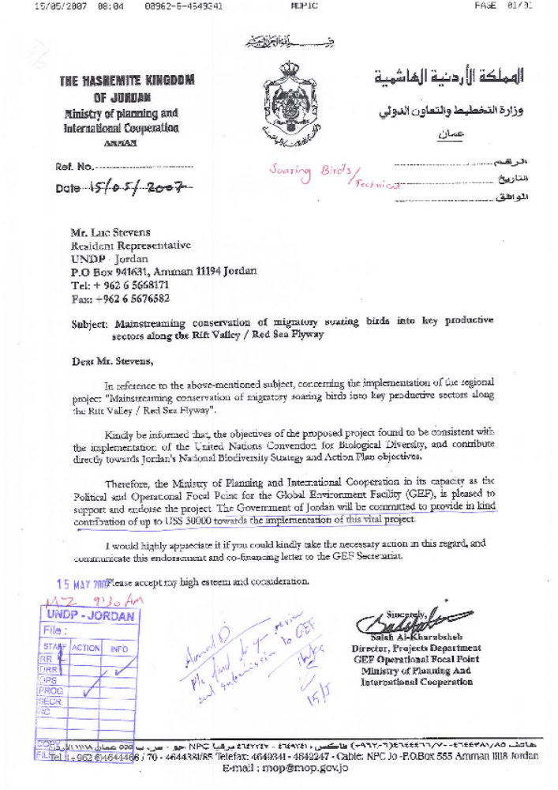

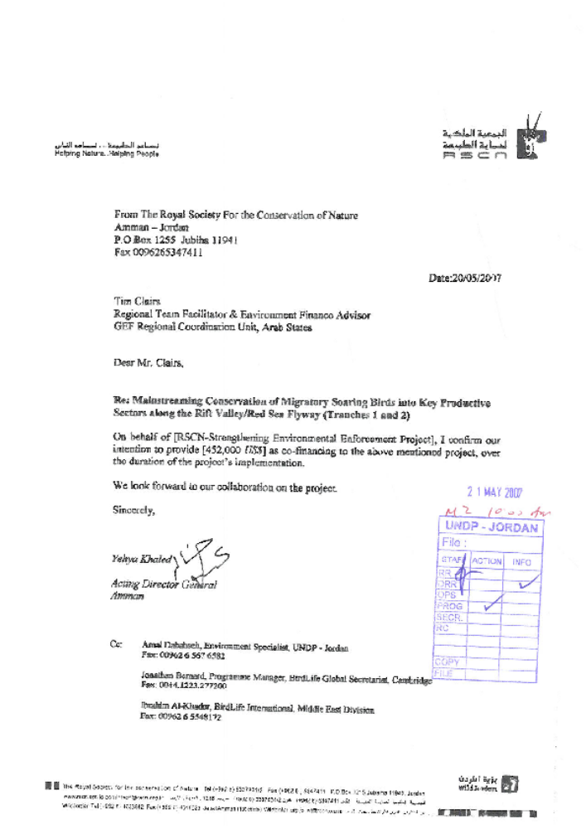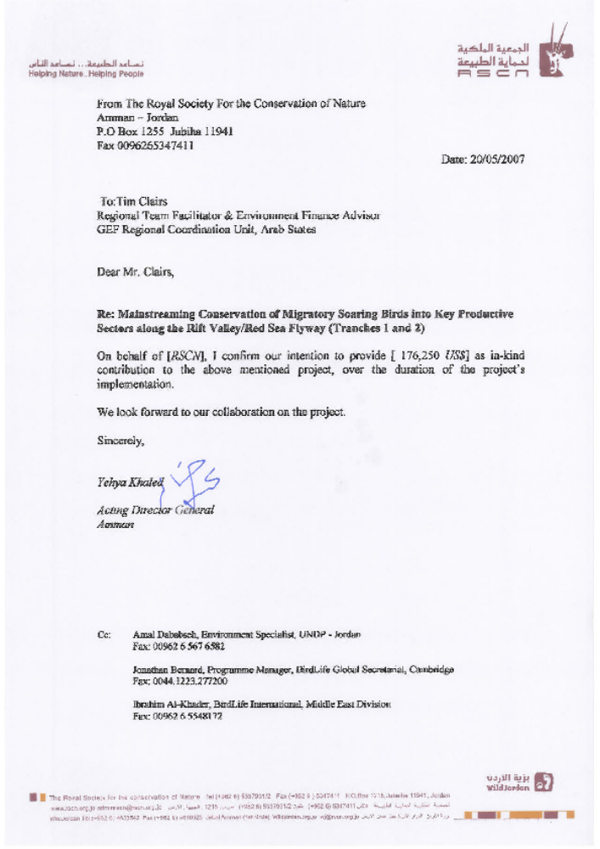
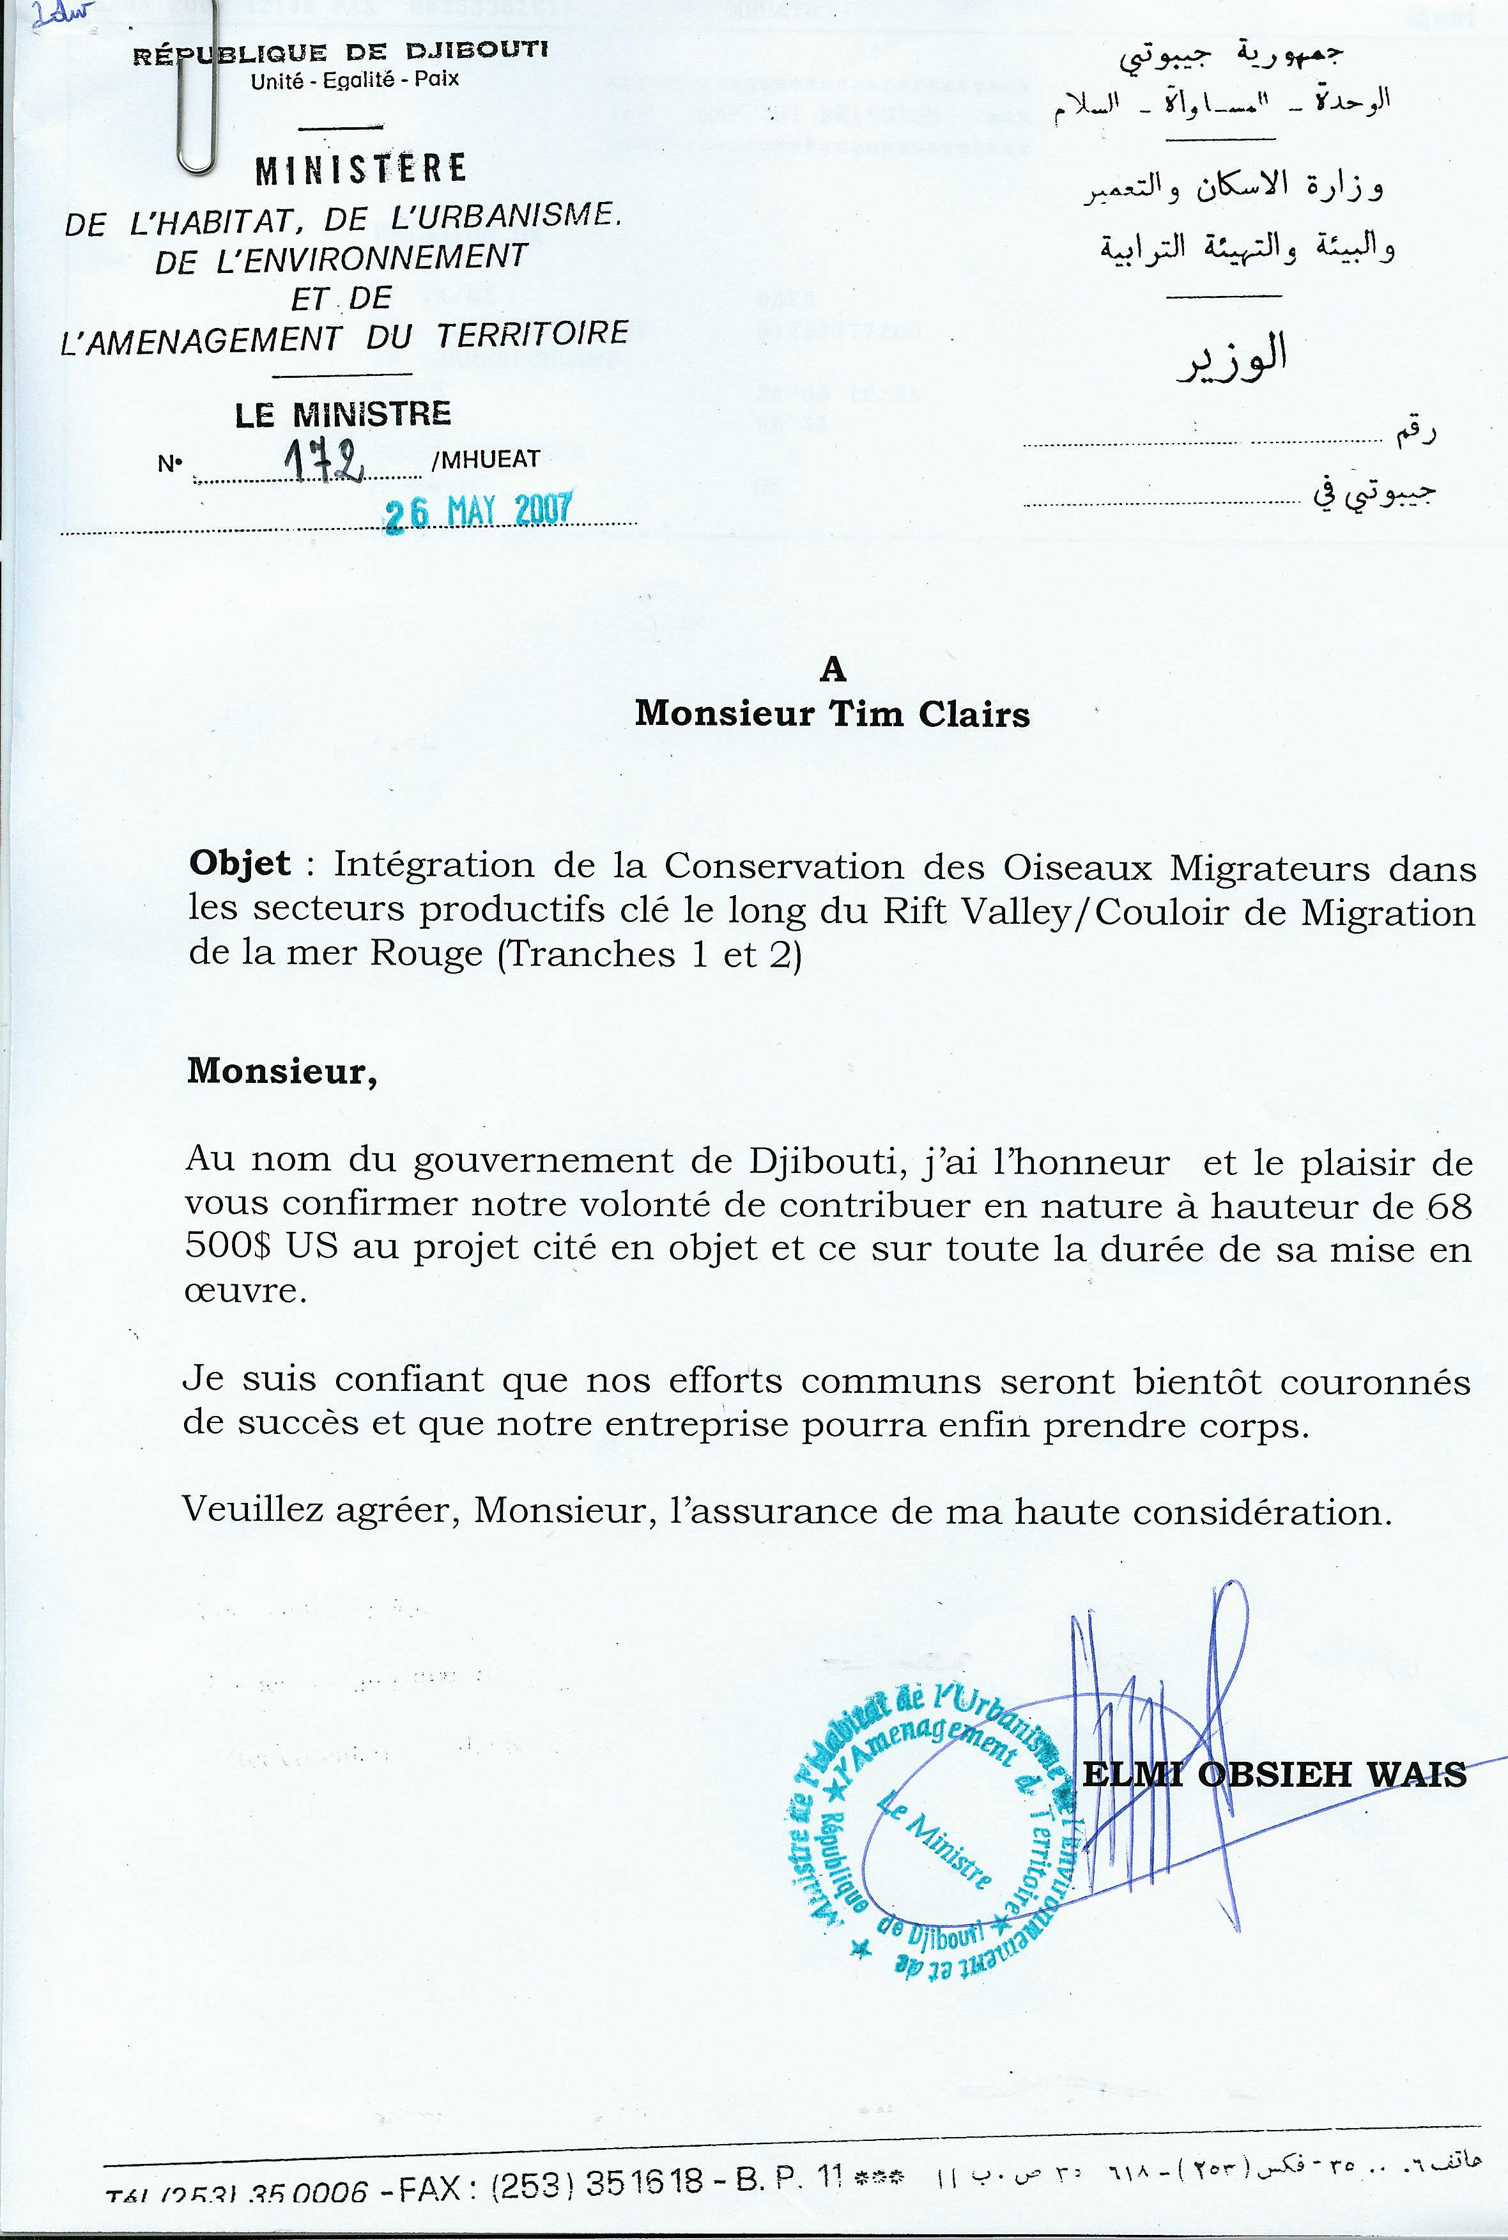

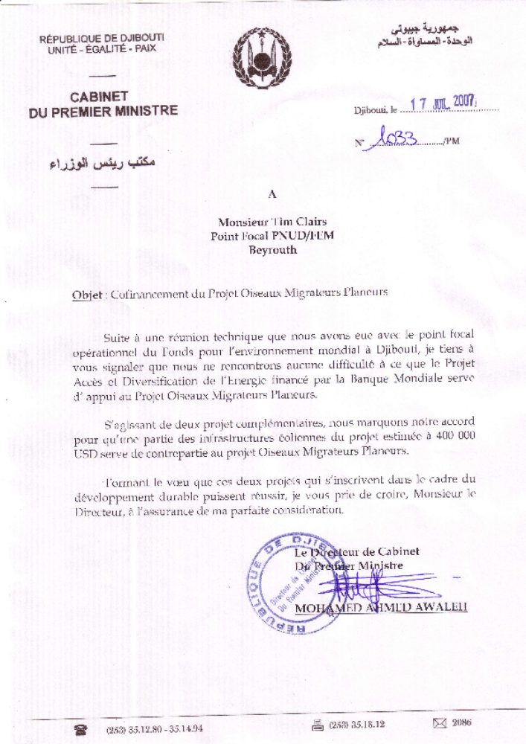
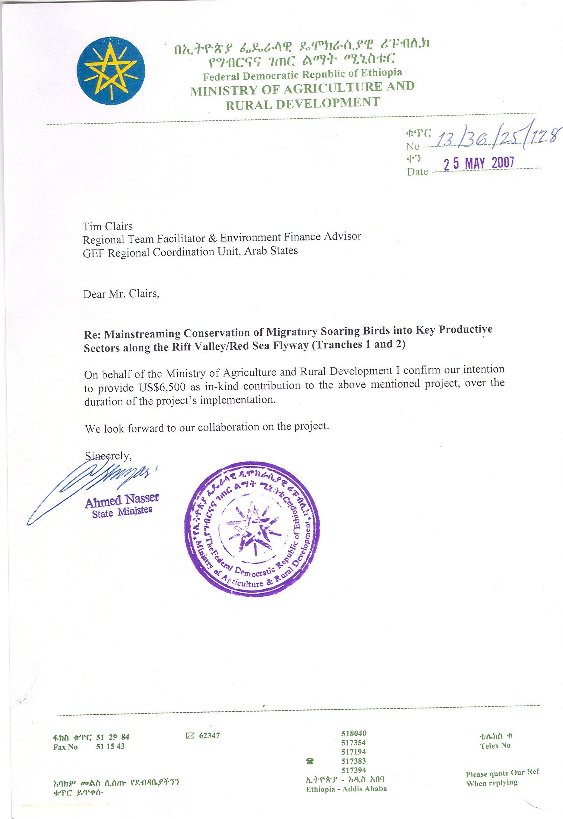

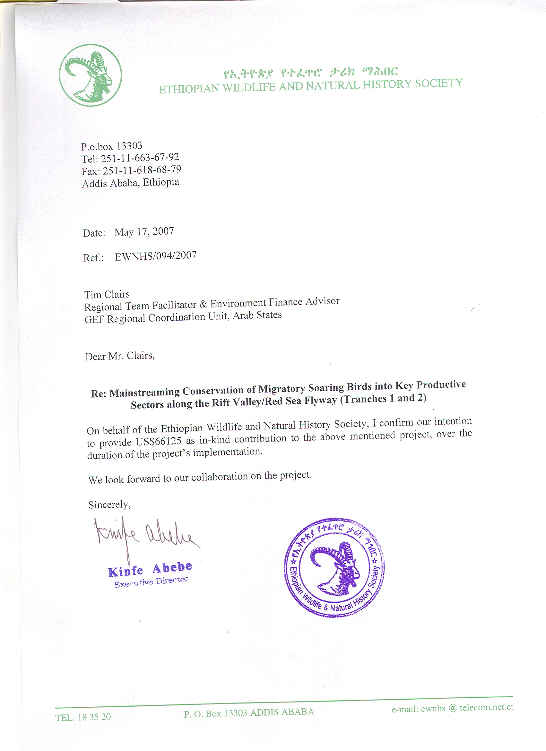

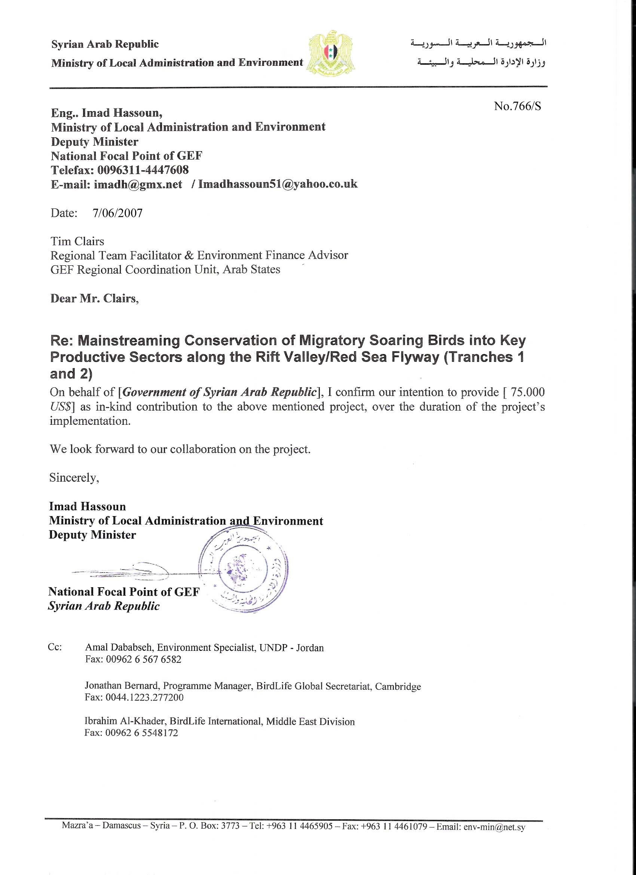

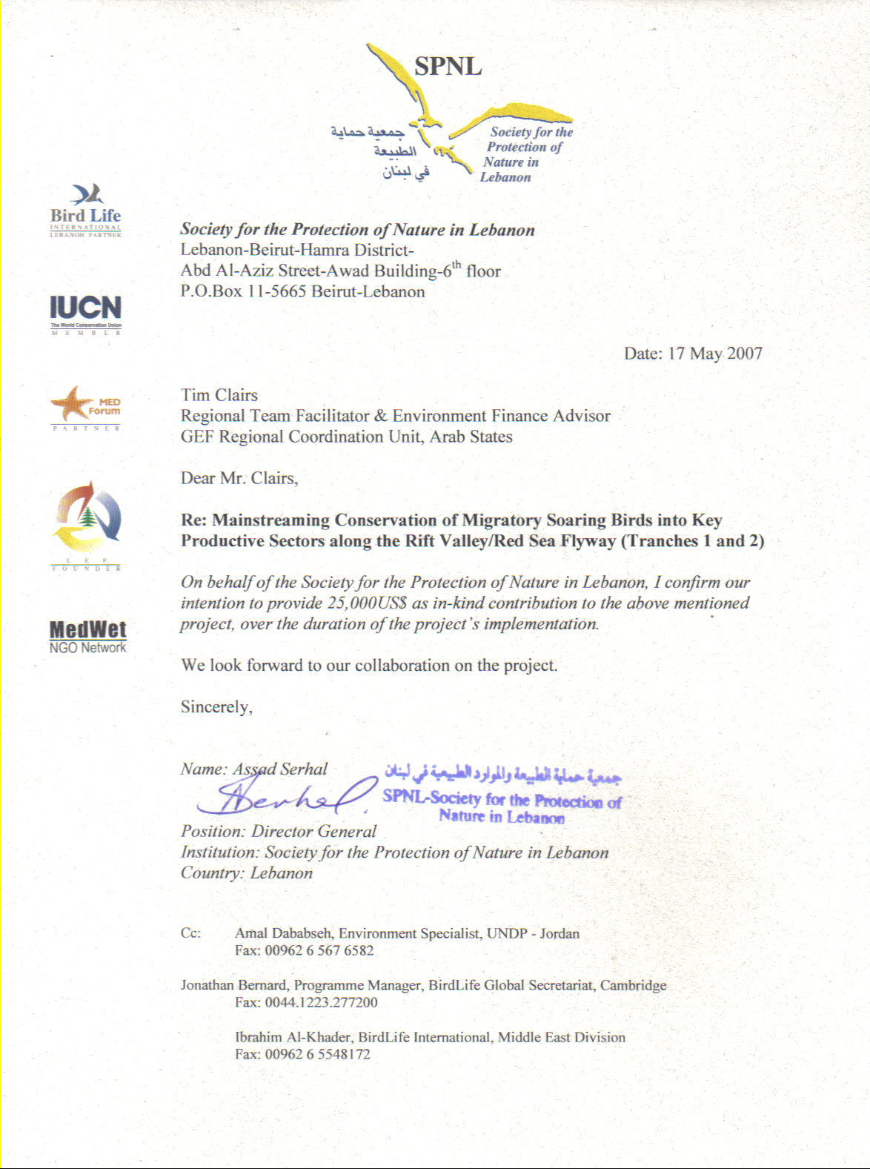

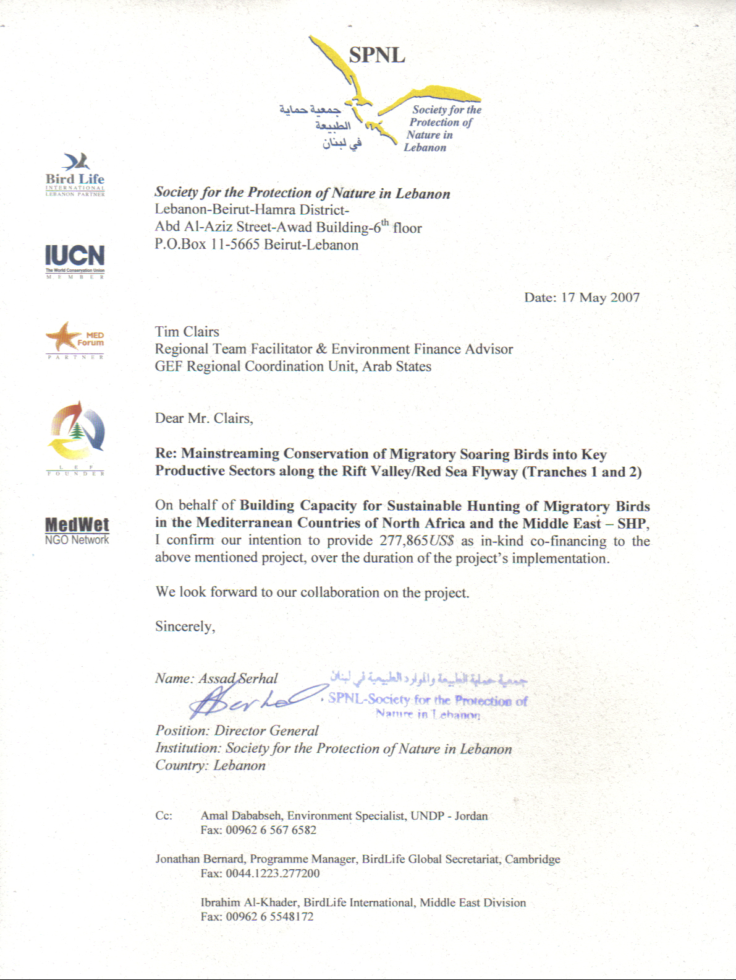

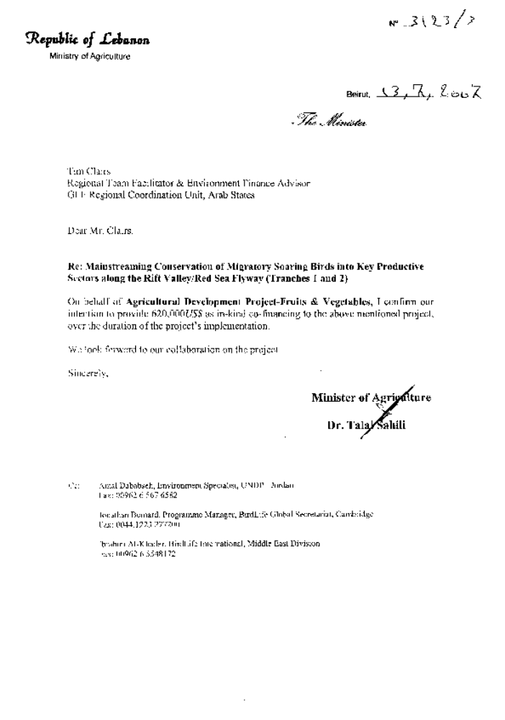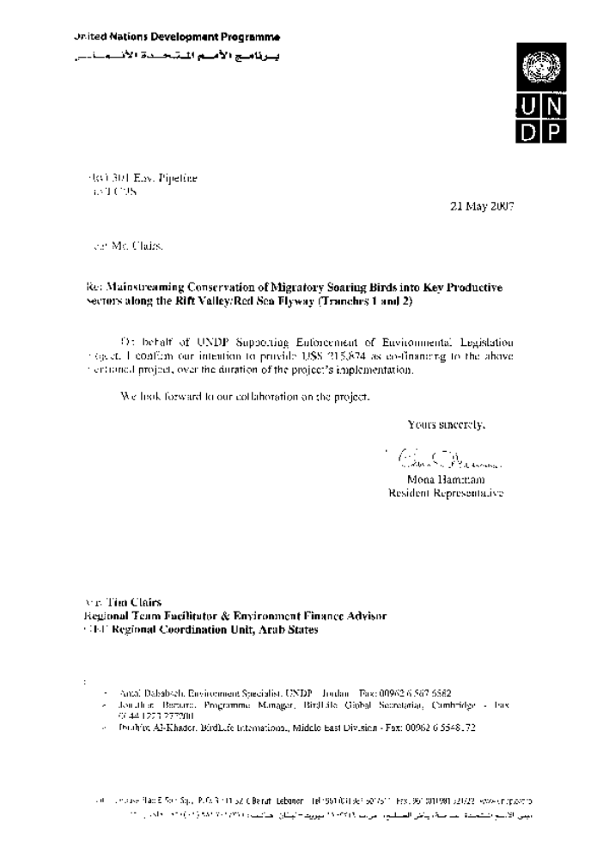
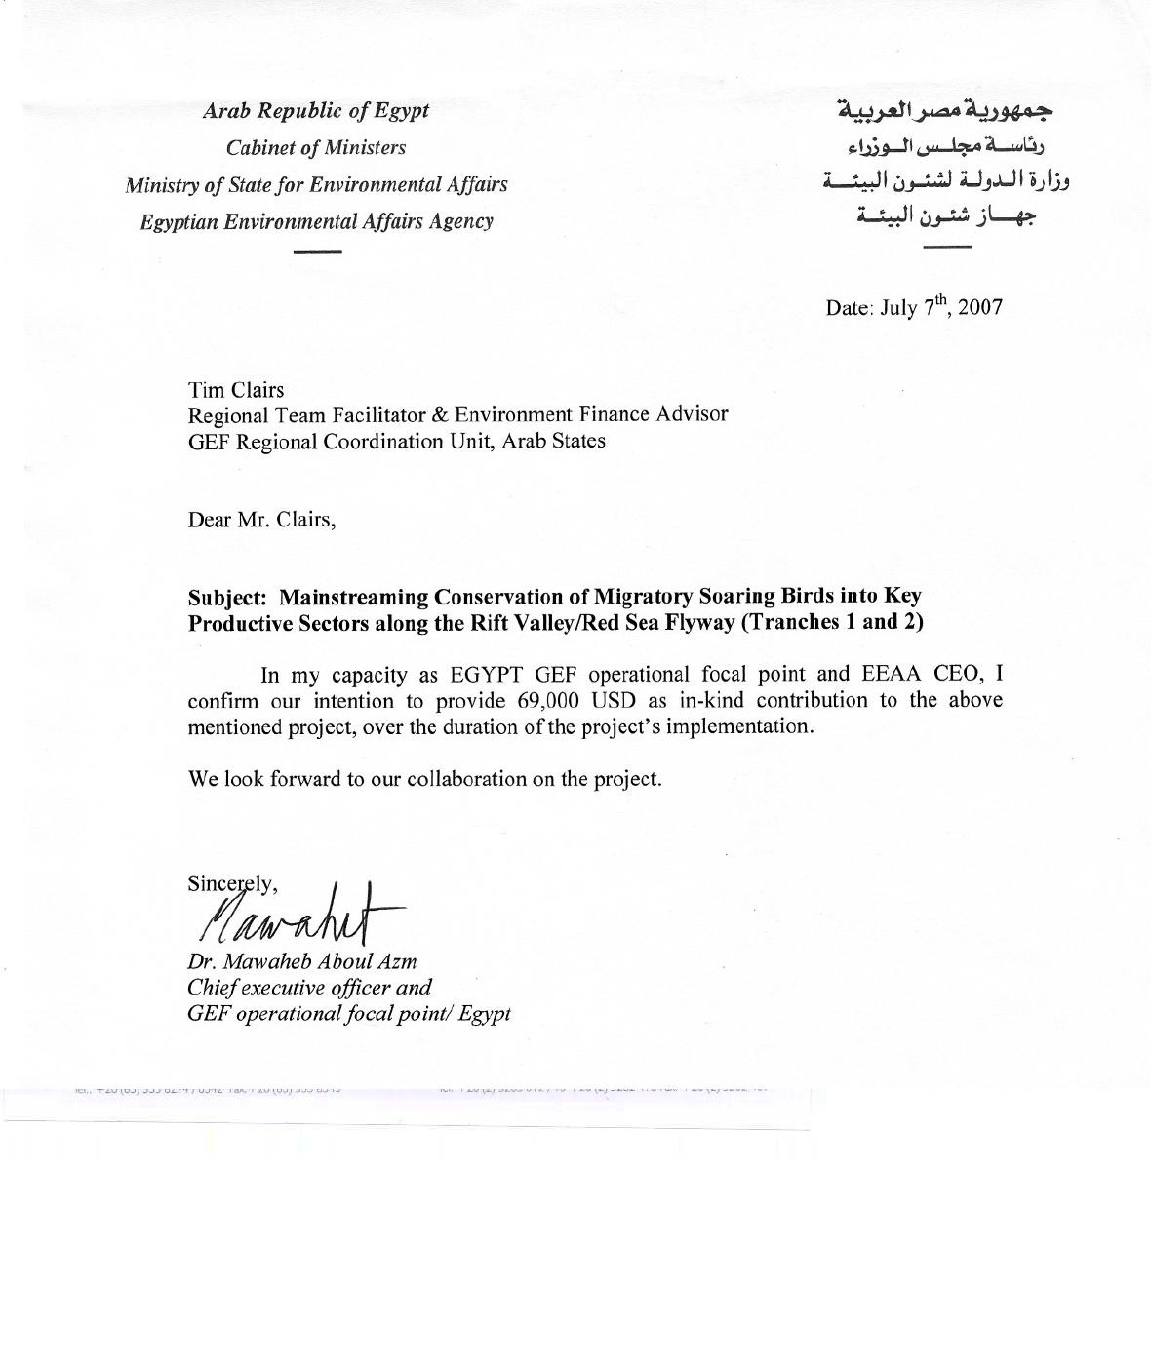

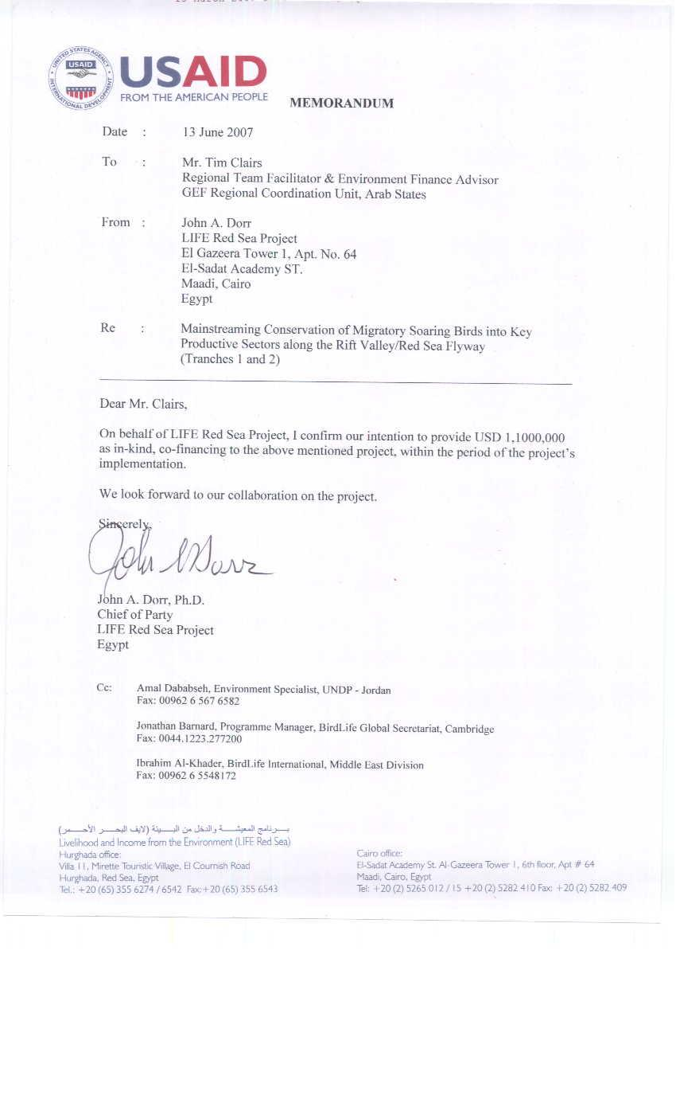

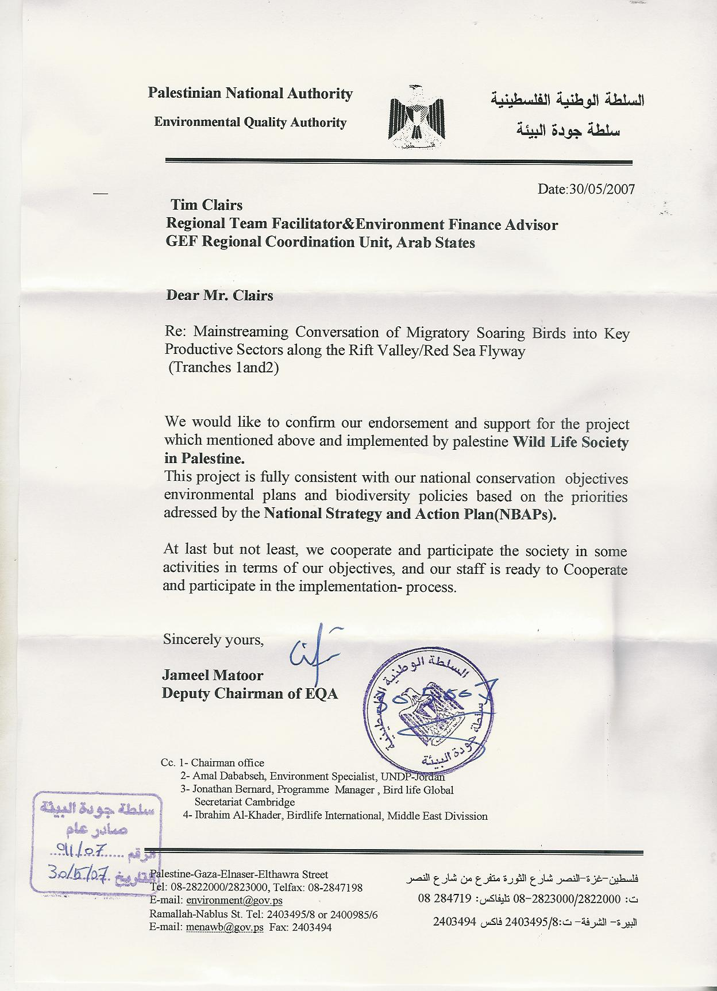

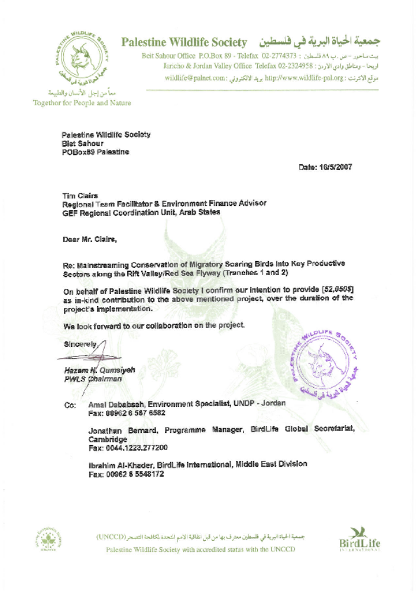

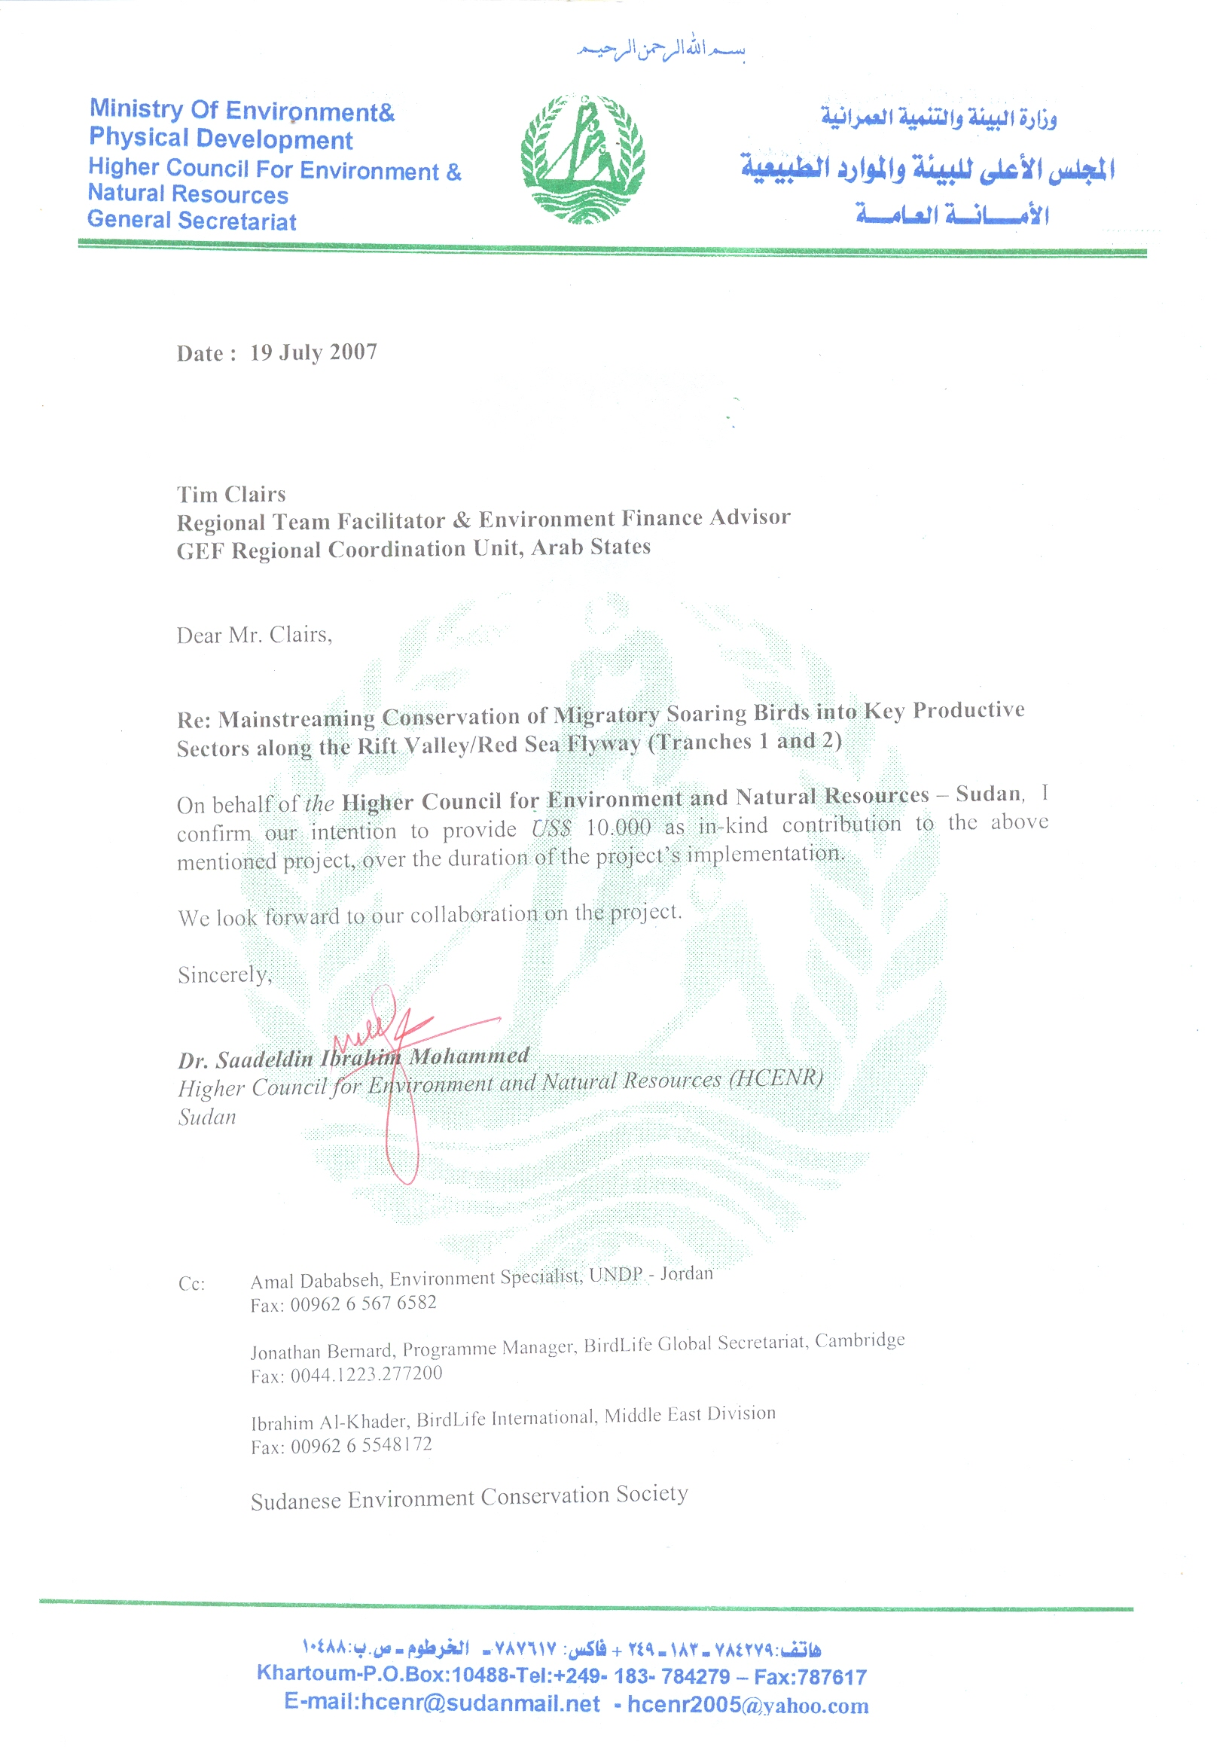

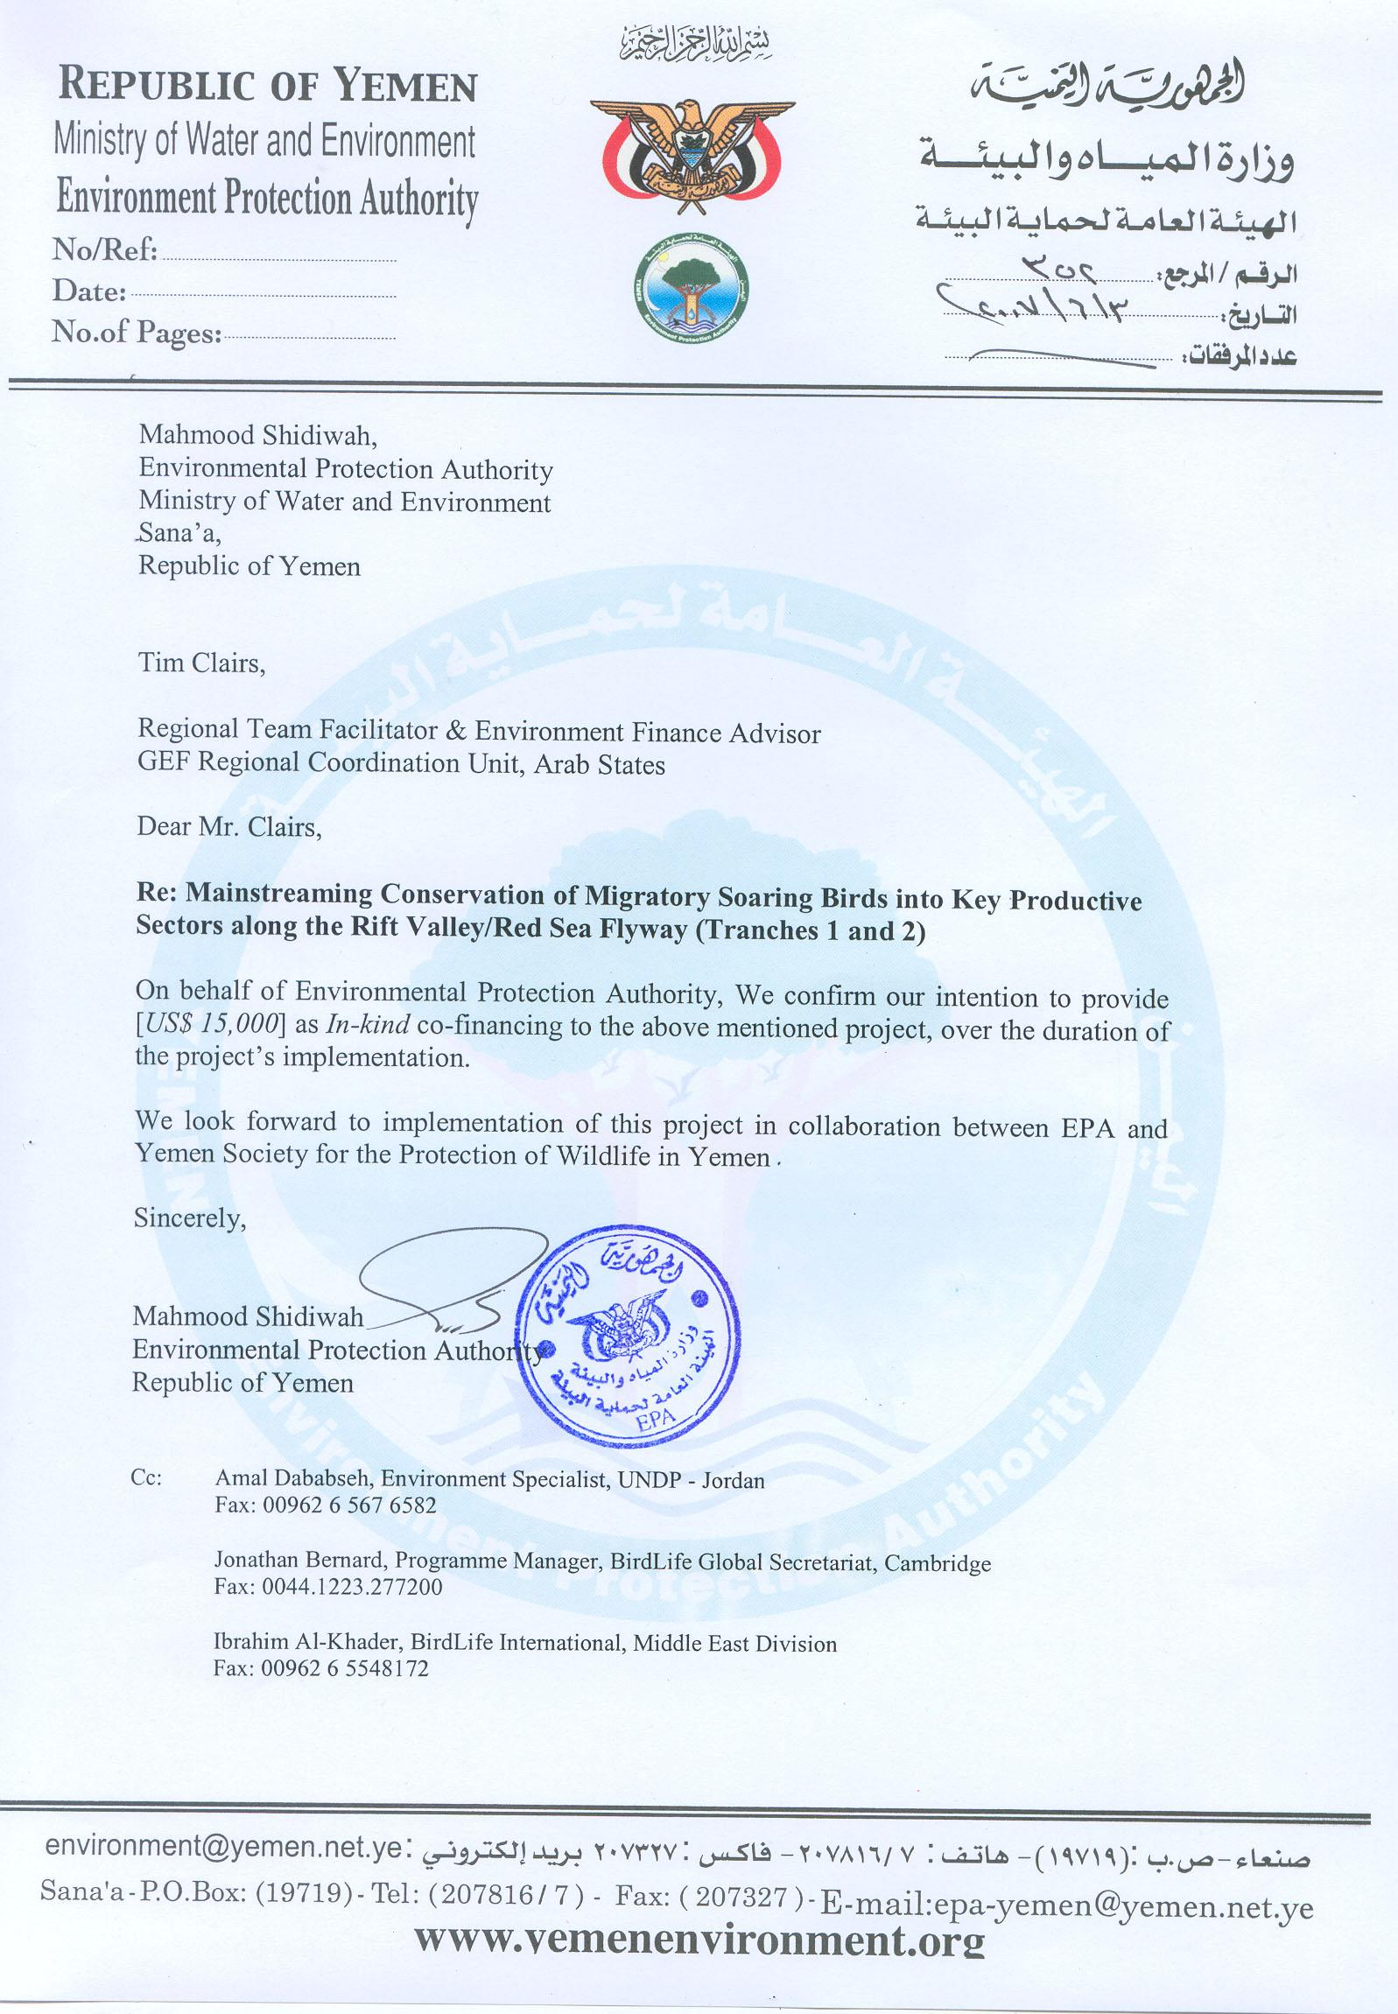

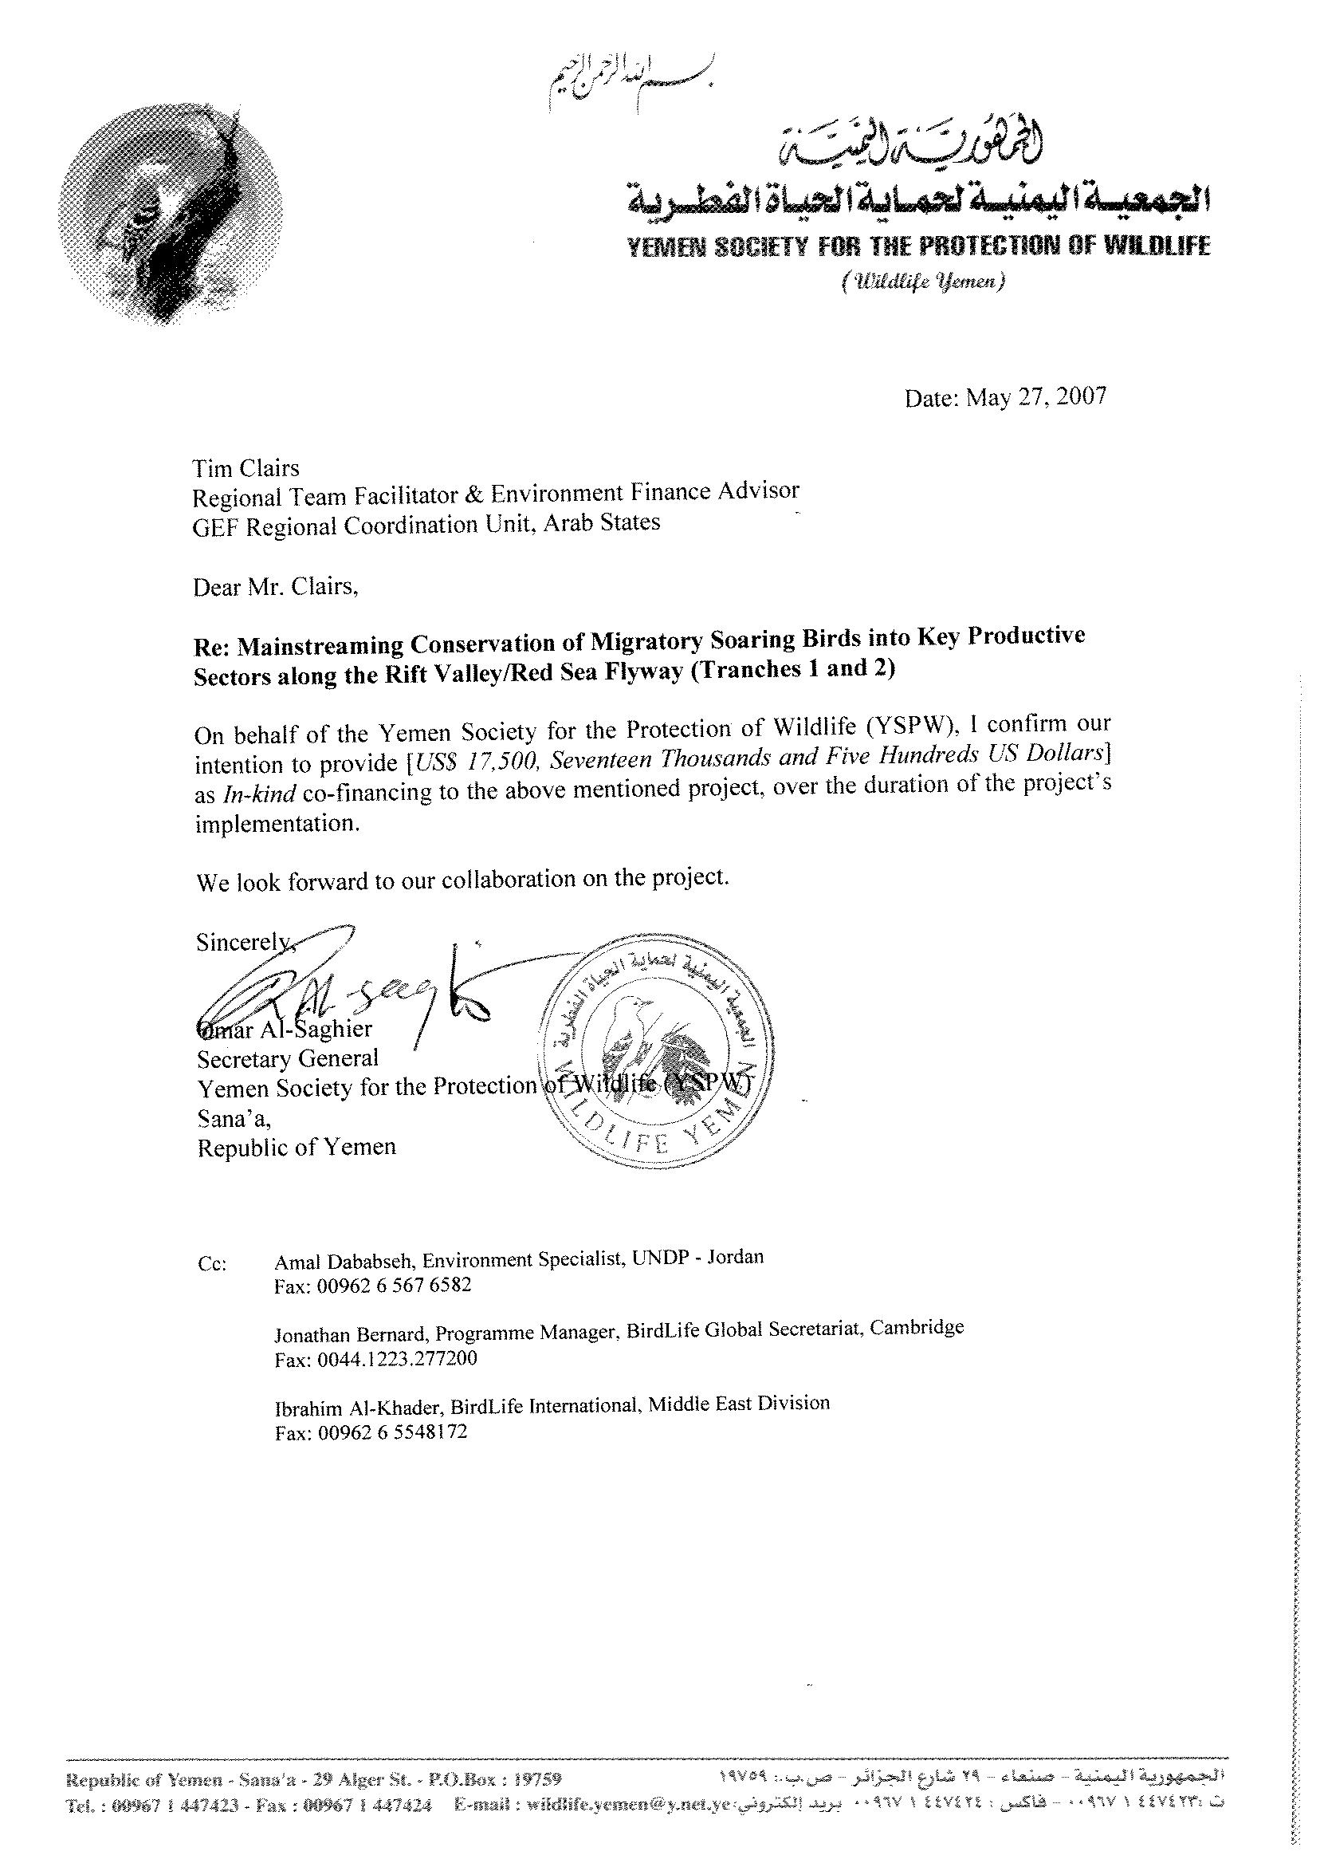

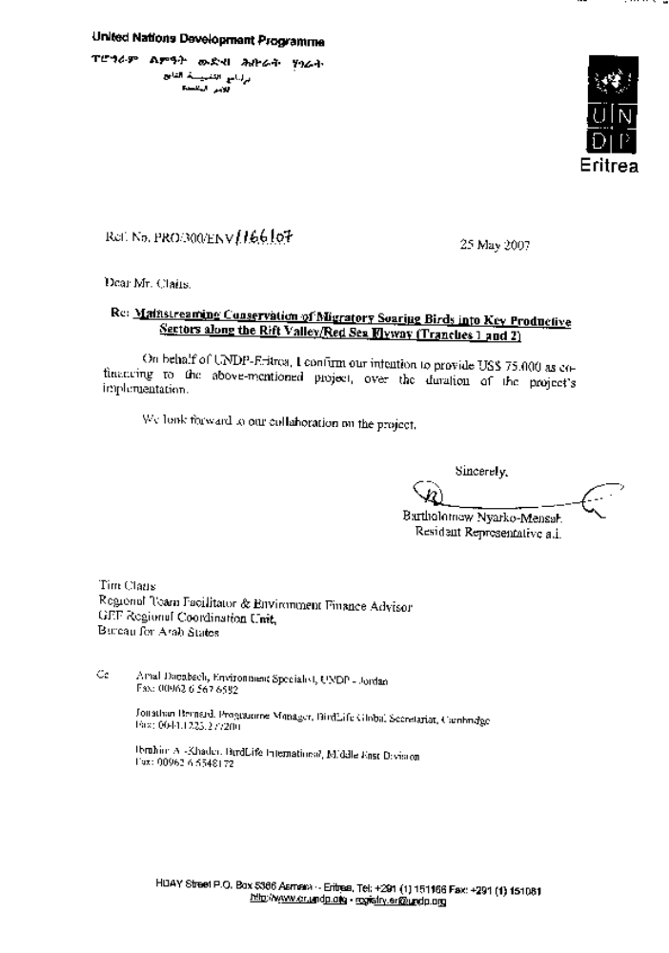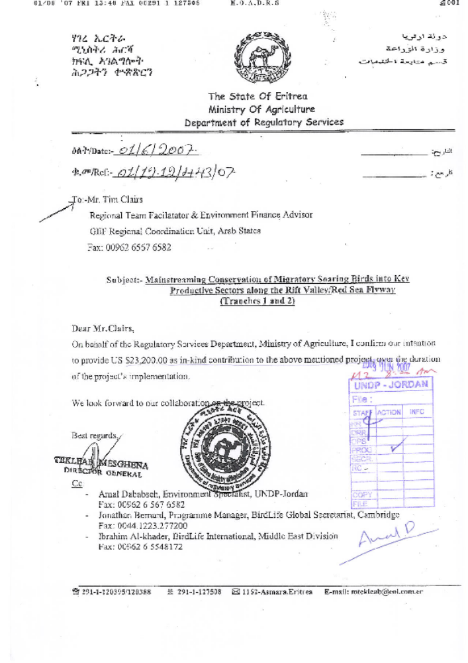

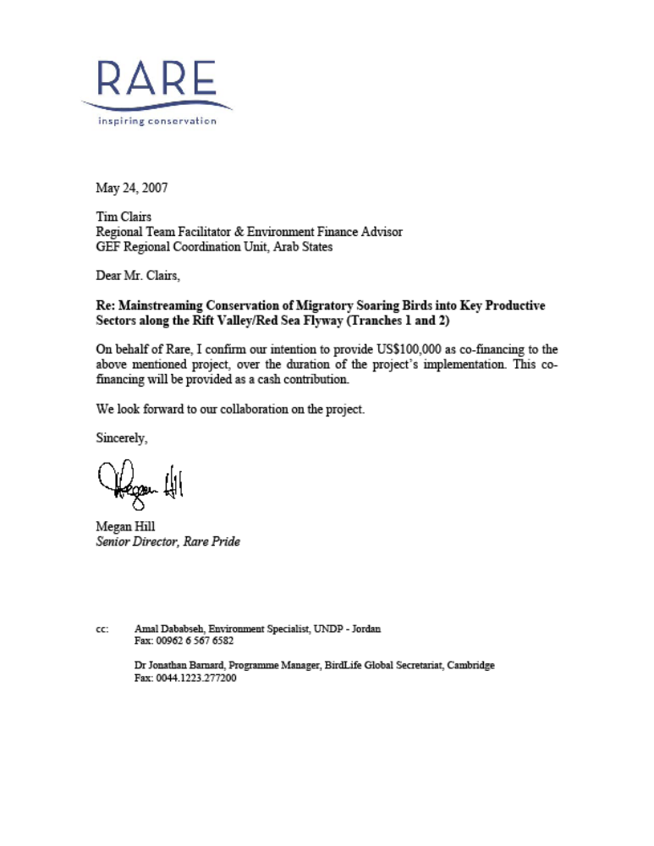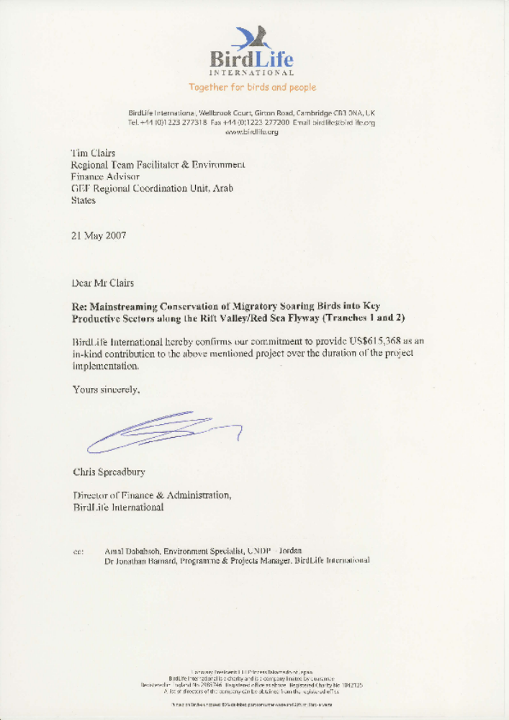

2. Memoranda of Understanding/Agreement.

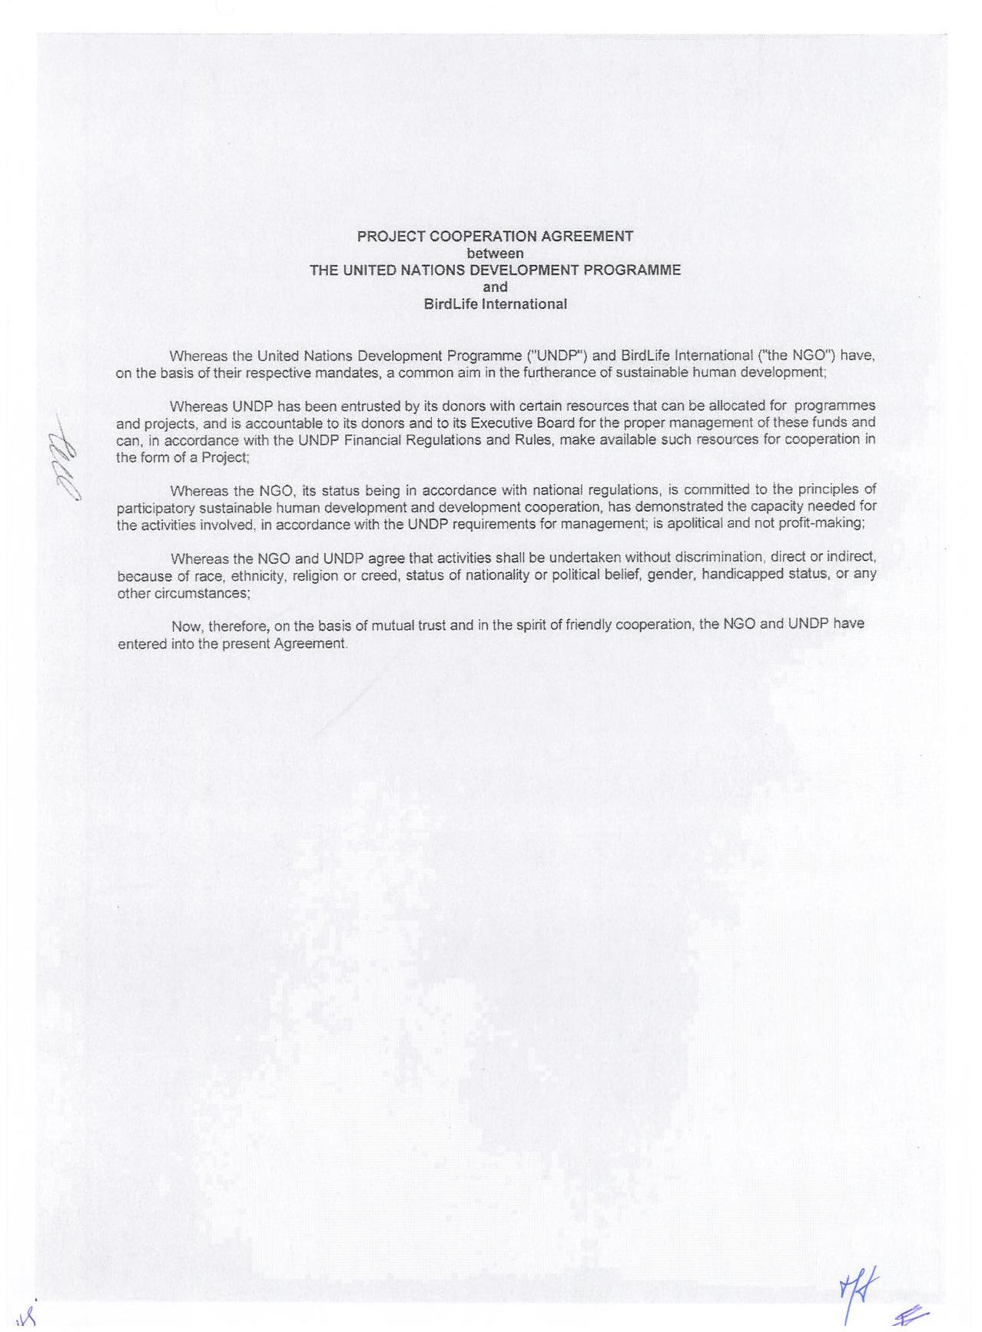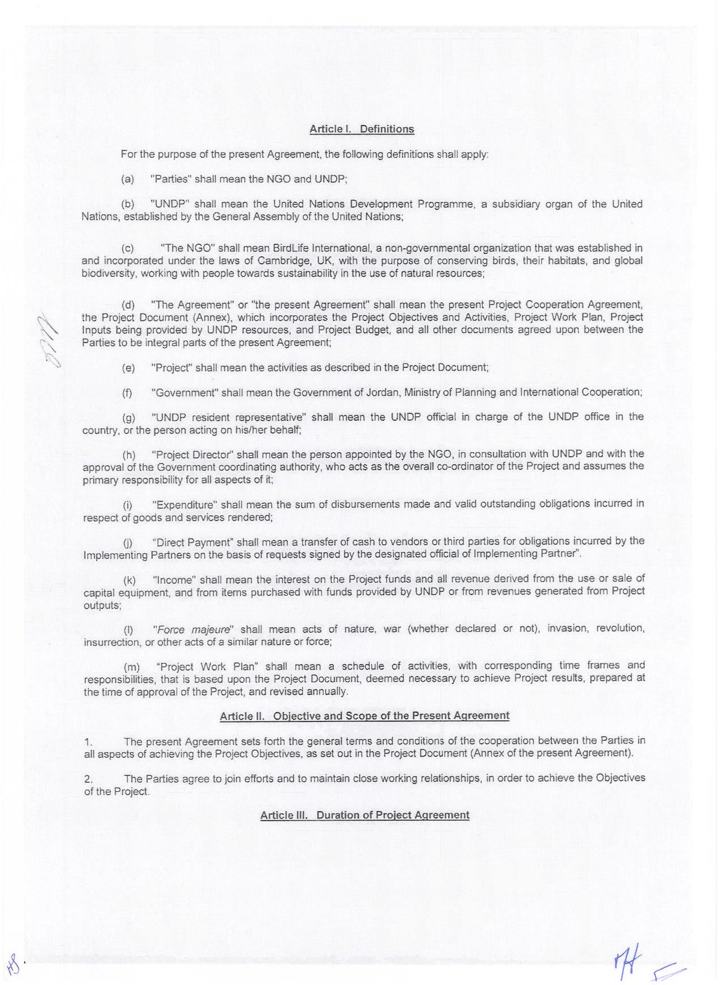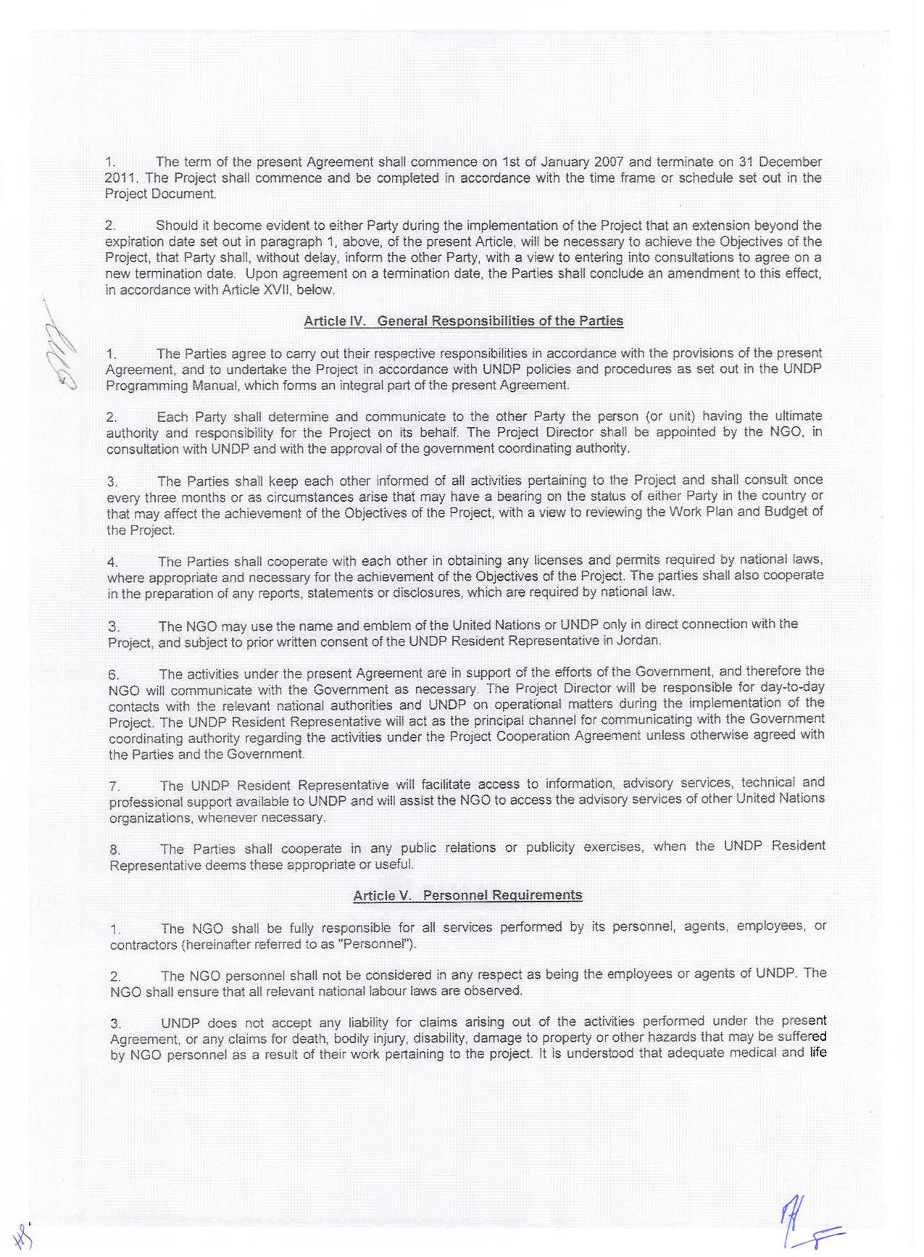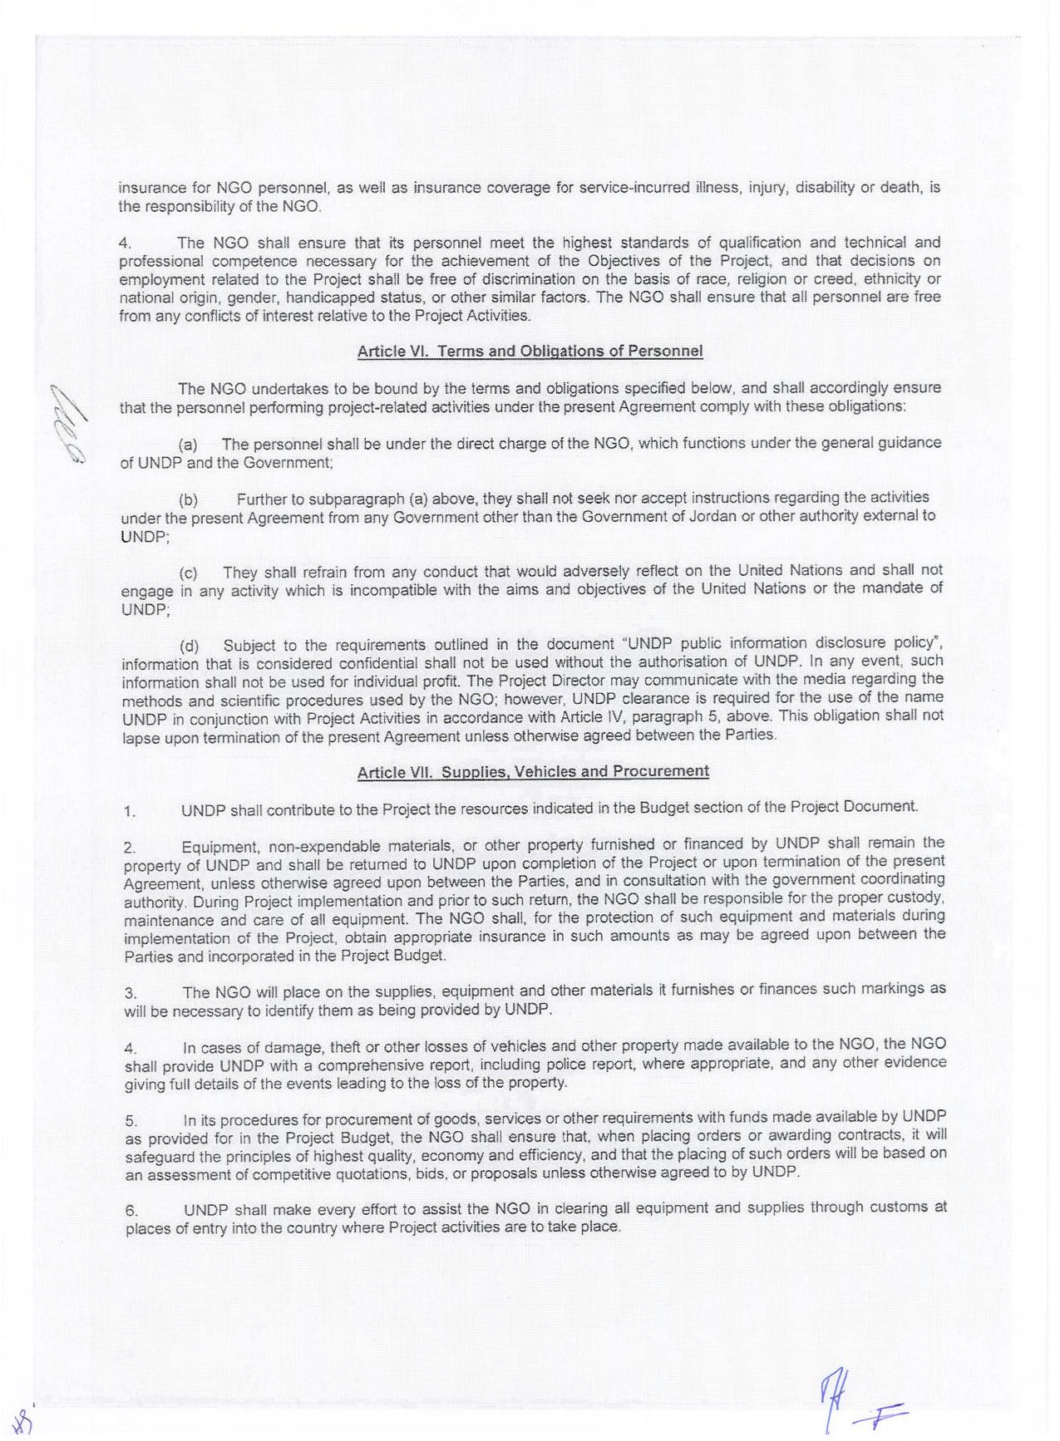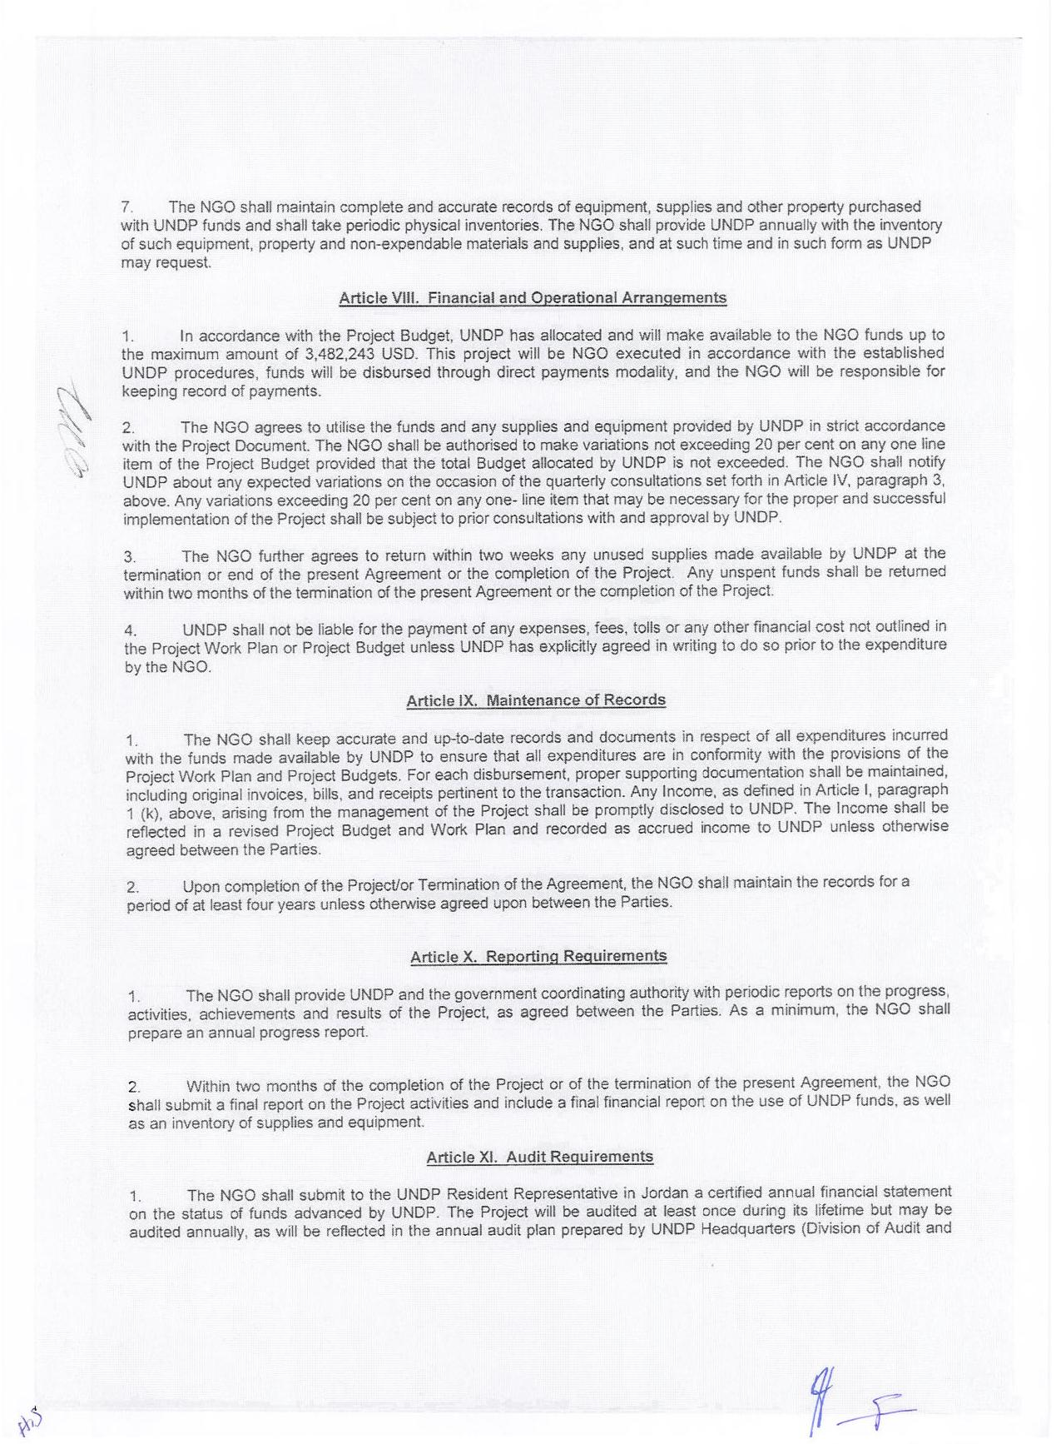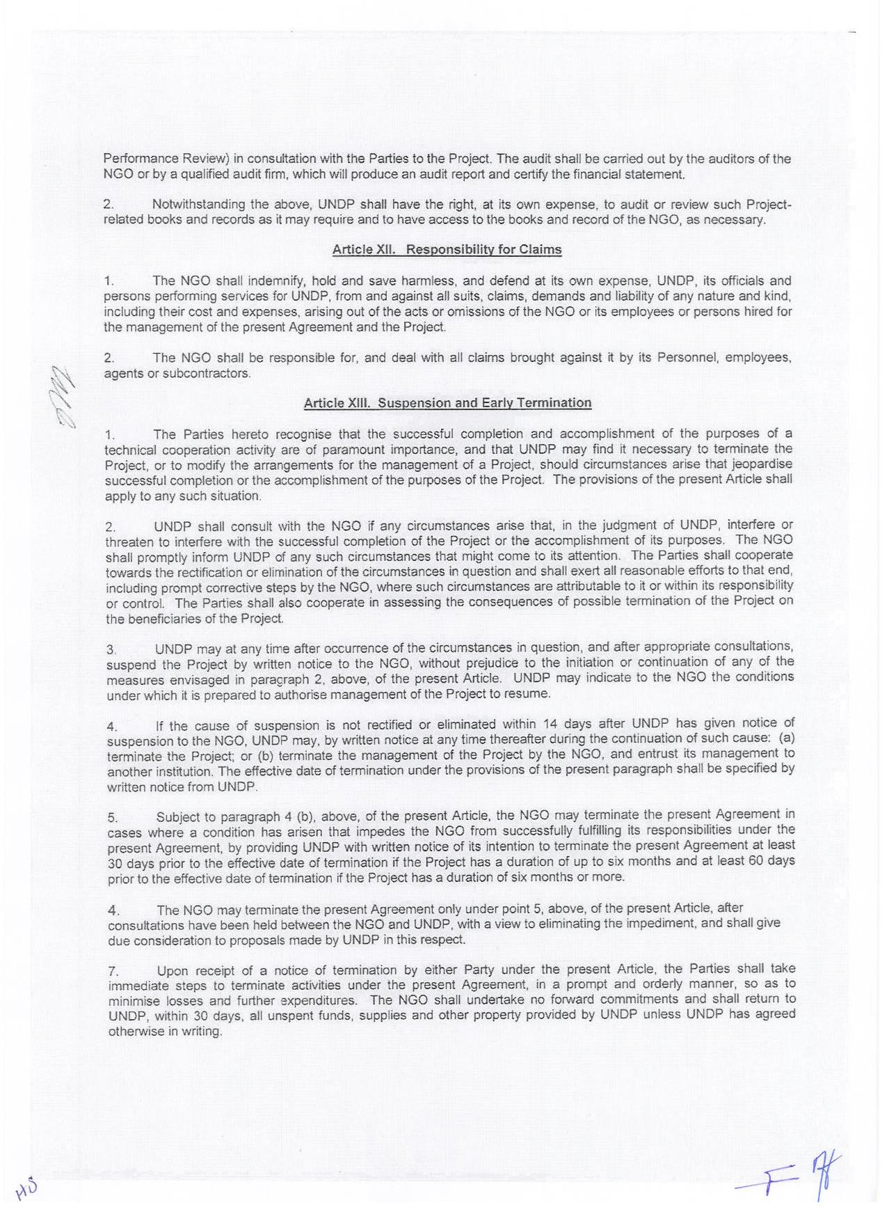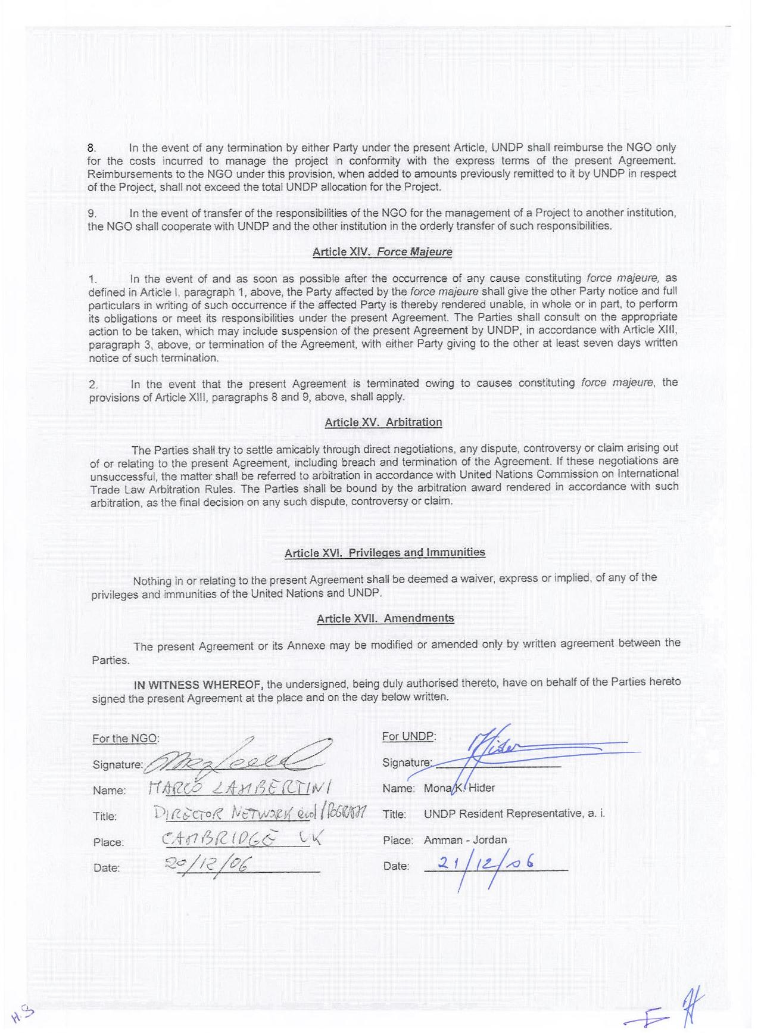

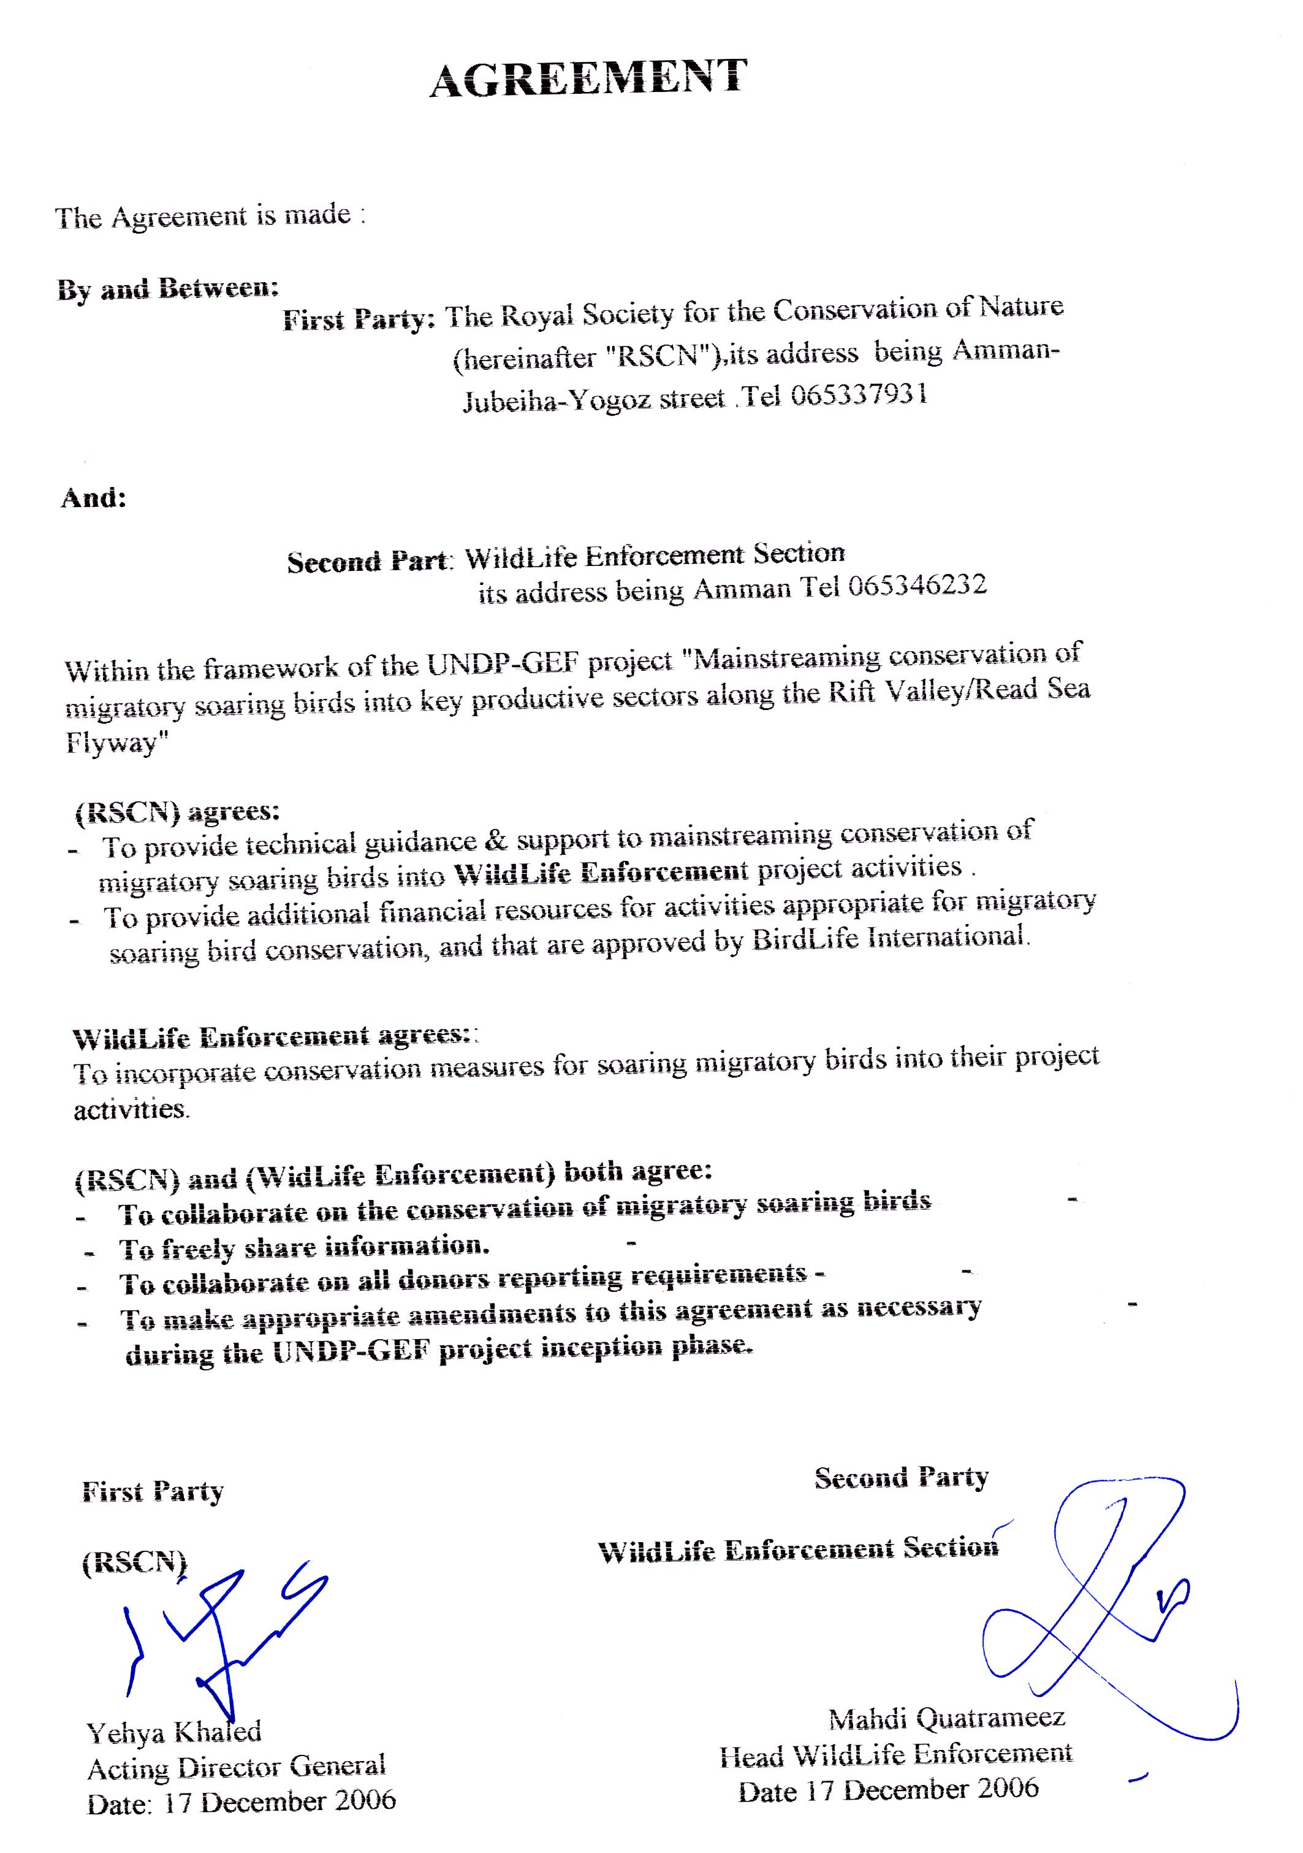

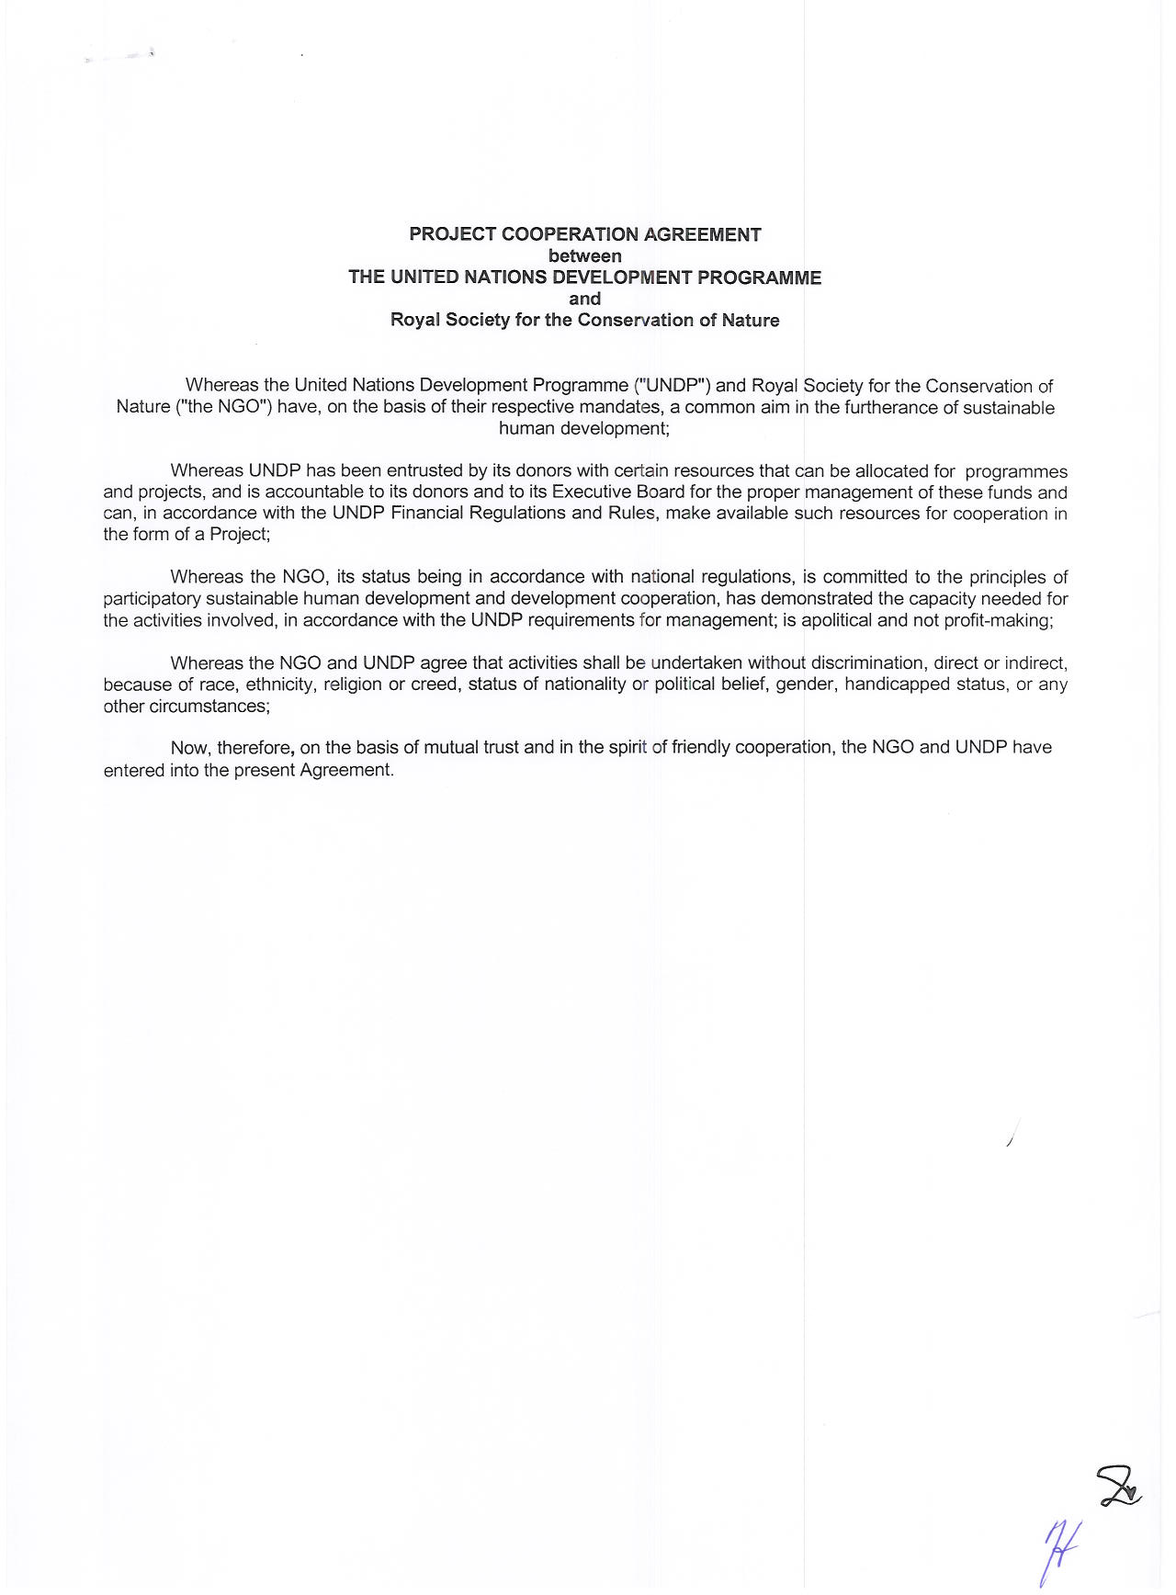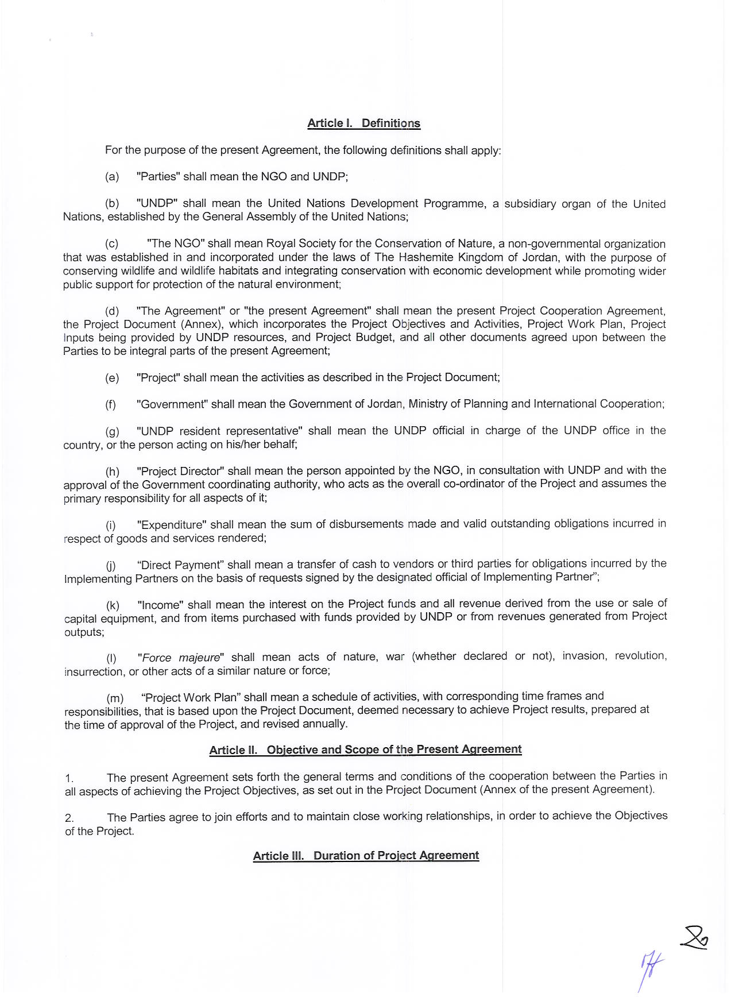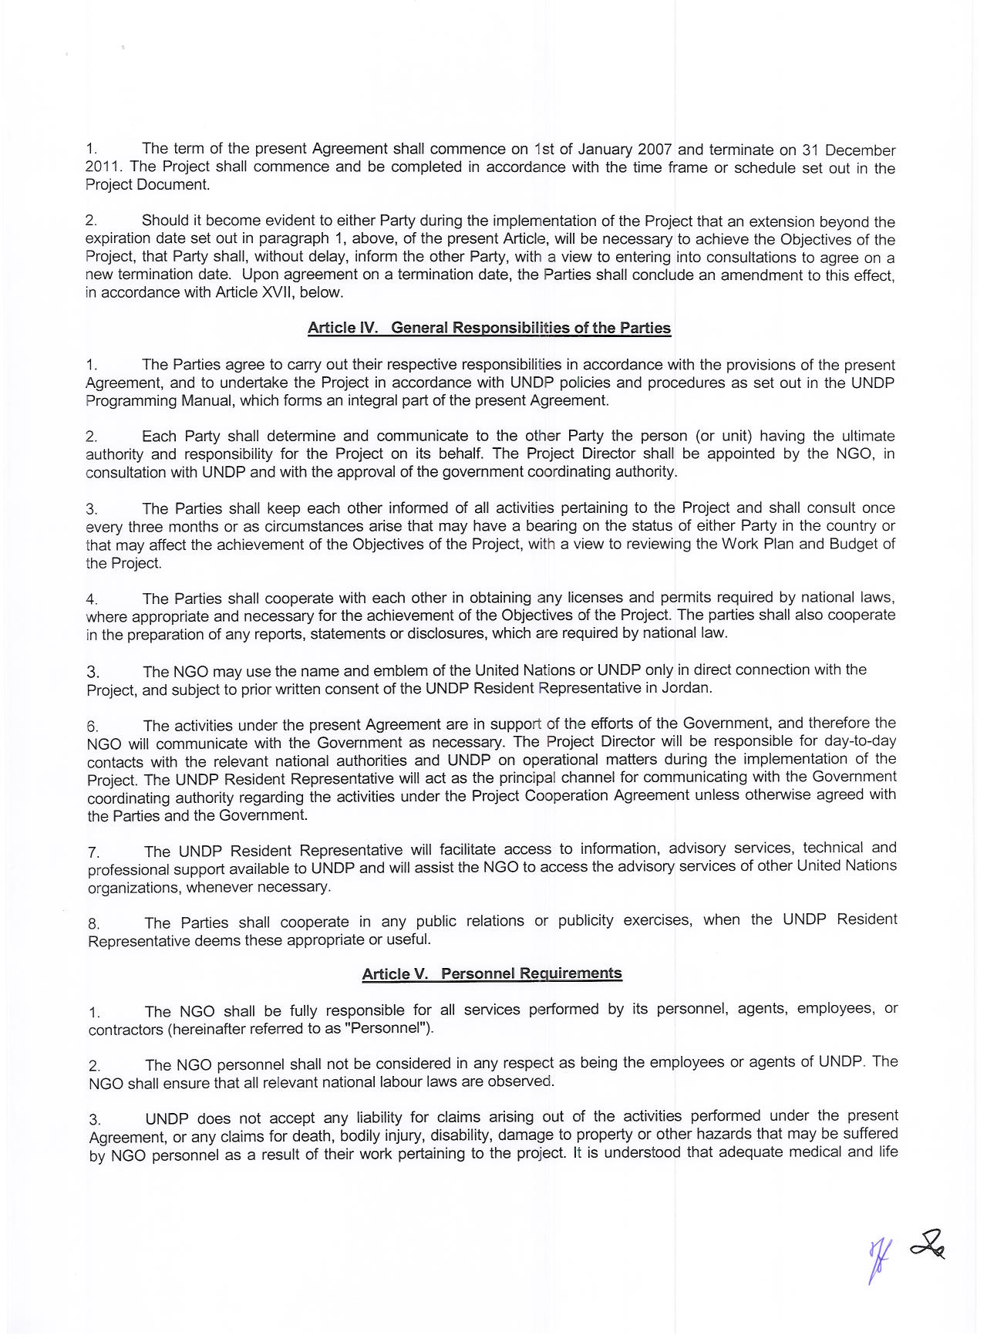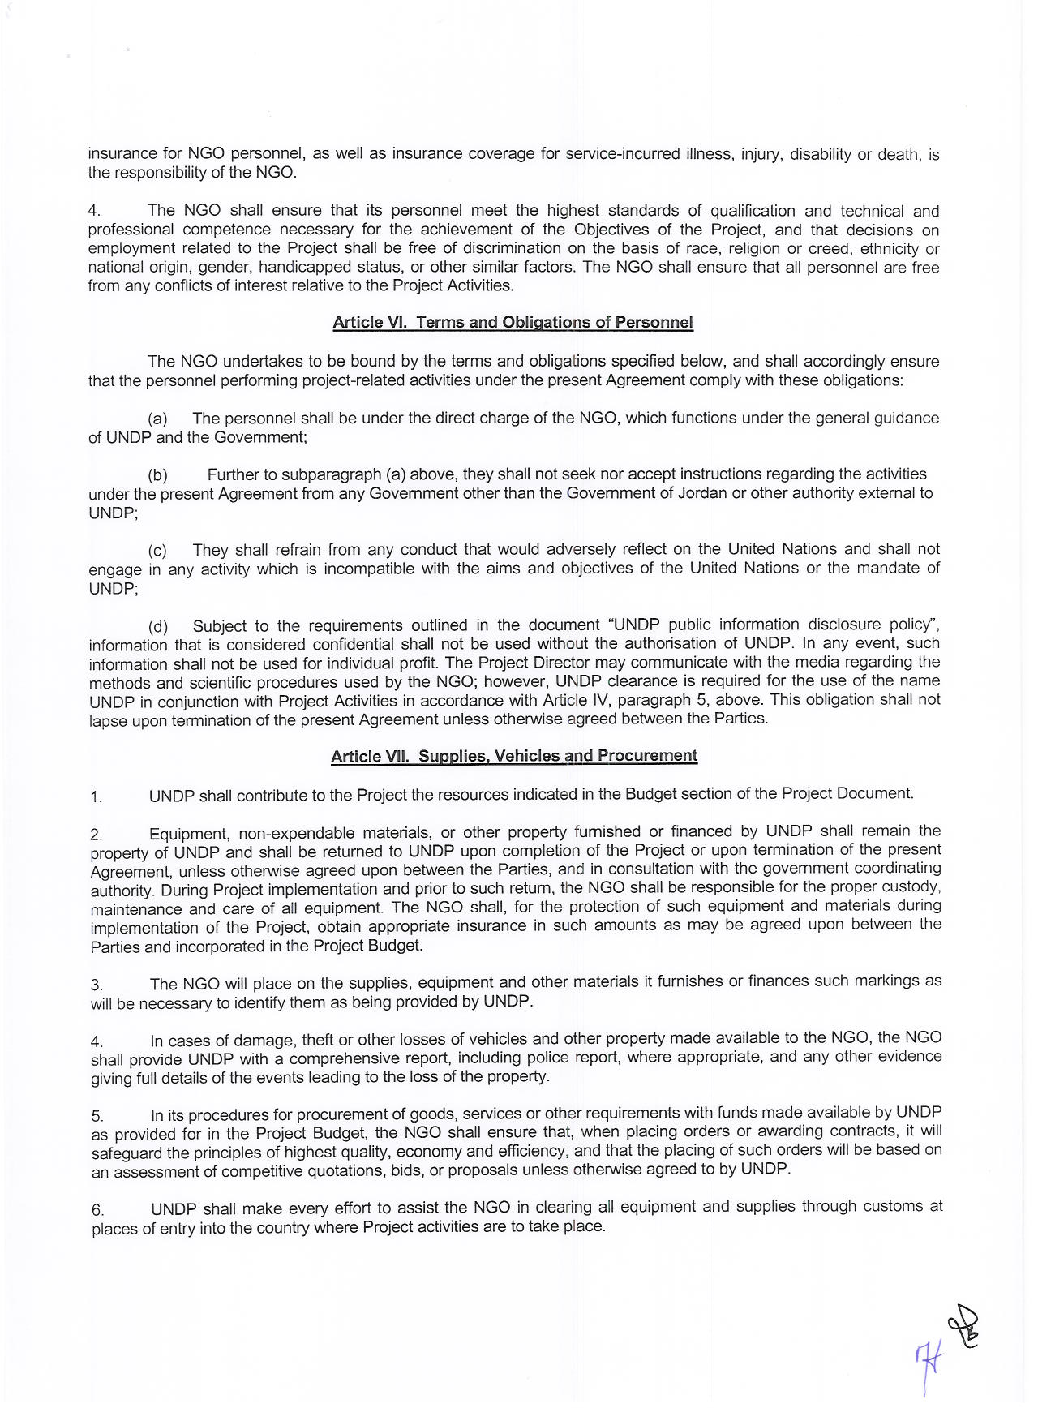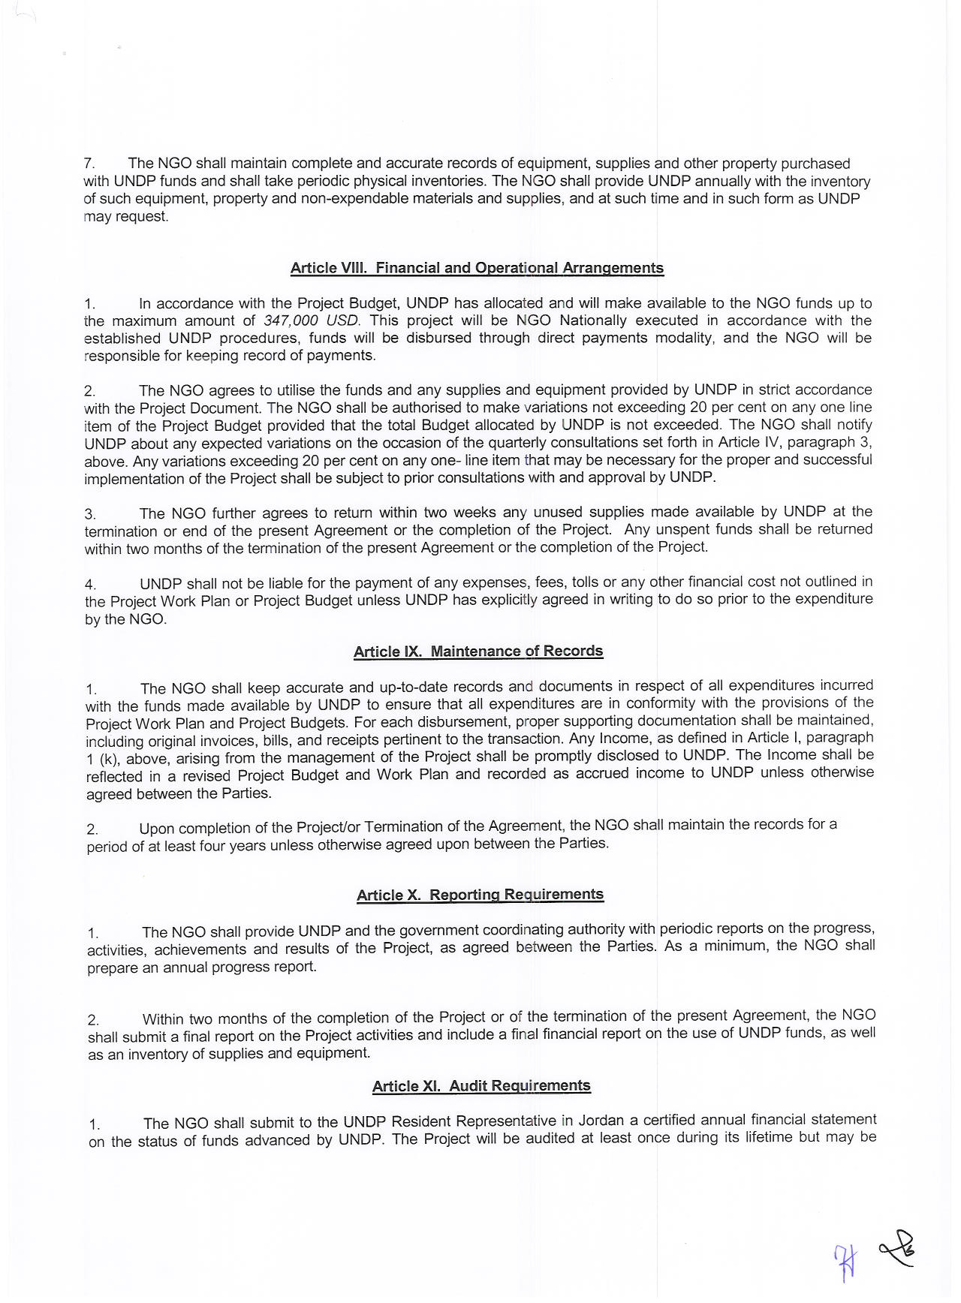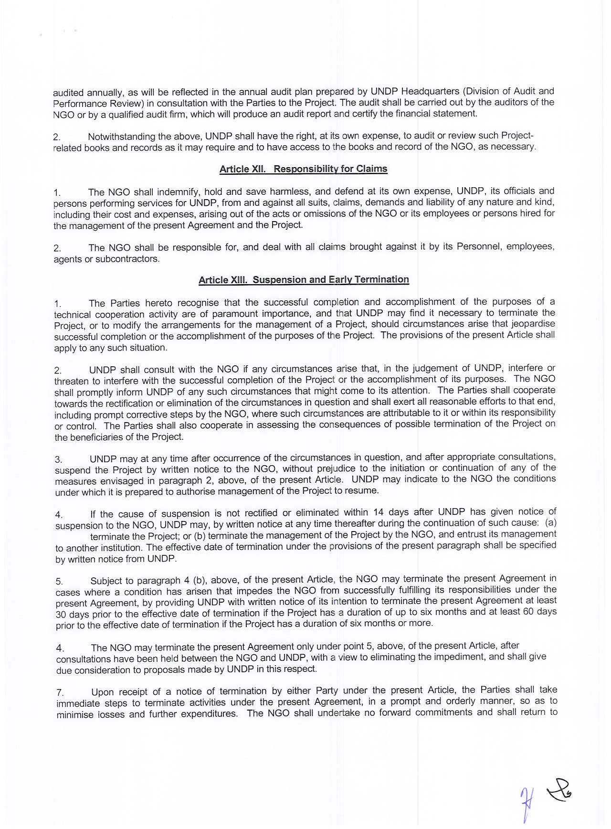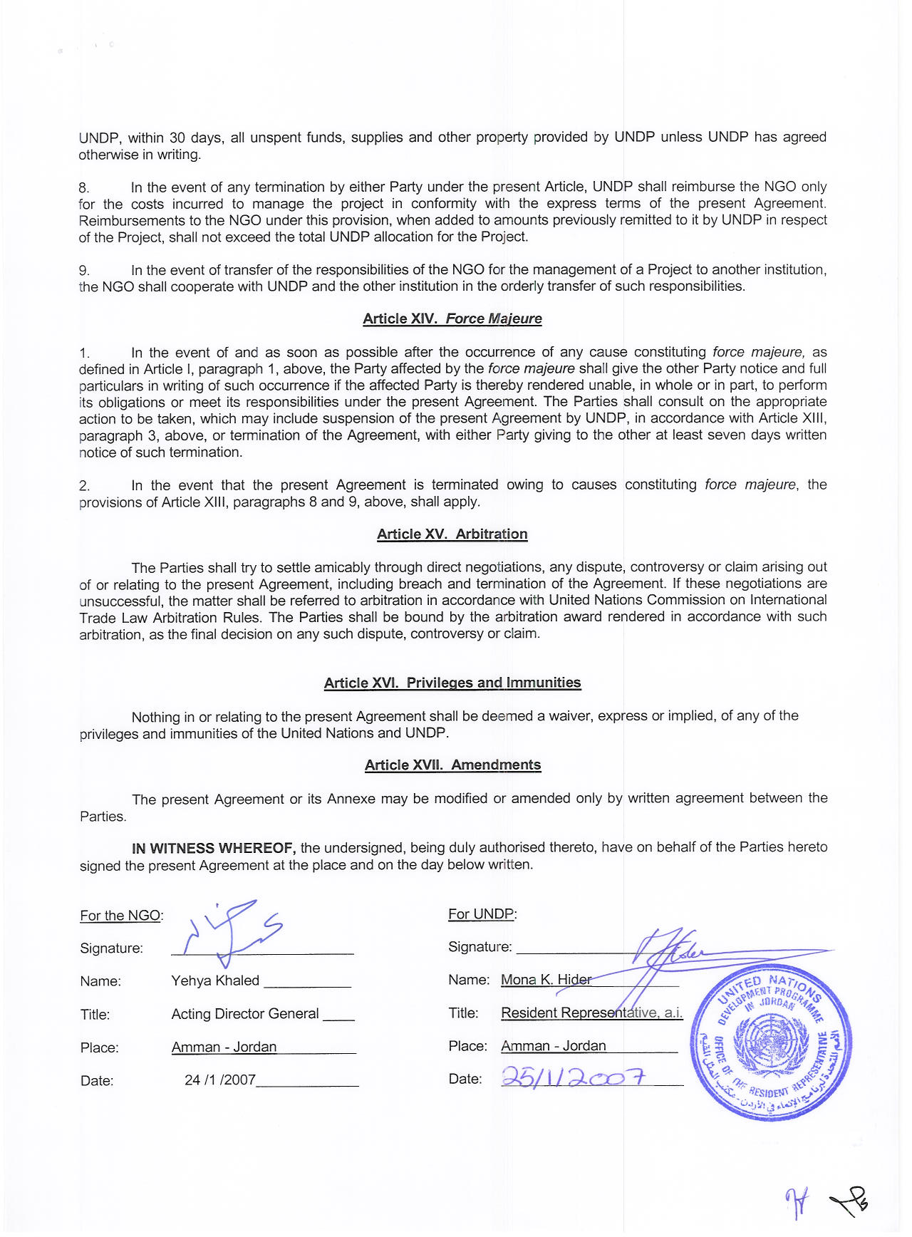

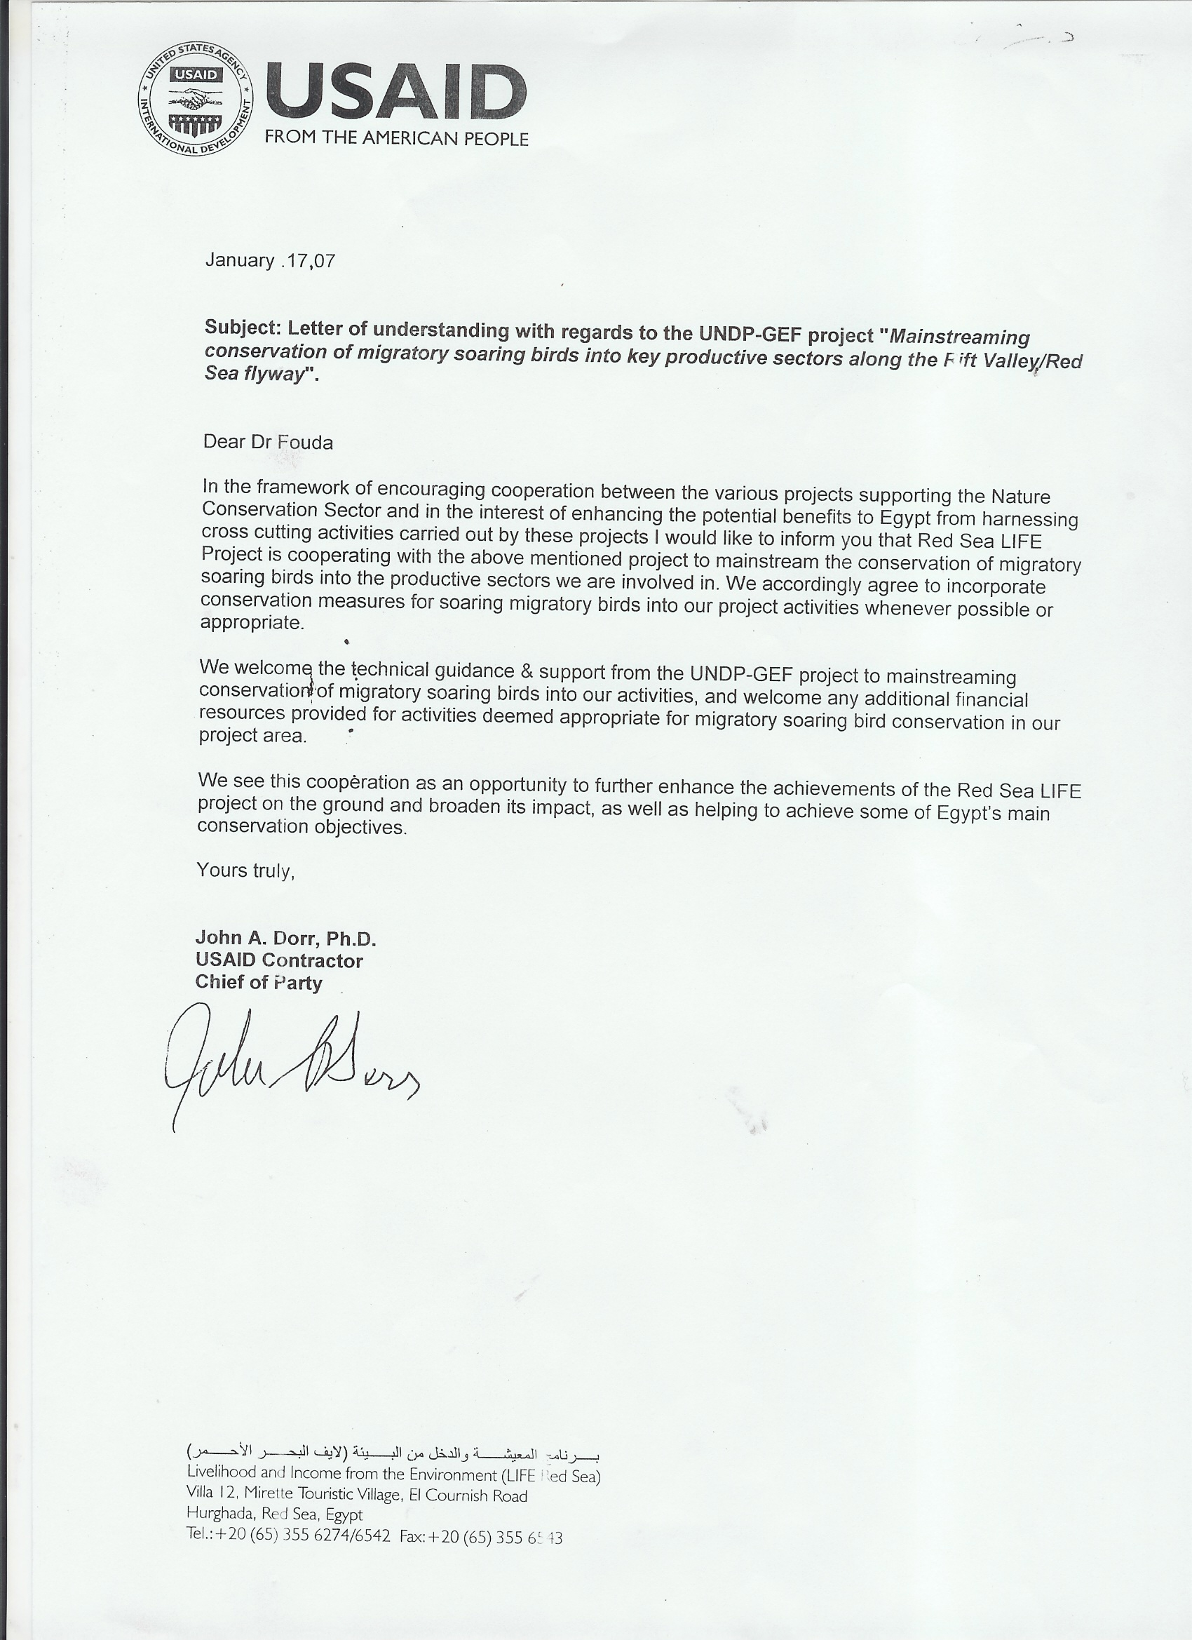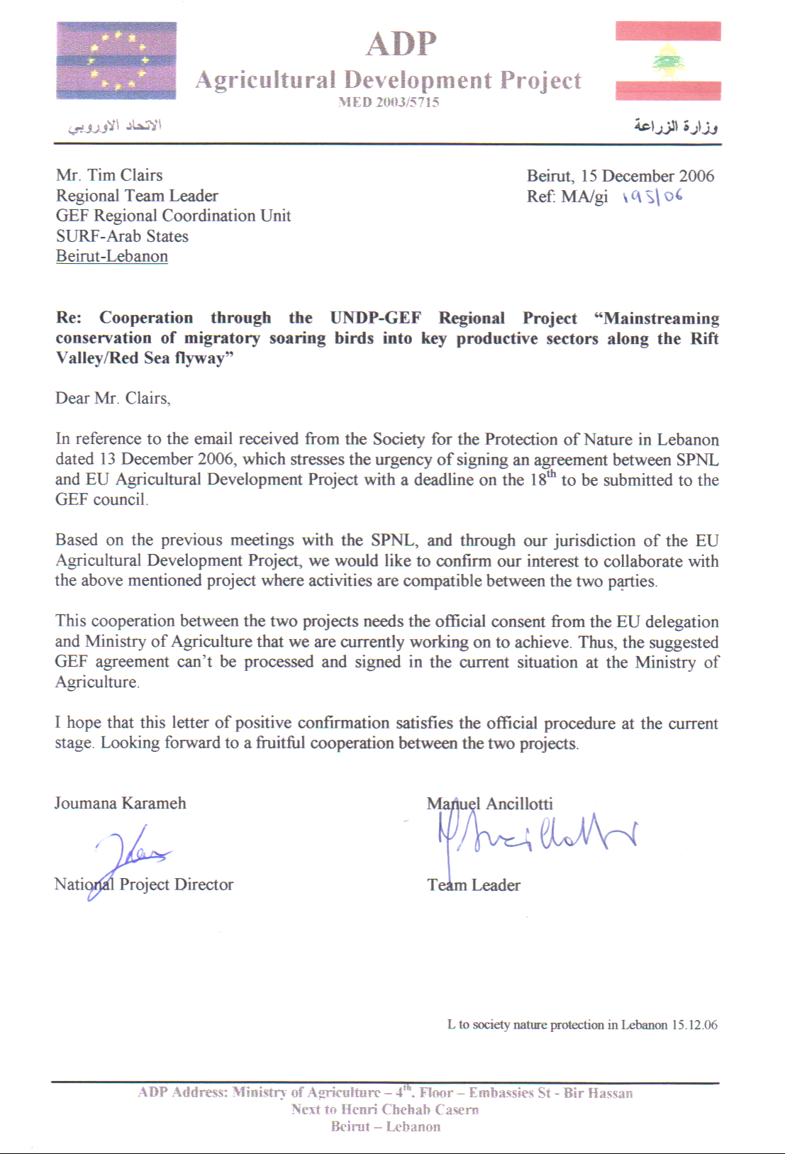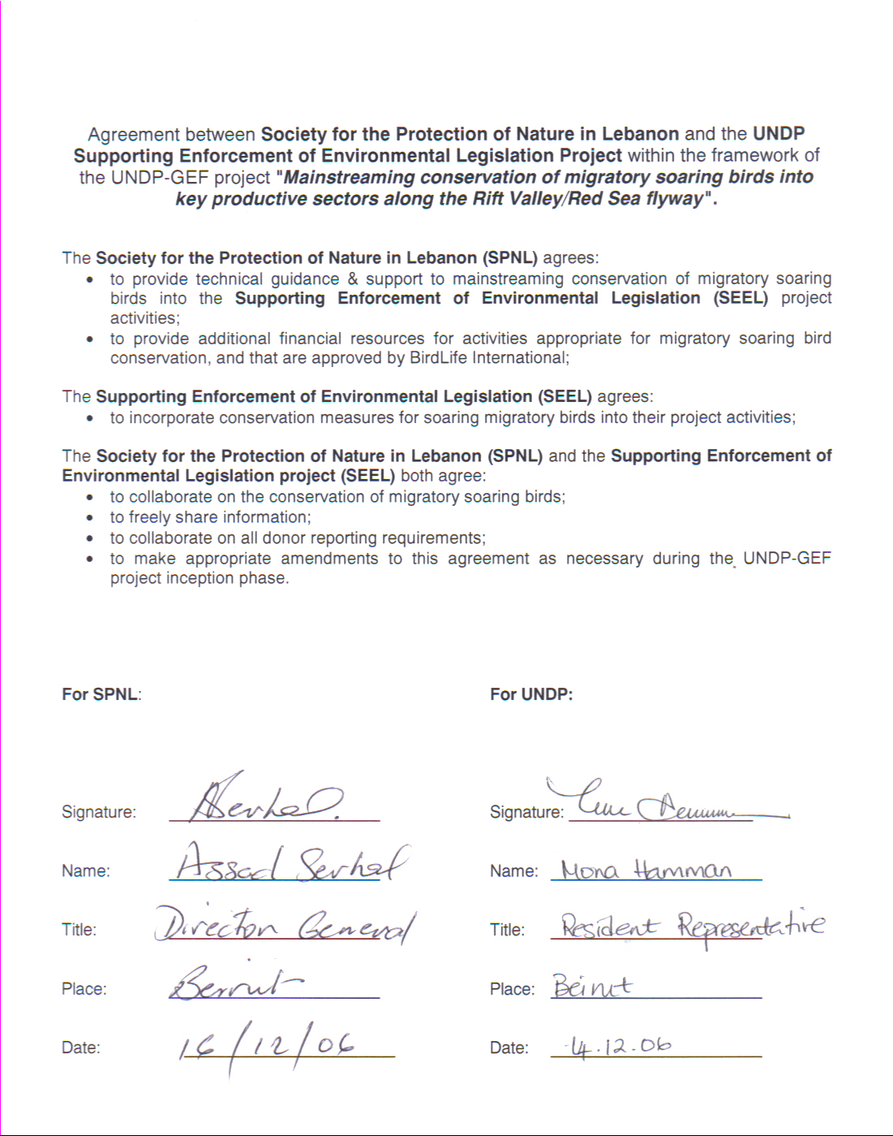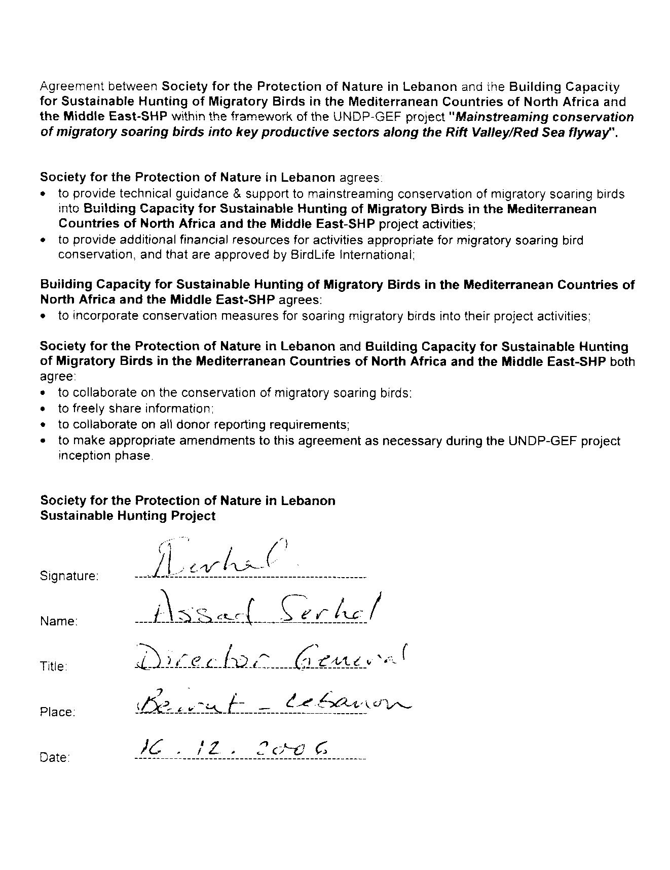

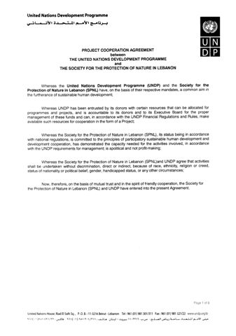

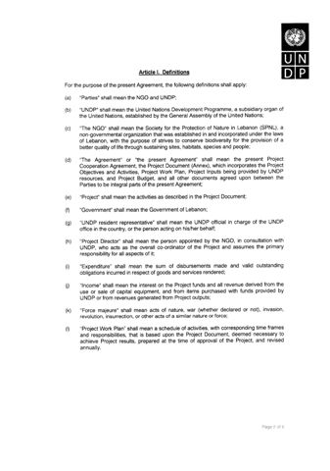

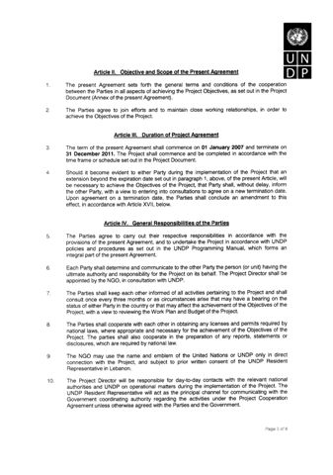
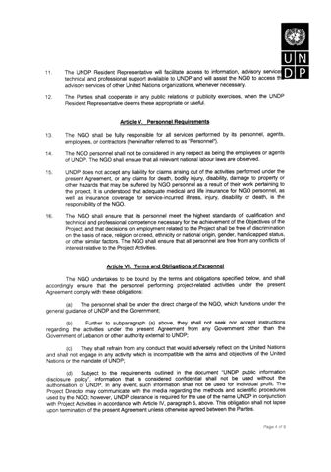
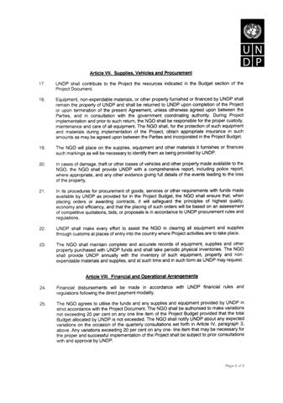

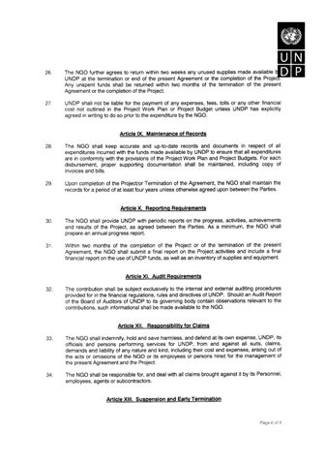

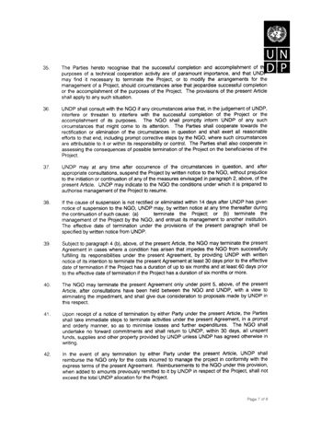
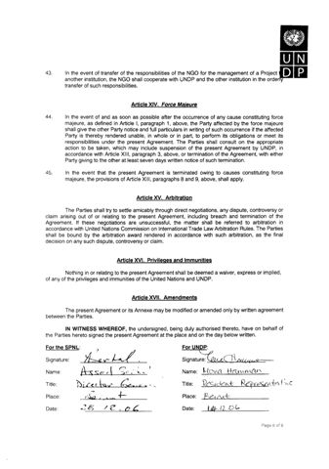

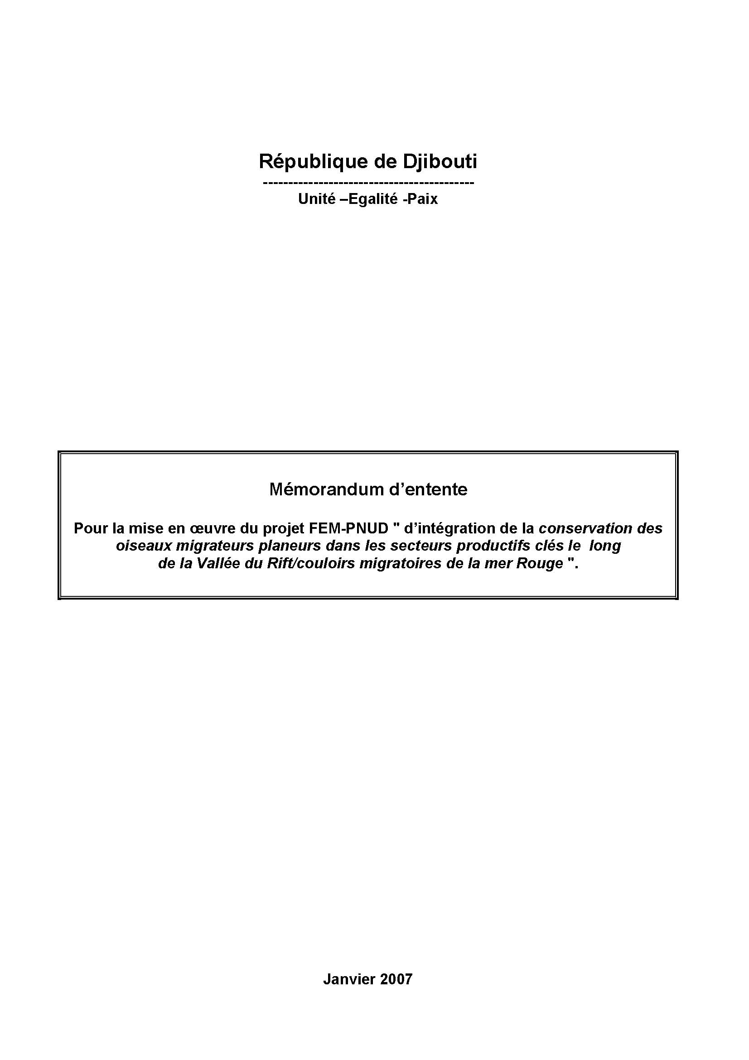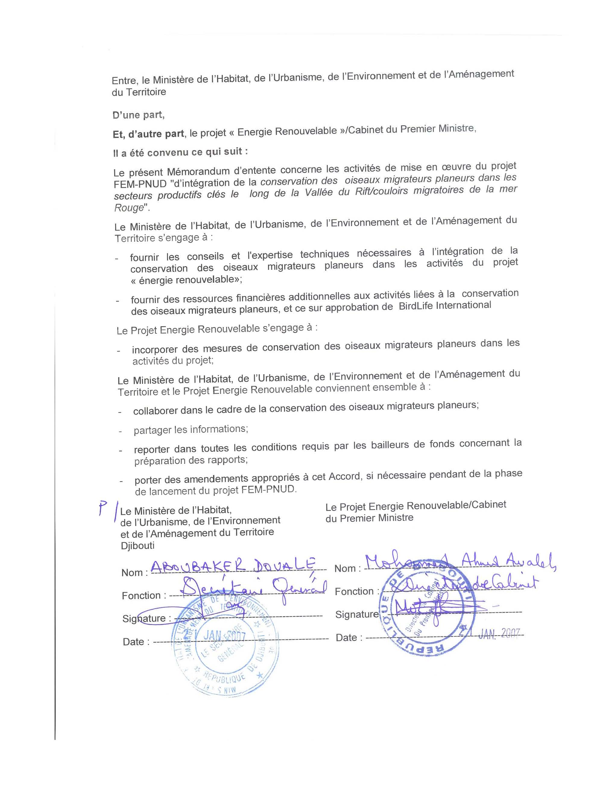

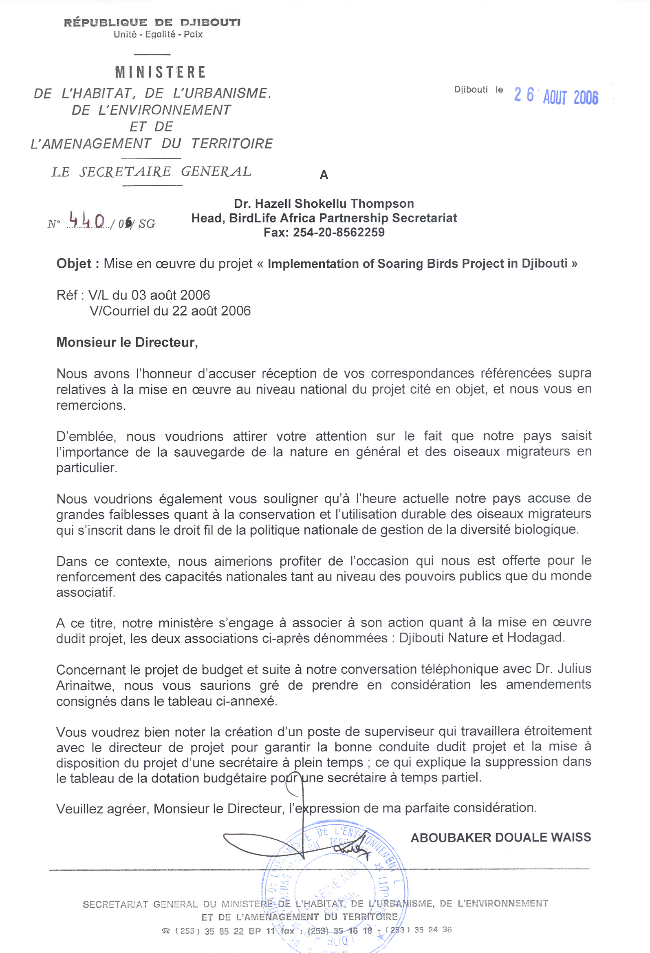

PART 2: Terms of References for key project staff and main sub-contracts

2.1 TERMS OF REFERENCE- REGIONAL FLYWAY FACILITY

Terms of Reference – Project Director

The terms of reference for the Project Director will cover the duration of the Project (60 months). The project Director will be a staff person of the Regional Flyway Facility, with input (100% of his/her time) funded by the project. The primary responsibility of the Project Director is to ensure the Project objectives, outputs and activities are achieved on time and to the satisfaction of UNDP. The PD will be based at the Regional Flyway Facility (RFF) office in Amman (accommodated within the BirdLife International Middle East Division)

Role of the Project Director
The Project Director will:
- Provide overall direction and co-ordination of the technical and administrative aspects of the project including inputs from the NIAs and UNDP-COs.
- Direct and provide guidance to achieve double mainstreaming objectives at national and regional levels.
- Help build the capacity of the national implementing agencies to enable them to participate in Tranche II at which time project partners will be expected to develop relationships with a wider range of stakeholders to achieve double mainstreaming.
- Coordinate through the Assistant Project Director, the two Flyways Officers and regional offices, and project activities of the BirdLife network. There will be linkages to BirdLife Partner and Affiliate organisations in participating countries through the regional offices, providing a network for influence, exchange, support, capacity development and knowledge management.
- Implement specific components of the Project, in collaboration with the RFF staff and regional offices.
- Identify and appoint, in conjunction with BirdLife International and consultation with UNDP-Amman any consultants required to carry out specific project components and training.
- Develop the terms of reference for international and national consultants carrying out specific project components of the Project.
- Supervise and co-ordinate the performance, in conjunction with the RFF staff, of the international and national partners in carrying out specific project components of the Project.
- Develop and submit an overall detailed work program with input from the implementing partners for the execution of the Project and the delivery of outputs
- Ensure that individual components of the Project are delivered on time and assure quality control.
- Develop and implement in coordination with RFF staff a fundraising strategy that aims to sustain the RFF beyond the project duration and responds to emerging fundraising opportunities. As far as possible this fundraising will be integrated within regional fundraising plans.
- Liaise with and supervise communication with UNDP/GEF.
- In coordination with UNDP-Amman, establish the Project Steering Committee (PSC), ensuring that it meets annually during the course of the Project.
- As the secretary of the PSC, ensure that the recommendations of the PSC are distributed and taken into account in the Project implementation.
- Oversee resource allocation and ensure budgetary control.
- Receive quarterly progress and financial reports from implementing partners, coordinate the input, certify and develop a consolidated project report to be submitted to UNDP/GEF.
- Supervise and facilitate the mid-term and final evaluation of the project by an independent evaluation team.
- Develop and submit a terminal report to UNDP-GEF and BirdLife International six months before the end of the project and implement the recommendation for its successful closure.
- Ensure that UNDP/GEF norms and standards for project monitoring and reporting are properly met.
- Attend as appropriate national, regional and international events to enhance information sharing and dissemination and lessons learned.
- Ensure coordination mechanisms are established in each relevant country to include as a minimum the UNDP-CO, the national partner/implementing agency, and the GEF-OFP.
- Develop a comprehensive Business Plan for the sustainable operation of the RFF beyond the project life with an exit strategy for the integration of the RFF within the structure of BirdLife International.
- Coordinate, consult and synthesize relationships with other GEF or non-GEF funded projects which could serve and enhance the objectives of this project.

Relationships
The Project Director will:
- Report as appropriate to the BirdLife Site Action Unit regarding project performance, administrative and financial issues.
- Be accountable to UNDP/GEF for the achievement of project objectives, results, and all fundamental aspects of project execution.
- Maintain regular communication with UNDP-GEF, the Project Steering Committee (PSC) and with BirdLife International.
- Maintain regular contact with Heads of BirdLife Regional Offices in Amman and Nairobi.
- Technical supervision of the regional project consultants and coordination of BirdLife international consultants.
- Facilitate communications with and among national implementing agencies.

Qualifications
The Project Director will have the following qualifications or be able to demonstrate:
- An advanced university degree (PhD or MSc) in any discipline related to the natural sciences.
- A minimum of 15 years of professional experience, five of which should be at the international level in project development, strategic planning and management, related to conservation and the conservation of habitats and/or their biological diversity.
- An ability to work with a variety of people including government officials, international and national non-governmental organizations (NGOs), local stakeholders, experts and consultants.
- Proven experience of working with government at high level.
- Proven experience in facilitating and chairing meetings and/or workshops.
- Proven knowledge of the environmental sector in the Middle East and/or North and Eastern Africa.
- Excellent communication skills.
- A proven ability to manage budgets.
- Proven track record in fundraising.
- Good organizational and planning skills and an ability to adhere to deadlines.
- Excellent writing skills.
- Fluency in written and spoken English and a second UN language. (Arabic is a significant additional advantage).

Input
Full-time for the duration of the Project (100%)
Terms of Reference - Assistant Project Director

The terms of reference for the Assistant Project Director (APD) will run for 60 months of the Project. His/her input (100% of the time) will be funded by the project. The APD will have appropriate marketing and communication skills and project managing capacity. The APD will be based at the Regional Flyway Facility (RFF) office in Amman.

Role of the Assistant Project Director
Within the RFF, the APD will:
- Assist the Project Director to provide direction and co-ordination of the technical and administrative aspects of the project.
- Implement specific components of the Project, in collaboration with the Project Director mainly those related to communication, marketing and branding, and fundraising.
- Ensure all administrative and operational activities of the project are successfully implemented.
- Co-ordinate through the Flyway Officers (FOs), the performance of National Implementing Agencies, and international consultants carrying out specific project components of the Project, under the supervision of the Project Director.
- Coordinate input from the different implementing agencies for the development of an overall and detailed five-year and annual work programmes.
- Coordinate the preparation and submission of quarterly technical and financial reports from the different implementing partners and submit for the approval of the Project Director.
- Establish a monitoring and evaluation system for the entire project in coordination with the implementing agents and according to verifiable indicators for the achievement of the project objectives and results ensuring that individual components of the Project within the region are delivered on time.
- Supervise the two FOs and RFF finance and administrative staff.
- Assist Project Director and FOs with exploring new vehicles for Tranche I and II countries and sustainability of the RFF.
- Develop in coordination with the FOs, international consultants and implementing partners an overall communication, knowledge management and outreach strategy and action plan for the dissemination of the project findings, results and knowledge products.

Relationships
The APD will:
- Assist PD to Co-ordinate project implementation.
- The APD will be supervised by and report on a day-to-day basis to the PD. The APD will be accountable to the Project Director for the achievement of project objectives, results, and all fundamental aspects of project execution
- Coordinate and supervise the two Flyways Officers (FOs) with regard to Tranche 1 countries.
- Coordinate with the two FOs with regard to Potential National Implementing Agencies of the Tranche II countries within their respective regions and delivery of Capacity building programmes.
- Assist PD to maintain regular contact with and supervise the work of hired consultants as required.
- Assist PD and FOs to implement national activities of Branding & Marketing and Private Sector engagement.
- Assist PD in developing and implementing in coordination with FOs a fundraising strategy that aims to sustain the RFF beyond the project duration and responds to emerging fundraising opportunities. As far as possible this fundraising will be integrated within regional fundraising plans.
- Assist PD to develop and submit quarterly progress and financial reports to UNDP-GEF and to develop and submit a terminal report to UNDP- GEF and BirdLife International.
- Coordinate with the two FOs to develop and maintain communication mechanisms powered by RFF especially with regard to National liaison groups, any established technical groups and discussion forums.

Qualifications
The APD will have the following qualifications or be able to demonstrate:
- An advanced degree (MSc) or proven equivalent experience, in any appropriate discipline e.g. Natural Sciences, Project Management. Ancillary qualifications related to Marketing and communication will be advantageous
- A minimum of 10 years experience in project management, related to conservation and the conservation of habitats and/or their biological diversity.
- An ability to work with a variety of people including government officials, international and national non-governmental organizations (NGOs), local stakeholders, experts and consultants.
- Good organizational and planning skills and an ability to adhere to deadlines.
- Fluency in written and spoken English, as well as Arabic. Knowledge of French will be a distinct advantage.
- Willingness to travel within the region

Input
Full time for the duration of the Project (100%)

Terms of Reference – Flyways Officers

The terms of reference for the two Flyways Officers (FOs) will run for 60 months of the Project. Their input (100% of their time) will be funded by the project. The two FOs will have appropriate technical skills and knowledge of the regions concerned (Middle East and North Africa). The FO for the Middle East will be based at the RFF, and the FO for Africa will be based at the BirdLife regional secretariats in Nairobi.

Role of the Flyways Officers
Within their respective regions the FO will:
- Assist the PD and APD in providing direction and co-ordination of the technical aspects of the project in their respective regions.
- Implement specific components of the Project, in collaboration with the Assistant Project Director mainly those related to double mainstreaming and directing vehicles.
- Supervise and co-ordinate the performance of National Implementing Agents, and international consultants carrying out specific project components of the Project, in conjunction with the Assistant Project Director.
- Assist the Project Director to develop and submit a detailed work program for the execution of the Project and the delivery of outputs.
- Ensure that individual components of the Project within the region are delivered on time and reports are submitted on schedule.
- Coordinate communication within countries involved in the project to enhance partnership, information sharing and knowledge management.
- Supervise inclusion of co-financing and reporting of the Project, in close collaboration with the Assistant Project Director, Project Steering Committee, National Implementing Agencies, BirdLife International (Head of Africa or Head of Middle East Division, as appropriate), and UNDP-GEF
- Assist Project Director with exploring new vehicles for Tranche I and II countries and sustainability of the RFF.
- Oversee resource allocation and ensure budgetary control within the region
- Assist the Project Director to develop and submit quarterly progress and financial reports to UNDP-GEF and BirdLife International.

Relationships
The FOs will:
- Co-ordinate project implementation within their respective regions
- Be accountable and report to the Assistant Project Director who will supervise their work.
- Be accountable to the Project Director for the achievement of project objectives, results, and all fundamental aspects of project execution
- Maintain regular communication with National Implementing Agents of the Tranche 1 countries within their respective regions.
- Maintain regular communication with Potential National Implementing Agents of the Tranche II countries within their respective regions and delivery of Capacity building programmes.
- Maintain regular communication with the Project Director
- Maintain regular contact with and supervise the work of hired consultants as required

Qualifications
The FOs will have the following qualifications or be able to demonstrate:
- An advanced degree (MSc), or proven equivalent experience, in any discipline related to the natural sciences.
- A minimum of five years experience in project management, related to conservation and the conservation of habitats and/or their biological diversity.
- An ability to work with a variety of people including government officials, international and national non-governmental organizations (NGOs), local stakeholders, experts and consultants.
- Proven knowledge of the environmental sector within the respective region (Middle East/or North and Eastern Africa).
- Good communication skills.
- Good organizational and planning skills and an ability to adhere to deadlines.
- Fluency in written and spoken English, as well as Arabic (for the Middle East FO). A knowledge of either French or Arabic will be a distinct advantage for the North Africa FO.
- Willingness to travel within the region

Input
Full time for the duration of the Project (100%)
Terms of Reference – Finance and Administration Officer (FAO)

Role
The FAO will:
- Support the Regional Flyway Facility Project Director and Assistant Director with managing project funds in accordance with international accounting procedures and according to UNDP requirements.
- Maintain accurate, up-to-date, project accounts related to the project component directly implemented by the RFF and obtain for coordination and follow up on delivery other financial records for components implemented by the IAs.
- Produce financial reports for internal and external purposes according to reporting schedules.
- Supervise and monitor procurement procedures to conform to UNDP requirements.
- Assist in transferring knowledge and expertise in project financial management to partners.
- Keep track of all assets procured by the project and ensure appropriate recording, bookkeeping, and facilitate maintenance for the smooth running of office facilities in collaboration with Middle East Regional Division Staff and the office secretary.
- Prepare and coordinate annual independent financial audits.

Relationships
The FAO will:
- Report to the Assistant Project Director
- Be accountable to the Project Director on submitting timely and high quality financial and accounting reports.
- Maintain good communications with other Regional Flyway Facility, BirdLife International and National Implementing Agent staff
- Maintain good communications with UNDP-Jordan and the BirdLife Regional Divisions.

Qualifications
The FAO will have the following qualifications or be able to demonstrate:
- A recognised accountancy or business management qualification.
- A minimum of five years experience in accounting of donor funded projects.
- An ability to work with a variety of people including government officials, international and national non-governmental organizations (NGOs), local stakeholders, experts and consultants.
- Excellent communication skills.
- A proven ability to manage complex budgets and in preparing financial reports.
- Good organizational and planning skills and an ability to adhere to deadlines.
- Fluency in written and spoken English and Arabic and/or French

Input
Full time for the duration of the project (100)
Terms of Reference – Secretary and Receptionist (SEC)

Role
The SEC will:
- Support the Regional Flyway Facility in secretarial and support functions as necessary.
- Provide human resources management services to RFF staff in collaboration with UNDP Amman and BirdLife International.
- Maintain and update personnel records, contracts, MOUs and documentation.
- Assist in organizing workshops, meetings, activities and seminars as directed by the PD.
- Maintain office equipment to ensure high productivity of staff and consultants.

Relationships
The SEC will:
- Report to the Regional Flyway Facility Project Director
- Maintain good communications with other Regional Flyway Facility, BirdLife International and National Implementing Agent staff
- Maintain good communications with UNDP-Jordan

Qualifications
The SEC will have the following qualifications or be able to demonstrate:
- A recognised secretarial or business management qualification.
- A minimum of five years experience.
- An ability to work with a variety of people including government officials, international and national non-governmental organizations (NGOs), local stakeholders, experts and consultants.
- Excellent communication skills.
- Excellent computer skills
- Fluency in written and spoken English and Arabic and/or French

Input
Full time for the duration of the project (100%)
Terms of Reference – Head of BirdLife International Regional Divisions (HOD), Middle East and Africa.

Role as related to the project
The HOD will:
- Provide technical and managerial support to the Regional Flyway Facility Project Director in their respective region.
- Work towards institutionalising the Regional Flyway Facility into the existing BirdLife International partnership structure
- Promote the flyway approach within the BirdLife International regional partnerships

Relationships
The HOD will:
- Work with the BirdLife Site Action Unit and UNDP regarding project performance, administrative and financial issues.
- Facilitate communication between the Regional Flyway Facility and BirdLife International partners.

Input
50 days per year for the duration of the project (25% of their time). These two posts will be funded by BirdLife International. The Head of Division may delegate part of his/her time to the Programme Development Officer without compromising the level of coordination and communication with BirdLife Secretariat and other partners.

Terms of reference – Project Steering Committee (PSC)

Composition
- UNDP-GEF Regional Technical Adviser, SURF-Arab States
- UNDP-Jordan PPRR or his/her delegate.
- UNDP Project Coordination Officer.
- Regional Flyways Facility Project Director
- Head, BirdLife International, Middle East and Central Asia Partnership Office
- Head, BirdLife International Africa Partnership Secretariat
- Programme & Projects Manager, BirdLife International Site Action Unit
- National Project Managers (Egypt, Djibouti, Jordan, Lebanon)
- Project Manager/CTA for mainstreaming ‘vehicle’ projects
- Government of Jordan GEF/OFP as lead host country
- UNDP/COs’ representatives
- Co-opted members as necessary

Duties
- Provide strategic guidance to project implementation and approve 5-year and annual work plans;
- Coordinate information sharing among the major project stakeholders;
- Plan and guide external project reviews and evaluations;
- Assist in reviewing project risks and facilitate removing obstacles and disseminate lessons learnt in their respective organizations;
- Guide response to external project reviews and evaluations;
- Monitor project implementation against the project strategy and guide adjustments in implementation;
- Facilitate coordination with other internationally funded projects, including GEF projects (and especially the GEF/UNEP AEWA-Flyways project);
- Identify and secure support and supporters to the project from the private sector;
- Facilitate co-ordination with other government projects and programmes;
- Facilitate consultation with, and participation of, a broad range of stakeholders; and
- Assist in resource mobilization activities and efforts for the sustainability of the RRF.

Procedures
- The PSC shall conduct business through meetings convened once a year.
- At the first meeting of the PSC, the PSC members will review this TOR and the PSC membership, and adopt changes as appropriate
- The Project Director will organise the meetings and act as Secretary and will prepare and distribute all concerned documents in advance of meetings, including the meeting agenda.
- In between meetings, PSC business will be conducted through e-mail, coordinated by the Project Director

Input
At least 1 formal meeting per year throughout the duration of the project

2.2 TERMS OF REFERENCE- NATIONAL

Terms of reference - National Project Manager (NPM)

Description of Responsibilities
Under the overall direction and guidance of the Project Director, direct supervision of the corresponding UNDP/CO and in close and regular consultation with the Regional Flyway Officer, the National Project Manager (NPM) has the responsibility for the national delivery of the project’s outcomes and activities in accordance with the project document and agreed work plan. He/She will serve on a full-time basis and will be committed to the day-to-day management of the national project component and for its successful implementation in line with the UNDP-GEF standards. The specific tasks and responsibilities include the following:

Project management (40%)
- Provide overall management and planning for the implementation of the national project’s outcomes, outputs and activities according to the project document and annual work plan;
- Participate in regional conferences, workshops and meetings to provide input in the strategic planning & implementation of the project.
- Establish coordination mechanisms and maintain continuous liaison with BirdLife International, UNDP-CO, GEF-OFP, ‘vehicle’ projects and the national implementing agencies.
- Play a lead role in the alignment and implementation of national project activities and help ensure that these are coordinated with the ‘vehicles’, other national and UNDP initiatives.
- Develop and submit a detailed work program for the national execution of the project and the delivery of outputs.
- Ensure that individual national components of the project are delivered on time according to the work plan and assure quality control.
- Document project activities, processes and results.
- Provide financial oversight and ensure financial accountability for the Project (monitor and manage the allocation of available budget to project activities, undertake all necessary financial arrangements, processes, requests for authorizations, payments).
- Ensure preparation & timely delivery of narrative & financial reporting (quarterly, progress and annual reports) submitted to BirdLife International and UNDP; taking into account the norms and standards for project monitoring and reporting are properly met.
- Provide management oversight to daily operational and administrative aspects of project (procurement, recruitment, staff supervision); Supervise all staff assignments, consulting agreements and procurements ;
- Identify and appoint (in collaboration with UNDP-CO) national experts/consultants, in conjunction with the RFF, to be hired for the implementation of specific project components or training of the project, develop TOR and agreements, and follow-up on performance.
- Initiate, in coordination with the UNDP-CO, the National Advisory Committee, and ensure that the Project acts as the Secretariat for the Committee (calling for meetings, preparing and consulting on agenda, steering discussions, follow-up on decisions, keep members informed on the progress, etc.).
- Establish and manage office facilities as needed to support project activities.
- Ensure sound programme monitoring and evaluation.
- Develop a resource mobilization strategy, to be considered as part of the RFF resource mobilization strategy, for the national component of the project; maintain effective liaison with funding partners and further develop the project’s resource base, whenever possible.

Project Outreach (Education, Awareness, Networking) (30%)
- Participate in project regional capacity building workshops.
- Prepare, in collaboration with the Regional Flyway Facility, a national outreach plan for mainstreaming MSB concerns.
- Prepare & perform awareness campaign & presentations to target audiences (decision makers, universities, general public …).
- Attend as appropriate national, regional and international events to enhance information sharing and dissemination and lessons learned.
- Establish continuous liaison with media providing updates on the project.
- Document and disseminate lessons learned and best practices.
- Participate in, & contribute to, the regional activities and network established by BirdLife international for the project; a network for influence, exchange, support, capacity-development and knowledge management.
- Contribute to, and draw from, relevant knowledge management networks
- Develop and implement national activities of Branding & Marketing and Private Sector engagement.

Technical input for double mainstreaming ‘vehicles’ (30%)
- Participate in the capacity building regional workshops organized by the project, on skills for double mainstreaming SB concerns.
- Research, prepare & provide technical input (content and services) on MSB concerns to vehicle project activities as identified in discussions with the ‘vehicles’ and the Regional Flyway Facility.
- Implement national activities separate from the ‘vehicles’ (e.g. opportunities to mainstream MSB considerations directly into the national private sector) in collaboration with the Regional Flyway Facility.
- Participate in technical or liaison groups as required by the Regional Flyway Facility.

Relationships
The National Project Manager will:
- Report directly to the BirdLife International Regional Flyway Facility and UNDP-CO regarding project performance, administrative and financial issues.
- Be accountable to BirdLife International and the UNDP-CO for the achievement of national project objectives, results, and all fundamental aspects of project execution.
- Maintain regular communication with BirdLife International, UNDP-CO, GEF-OFP, mainstreaming ‘vehicles’ and the National Advisory Committee.

Qualifications and Experience
The National Project Manager will have the following qualifications, or be able to demonstrate:

Education
- An advanced university degree (MSc or higher) in any appropriate discipline related to environment, biodiversity, natural resource management, project management.
- Additional qualifications or experience related to marketing and communication will be advantageous

Experience, Skills and Competencies
- A minimum of six years national experience in project development and management; related to conservation and the conservation of habitats and/or biological diversity.
- Proven knowledge of the environmental sector in the country; overview knowledge of the region is an added asset.
- Previous success in resource mobilization;
- A through understanding of national socio-economic issues, civil society and NGO environment, institutional setup, legal framework and regulation.
- Proven ability to work with a variety of people including government officials, international and national NGOs, local stakeholders, experts and consultants.
- Strong leadership, managerial and team-building skills; committed to enhancing and bringing additional value to the work of the team as a whole.
- Proven experience in facilitating and chairing meetings and/or workshops.
- Excellent communication, presentation and facilitation skills.
- A proven ability to manage budgets.
- Good organizational and planning skills and a proven ability to adhere to deadlines.
- A proven ability to provide financial and progress reports in accordance with reporting schedules.
- Good computer skills;
- Fluency in verbal and written English and Arabic or French.

Input
Full-time for the duration of the project (100%)
Terms of reference - National Assistant (NA)

Description of Responsibilities
Under the overall guidance of the National Project Manager (NPM), the National Assistant (NA) has the responsibility to support the delivery of the project’s outcomes and activities in accordance with the project document and agreed work plan. He/She will be committed to the day-to-day support of the project and for its successful implementation in line with the UNDP/GEF standards. The specific tasks and responsibilities include the following:

Project management
- Assist NPM to co-ordinate project implementation.
- Assist the NPM in maintaining continuous liaison with BirdLife International, UNDP-CO, GEF-OFP, ‘vehicle’ projects, and the national partners of the project.
- Ensure documenting project activities, processes and results.
- Facilitate all necessary financial arrangements, processes, requests for authorizations, and payments.
- Support the NPM in maintaining continuous contacts with vehicle projects on progress of activities, and collating reported information to be included in progress reports.
- Assist NPM to develop and submit progress and financial reports to BirdLife International & UNDP in accordance with the reporting schedule.
- Support the NPM in daily operational and administrative aspects of project.
- Assist NPM to maintain regular contact with and supervise the work of hired national experts/consultants as required.
- Facilitate the role of the project as the Secretariat for the National Advisory Committee (calling for meetings, preparing and consulting on agenda, steering discussions, follow-up on decisions, keep members informed on the progress, etc.).
- Manage office facilities as needed to support project activities.
- Support the NPM in assuring sound programme monitoring and evaluation.
- Perform other related functions as required by the National Project manager.

Project Outreach (Education, Awareness, Networking)
- Support the NPM in preparing awareness campaigns & presentations to target audiences (decision makers, universities, general public…).
- Assist the NPM in keeping continuous liaison with media providing updates on the project.
- Support the NPM in documenting and disseminating lessons learned and best practices.
- Assist NPM to implement national activities of Branding & Marketing and Private Sector engagement.

Technical input for double Mainstreaming in Vehicles
- Support the NPM in research, & preparing technical input (content and services) on MSB concerns to vehicle project activities as identified in the bilateral agreements.
- Assist the NPM in implementing national activities remote from the vehicles (e.g. opportunities to mainstream MSB considerations directly into the national private sector) working with assistance from the BL.
- Participate in technical or liaison groups powered by BL.

Relationships
The National Technical Assistant will:
- Report to the NPM regarding project performance, administrative and financial issues.
- Be accountable to NPM for the achievement of national project objectives, results, and all fundamental aspects of project execution.

Qualifications and Experience
The National Technical Assistant will have the following qualifications or be able to demonstrate:

Education
- A first university degree (BSc), in any appropriate discipline related to environment, biodiversity, natural resource management, project management.
- Additional qualifications or experience related to Marketing and communication will be advantageous

Experience, Skills and Competencies
- A minimum of three years experience in project management, related to conservation and the conservation of habitats and/or their biological diversity.
- Proven knowledge of the environmental sector in the country.
- Previous experience in management of project cycles, including project formulation, monitoring, reporting and evaluation;
- An ability to work with a variety of people including government officials, international and national non-governmental organizations (NGOs), local stakeholders, experts and consultants.
- Proven experience in facilitating meetings and/or workshops.
- Excellent communication, presentation and facilitation skills.
- A proven ability to manage budgets.
- Good organizational and planning skills and an ability to adhere to deadlines.
- A proven ability to provide financial and progress reports in accordance with reporting schedules.
- Good computer skills; Fluency in verbal and written English and Arabic or French.

Input
Full-time for the duration of the Project (100%)
Terms of reference - National Advisory Committee (NAC)

Composition
- Representatives from UNDP-CO, the National Project Manager, mainstreaming ‘vehicle’ project executants, GEF-OFP, National Implementing Partner.
- The Government Departments responsible for wildlife and environmental management,
- Other stakeholders (e.g. academic and scientific institutions and other NGOs in the country) and relevant private sector institutions will be co-opted as necessary.

Duties
- In collaboration with the NPM, provides overall guidance and strategic direction to the national implementation in accordance with the project document and annual work plan, and oversees its implementation.
- Review progress reports and proposed workplans, review project compliance to implementation strategy (project monitoring and evaluation).
- Contributes to developing and implementing strategies for national sustainability.
- Mobilise political and institutional support for the project and harness the engagement of other stakeholders and identify more opportunities for mainstreaming.

Procedures
- The NAC should meet on a quarterly basis.
- NAC will appoint a chair from its membership. Chairmanship could be rotational.
- The NAC will co-opt relevant experts in the identified threats to MSB and in advocacy and marketing as necessary.
- NAC can form sub-committees or Task Forces to address specific aspects of the project.
- The National Project Manager will act as Secretary for the NAC.

PART 3: Stakeholder Involvement Plan

Stakeholders identified

The list of key stakeholders varies by country, according to the national problem analysis (particularly the key threats to MSBs in each country) and the national opportunities for “mainstreaming” MSBs concerns into key sectors other than environment or biodiversity conservation. Project stakeholders were grouped into the following categories: governmental agencies; non-governmental organizations; local community groups; national agencies; private sector; international agencies.

Governmental agencies

Names and responsibilities vary between countries but across the region governmental stakeholders include ministries and their agencies responsible for: environment (may include hunting, wildlife trade, biodiversity, protected areas); agriculture (hunting, pesticides, some protected areas); forestry (some protected areas/ habitat restoration); waste management; local administration/ municipalities; electricity/ energy/ power; renewable energy; land use; planning; water/ irrigation; marine/ coastal management; climate change/ desertification; transport/ roads; petroleum; tourism; education. Others such as ministry of interior (hunting, trade), social affairs, health, justice, finance, defense and economy were identified in some country analyses.

Across the region, key ministries and agencies are characterized by lack of awareness of MSBs, their conservation needs and the actual or potential impacts of their sector on MSBs and biodiversity generally. The readiness to collaborate with the project is very variable in different countries and in different sectors with some encouraging results from the PDF-B stage (e.g. willingness of Lebanon and Sudan Ministries of Power/ Electricity to consider mitigation measures on power lines and siting of distribution networks away from flyways once the negative impacts on MSBs were explained). Government agricultural extension services working with rural communities were identified as useful existing mechanisms for awareness-raising and community involvement in the project.

Non-governmental organizations and local community groups

In seven of the 11 project countries, the lead implementing agency is a national NGO which forms part of the Middle East or Africa Partnership of BirdLife International. In other countries there is no strong tradition of NGO leadership in biodiversity conservation and the project will be led by a relevant government agency – e.g. Nature Conservation Sector of Egyptian Environmental Affairs Agency; National Commission for Wildlife Conservation and Development in Saudi Arabia. In most project countries there is a wide range of other NGOs and community based organizations (CBOs) with interests and skills in wildlife, sustainable development, agriculture etc. which will contribute to project implementation (e.g. farmers' and fishermen's cooperatives and local community development organizations in Yemen). Particular NGO strengths identified in stakeholder analyses in several countries (e.g. Jordan, Lebanon, and Ethiopia) include community involvement, awareness-raising, environmental education and project management (e.g. through experience of managing regional and national BirdLife International Important Bird Areas programmes). In Palestine, the non-governmental Hunting Club will work with the project on an anti-hunting campaign to stop hunting of rare, threatened species.

Other National agencies

National agencies in some countries are key stakeholders whose involvement in the project is essential for success. In Jordan, the Aqaba Special Economic Zone Authority (ASEZA) and Jordan Valley Authority (JVA) are the most influential bodies in terms of development, land management and enforcement of policy and legislation in the Aqaba and Jordan Valley bottlenecks. The Lebanese Council for Development and Reconstruction is responsible for planning and implementation of all large rehabilitation and development projects nationally. National unions and syndicates in Syria (e.g. students, farmers, writers and teachers) are identified as key stakeholders in relation to public awareness.

Private sector

Key stakeholders in the private sector include hunting clubs and their members (e.g. Lebanon); Universities, research institutes and natural history museums; various branches of the media (TV, radio, newspapers); general public; private tour company operators (ecotourism potential).

International agencies

UNDP Country Offices (COs) played strong roles in project development, through involvement in stakeholder workshops and in identifying opportunities for “mainstreaming” MSB conservation into other sectors and existing projects (“double mainstreaming”). Suitable projects for this approach, in agriculture, waste management, hunting and tourism have been identified through UNDP in four project countries with a total of six projects in Djibouti, Egypt, Jordan and Lebanon to be included in Tranche I. COs also assisted project development and stakeholder participation through distribution of communication tools (project briefing sheets, fund-raising brochure, Power Point presentation on raptor migration). Other contributing international bodies include international NGOs (BirdLife International), other projects and donors (e.g. International development aid agencies).

Project beneficiaries
Although four sectors (agriculture, hunting, waste management and energy production) have been identified as representing significant threats to MSBs, this does not mean the stakeholders in these sectors will be disadvantaged by the project. Staff of government agencies, NGOs and some private sector groups will benefit from training and capacity building opportunities offered by the project. The “double mainstreaming” approach means that the project will add value to existing projects in these sectors and bring benefits to these sectoral groups – e.g. hunters and farmers (Sustainable Hunting Project; Agricultural Development Project, both in Lebanon). Other MSB project inputs may be neutral in terms of impact on local communities but will benefit stakeholders directly involved in implementation (e.g. the Power Access and Diversification Project, Djibouti – siting and monitoring of wind turbines to ensure that these are “flyway-friendly”). There will also be “general public” benefits in terms of increased awareness and access to information. In other cases, the double mainstreaming approach means that the project will assist governments to improve and/ or enforce existing legislation and meet their own obligations in relation to international conventions (e.g. Strengthening the Lebanese Judiciary System in the Enforcement of Environmental Legislation; Strengthening Environmental Enforcement, Jordan).

In relation to the tourism sector, the addition of MSB information and concerns can bring benefits in terms of new opportunities to attract tourists to bottleneck sites and to interpret both the MSBs experience and other natural heritage interest. There is potential for local community benefits through increasing ecotourism activity and revenues and this may have a positive impact on other sectoral groups (e.g. farmers, hunters) who become involved in ecotourism (e.g. Sustainable Economic Growth in the Red Sea Governorate Project, Egypt). More details of all these projects and the “double mainstreaming” approach are given in the Project Strategy under Outcome 3 (paragraphs 60-64).

Risks of negative impacts/ opposition to the project
The national stakeholder analyses for each country revealed widespread lack of awareness of MSBs concerns. In some cases there was lack of interest and concern for MSBs even after approaches had been made by the project. (This was manifest particularly as reluctance by government staff to provide relevant sectoral information for national reviews during the PDF-B stage). However, there was no outright opposition to the project and its aims and no specific stakeholders were identified as being likely to suffer negative impacts or to oppose project activities.

Hunter and farmer stakeholder groups could take a negative attitude to attempts by the project to support strengthening or enforcement of relevant legislation (hunting, trade and pesticide use/ control). However, such activities will be carried out alongside awareness campaigns targeted at hunters, farmers and other key targets, to explain the importance and values of MSBs and the details and reasons for the legislation and the advantages of such activities to the stakeholders. The same situation may apply in the energy and waste management sectors but in practice it is likely that project activities to influence these sectors will be of mutual benefit to local communities (e.g. in terms of human health and improved environmental practices) and to MSBs along the flyway. For example, strengthened EIA for energy developments can lead to improved design and sitting, with better landscape outcomes and better management and treatment of wastes to help protect MSBs are also likely to benefit human health and local communities generally.

SIGNATURE PAGE

Country: Jordan

UNDAF Outcome(s)/Indicator(s): _____________________________________
(Link to UNDAF outcome., If no UNDAF, leave blank)

Expected Outcome(s)/Indicator (s): Energy and Environment for Sustainable Development /
(CP outcomes linked t the SRF/MYFF goal and service line) Environmentally Sustainable intervention at the community level/Number of projects executed by NGOs
For the protection of the environment

Expected Output(s)/Indicator(s):

(CP outcomes linked t the SRF/MYFF goal and service line) Conservation and sustainable use of biodiversity/
Governments and local communities empowered to better manage biodiversity and the ecosystem it provides

Implementing partner: BirdLife International
(designated institution/Executing agency)

Other Partners: BirdLife International’s National Partners

Programme Period 2003 - 2007

Programme Component: Energy and Environment for Sustainable Development

Project Title: Regional: Mainstreaming Conservation of Migratory Soaring Birds into Key Productive Sectors along the Rift Valley/Red Sea Flyway

Project ID: 00051312

Project Duration: Tranche I - 5 years
Tranche II – 5 years

Management Arrangement: Mixed, NEX and NGO Execution Modalities
Total Budget $9,743,243 +GMS

General Management Support Fee $
Allocated resources: $ 9,743,243

TRANCHE I
GEF Component | $6,243,243
Co-financing
GEF Agency | $215,874
Government | $769,200
NGOs | $1,782,158
Others | $2,120,000
Sub-Total Co-financing: | $4,887,232
Total Tranche I Financing: | $11,130,475
Financing for Associated Activities (Tranche I): $37,017,941
TRANCHE II
GEF | $3,500,000
Expected Leveraged Resources: | $10,500,000
Total Tranche II Financing: | 14,000,000

Agreed by (Government of Jordan): _______________________________________________________

Agreed by (Implementing partner/Executing agency- BLI):________________________________

Agreed by (UNDP-JORDAN):_____________________________________________________________

ANNEXES

The list of species included as soaring birds that migrate along the Rift Valley/Red Sea flyway was initially compiled during the PDF-A stage by ornithologists from the participating countries, and then revised during the PDF-B by two experts in the field - Richard Porter, who was commissioned to produce a report on the key bottleneck sites for soaring birds passing along the flyway, and Graham Tucker, who was contracted to review the conservation status and threats to these birds (Annex 7 and 8 respectively). The two lists of species considered by each report were slightly different - the Porter report lists 36 species, the Tucker report 39 - the differences reflect slightly different data sources and poor information about the status of some bird species passing along this flyway. These lists have been further reviewed by Richard Porter and Graham Tucker in April 2006 and the agreed combined list of 37 species given above are the species of birds considered by this project.
As described by WWF – see http://www.nationalgeographic.com/wildworld/terrestrial.html and http://www.worldwildlife.org/science/ecoregions/biomes.cfm
except Saudi Arabia at US$12,000
at 3.45% per annum Yemen has the highest growth rate in the world
Falconry is a widespread and institutionalised sport in the Gulf States and depends on a supply of falcons of which the Peregrine Falco peregrinus, Saker F. cherrug and Lanner F. biarmicus are particularly favoured if wild-caught.
Numbers exclude those lost to scavengers
In Egypt, the proliferation of garbage has led to a dramatic increase in the Indian House Crow population at Suez and other sites along the Red Sea coast, estimated in the thousands to tens of thousand. Indian House Crows have been observed harassing migrating birds of prey flying through, and roosting in, the area and are thought to be a factor contributing to the declining numbers of MSBs migrating through Suez.
Full details of these projects, the proposed double mainstreaming activities envisaged, and the costs and co-finacing estimates can be found in the Incremental Cost Analysis in Section II
The "Equator Principles" form a banking industry framework developed by banks under guidance from the IFC in 2002 for managing social and environmental issues related to the financing of development projects. Currently 33 banks from over 15 countries have adopted the principles and will apply them globally to project financings in all industry sectors.
RARE is a conservation charity founded 30 years ago whose mission is to protect wildlands of globally significant biodiversity by enabling local people to benefit from their preservation. RARE’s approach is based on the recognition that people are the key to lasting change. Since 1988, RARE’s partnerships with leading NGOs, e.g. The Nature Conservancy and Conservation International, have led to 66 successful projects in ecologically significant regions around the world.
“Emerging Directions in Biodiversity Under GEF 3: Information Document for the May 2003 GEF Council”, GEF Secretariat, 25 March 2003.
UN (“Bonn”) Convention on the Conservation of Migratory Species of Wild Animals
African-Eurasian Waterbird Agreement (under CMS)
7th Meeting of the Conference of the Parties to the CMS, Bonn, 18-24 September 2002
UNDP-GEF Biodiversity Advisory Note on GEF Biodiversity Strategic Priority 2 issued on 9 March 2005.
The various ‘selected…sites’ indicated in this logframe (largely referring to bottleneck sites) will be agreed at the inception phase based on the feasibility of data collection, local social and environmental conditions, existing baseline data, whether included within area of operation of project “vehicles” and other criteria. The exact boundaries and area of these sites will also be defined at inception. However, the minimum baseline area will comprise that of the flyway covered by the project “vehicles” identified for Tranche I – that is the Rift Valley in Jordan (35,000 sq km), all of Lebanon (10,500 sq km) and the areas covered by the LIFE Red Sea Project in Egypt (8,100 sq km) and Djibouti Power Access project (100 sq km), giving a total area of 53,700 sq km.
BirdLife International and the project partners, with guidance and input from UNDP-GEF, undertook an assessment of the capacity of the partners to undertake mainstreaming activities (see Annex 13 of Project Document). Nine key areas for mainstreaming were identified, and a target score of at least 2 (scores range from 0-3) for each of the 9 key areas has been set for partners to allow entry into Tranche II. The self-assessment will be verified by UNDP and set as the baseline before CEO endorsement.
See Annex 11 of Project Document for details of the 6 initial reform “vehicles” and the integration of the Soaring Birds Project into these projects
The targets given here will be better defined through a workshop at the inception stage involving additional input from experts on wind and transmission line mortality from Europe and the US to allow for species-specific differences.

